Exercise 4

Exercise in Feature Extraction

Question 1: x (kernel size) is changes regarding to sigma. *g(x,sigma)*

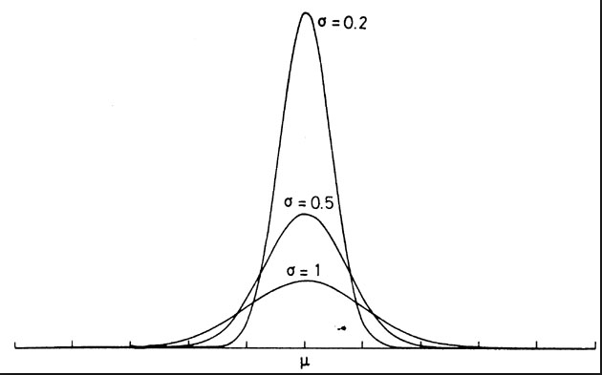

Question 2:

Ix= filter2(g',im,'same'); % column g' (+)

Ix= filter2(g,Ix,'same'); % row g(+)

Question 3: Calculate the 3 components of the C(x, y) matrix and display the images.

Ix2 = filter2(g, Ix.^2, 'same');

Iy2 = filter2(g, Iy.^2, 'same');

Ixy = filter2(g, Ix.*Iy, 'same');

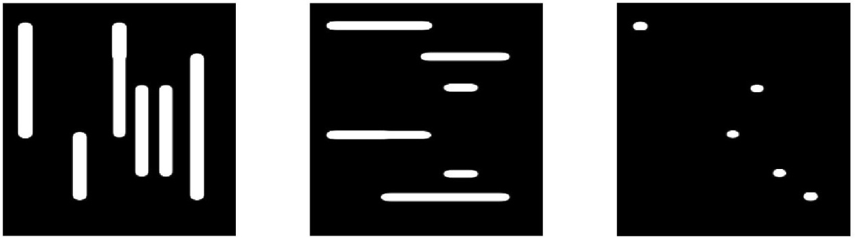

Question 4: Implement the Harris score and display it.

k = 0.04;

r = (Ix2.*Iy2 - Ixy.^2) - k*(Ix2 + Iy2).^2;

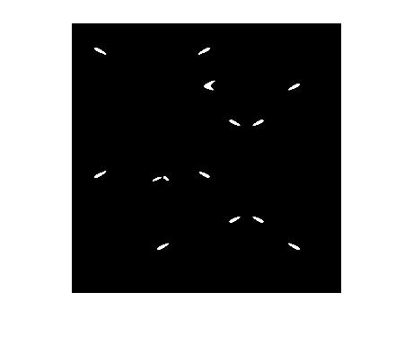

Question 5: What is the maximum r(x, y) value?

maxr = max(max(r));

2.052730862099187e+05

Question 6: Threshold the r(x, y) image with a threshold value set as an appropriate percentage of the above calculated maximum. Display the result for varying thresholds.

thresh = 0.5*maxr;

With a high threshold we get fewer corners and with a lower threshold we get more corners.

Question 7: Do non-maximum suppression on the pixel positions which are above your chosen threshold above. The remaining pixels are your corner pixels. Display the result.

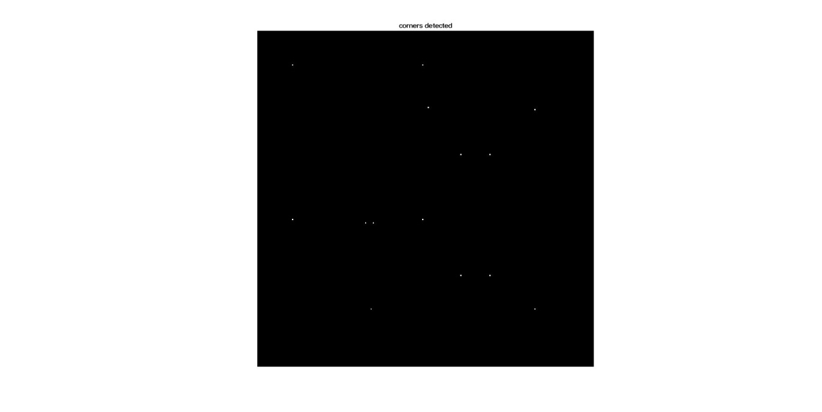

Question 8: Extract the coordinates of the Harris corners x, y, and display on the original image.

**x** **y**

31 32

169 32

172 97

249 102

172 104

31 148

169 148

69 153

111 182

219 182

111 208

219 208

71 248

249 248

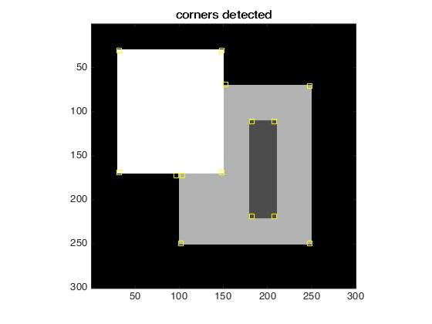

Question 9: Apply your Harris corner detector to the two images House1.bmp and House2.bmp, and display the results.

House 1:

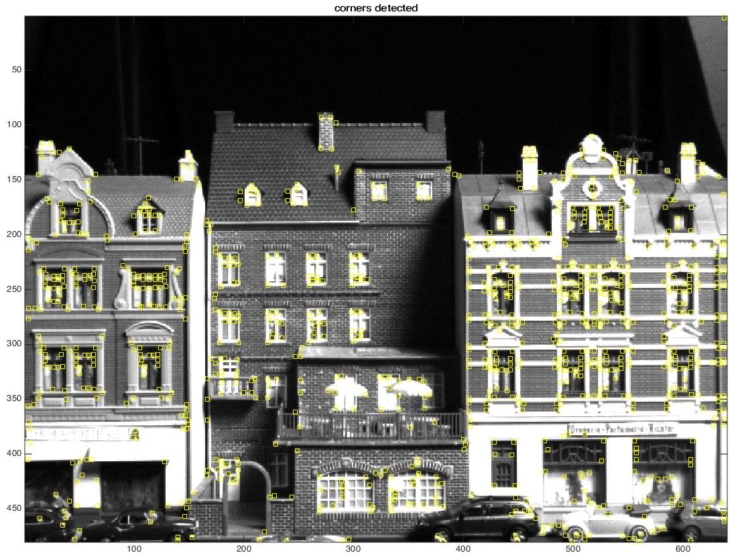

House 2:

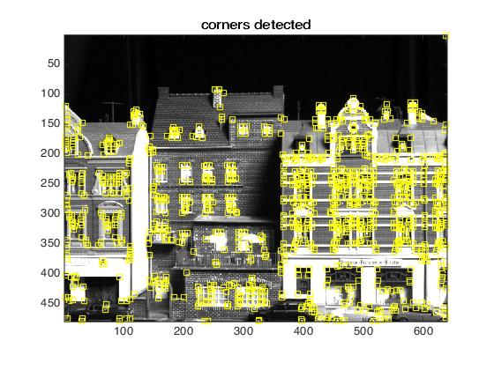

Edge detection

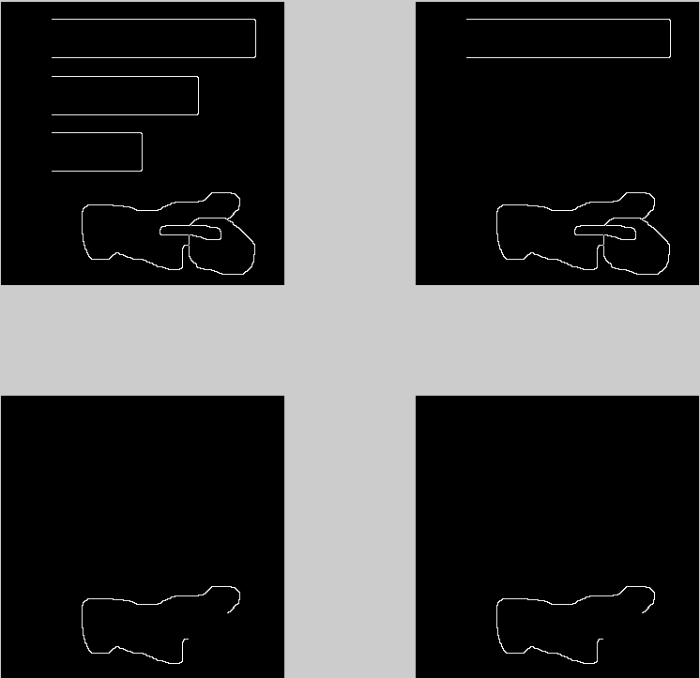

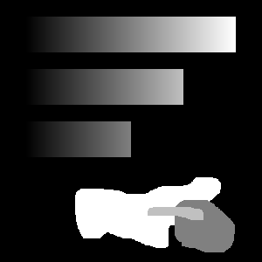

im_edge1 = edge(im4, 'canny',[0.1 0.2],0.9); focus on small changes,

im_edge2 = edge(im4, 'canny' , [0.1 0.9],0.1);

im_edge3 = edge(im4, 'canny' ,[0.6,0.99],0.9);

im_edge4 = edge(im4, 'canny' ,[0.6,0.99],0.1);

big sigma gives dominant edge, but threshold has priority.

Edge measured uses gradient magnitude, Non-Maximum Suppression: an edge point is most perpendicular to the edge, used for comparison.

2 threshold

Gradient magnitude >T1 labelled as edge, as long as they pass NMS

T1 < gradient magnitude < T2 labelled as edge, only if they are part of a line where part of it is above the T1 threshold.

Assumption that all edge pixels pass the non-maximum suppression criteria.