# 9.1

## 1. Background subtraction

1. Look at absolute difference between BaseL and ImL{1:24}, as well as BaseR and ImR{1:24}.
2. Convert to binary image.
3. Median filter and dilation.
4. Concatenate centroid and convert cell2table, table2array.
5. Organize 2D points as 2 by 24 matrix.

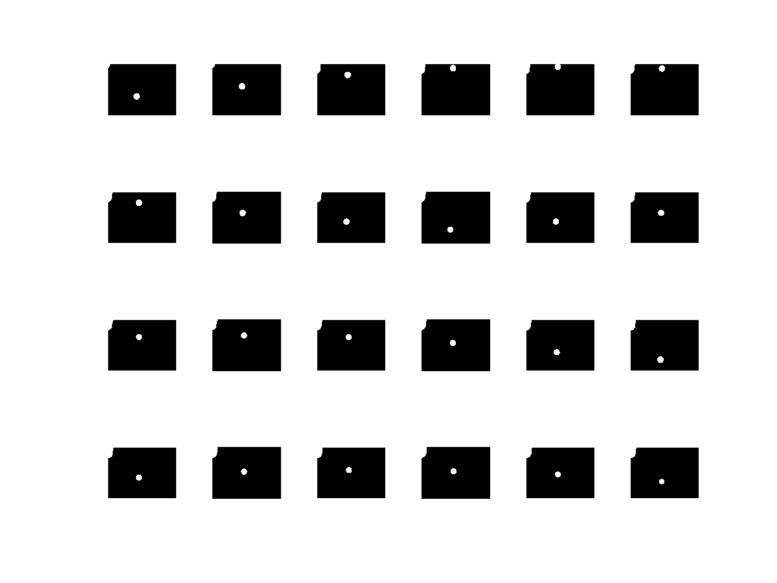

Figure 1 CamL Binary Image

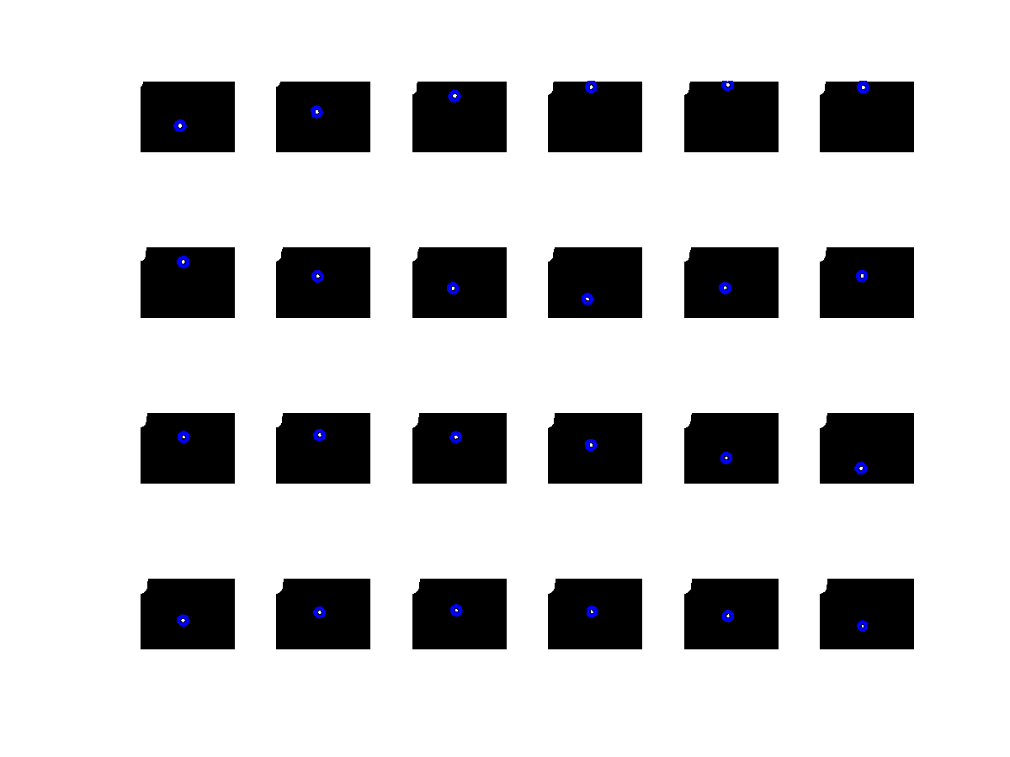

Figure CamR Circle detection using “imfindcircles”

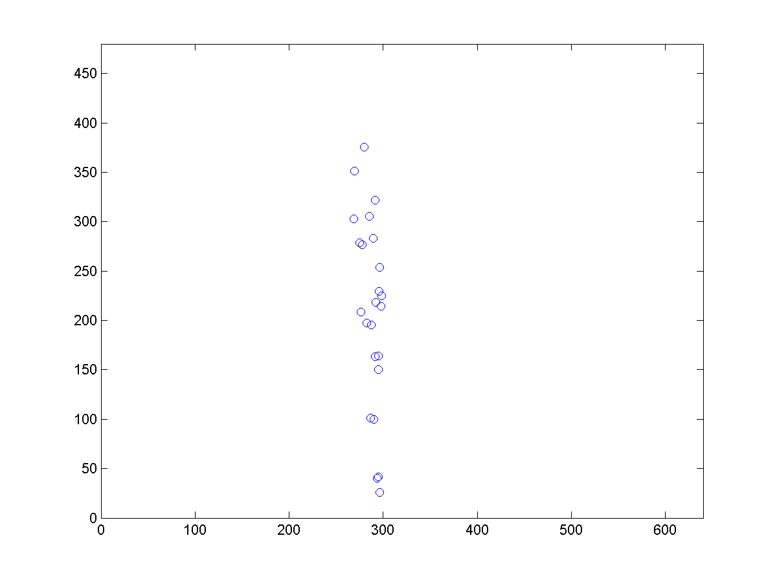

Figure 3 CamR ball movement

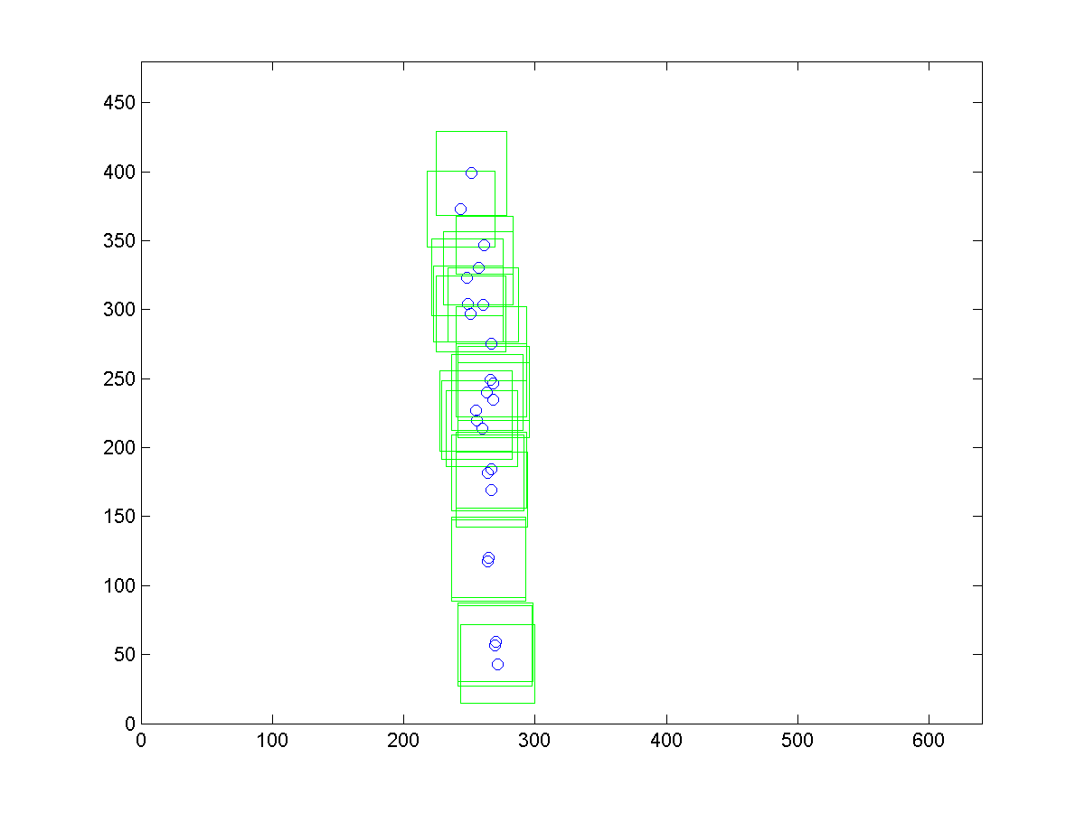

Figure 4 CamL ball movement

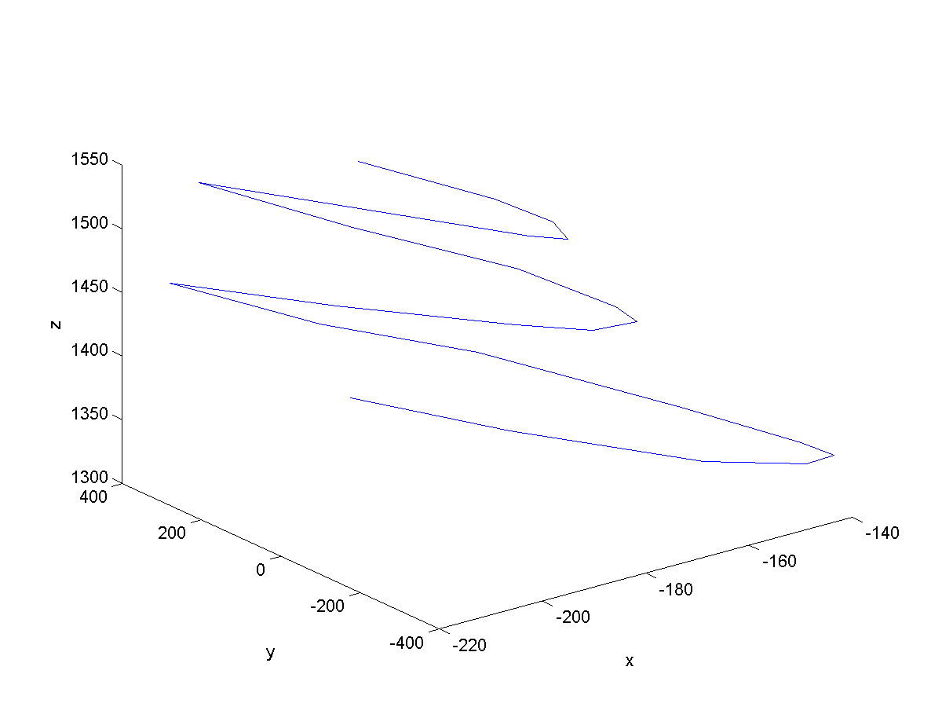

Figure 5 3D ball movement

Camera matrices are given, When 2D points are ready, we can find the 3D point Q using point triangulation through linear algorithm.

q = P*Q

where P is camera matrices, q is 2D point. Global Coor as on the firstcam.