K-Means Clustering

The idea of the k-means clustering algorithm average distance from the data points xi to their respective cluster mean, uj is minimized.

Steps:

1. Extract SIFT features and descriptors from all images(maximally stable extremal regions (MSER) is better), and store them as a combined data set (cell2mat). This are interpreted as a lot of data points in the 128 dimensional space of the SIFT descriptor. (114707 x128)
2. clusters k = number of visual words.

The k-means algorithm is initialized randomly by k points for the clusters. In all following iterations, each data point is assigned to the closest cluster center, where the centers are computed as the means of associated data points.

1. For each SIFT descriptor in each image, determine which cluster and thus visual word it belongs to. (114707 x 1)
2. Compute the histogram of visual words for the given image. (99 x50)
3. Compute the image descriptor of the query image.
4. Compute the distance between the query image and each image in the database.

From the histogram, we can see that the No.72 on x axis has the lowest number, meaning the shortest distance to the query image. But it is not the right match, instead, No.73 (the 2nd closest) turns out to be the right match.

A reason could also be that the image you are searching for doesn’t look a lot like the images it should be matched to in terms of visual words.

In other words, a lack of similarity between features in the query image and its matches.

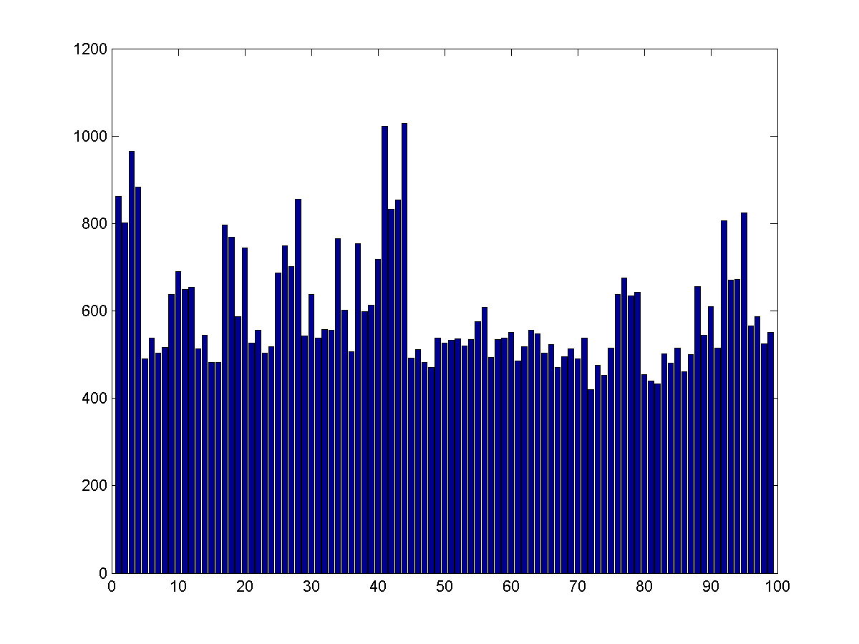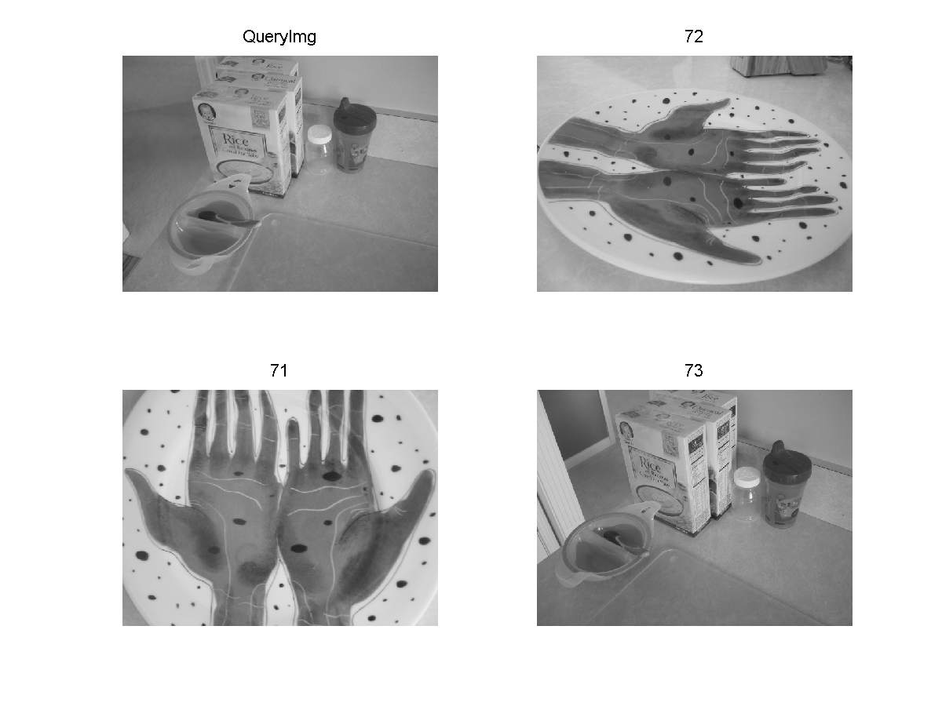

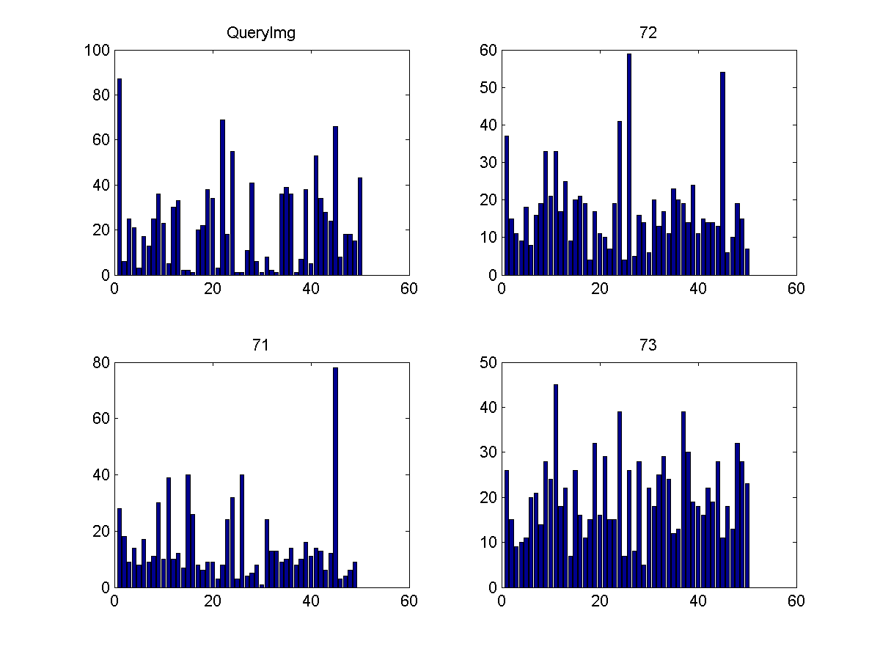

The above figure shows that the images in the first row has more similar histograms than the rest.

Maybe you can investigate the histograms and see if you notice something strange in the cases it doesn’t work. If you are sure it is not an error in your code, then these observations could be good to discuss at the exam.

