# LAB 11

# 1 When the face recognition works well, when it does not?

## 1.1 Options.Resize

Options.Resize is a Boolean, if it is **true**, it will resize the image to maximum size 384 for **less** cpu-time. That will mean less objects will be detected. But it is not a determinator for how many object could be detected. i.e.

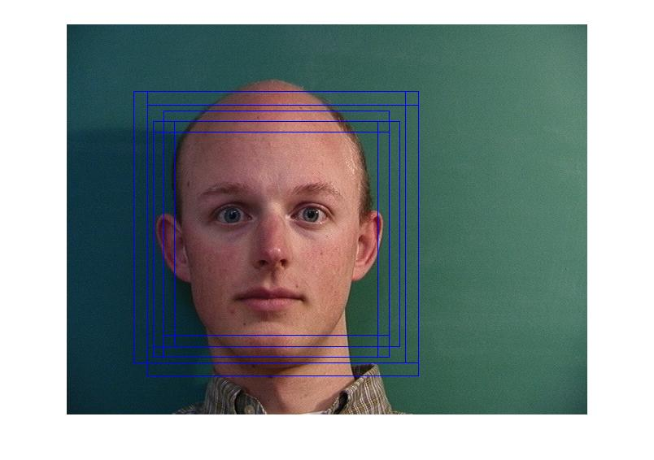

When resize is false, 8 objects can be detected from 33-5m.jpg, when it true, 9 objects can be detected.

Figure 1 33-5m.jpg - 9 objects

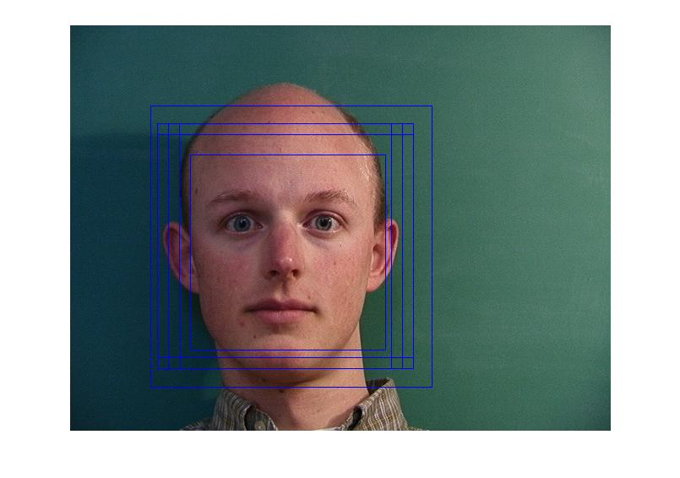

Figure 2 33-5m.jpg - 8 Objects

When resize is true, it wrongly detected lamp as face. Might because the lamb is cone or T shape.

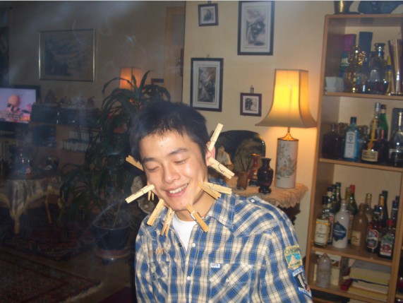

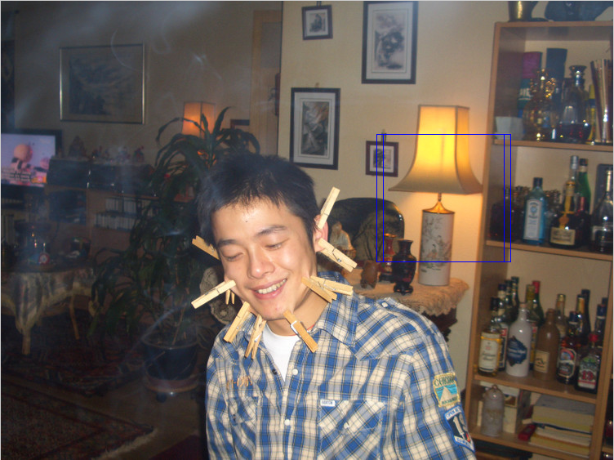

Figure 3 true Figure 4 false

## 1.2 Side face

Side face could be a serious problem for the object detection.

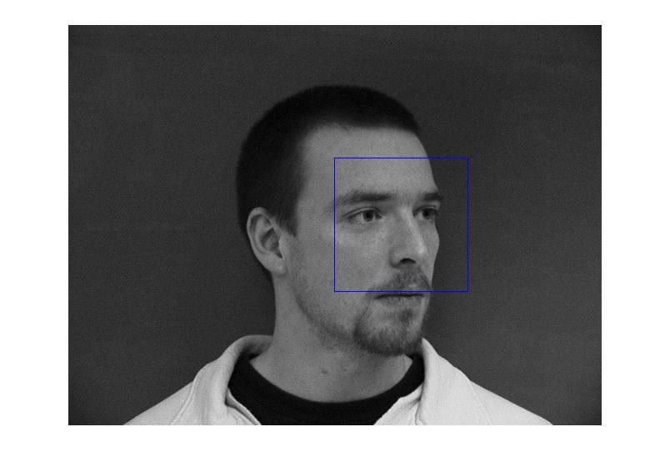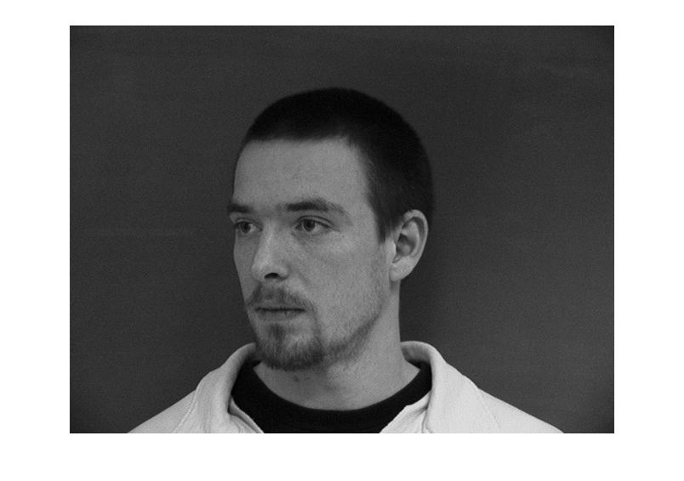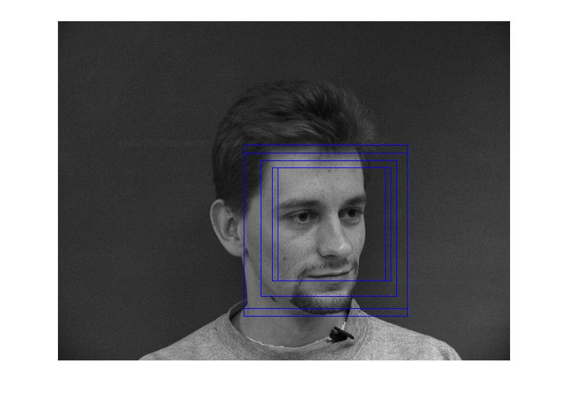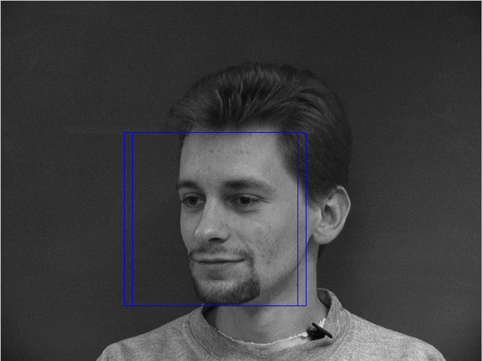

## 1.3 Rotated head

Rotated head and exaggerated facial expression could also affect object detection

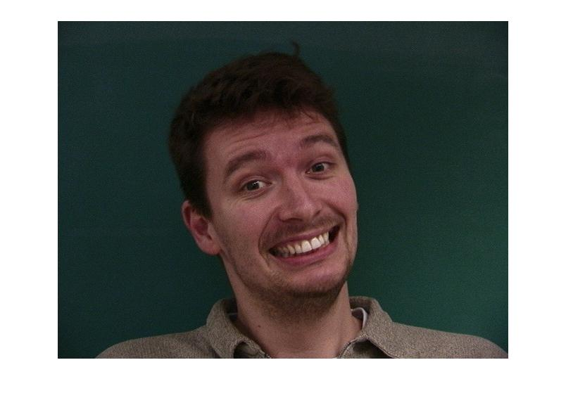



## 1.4 sunglasses

The detector works still good with sunglasses.

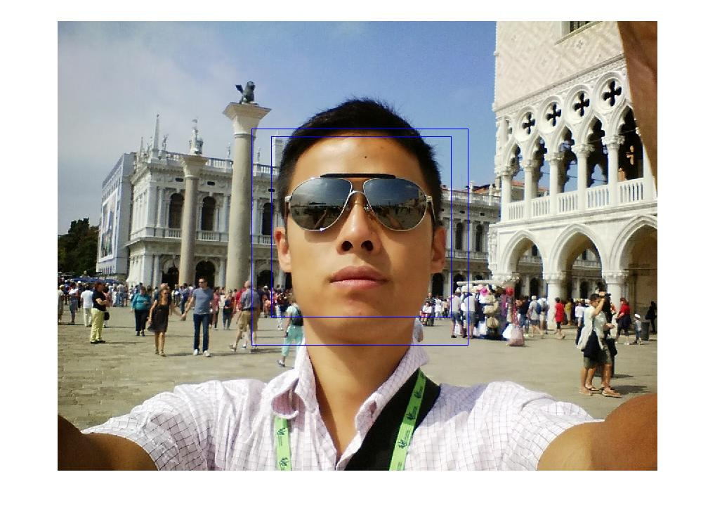

1.5 small object

Small faces are not able to be detected.



