**Question 1:** For a spherical Earth (*R = 6 378 000 m*) calculate the length (with the precision of 3

decimals) of

i) 1° ii) 1' iii) 1"

along a **meridian** and along a **parallel** at

φ = 0° b) φ = 20° c) φ = 40° d) φ = 60° e) φ = 80° f) Lyngby

Matlab code:

Re=6370;

i=[1,1/60,1/3600];

rad = i * (pi/180);

% length of meridian:

LM= Re * rad

%length of parallel:

LP0= Re * rad * cos(0*pi/180)

LP20= Re * rad * cos(20*pi/180)

LP40= Re * rad * cos(40*pi/180)

LP60= Re * rad * cos(60*pi/180)

LP80= Re * rad * cos(80*pi/180)

% Lyngby coordinates: lat:55g 46m 12s log:12g,30m,00s

% convert dms to degrees:

dms = [55 46 12];

deg = dms2degrees(dms)

deg1 = abs(55) + abs(46)/60 + abs(12)/3600

LPLyngby= Re * rad * cos(deg*pi/180)

Output:

LM = 111.1775 1.8530 0.0309

LP0 = 111.1775 1.8530 0.0309

LP20 = 104.4727 1.7412 0.0290

LP40 = 85.1669 1.4194 0.0237

LP60 = 55.5887 0.9265 0.0154

LP80 = 19.3058 0.3218 0.0054

deg = 55.7700

deg1 = 55.7700

LPLyngby = 62.5391 1.0423 0.0174

**Question 2:** Take the coordinates of points at the coast in Helsingør and Helsingborg from Google

Earth in geodetic coordinates with datum WGS84 with a precision of 2 decimals for the seconds.

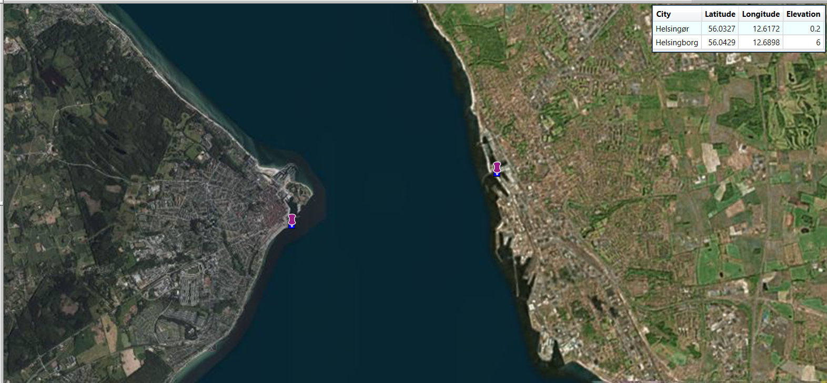

**Question 3:** Transform the coordinates (given in the file Coordinates2.xls) of question 2 to UTM

coordinates in zone 33 in datum ETRF89. Perform this task in

i) MapInfo

ii) KMStrans

|  |  |  |  |
| --- | --- | --- | --- |
| City | Latitude | Longitude | Elevation |
| Helsingør | 56.0326556 | 12.6172278 | 0.2 |
| Helsingborg | 56.0428722 | 12.689775 | 6 |
|  |  |  |  |
|  |  |  |  |
| **Convert geoHetrs89_h_dvr90 to utm33Hetrs89_h_dvr90** | | | |
|  |  |  |  |
| **Mapinfo** | northing | easting |  |
| Helsingør | 6212412.4 | 351525.8 |  |
| Helsingborg | 6213395.5 | 356083.4 |  |
|  |  |  |  |
|  |  |  |  |
| **KMSTrans2** | northing | easting | Geoid height |
| Helsingør | 6212275 | 351533.1 | 36.3876 |
| Helsingborg | 6213258.2 | 356090.5 | 36.4794 |

**Question 4:** Calculate the distance in sub-millimetre precision between the 2 points using

i) Great circle method

ii) MapInfo

iii) KMStrans

Matlab code:

%Q4. great circle method

fi1 = 56.032656;

fi2 = 56.0428722;

lambda1 = 12.617228;

lambda2 = 12.689775;

cosD = sin(fi1 * pi/180) * sin(fi2 *pi/180) + cos(fi1 * pi/180) * cos(fi2*pi/180) *(lambda2-lambda1)

dist = Re * acos(cosD)

dist2 =acosd(cosD)* 2*pi*Re/360

output:

cosD = 0.7106

dist = 4.9718e+03

dist2 = 4.9718e+03

KMSTrans2 gives 4662.872 m, Mapinfo gives

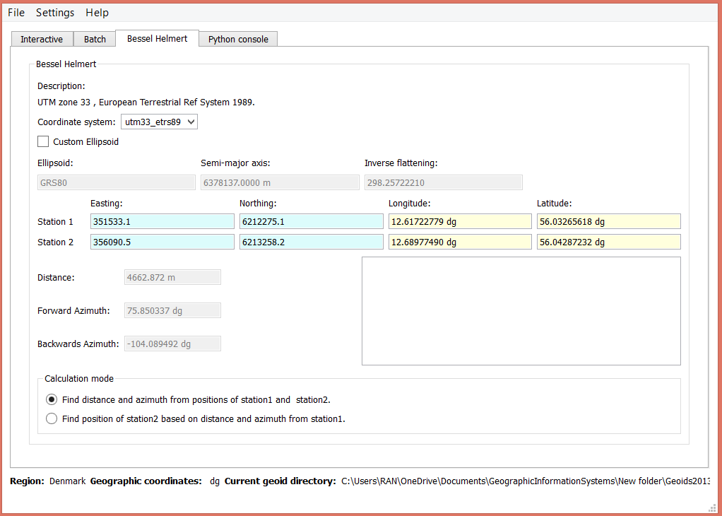

**Question 5:** Calculate the geoid heights at the 2 points of question 2 using KMStrans. How does

the geoid change over this distance? When do you have to consider this difference? List 3 different

applications for which you have to consider the geoid heights.

From the converted geoid heights we can clearly see that Helsinborg is 9.18 cm higher than Helsingør.

Orthometric height (elevation:H) becomes less in Helsinborg than in Helsingør, since H = ellipsoid height – geoid. GPS only sends ellipsoid height, which is a nicely modified circle around the global. Whereas local height can be very different from each other, geoid height can pave the way to calculate the precise local height. Relevant applications could be bay bridge, motorway, railway and skyscraper projects.

%Q5. difference of Geoid heights

g = 36.3876;

b = 36.4794;

c = b – g

output:

c =0.0918