**Registering a Raster Image Lab**

Martin Candee ([s147559@student.dtu.dk](mailto:s147559@student.dtu.dk))

Ran Wang ([111503@student.dtu.dk](mailto:111503@student.dtu.dk))

Inaluk Agathe Lennert Groth ([s104177@student.dtu.dk](mailto:s104177@student.dtu.dk))

Lab on 17th February, 2015

## Introduction

This report  focuses on depicting the basic knowledge about spatial data acquisition including digitizing, transformation, edition and verification. Topic 1 and 2 will primarily dedicated on theory of aforementioned points,  and Topic 3 will introduce lab process about how to realize them in Mapinfo.

## Topic 1 spatial data collection

The sources of spatial data come in many forms: existing map, satellite imagery, field surveying and  aerial photographs.   The best data collection retains the maximum amount of information, since the accuracy is important for GIS. However, the activity of collection and maintenance are expensive and time consuming . The methods for spatial data input can be manual digitizing, scanning of analogue maps; image data input and conversion to a GIS; Transfer data from existing digital sources. Satellite data cover globally is good for large area projects and for mapping inaccessible areas, whereas aerial data is suitable for large scale GIS projects, e.g.urban areas or archaeological sites. Data can be exchanged or transferred between different GIS packges and data formats. Digitizing is a procedure of information conversion from analog to digital. onscreen digitizing is interactive approach of creating as well as editing map.

## Topic 2 quality control of spatial data input

The basic map transformations are translation, scale, rotation and affine, and these transformations could create errors. Use RMSE to check the difference between the original control points and the new control point locations. If the error is big, re-pick control points.

## Topic 3 practice of data digitizing and transformation

In this lab, we were to take a raster image of a DTU campus map and overlay it on a satellite image of the DTU campus. The goal was to take a red outline line that matches the satellite image and impose and reposition it onto the DTU campus maps with as much accuracy as possible. The two images are of the same location, but are positioned different ways and also have different coordinate systems. Therefore, we matched 4 different control points from both images. It was repeated  multiple times to get the minimum amount of error as possible.

When this was completed, the DTU campus map was overlapped on the satellite image, and the outline of the campus matched up quite well. It was very close to the same accuracy as when it was placed on the other map, but it was not exactly the same. Some of the discrepancies come from errors in picking control points from the campus map and attempting to match them to the campus image. There is also error since you are changing from pixels to the Universal Transverse Mercator (UTM) coordinate system. This is because in the calculation, there is an intermediate projection before you reach the final transformation, which can ultimately result in quite a large error.

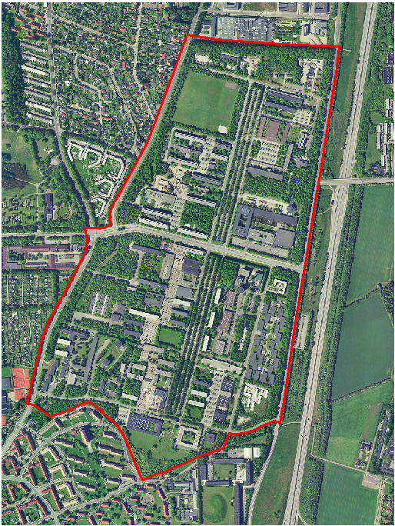

***Figure 1:*** Orthophoto of campus 

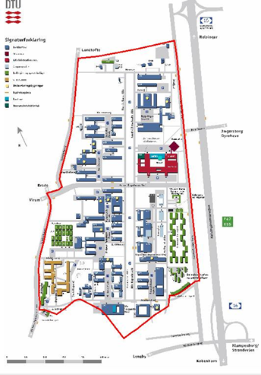

***Figure 2:*** campus overview 

## Conclusion

During this lab we have tried to register some  points in pixel and converted them to meters based on Danish Coordinate Systems-UTM Zone 32(ED50), so that they two different data match each other according to the delimiter. Technical speaking, if we have two types of spatial data, we can transform them by using a proper coordinate system in order to make a good match. We can control data precision by checking error between the original points and new control point locations in “error” under“Image Registration” dialog. Basically, after this lab we have a good understanding and practical skills of spatial data input, digitizing, transformation and quality control.