# Entities

The entities need to be considered in the database are ten objects in total:

1. Train

2. Station

3. Ramp

4. Door

5. Stair

6. Building

7. Elevator

8. Walkway

9. Platform

10. Sidewalk

As the City of Calgary is not interested in the LRT traffic control, but how well/bad the system works for handicapped people, I will consider Door the key entity. Because it connects platforms, stairs, buildings and walkways. There are two types of doors, namely semi-automated and manual. When it is manual, the system would not consider it handicap friendly. Street and plus15 level is not distinguishable as a 3d geometry is used to define the level.

## ER Diagram

According to the assignment description, the following are noted:

1. Access to Plus 15 walkway system is possible through elevators and ramps inside buildings.
2. Access to Plus 15 walkway system include stairs inside or outside the buildings
3. All downtown LRT stations have access ramps

Therefore, Bulding has accesee by the means of elevator, ramp and stair; Stations has elevator and ramps (only in the downtown); Sidewalk has only stairs.

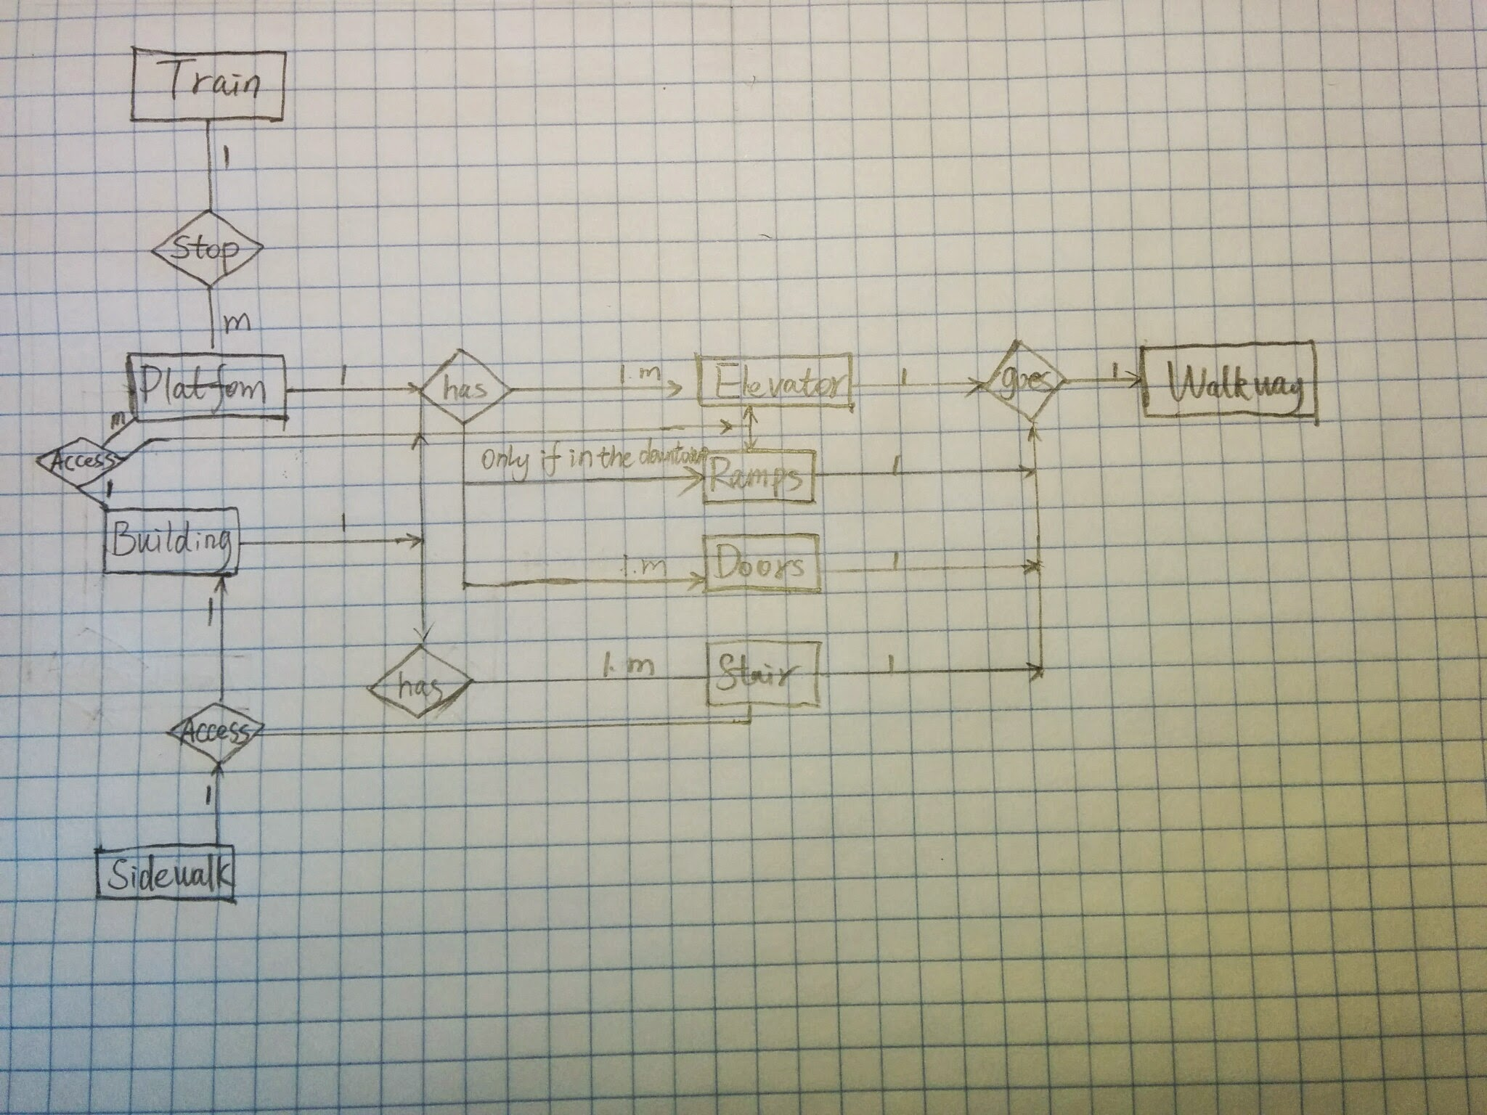

## Data dictionary

Train: A vehicle stopping at the platform used for public transportation.

Platform: An area where the C-Train arrives and departs from.

Ramp: A small incline located at each platform in the downtown area, and inside buildings

Door: A barrier to pass through when entering or exiting certain areas. Located between portions of the

Plus 15 Walkway system and inside buildings. Can be opened automatically, semi-automatically or manually.

Sidewalk: The area designated for pedestrian walking adjacent to a street. Have access points to platforms.

Stair: A connection between different vertical floors levels that is not handicap accessible. Located both inside and outside buildings.

Building: The structures that connect the sidewalks to walkways, as well as one walkway to another.

Houses elevators, stairs, doors and ramps.

Walkway: A corridor for walking that connects various buildings within the downtown area.

Elevator: A connection between different floor levels that is handicapped accessible. Located both within buildings and some on platforms.

## Relation schema

In order to make the geometry clear, I use the geometries in the relation schema: GEOM_POI = Point, GEOM_L = Line and GEOM_POL = Polygon

Train 🡨(TID, PID*, GEOM_POI)

Platform 🡨 (PID, EID*, RID*, STID*, GEOM_POL)

Ramp 🡨 (RID, WID*, GEOM_L)

Door 🡨 (DID, detection, button, hand, GEOM_POI)

Sidewalk🡨 (SIID, RID*, STID*, GEOM_L)

Stair 🡨 (STID, GEOM_L)

Building 🡨 (BID, RID*, STID*, EID*, DID*, GEOM_POL)

Walkway 🡨 (WID, STID*, DID*, EID*, GEOM_L)

Elevator 🡨 (EID, GEOM)

## Functional dependency diagram

Train = (TID, PID*, GEOM_POI)

Platform = (PID, EID*, RID*, STID*, GEOM_POL)

Ramp = (RID, WID*, GEOM_L)

Door = (DID, detection, button, hand, GEOM_POI)

Sidewalk = (SIID, RID*, STID*, GEOM_L)

Stair = (STID, GEOM_L)

Building = (BID, RID*, STID*, EID*, DID*, GEOM_POL)

Walkway = (WID, STID*, DID*, EID*, GEOM_L)

Elevator = (EID, GEOM)

## Normalization

We assume that doors can be opened in the following three ways:

1. detection and button,

2. button and by hand, and

3. by hand alone

There is no constraint in place, in the Door-table, that prohibit a door that have all three door-type attributes at once – even though such a door does not exist. We see two options:

1. Either we choose to make (DID, detection, button, hand) a candidate key, or

2. Spilt the Door table in two, Door and DoorType.

The first option is the easiest since no real changes are necessary. However, if there at some point would be introduced a new type of door e.g., one that could be opened an entirely new way, or if all doors that had a push button were upgraded into detection-type doors, there could be a problem. The former situation would require adding a completely new attribute-column to the Door table. The latter could introduce inconsistency in the database when updating every push-button door. Therefor we go with option 2. See the next question for the updated functional dependency diagram.

First normal form

• All key attributes are defined

• There are no repeating groups in the table

• All attributes are dependent on the primary key

Second normal form

• All are in 1NF

• There are no partial dependencies, i.e., no attribute is dependent on only a portion of the primary

Key.

Third normal form

• All are in 2NF

• All attributes are only determined by the candidate key

## Normalize diagram

Only Door is modified, the others remain the same.

Door (DID, DTID*, GEOM_POI)

DoorType (DTID, type)

## Compare diagram

The functional dependency diagrams only differ on Door and DoorType. This indicate that the normalized form can facilitate the enforcement of constraints on the data better than un-normalized diagram.

## Spatial data model

The spatial data model that would be particularly well suited for handling this problem would be a Network data model. A network data model is suitable for handling the three dimensions that is our requirement for the spatial data model, as stated in question one. Furthermore, we assume that the model has to be commercialized which excludes the Full Topology model in 3D, leaving us with the Network data model.

1. Additional (spatial) information

Additional spatial information that would facilitate the study of the quality of the interconnection of the

Plus 15 and LRT, would be the width of doors, ramps and walkways along with the grade (slope). In addition, height of doorsteps and curbs that can hinter wheelchairs will also improve the quality of the study.