**Lab #8 Report - Data analysis using geometrical and topological operators**

Ran Wang and Martin Candee

Topics:

Triangulated irregular network, or TIN, is a digital data structure that is very important in GIS. One of the most common uses for TIN is in surface representation, but algorithms such as slope, volume and spatial interpolation are also based on TIN models. A surface has three aspects to it, including an x, y and z coordinate, and to represent a surface in GIS a digital terrain model (or digital elevation model [DEM]) can be used. One approach to this is raster based, which is sometimes referred to as a computed DTM. On the other hand, a vector based approach can be used with triangulated irregular networks, also known as TIN. This is a set of nodes and edges that form irregular triangles, and at the three corners of each triangle, an elevation is represented. The third was to represent a surface is with contour lines, which are lines that connect points of equal elevation. DEM model data can be acquired through many techniques such as land surveying and photogrammetry, and they can be used for a multitude of this real world applications, from city and landscape modeling, to drainage system models and topographic maps.

TIN is very often used to represent surfaces, and it is important to understand that it is a topological structure, since each point represents an elevation. They are usually made using Delaunay Triangulation, with different techniques such as line sweep, incremental and divide and conquer. The idea behind the Delauney Triangle is that a circle around the three nodes of the triangle contains no other points in it. The diagram below shows a great example of how this should and should not look.

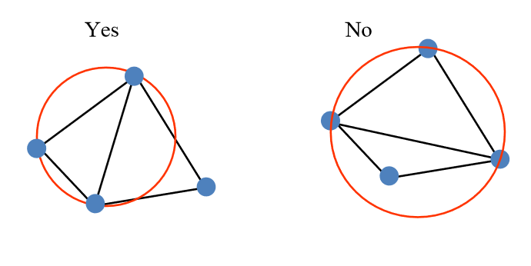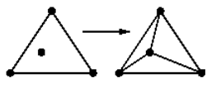

If a point is added to the data and it falls inside the circumcircle of a triangle, then three new triangles must be created, like the figure on the right illustrates. If you run into the problem that a point does lie inside the circumcircle of a triangle that is adjacent to another, then an edge flip can be performed. This is where the triangles are transformed by flipping the edge that the two triangles meet on. The incircle predicate is also important, because it projects a set of points in 3D space as a parabaloid, using the equations z=x2+y2. Breaklines are especially important in TIN models, and usually represent quick changes in the slope of the ground or a creek bank, but they can also be used for country borders and even coast lines.

Contour lines, as mentioned before, are another common way to display a surface, and they are particularly useful because so many people are familiar with how they work. Lines that are close together tell a steep gradients, while far apart lines show flat areas, and where a V forms is a drainage basin, so it is easy to get the idea in your head of what the surface actually looks like. Unfortunately, it does have downsides, since it usually needs special software to plot the contours, and it must be converted in order to be analyzed. For example, when creating contour lines from raster data, the contour lines must be interpolated inside each square of data, and it is entirely possible that these interpolations could be incorrect about the actual elevation in that area.

As mentioned above, slope along with aspect can also be derived from TIN data. The normal vector is perpendicular to and points away from the surface, and by using this algorithm, the slope can often be calculated. The Horn method for calculating slope is represented in the figure below.

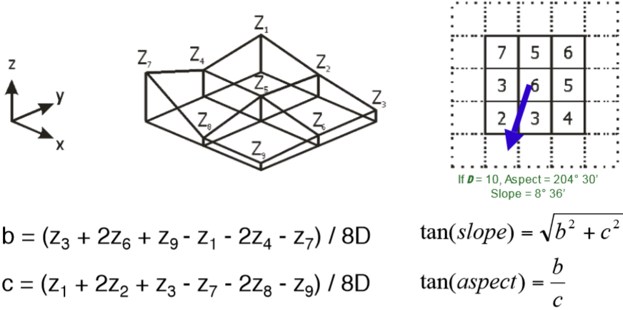

Volume can also be calculated, but it depends on which type of DTM is being used. For example, in a raster DTM, the volume of a column is represented by the equation V = A2 * h. However, in TIN models, the volume of a prism may need to be calculated, and this is done with the equation V = 1/3 (h1 + h2 + h3) * Area of triangle. So as you can see, volume calculations are done quite differently depending on the approach of DTM you are working with. It is clear though that digital terrain models TIN data models are very important for representing surfaces in GIS.

## Lab

The lab aims on using geometrical and topological operators with SQL queries. The first question asks to find the voting district that intersect with DTU_delimiter. The voting districts is given called AFSTEMOMR, basically, we just have to find the intersect area between two tables of AFSTEMOMR and DTU_delimiter. So I type the names of the two tables and the conditions applying intersects in SQL (see figure 1). Automatically, Mapinfo generates a nice intersects voting districts map (see figure 2).

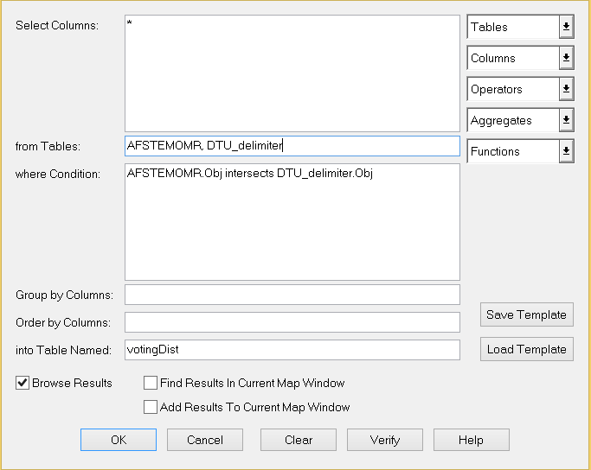

Figure 1 Voting district SQL

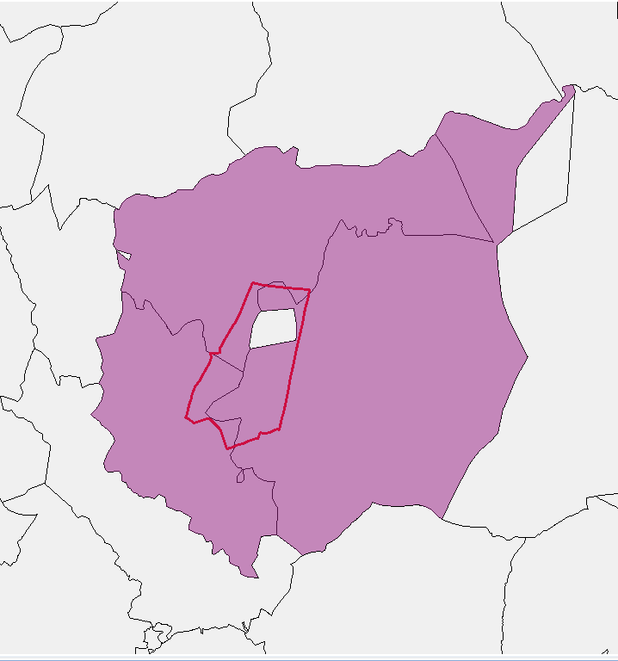

Figure 2 Voting districts intersecting with DTU_delimiter

In question 2 we are supposed to find the buildings on DTU campus that are within the voting districts. In other words, it asks to find the buildings that intersects with the voting districts, we write the query to intersect buildings with voting districts: Building.obj intersects votingDist.obj, and we get only the buildings within the voting district (see figure 3). Actually, we could have added more layers from TOP10DK, but we do not know Danish, so it doesn’t make sense for which layers we choose. However, we can imagine that data such as people’s religion, political proposition, income, educational level can all contribute to analysis of voting.

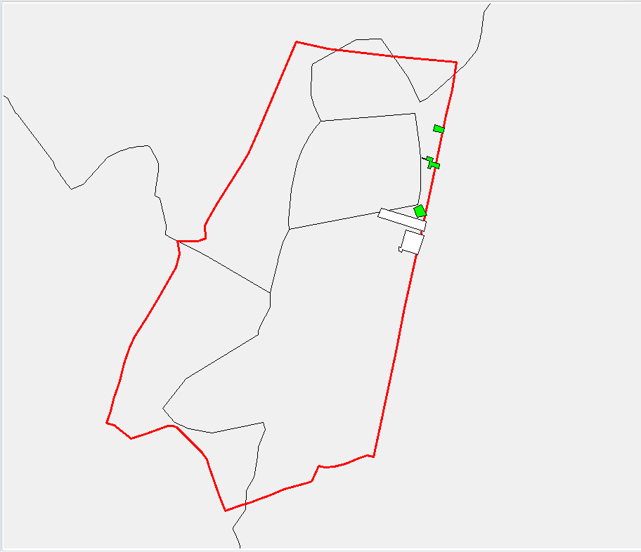

Figure 3 Buildings in voting district

In question 3 we have to find the buildings on DTU campus within 200 meters from the bus stops. We use buffer in spatial menu to draw a circle with radius of 200 meters for each bus stops. Figure 4 shows that all these buildings are within 200 meters to a bus stop.

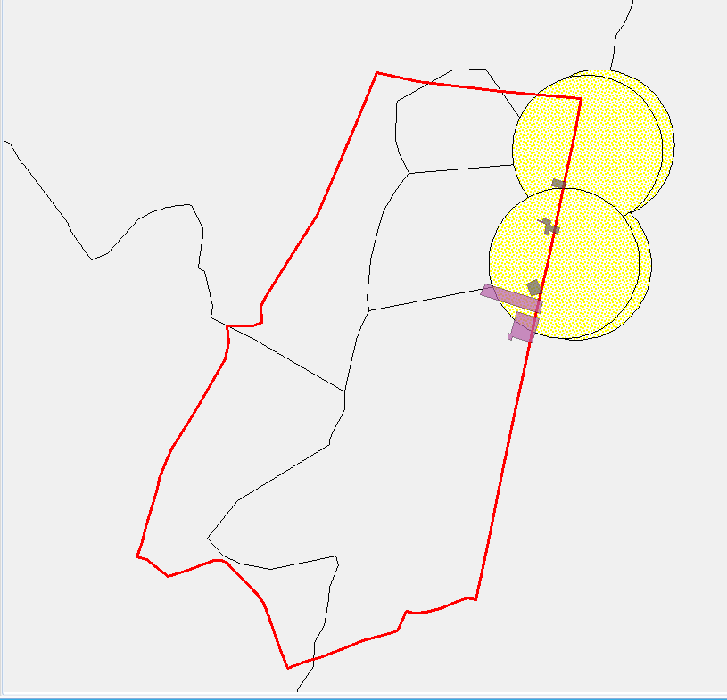

Figure 4 buildings within 200 meters to bus stops

Regarding question 4, we can see that all the buildings in figure 4 are covered by the buffers, which means that the buffers (geometric object) represents all points whose distance from this buffer is less than or equal to 200 meters. Therefore, we can decide that these buildings are within 200 meters to the bus stops.

The main difference between the digitized datasets by ourselves and the one in TOP10DK is that they are not overlapped with each other (see figure 5). That is because they used different coordinate system. In order to solve this, I changed the coordinate system to UTM zone 32, they match perfect with each other (see figure 6).

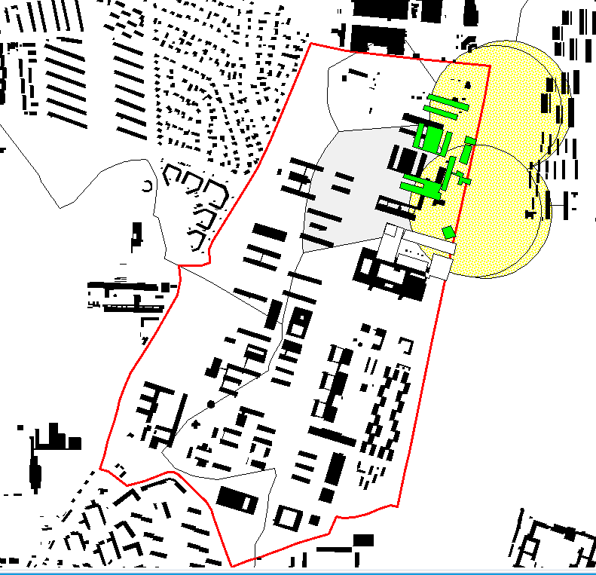

Figure 3 poorly matched layers

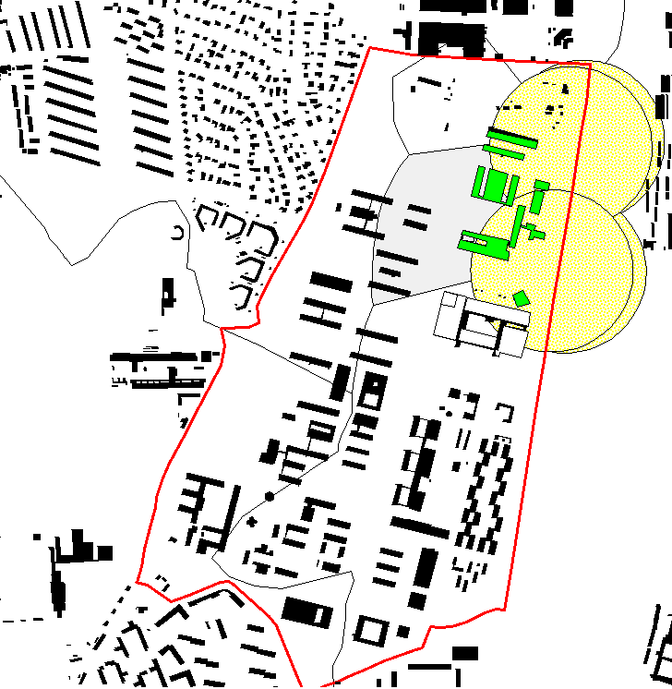

Figure 4 Matched layers

## Conclusion

From this lab we practiced on polygon overlay using spatial operators, aggregation (dissolve) of areas that have the same properties. We are getting more confident in using the SQL language to deal with data. The interest finding is that GIS can cross demographic fields can make perfect application of it. It might be very useful to think other ways of crossing GIS with some other fields, which could eventually benefit some researches.