

How to Use Harbor in DeviceOn
Rafael Yu
2022.5.9

To use on-premise Docker Registry service in DeviceOn, you can run a Harbor server.
Harbor is an open source registry server, you can find more detail in official website: (https://goharbor.io/)
There are two ways to use Harbor. One is install a Harbor server on your own machine. Another one is using a demo environment, which is hosted by Harbor officially.

Here will briefly introduce how to sign up a testing account and how to use it in DeviceOn.

Sign up a Harbor testing account in demo environment
(The testing account will vanish in 24 hours, and the data will be cleared or be changed w/o notifying)

- Open Harbor live demo website: https:// demo.goharbor.io /account/sign-in
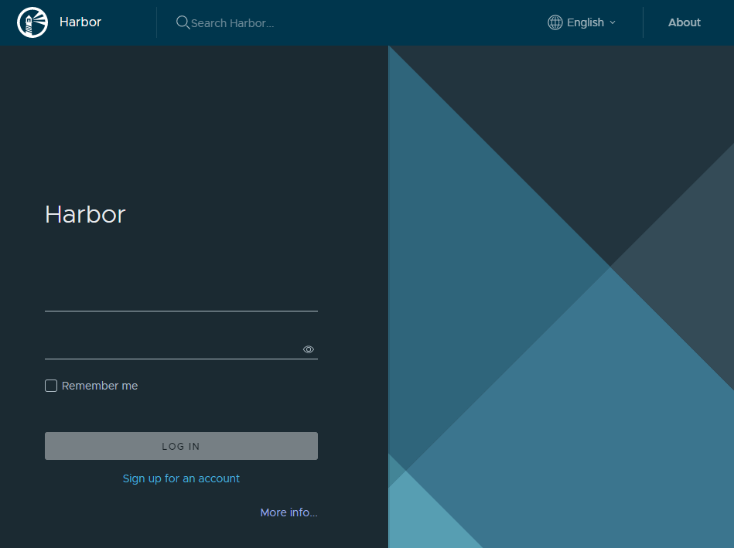
- Click [Sign up for an account]. Fill required columns then click [SIGN UP].
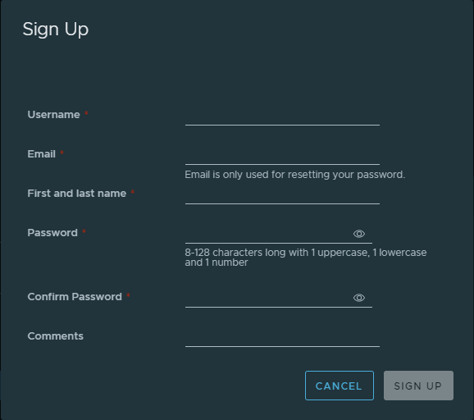

- Sign in with the account you created.
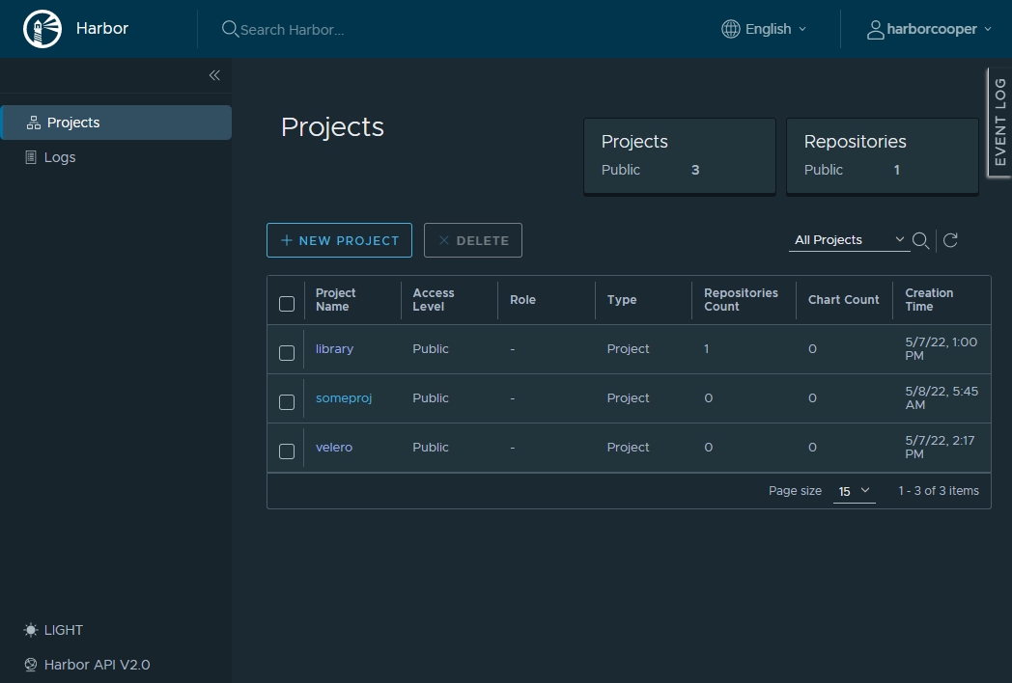
- Click [NEW PROJECT] to create a namespace of registry. Enter a unique name, here we use “my-harbor-2” as sample.
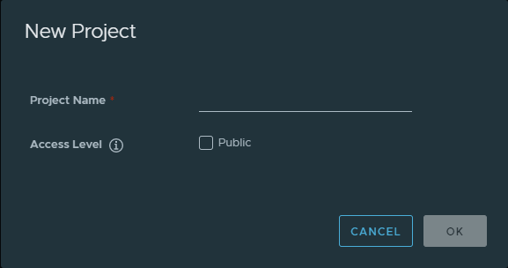
Click [OK], the new project list below
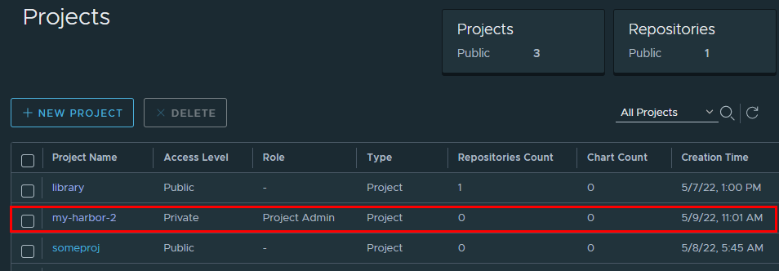
For now, our Harbor registry is ready for DeviceOn.
DeviceOn need Registry connection info are: Registry URL, user, token.
Registry URL | {Harbor URL}/{Project Name}
User | {Harbor User Name}
Token | {Harbor User Password}
Below is our sample
Registry URL | demo.goharbor.io/my-harbor-2
User | harborrrrr
Token | Abcd123456

Set up Harbor registry in DeviceOn
- Open [Registries] in Container Management
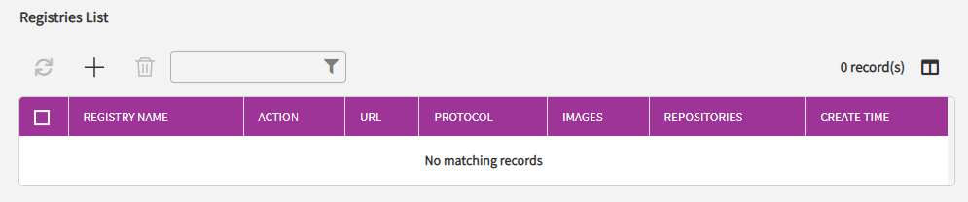

- Click [＋] to add new registry connection info
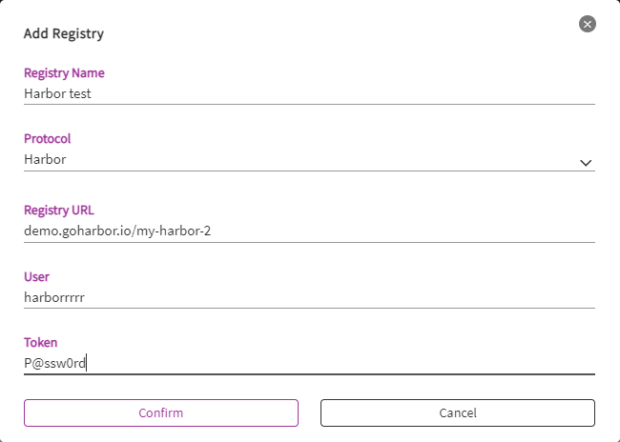
Click [Confirm] to finish. A new row will show in list.
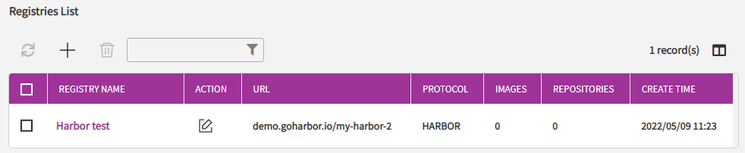

- Click the registry name to view detail of registry we just created.
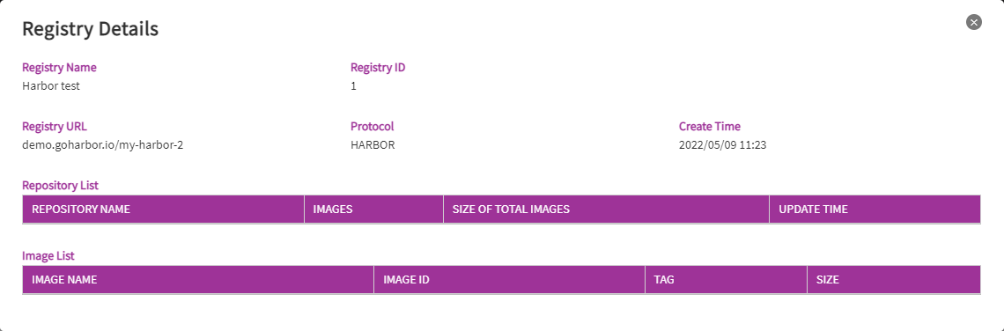

After creating a registry connection info in DeviceOn, we can push a container image to Harbor to verify Harbor and DeviceOn.

Push image to Harbor Registry, and synchronize to DeviceOn
- Docker login Harbor registry.
$ sudo docker login demo.goharbor.io
Username: harborrrrr
Password:
Succeeded
- Tag an image in format: {Harbor URL}/{Project Name}/{Image Name}:{Tag}
$ sudo docker image tag hello-world demo.goharbor.io/my-harbor-2/test-image:latest
- Push the image.
$ sudo docker image push demo.goharbor.io/my-harbor-2/test-image:latest
The push refers to repository [demo.goharbor.io/my-harbor-2/test-image]
e07ee1baac5f: Pushed
latest: digest: sha256:f54a58bc1aac5ea1a25d796ae155dc228b3f0e11d046ae276b39c4bf2f13d8c4 size: 525
- Synchronize manually in DeviceOn.
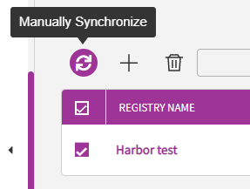

- Check the image is in image list.
