实验三 Javascript程序设计
- 在网页上从小到大输出彩虹文字。
<div id="welcome">
<span class="rainbow-text char-w">w</span><span class="rainbow-text char-e">E</span><span class="rainbow-text char-l">L</span><span class="rainbow-text char-c">c</span><span class="rainbow-text char-o">O</span><span class="rainbow-text char-m">M</span><span class="rainbow-text char-e2">E</span>
</div>
#welcome {
text-align: center;
margin: 40px 0;
}

.rainbow-text {
display: inline-block;
font-weight: bold;
font-family: Arial, sans-serif;
}

.char-w { color: red; font-size: 40px; }
.char-e { color: green; font-size: 50px; }
.char-l { color: blue; font-size: 60px; }
.char-c { color: yellow; font-size: 70px; }
.char-o { color: black; font-size: 80px; }
.char-m { color: orange; font-size: 90px; }
.char-e2 { color: purple; font-size: 100px; }
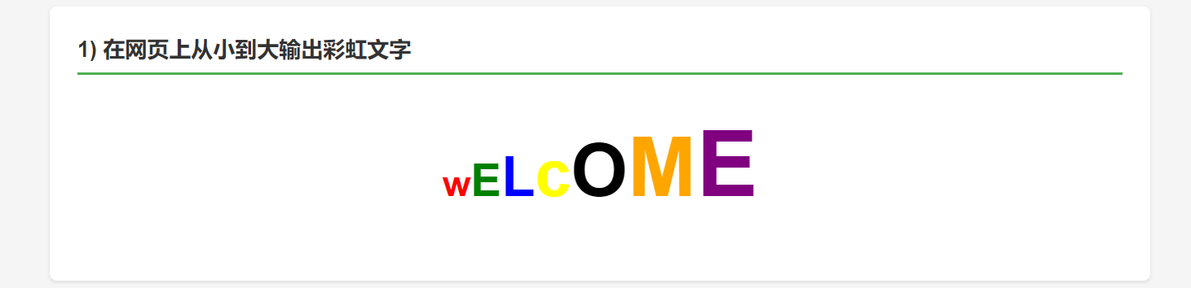

- 使用表格显示一个8*8的国际象棋棋盘
<div class="question">
<h2>2) 使用表格显示一个 8×8 的国际象棋棋盘</h2>
<table id="chessboard">
<tr>
<td class="white-cell"></td>
<td class="black-cell"></td>
<td class="white-cell"></td>
<td class="black-cell"></td>
<td class="white-cell"></td>
<td class="black-cell"></td>
<td class="white-cell"></td>
<td class="black-cell"></td>
</tr>
<tr>
<td class="black-cell"></td>
<td class="white-cell"></td>
<td class="black-cell"></td>
<td class="white-cell"></td>
<td class="black-cell"></td>
<td class="white-cell"></td>
<td class="black-cell"></td>
<td class="white-cell"></td>
</tr>
<tr>
<td class="white-cell"></td>
<td class="black-cell"></td>
<td class="white-cell"></td>
<td class="black-cell"></td>
<td class="white-cell"></td>
<td class="black-cell"></td>
<td class="white-cell"></td>
<td class="black-cell"></td>
</tr>
<tr>
<td class="black-cell"></td>
<td class="white-cell"></td>
<td class="black-cell"></td>
<td class="white-cell"></td>
<td class="black-cell"></td>
<td class="white-cell"></td>
<td class="black-cell"></td>
<td class="white-cell"></td>
</tr>
<tr>
<td class="white-cell"></td>
<td class="black-cell"></td>
<td class="white-cell"></td>
<td class="black-cell"></td>
<td class="white-cell"></td>
<td class="black-cell"></td>
<td class="white-cell"></td>
<td class="black-cell"></td>
</tr>
<tr>
<td class="black-cell"></td>
<td class="white-cell"></td>
<td class="black-cell"></td>
<td class="white-cell"></td>
<td class="black-cell"></td>
<td class="white-cell"></td>
<td class="black-cell"></td>
<td class="white-cell"></td>
</tr>
<tr>
<td class="white-cell"></td>
<td class="black-cell"></td>
<td class="white-cell"></td>
<td class="black-cell"></td>
<td class="white-cell"></td>
<td class="black-cell"></td>
<td class="white-cell"></td>
<td class="black-cell"></td>
</tr>
<tr>
<td class="black-cell"></td>
<td class="white-cell"></td>
<td class="black-cell"></td>
<td class="white-cell"></td>
<td class="black-cell"></td>
<td class="white-cell"></td>
<td class="black-cell"></td>
<td class="white-cell"></td>
</tr>
</table>
</div>
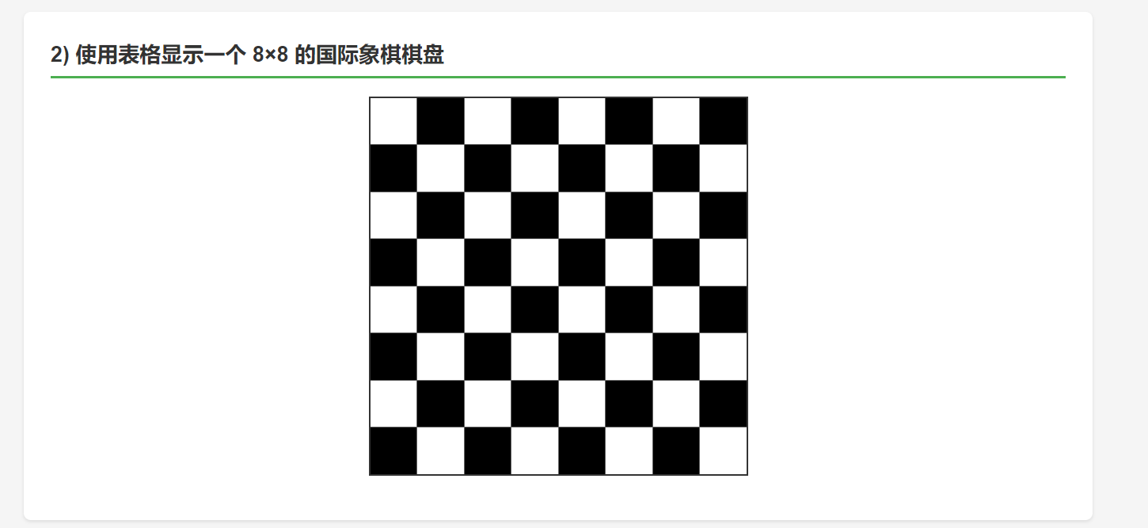
- 实现如下图的两个单击按钮事件的功能：
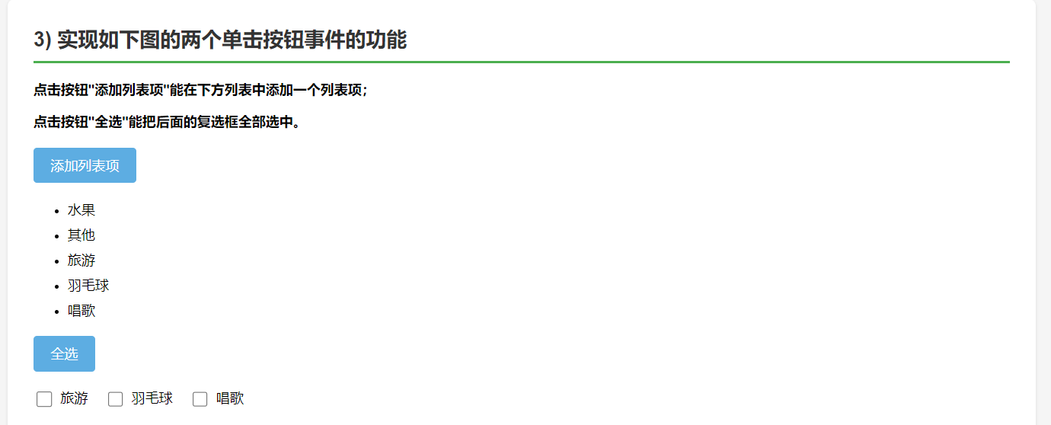
<div class="question">
<h2>3) 实现如下图的两个单击按钮事件的功能</h2>
<p><strong>点击按钮"添加列表项"能在下方列表中添加一个列表项；</strong></p>
<p><strong>点击按钮"全选"能把后面的复选框全部选中。</strong></p>

<div class="button-group">
<button class="btn" onclick="addListItem()">添加列表项</button>
</div>

<ul id="fruitList">
<li>水果</li>
<li>其他</li>
</ul>

<div class="button-group">
<button class="btn" onclick="selectAll()">全选</button>
<div class="checkbox-group">
<label><input type="checkbox" name="hobby" value="旅游"> 旅游</label>
<label><input type="checkbox" name="hobby" value="羽毛球"> 羽毛球</label>
<label><input type="checkbox" name="hobby" value="唱歌"> 唱歌</label>
</div>
</div>

<p style="color: #666; font-size: 14px;">（说明：列表项和复选框选项内容自己设计）</p>
<p style="color: #2E86C1; font-size: 14px; margin-top: 10px;">
💡 <strong>使用提示：</strong>先勾选下面的复选框，然后点击"添加列表项"按钮，选中的内容会被添加到上方列表中。
</p>
</div>
// ========== 题目3：按钮事件 ==========
function addListItem() {
const list = document.getElementById('fruitList');
const checkboxes = document.getElementsByName('hobby');
let hasChecked = false;

// 遍历所有复选框
checkboxes.forEach(checkbox => {
if (checkbox.checked) {
hasChecked = true;
// 创建新的列表项
const newItem = document.createElement('li');
newItem.textContent = checkbox.value;
list.appendChild(newItem);
// 取消勾选
checkbox.checked = false;
}
});

// 如果没有选中任何项，提示用户
if (!hasChecked) {
alert('请先勾选下面的复选框！');
}
}

function selectAll() {
const checkboxes = document.getElementsByName('hobby');
checkboxes.forEach(checkbox => {
checkbox.checked = true;
});
}

- 用JS实现轮播图效果（至少包含3张图片）
let currentIndex = 0;
let autoPlayInterval = null;
const slides = document.querySelectorAll('.carousel-slide');
const dots = document.querySelectorAll('.dot');

function showSlide(index) {
// 确保索引在有效范围内
if (index >= slides.length) {
currentIndex = 0;
} else if (index < 0) {
currentIndex = slides.length - 1;
} else {
currentIndex = index;
}

// 隐藏所有幻灯片
slides.forEach(slide => {
slide.classList.remove('active');
});

// 移除所有圆点的激活状态
dots.forEach(dot => {
dot.classList.remove('active');
});

// 显示当前幻灯片
slides[currentIndex].classList.add('active');
dots[currentIndex].classList.add('active');
}

function nextSlide() {
showSlide(currentIndex + 1);
}

function prevSlide() {
showSlide(currentIndex - 1);
}

function currentSlide(index) {
showSlide(index);
}

function toggleAutoPlay() {
if (autoPlayInterval) {
clearInterval(autoPlayInterval);
autoPlayInterval = null;
event.target.textContent = '自动播放';
} else {
autoPlayInterval = setInterval(() => {
nextSlide();
}, 3000);
event.target.textContent = '停止播放';
}
}

<div class="question">
<h2>4) 用 JS 实现轮播图效果（至少包含 3 张图片）</h2>

<div class="carousel-container">
<div class="carousel-slide active">
<img src="https://images.unsplash.com/photo-1506905925346-21bda4d32df4?w=600&h=400&fit=crop" alt="山景1">
</div>
<div class="carousel-slide">
<img src="https://images.unsplash.com/photo-1469474968028-56623f02e42e?w=600&h=400&fit=crop" alt="自然2">
</div>
<div class="carousel-slide">
<img src="https://images.unsplash.com/photo-1501785888041-af3ef285b470?w=600&h=400&fit=crop" alt="风景3">
</div>
<div class="carousel-slide">
<img src="https://images.unsplash.com/photo-1472214103451-9374bd1c798e?w=600&h=400&fit=crop" alt="海滩4">
</div>
</div>

<div class="carousel-controls">
<button class="carousel-btn" onclick="prevSlide()">上一张</button>
<button class="carousel-btn" onclick="nextSlide()">下一张</button>
<button class="carousel-btn" onclick="toggleAutoPlay()">自动播放</button>
</div>

<div class="carousel-dots">
<span class="dot active" onclick="currentSlide(0)"></span>
<span class="dot" onclick="currentSlide(1)"></span>
<span class="dot" onclick="currentSlide(2)"></span>
<span class="dot" onclick="currentSlide(3)"></span>
</div>
</div>
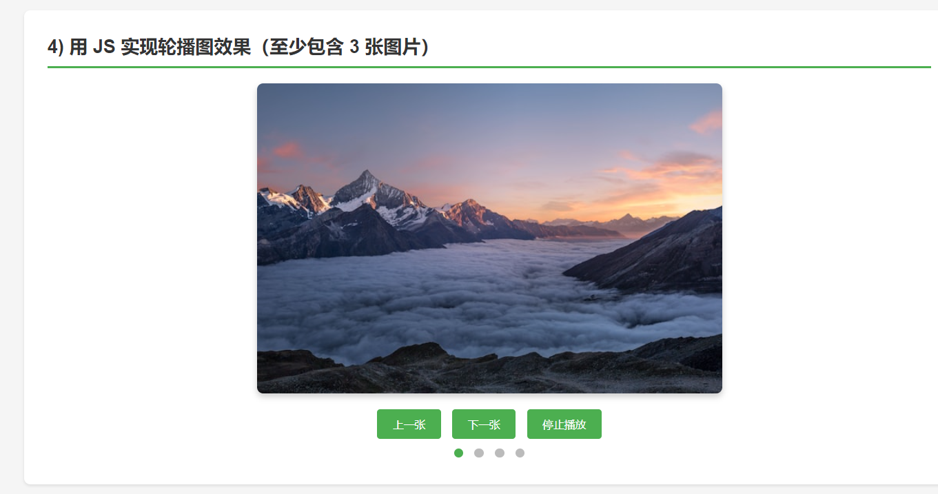
- 四则运算，参考效果图如下：
<div class="question">
<h2>4) 用 JS 实现轮播图效果（至少包含 3 张图片）</h2>

<div class="carousel-container">
<div class="carousel-slide active">
<img src="https://images.unsplash.com/photo-1506905925346-21bda4d32df4?w=600&h=400&fit=crop" alt="山景1">
</div>
<div class="carousel-slide">
<img src="https://images.unsplash.com/photo-1469474968028-56623f02e42e?w=600&h=400&fit=crop" alt="自然2">
</div>
<div class="carousel-slide">
<img src="https://images.unsplash.com/photo-1501785888041-af3ef285b470?w=600&h=400&fit=crop" alt="风景3">
</div>
<div class="carousel-slide">
<img src="https://images.unsplash.com/photo-1472214103451-9374bd1c798e?w=600&h=400&fit=crop" alt="海滩4">
</div>
</div>

<div class="carousel-controls">
<button class="carousel-btn" onclick="prevSlide()">上一张</button>
<button class="carousel-btn" onclick="nextSlide()">下一张</button>
<button class="carousel-btn" onclick="toggleAutoPlay()">自动播放</button>
</div>

<div class="carousel-dots">
<span class="dot active" onclick="currentSlide(0)"></span>
<span class="dot" onclick="currentSlide(1)"></span>
<span class="dot" onclick="currentSlide(2)"></span>
<span class="dot" onclick="currentSlide(3)"></span>
</div>
</div>
function calculate() {
const num1 = parseFloat(document.getElementById('num1').value);
const num2 = parseFloat(document.getElementById('num2').value);
const operator = document.getElementById('operator').value;
const resultField = document.getElementById('result');

// 验证输入
if (isNaN(num1) || isNaN(num2)) {
resultField.value = '请输入有效数字';
return;
}

let result;
switch(operator) {
case '+':
result = num1 + num2;
break;
case '-':
result = num1 - num2;
break;
case '*':
result = num1 * num2;
break;
case '/':
if (num2 === 0) {
resultField.value = '除数不能为0';
return;
}
result = num1 / num2;
break;
default:
result = '未知运算符';
}

// 保留两位小数（如果有小数）
result = Math.round(result * 100) / 100;
resultField.value = result;
}

