Supplementary Figures
This document compiles the final supplementary figure atlas with detailed figure descriptions placed directly below each figure for manuscript assembly.

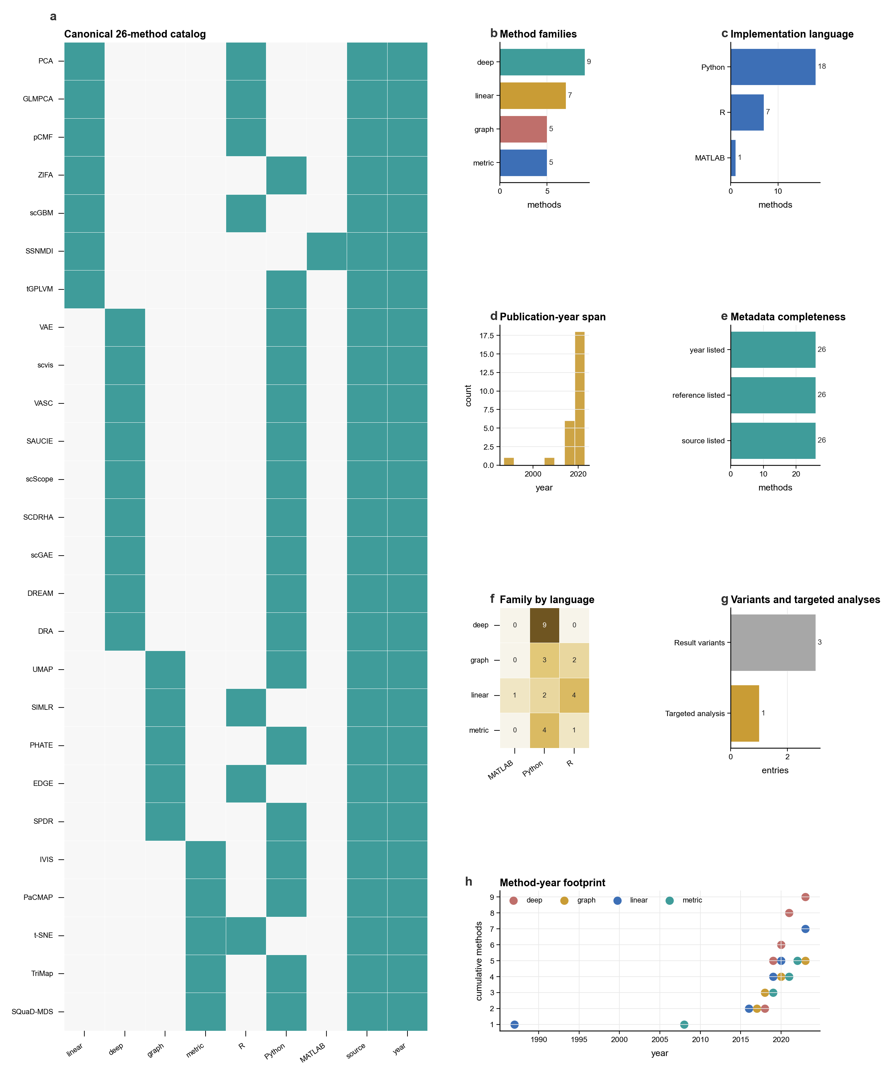
Supplementary Figure S1. Method catalog and benchmark-scope audit. Taxonomy and inclusion audit for the dimensionality-reduction methods evaluated in the benchmark. The figure separates the full benchmark method set from targeted reference analyses and summarizes method families, algorithmic assumptions, input requirements, and reproducibility metadata. Specifically, panel a shows canonical method membership and reproducibility metadata; panel b shows family accounting; panel c shows implementation language accounting; panel d shows publication-year coverage; panel e shows metadata completeness; panel f shows family-language cross-tabulation; panel g shows targeted controls and variants; panel h shows temporal method footprint.

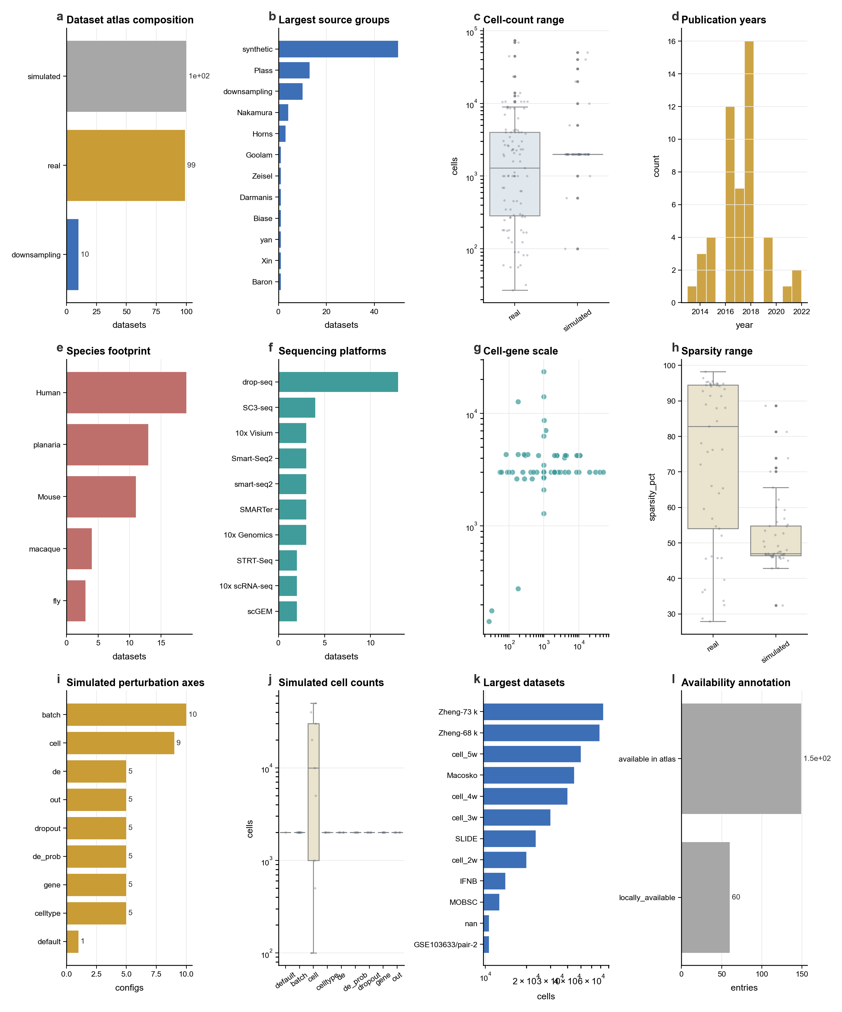
Supplementary Figure S2. Full 100-dataset benchmark atlas. Overview of the complete benchmark data landscape, including real and simulated datasets, data scale, technology classes, sparsity, cell-type composition, and source-data routing used for figure generation. Specifically, panel a shows dataset type accounting; panel b shows source groups; panel c shows cell-count range; panel d shows publication years; panel e shows species footprint; panel f shows sequencing technologies; panel g shows cell-gene scale; panel h shows sparsity; panel i shows simulation axes; panel j shows simulated scale; panel k shows largest datasets; panel l shows availability.

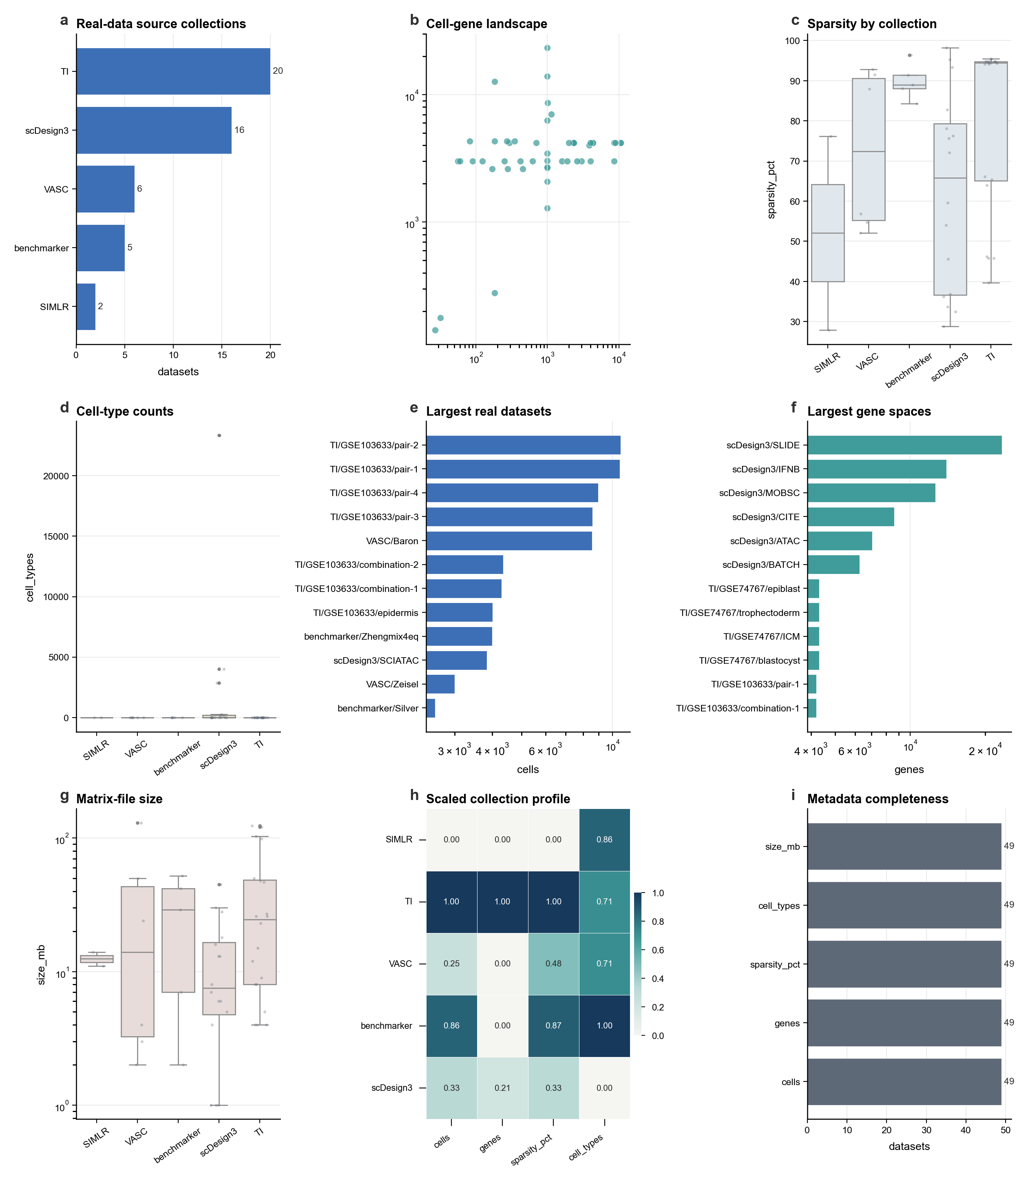
Supplementary Figure S3. Real-dataset metadata landscape. Detailed characterization of the real scRNA-seq datasets, showing how dataset size, feature space, sparsity, technology, cell-type labels, and metadata completeness vary across the curated real-data collection. Specifically, panel a shows source collections; panel b shows cell-gene scale; panel c shows sparsity; panel d shows cell types; panel e shows largest cell counts; panel f shows largest gene spaces; panel g shows matrix size; panel h shows scaled collection profile; panel i shows metadata completeness.

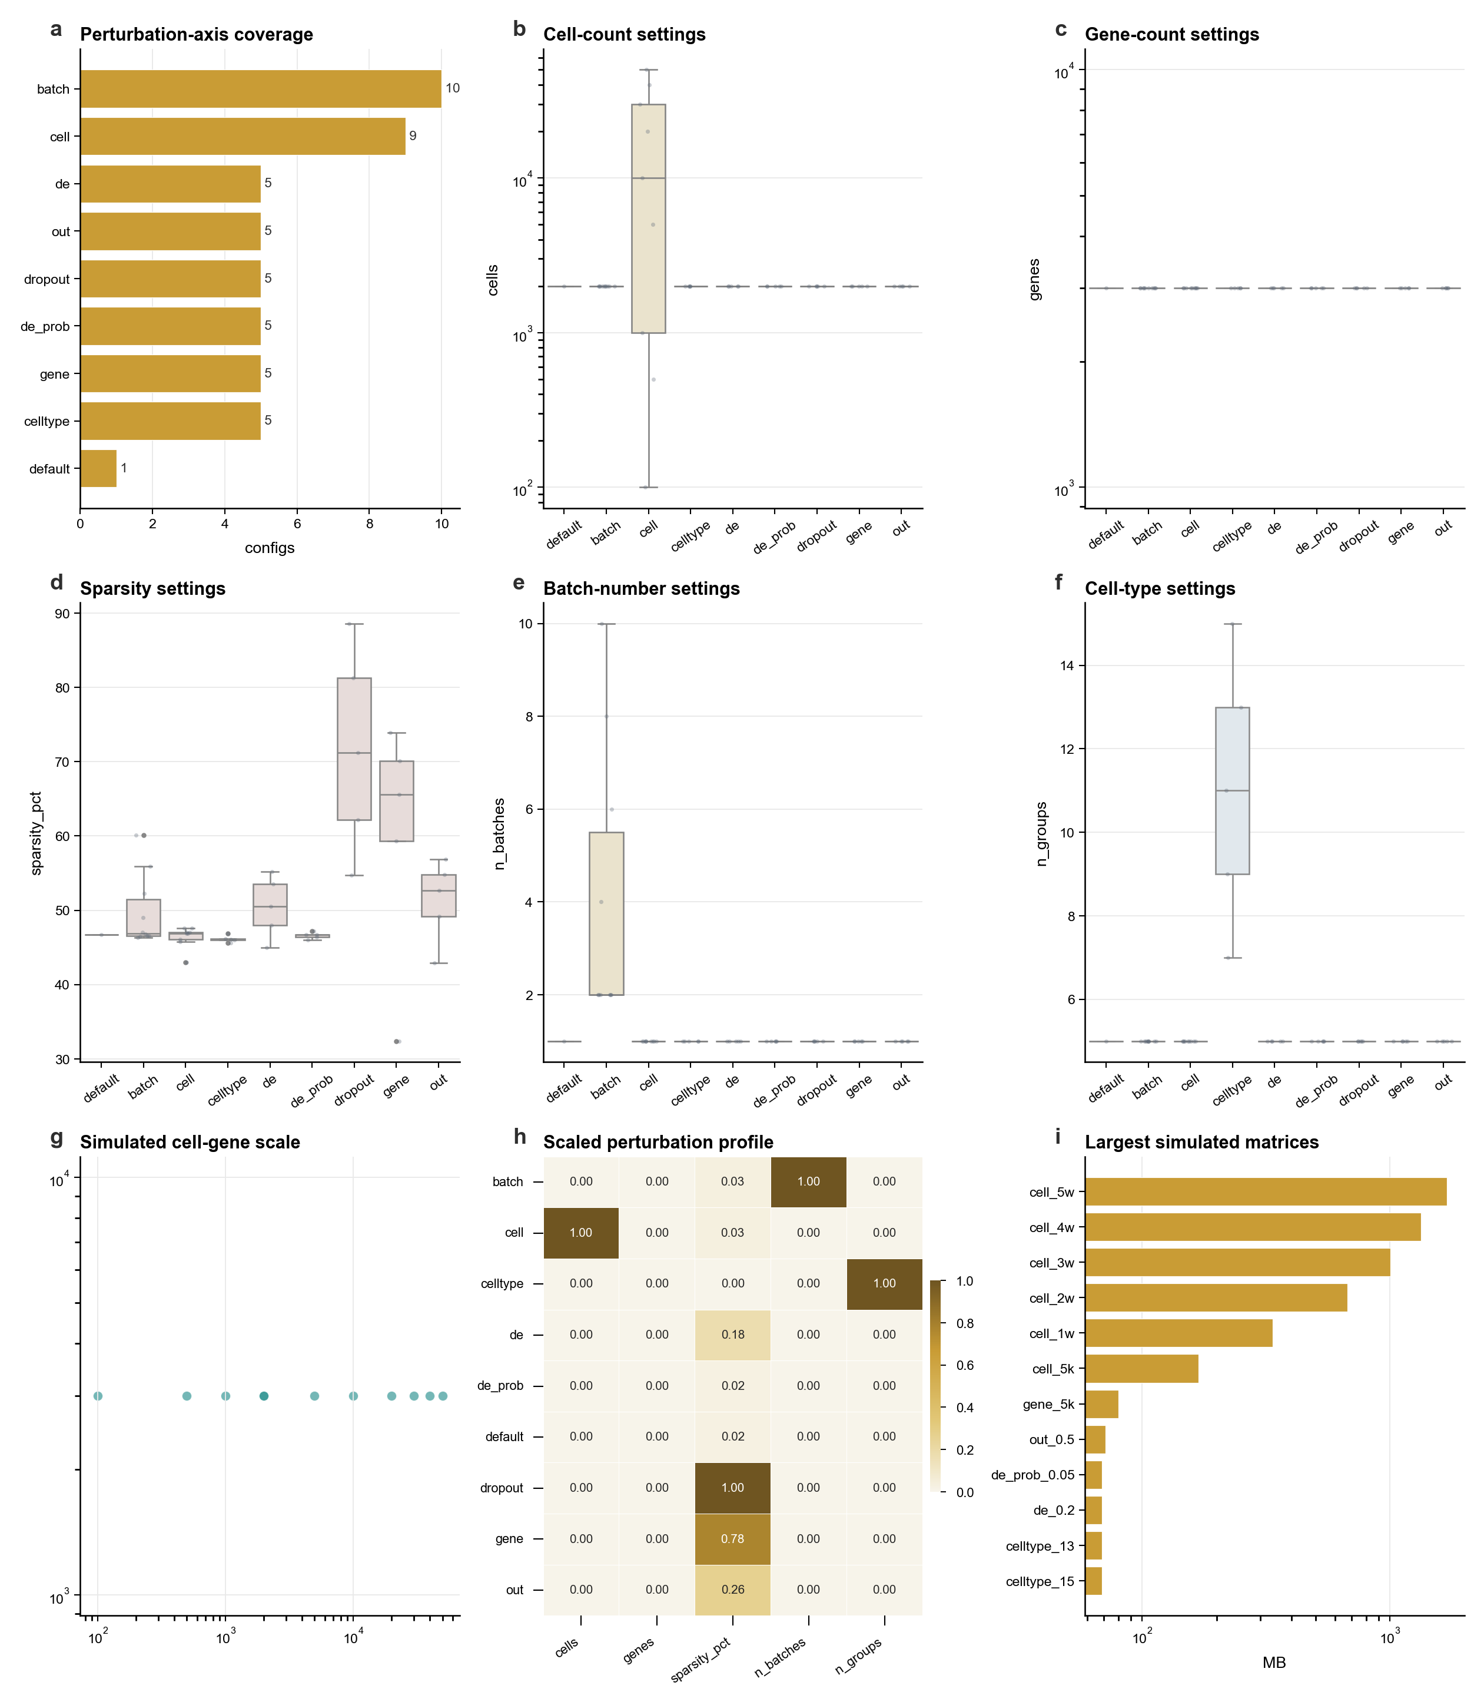
Supplementary Figure S4. Simulated-parameter atlas. Design map for the simulated benchmark datasets, summarizing perturbation axes, simulation settings, size regimes, and how simulated data support robustness, stability, and sensitivity analyses. Specifically, panel a shows axis coverage; panel b shows cell settings; panel c shows gene settings; panel d shows sparsity settings; panel e shows batch settings; panel f shows cell-type settings; panel g shows cell-gene scale; panel h shows scaled parameter profile; panel i shows matrix size.

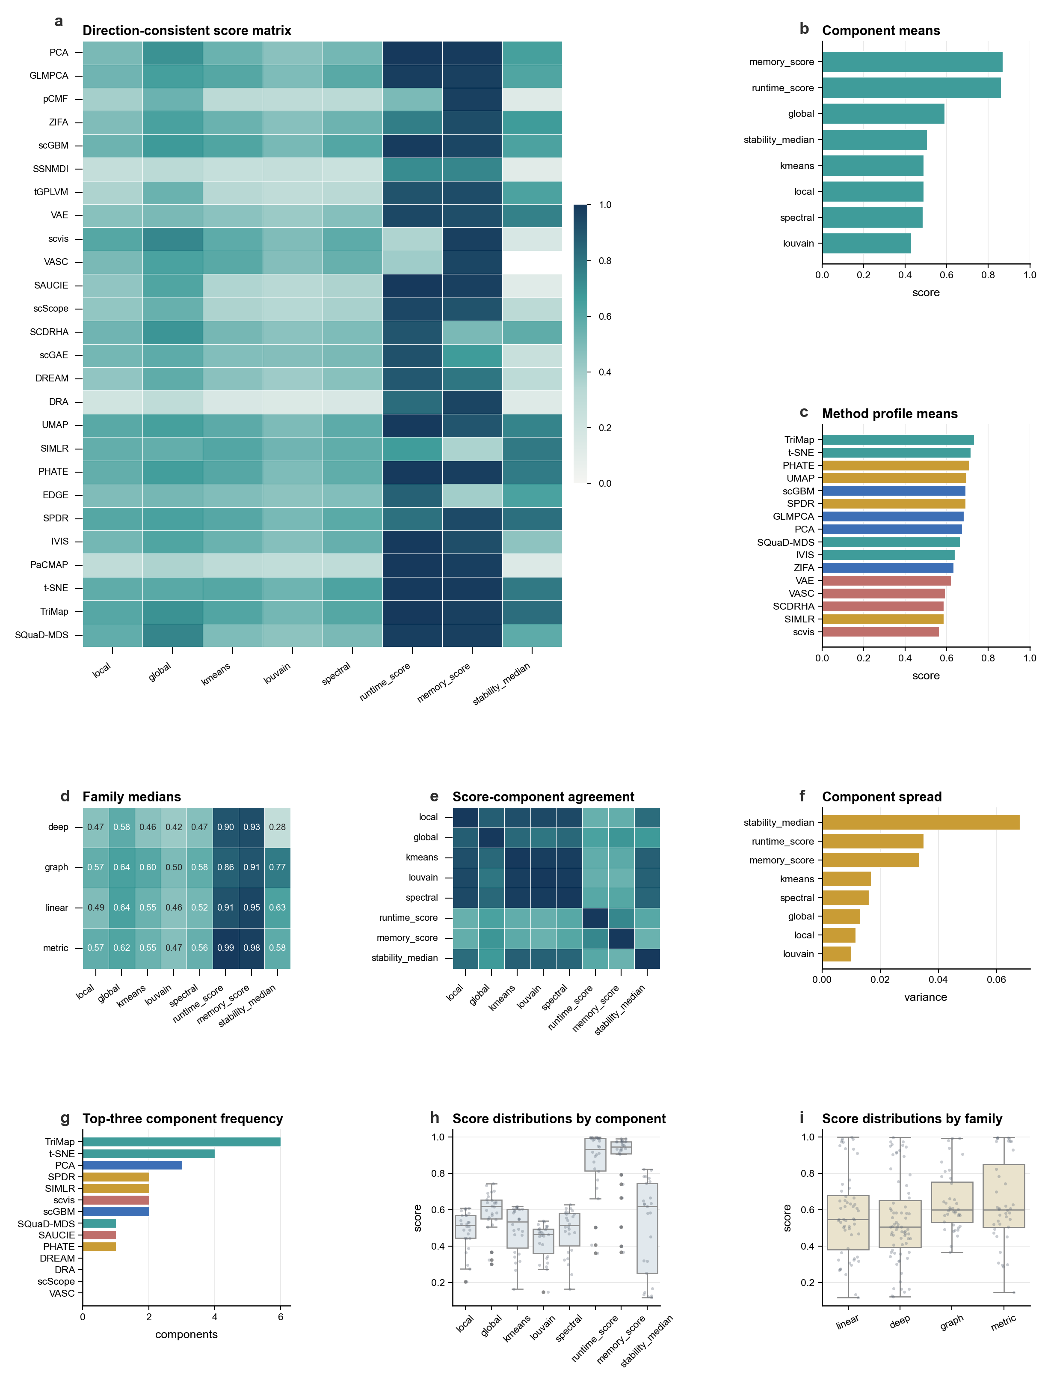
Supplementary Figure S5. Full profile-score atlas. Full direction-consistent score landscape across methods and metrics. The figure extends the main profile-score summary by showing metric-level behavior, domain aggregation, method-family structure, and score-frequency patterns. Specifically, panel a shows full score matrix; panel b shows component means; panel c shows method means; panel d shows family medians; panel e shows component agreement; panel f shows component spread; panel g shows top frequency; panel h shows component distributions; panel i shows family distributions.

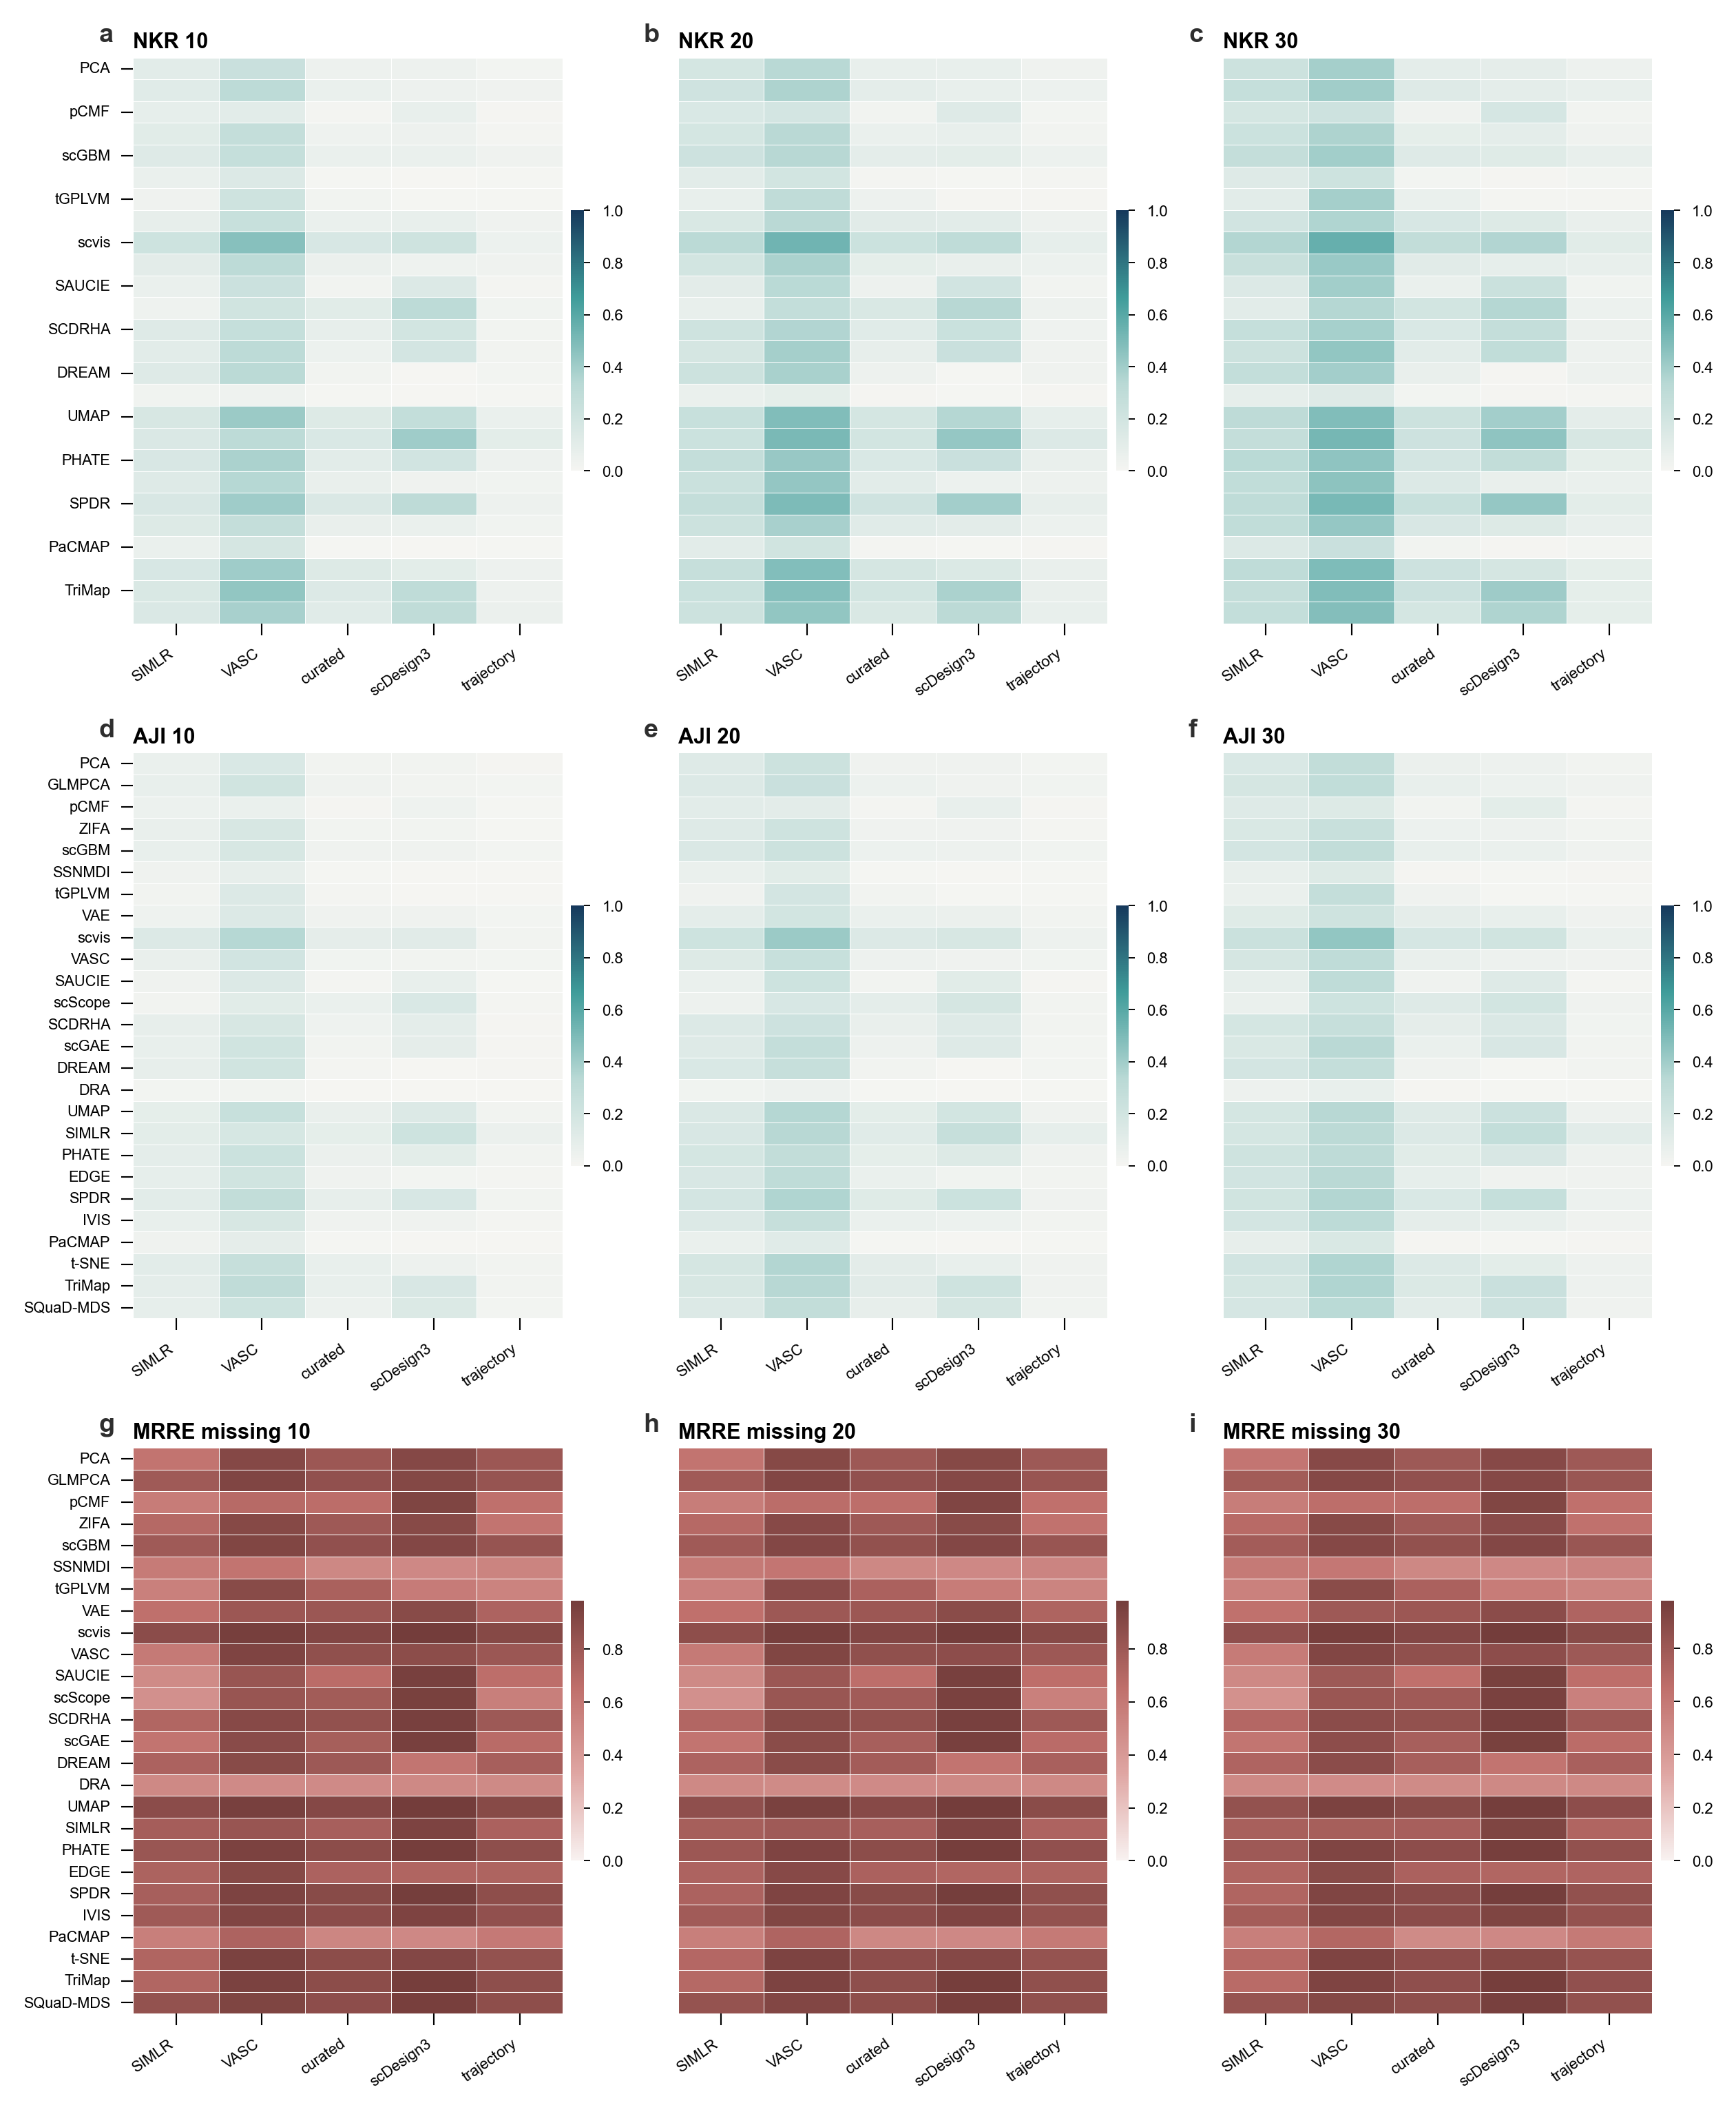
Supplementary Figure S6. Local-neighborhood structure atlas. Expanded analysis of local-neighborhood preservation, including neighborhood-retention, adjusted-neighborhood overlap, rank-error behavior, and method-family summaries across the benchmark datasets. Specifically, panel a shows NKR 10 across reference collections; panel b shows NKR 20 across reference collections; panel c shows NKR 30 across reference collections; panel d shows AJI 10 across reference collections; panel e shows AJI 20 across reference collections; panel f shows AJI 30 across reference collections; panel g shows MRRE missing 10 across reference collections; panel h shows MRRE missing 20 across reference collections; panel i shows MRRE missing 30 across reference collections.

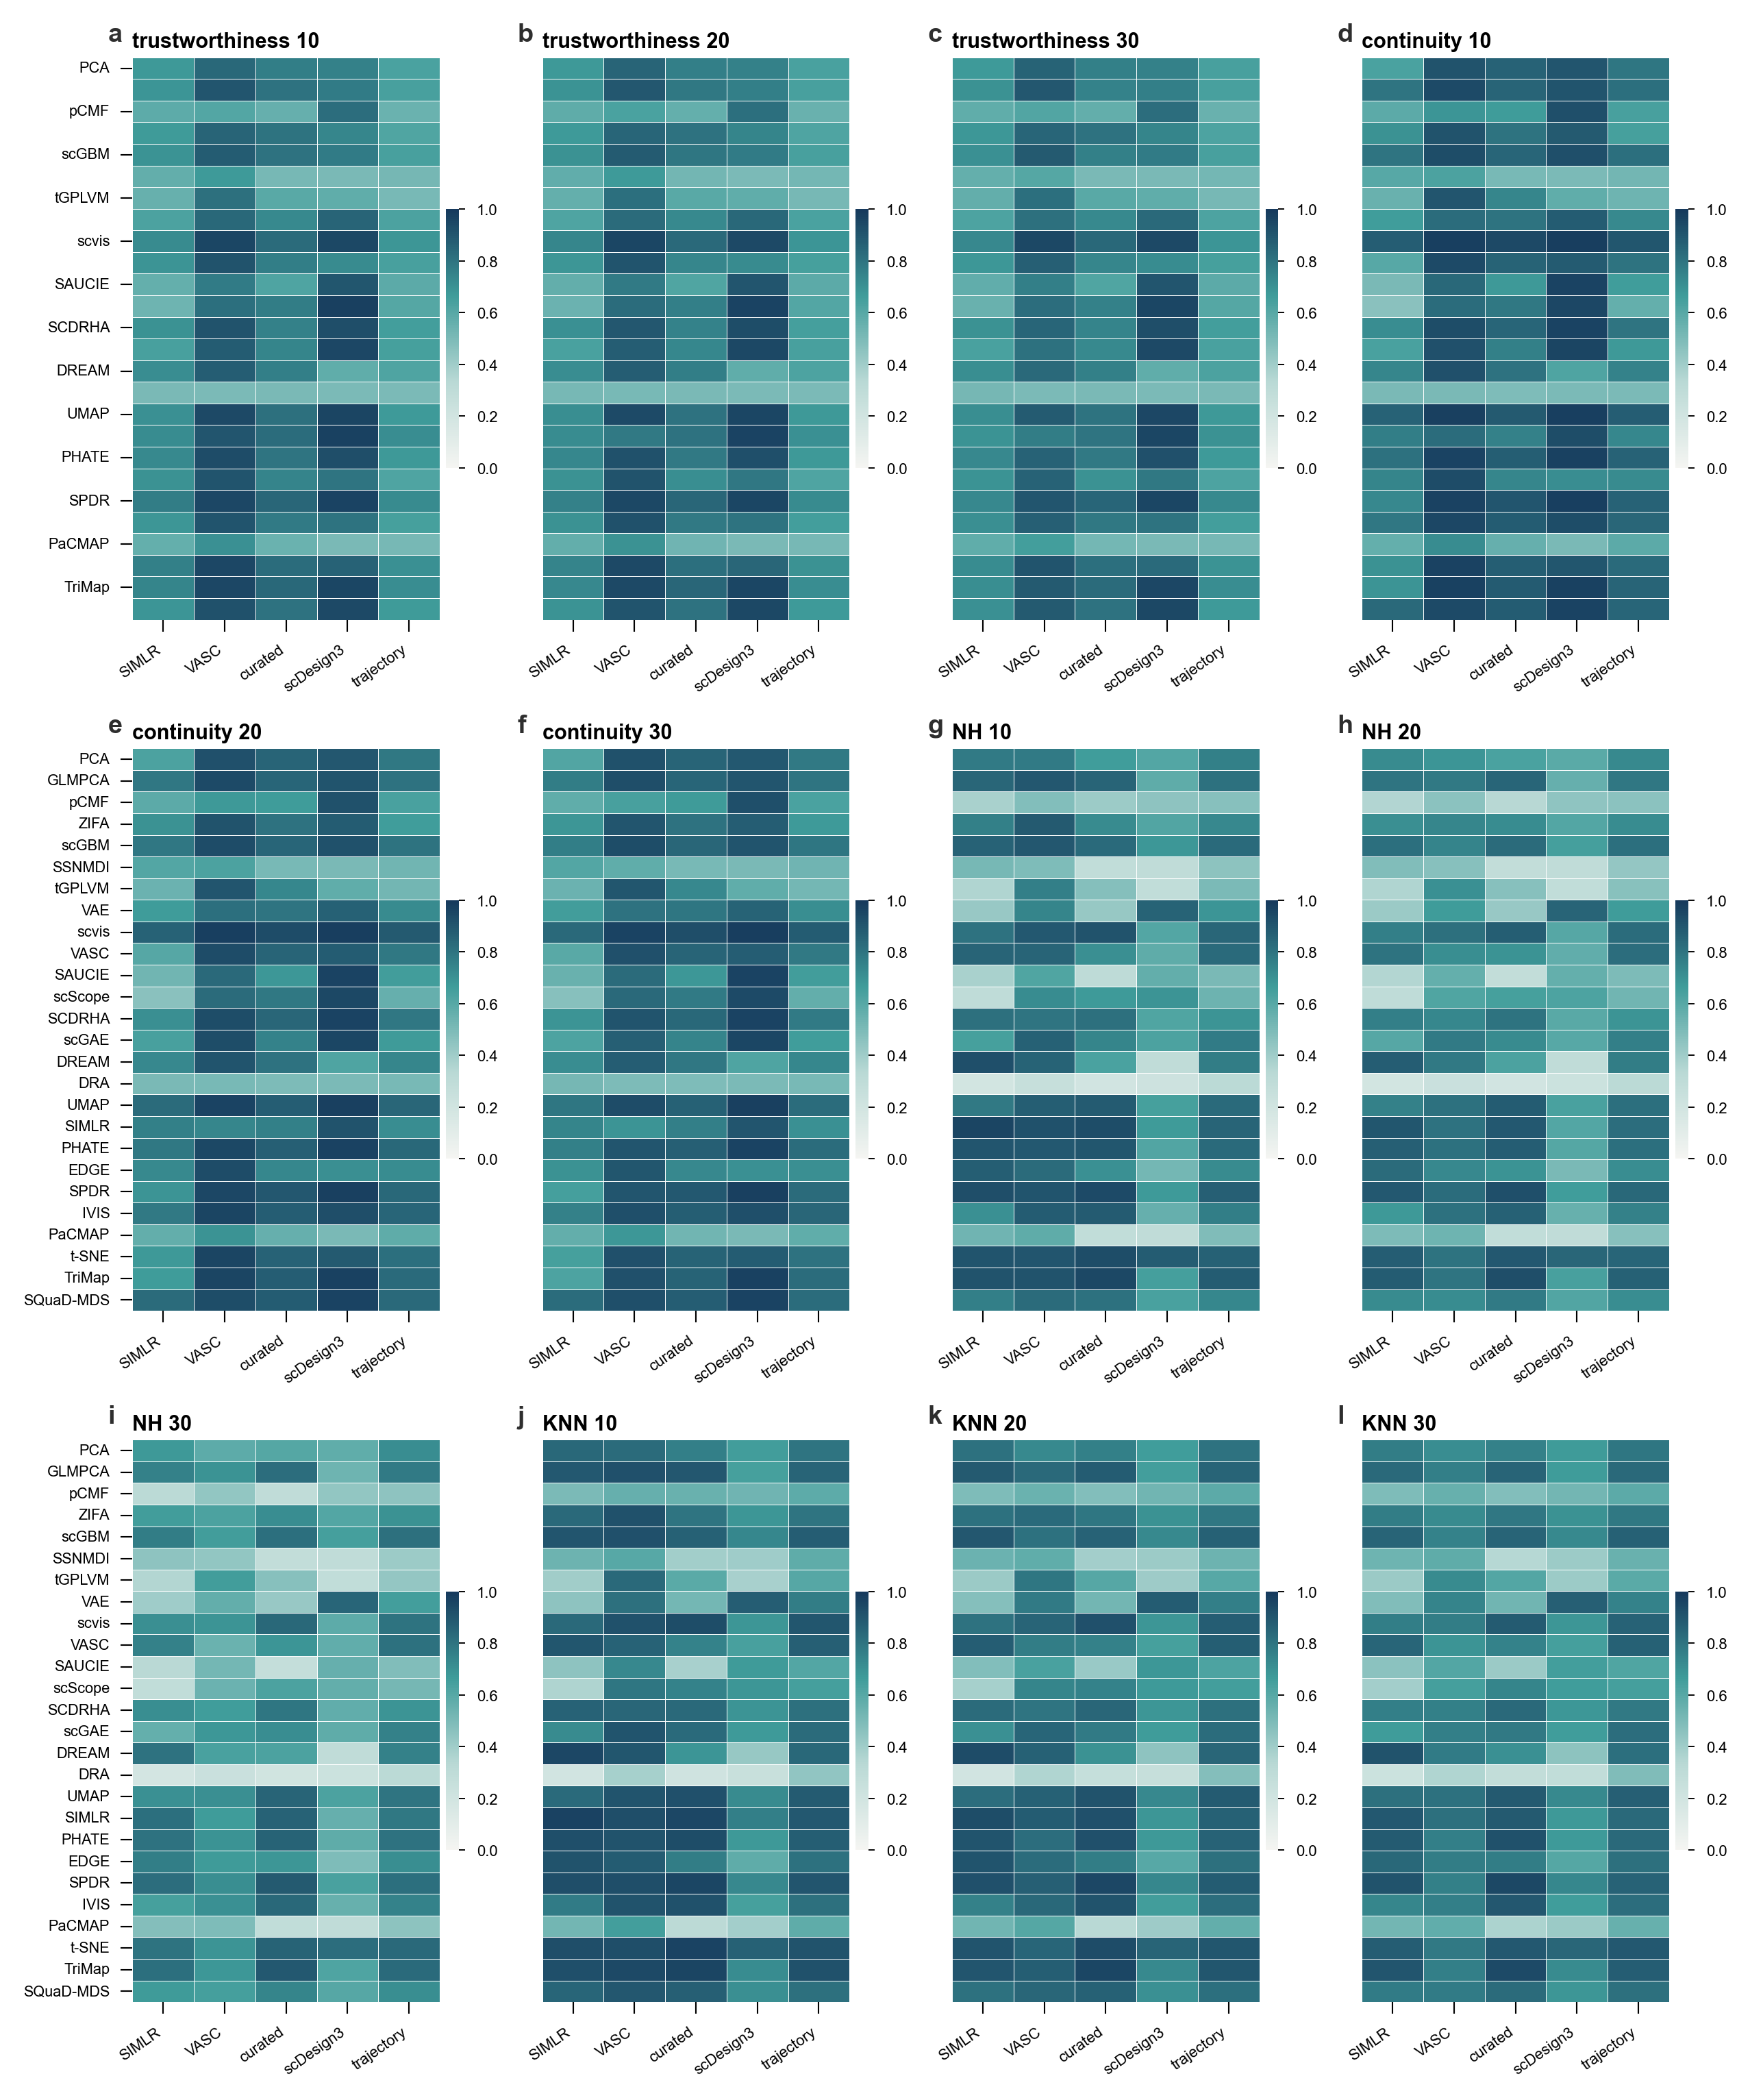
Supplementary Figure S7. Trustworthiness, continuity, neighborhood-hit and KNN atlas. Metric-level atlas for complementary local and manifold-neighborhood criteria. The panels show how methods preserve local neighborhoods under trustworthiness, continuity, neighborhood-hit, and KNN-based evaluations. Specifically, panel a shows trustworthiness 10 collection matrix; panel b shows trustworthiness 20 collection matrix; panel c shows trustworthiness 30 collection matrix; panel d shows continuity 10 collection matrix; panel e shows continuity 20 collection matrix; panel f shows continuity 30 collection matrix; panel g shows NH 10 collection matrix; panel h shows NH 20 collection matrix; panel i shows NH 30 collection matrix; panel j shows KNN 10 collection matrix; panel k shows KNN 20 collection matrix; panel l shows KNN 30 collection matrix.

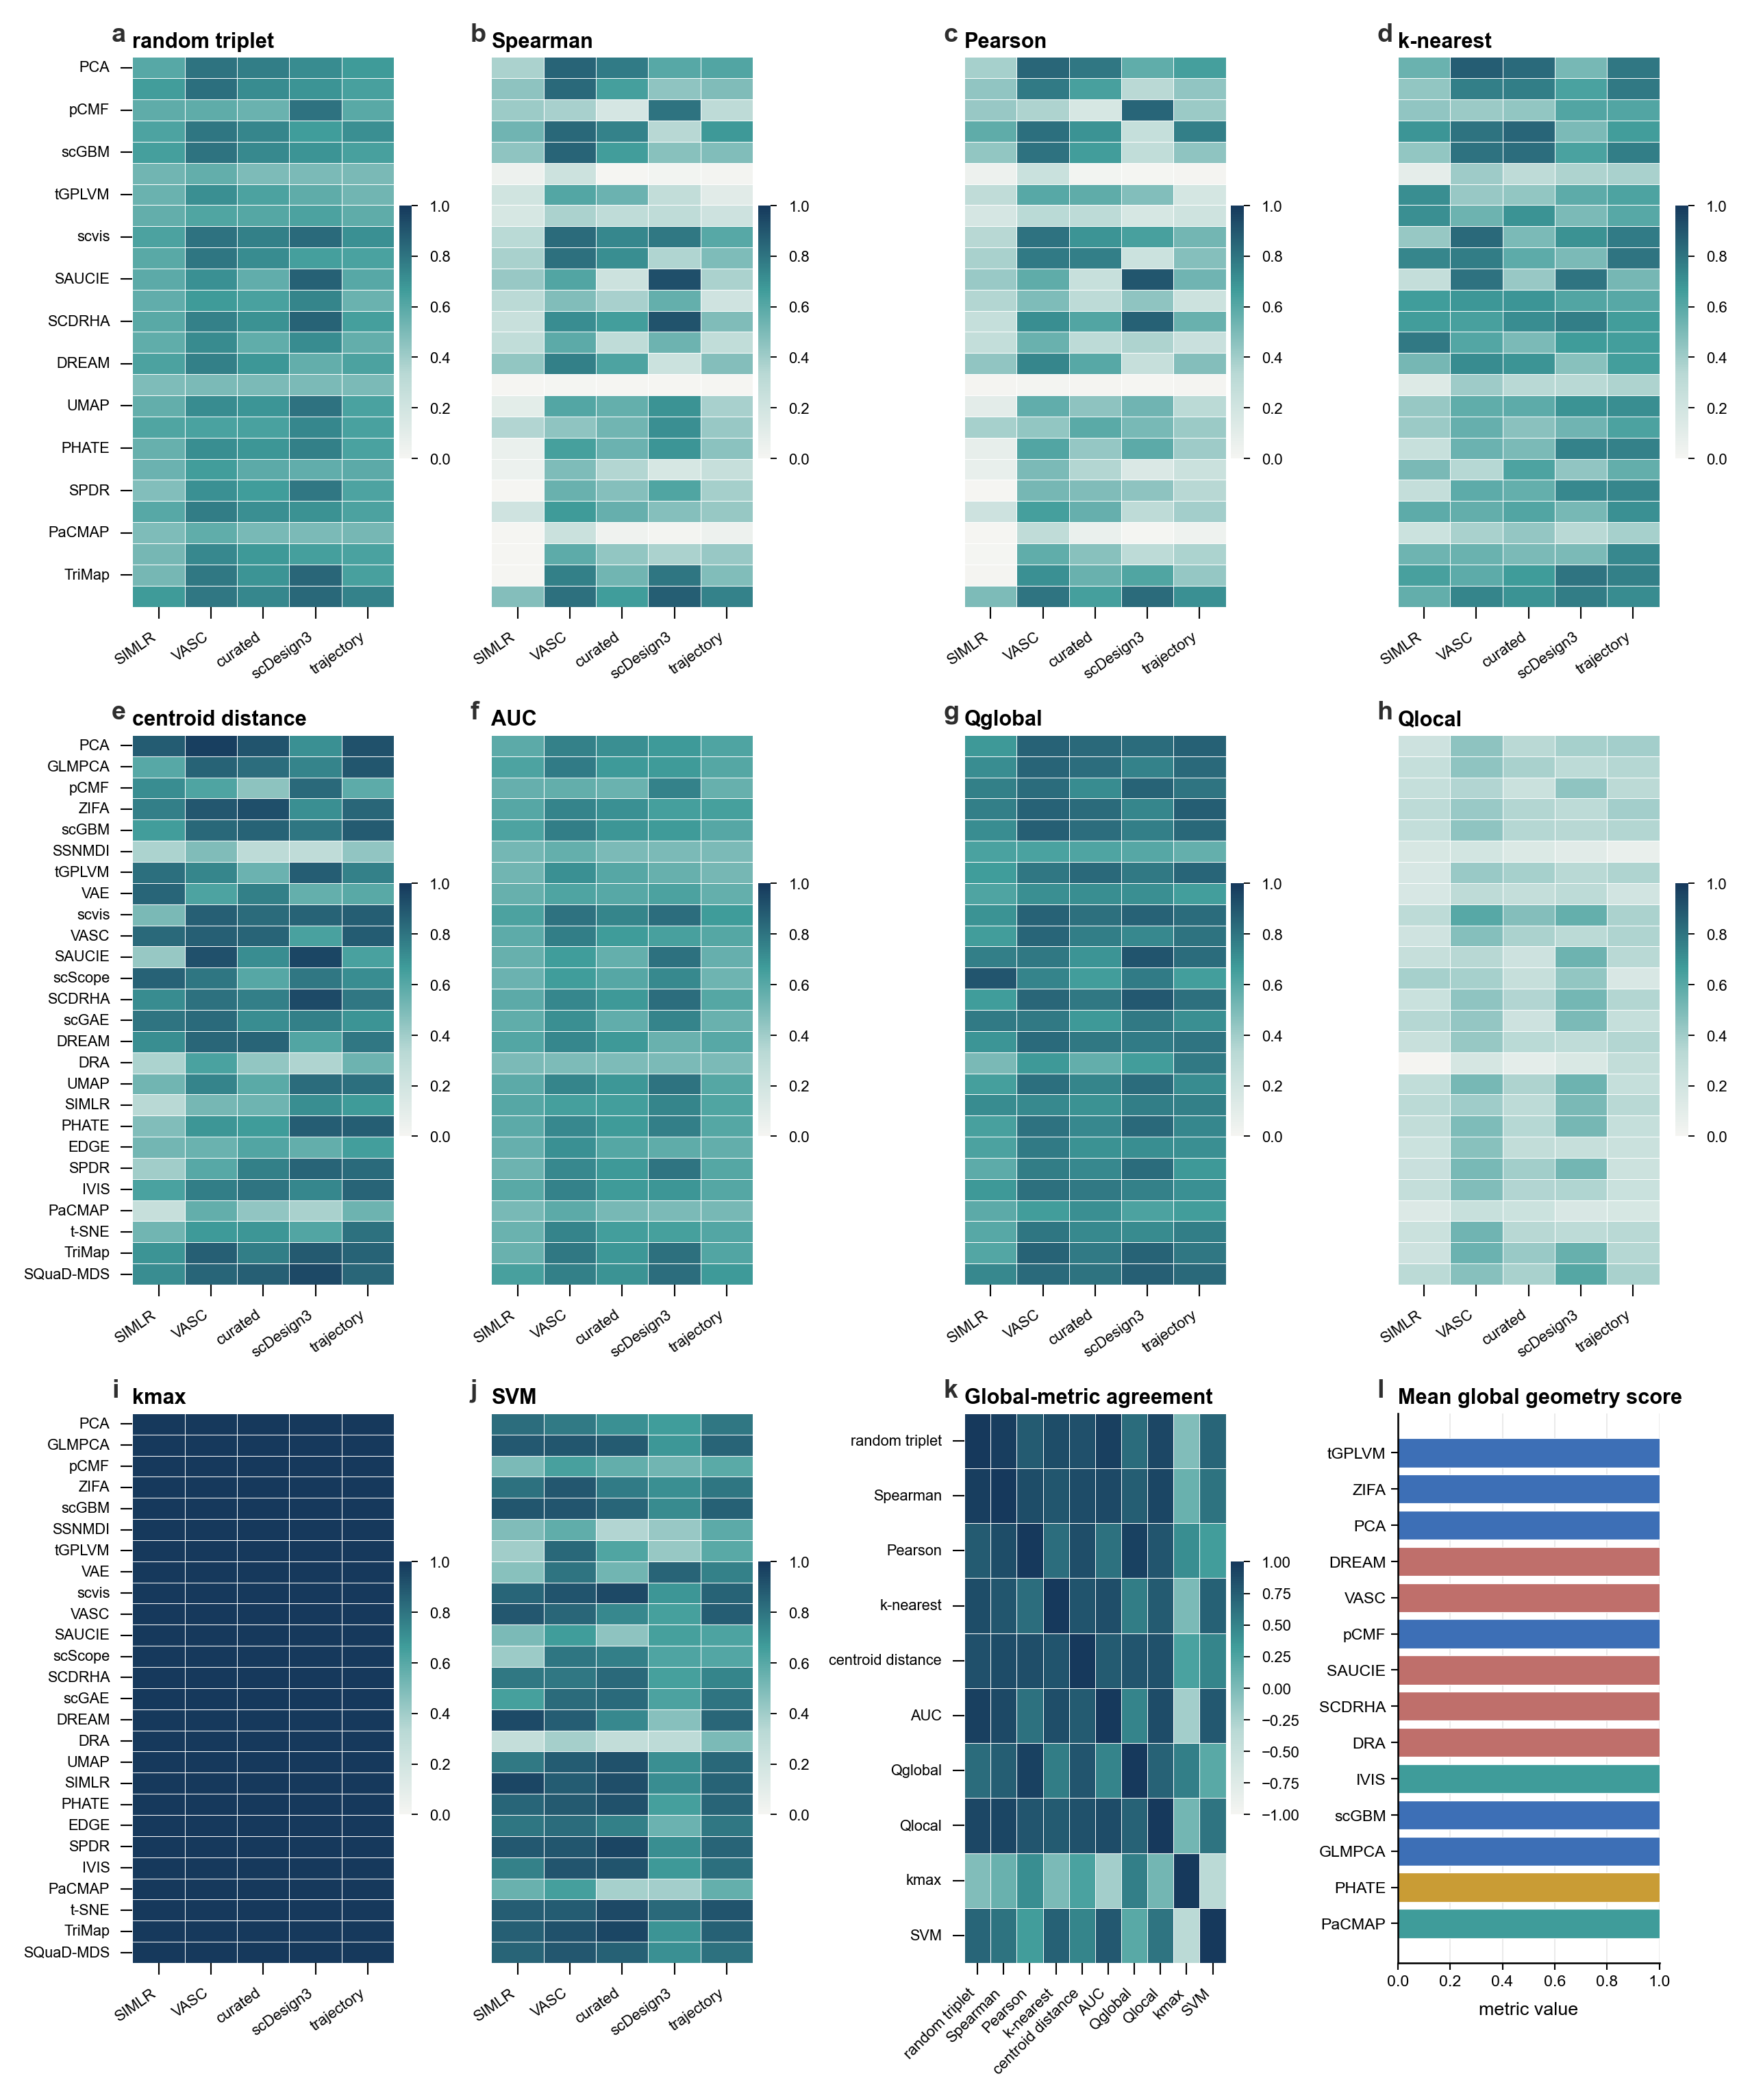
Supplementary Figure S8. Global-geometry and class-geometry atlas. Expanded global-structure evaluation, including distance, correlation, separability, and class-geometry criteria that complement the main global-preservation results. Specifically, panel a shows random triplet collection matrix; panel b shows Spearman collection matrix; panel c shows Pearson collection matrix; panel d shows k-nearest collection matrix; panel e shows centroid distance collection matrix; panel f shows AUC collection matrix; panel g shows Qglobal collection matrix; panel h shows Qlocal collection matrix; panel i shows kmax collection matrix; panel j shows SVM collection matrix; panel k shows metric agreement; panel l shows method-level global summary.

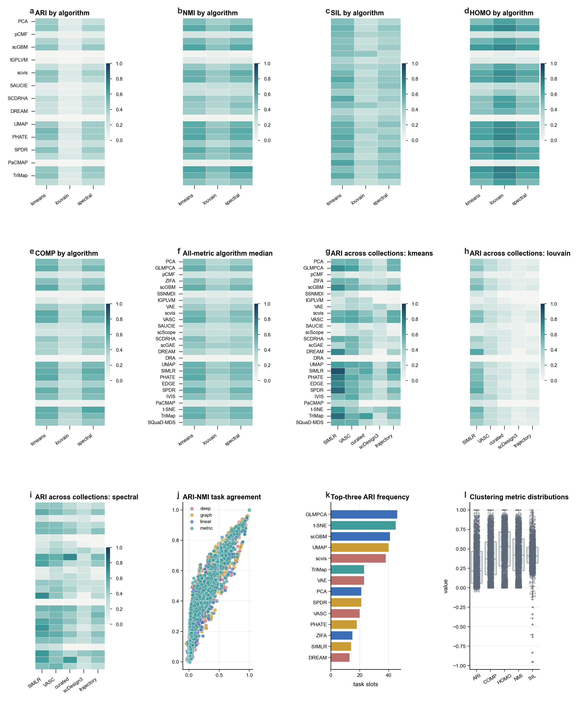
Supplementary Figure S9. Clustering-concordance atlas. Full clustering-concordance analysis across methods and datasets. The figure summarizes agreement between low-dimensional representations and reference cell labels under multiple clustering-quality criteria. Specifically, panel a shows ARI by algorithm; panel b shows NMI by algorithm; panel c shows SIL by algorithm; panel d shows HOMO by algorithm; panel e shows COMP by algorithm; panel f shows algorithm median; panel g shows k-means ARI collections; panel h shows Louvain ARI collections; panel i shows spectral ARI collections; panel j shows ARI-NMI agreement; panel k shows top-three ARI frequency; panel l shows metric distributions.

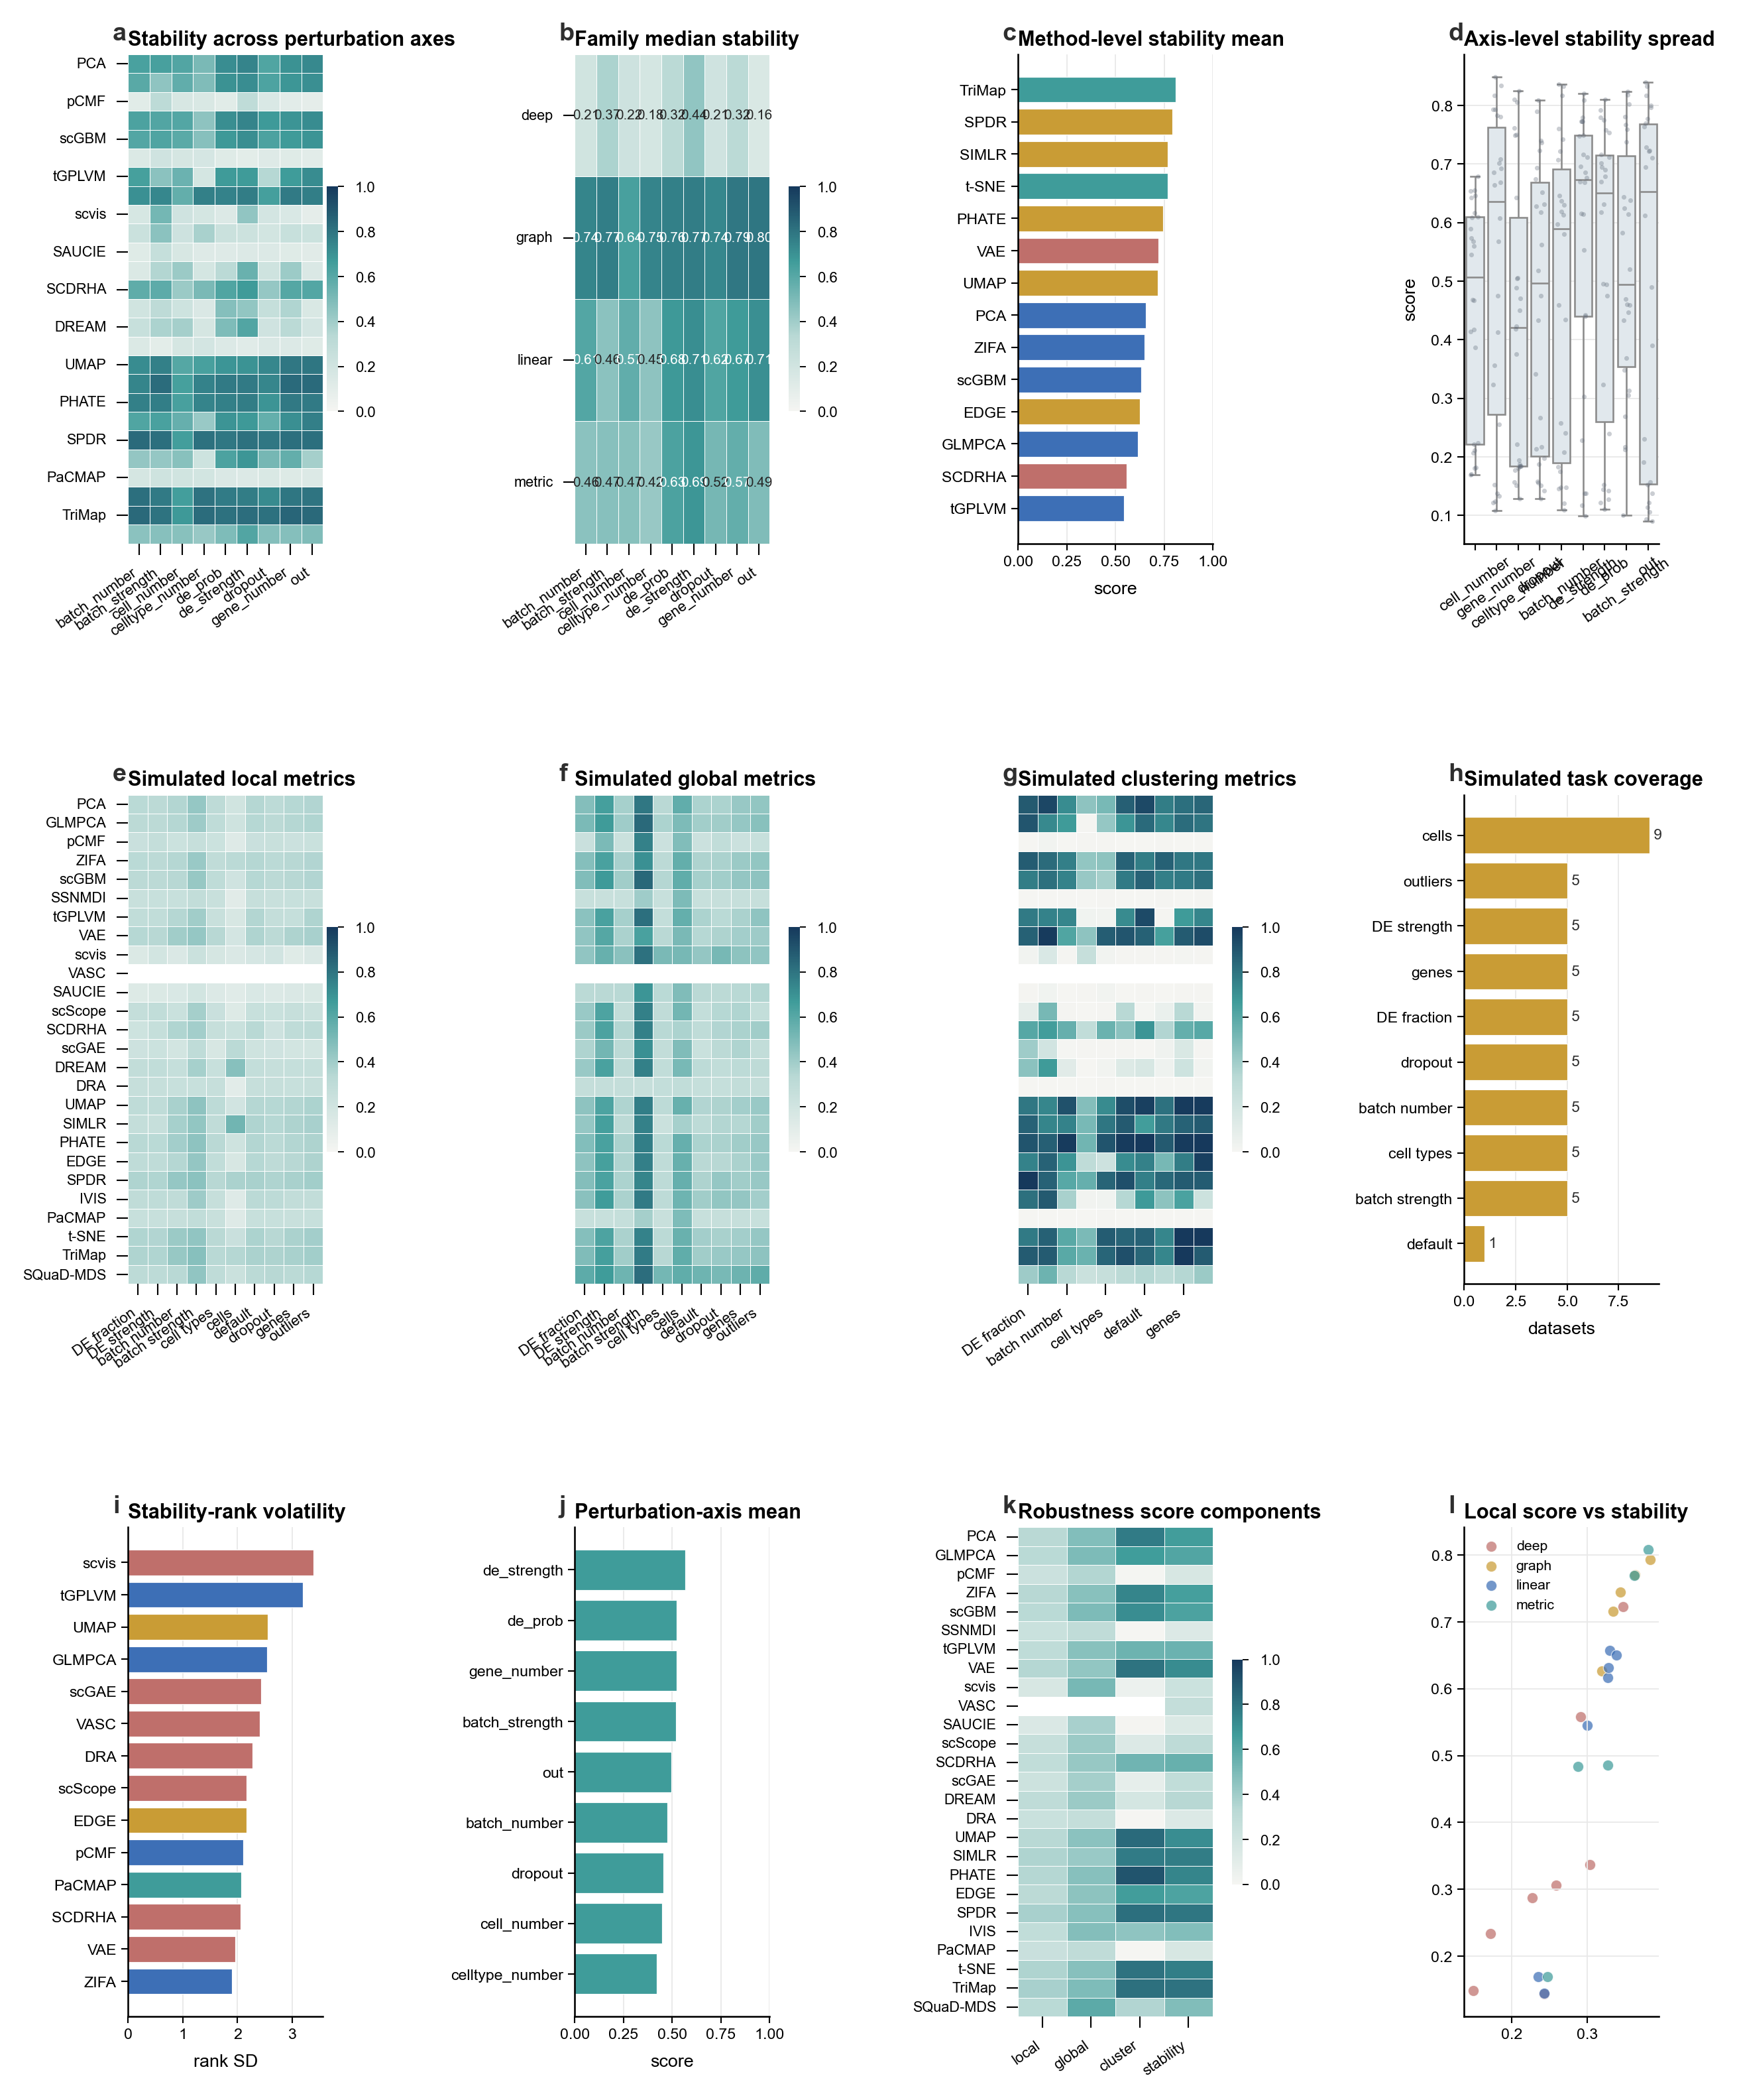
Supplementary Figure S10. Simulated robustness and stability atlas. Stress-test results from simulated datasets, summarizing method behavior across controlled perturbations, replicate stability, and parameter regimes. Specifically, panel a shows stability matrix; panel b shows family stability; panel c shows method stability; panel d shows axis spread; panel e shows simulated local metrics; panel f shows simulated global metrics; panel g shows simulated clustering metrics; panel h shows simulated task coverage; panel i shows rank volatility; panel j shows axis means; panel k shows robustness components; panel l shows local-stability association.

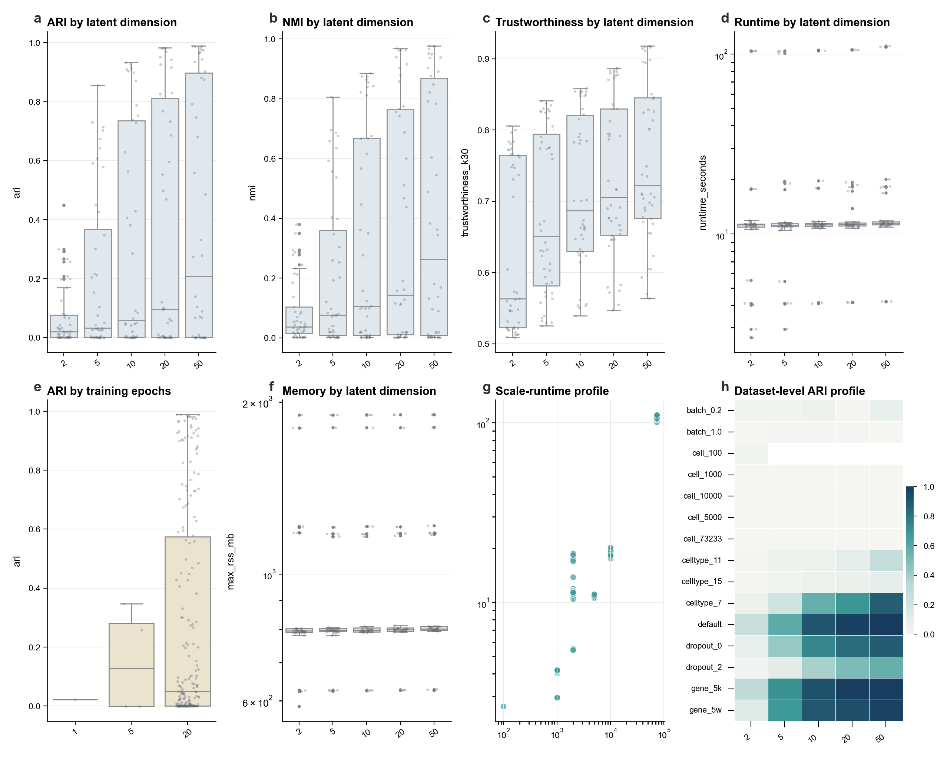
Supplementary Figure S11. scVI targeted reference analysis. Targeted reference analysis for scVI on selected datasets and evaluation settings. The figure positions scVI relative to the benchmarked dimensionality-reduction methods without redefining the prespecified full method set. Specifically, panel a shows ARI dimension; panel b shows NMI dimension; panel c shows trustworthiness dimension; panel d shows runtime dimension; panel e shows epoch effect; panel f shows memory; panel g shows scale-runtime; panel h shows dataset-level ARI.

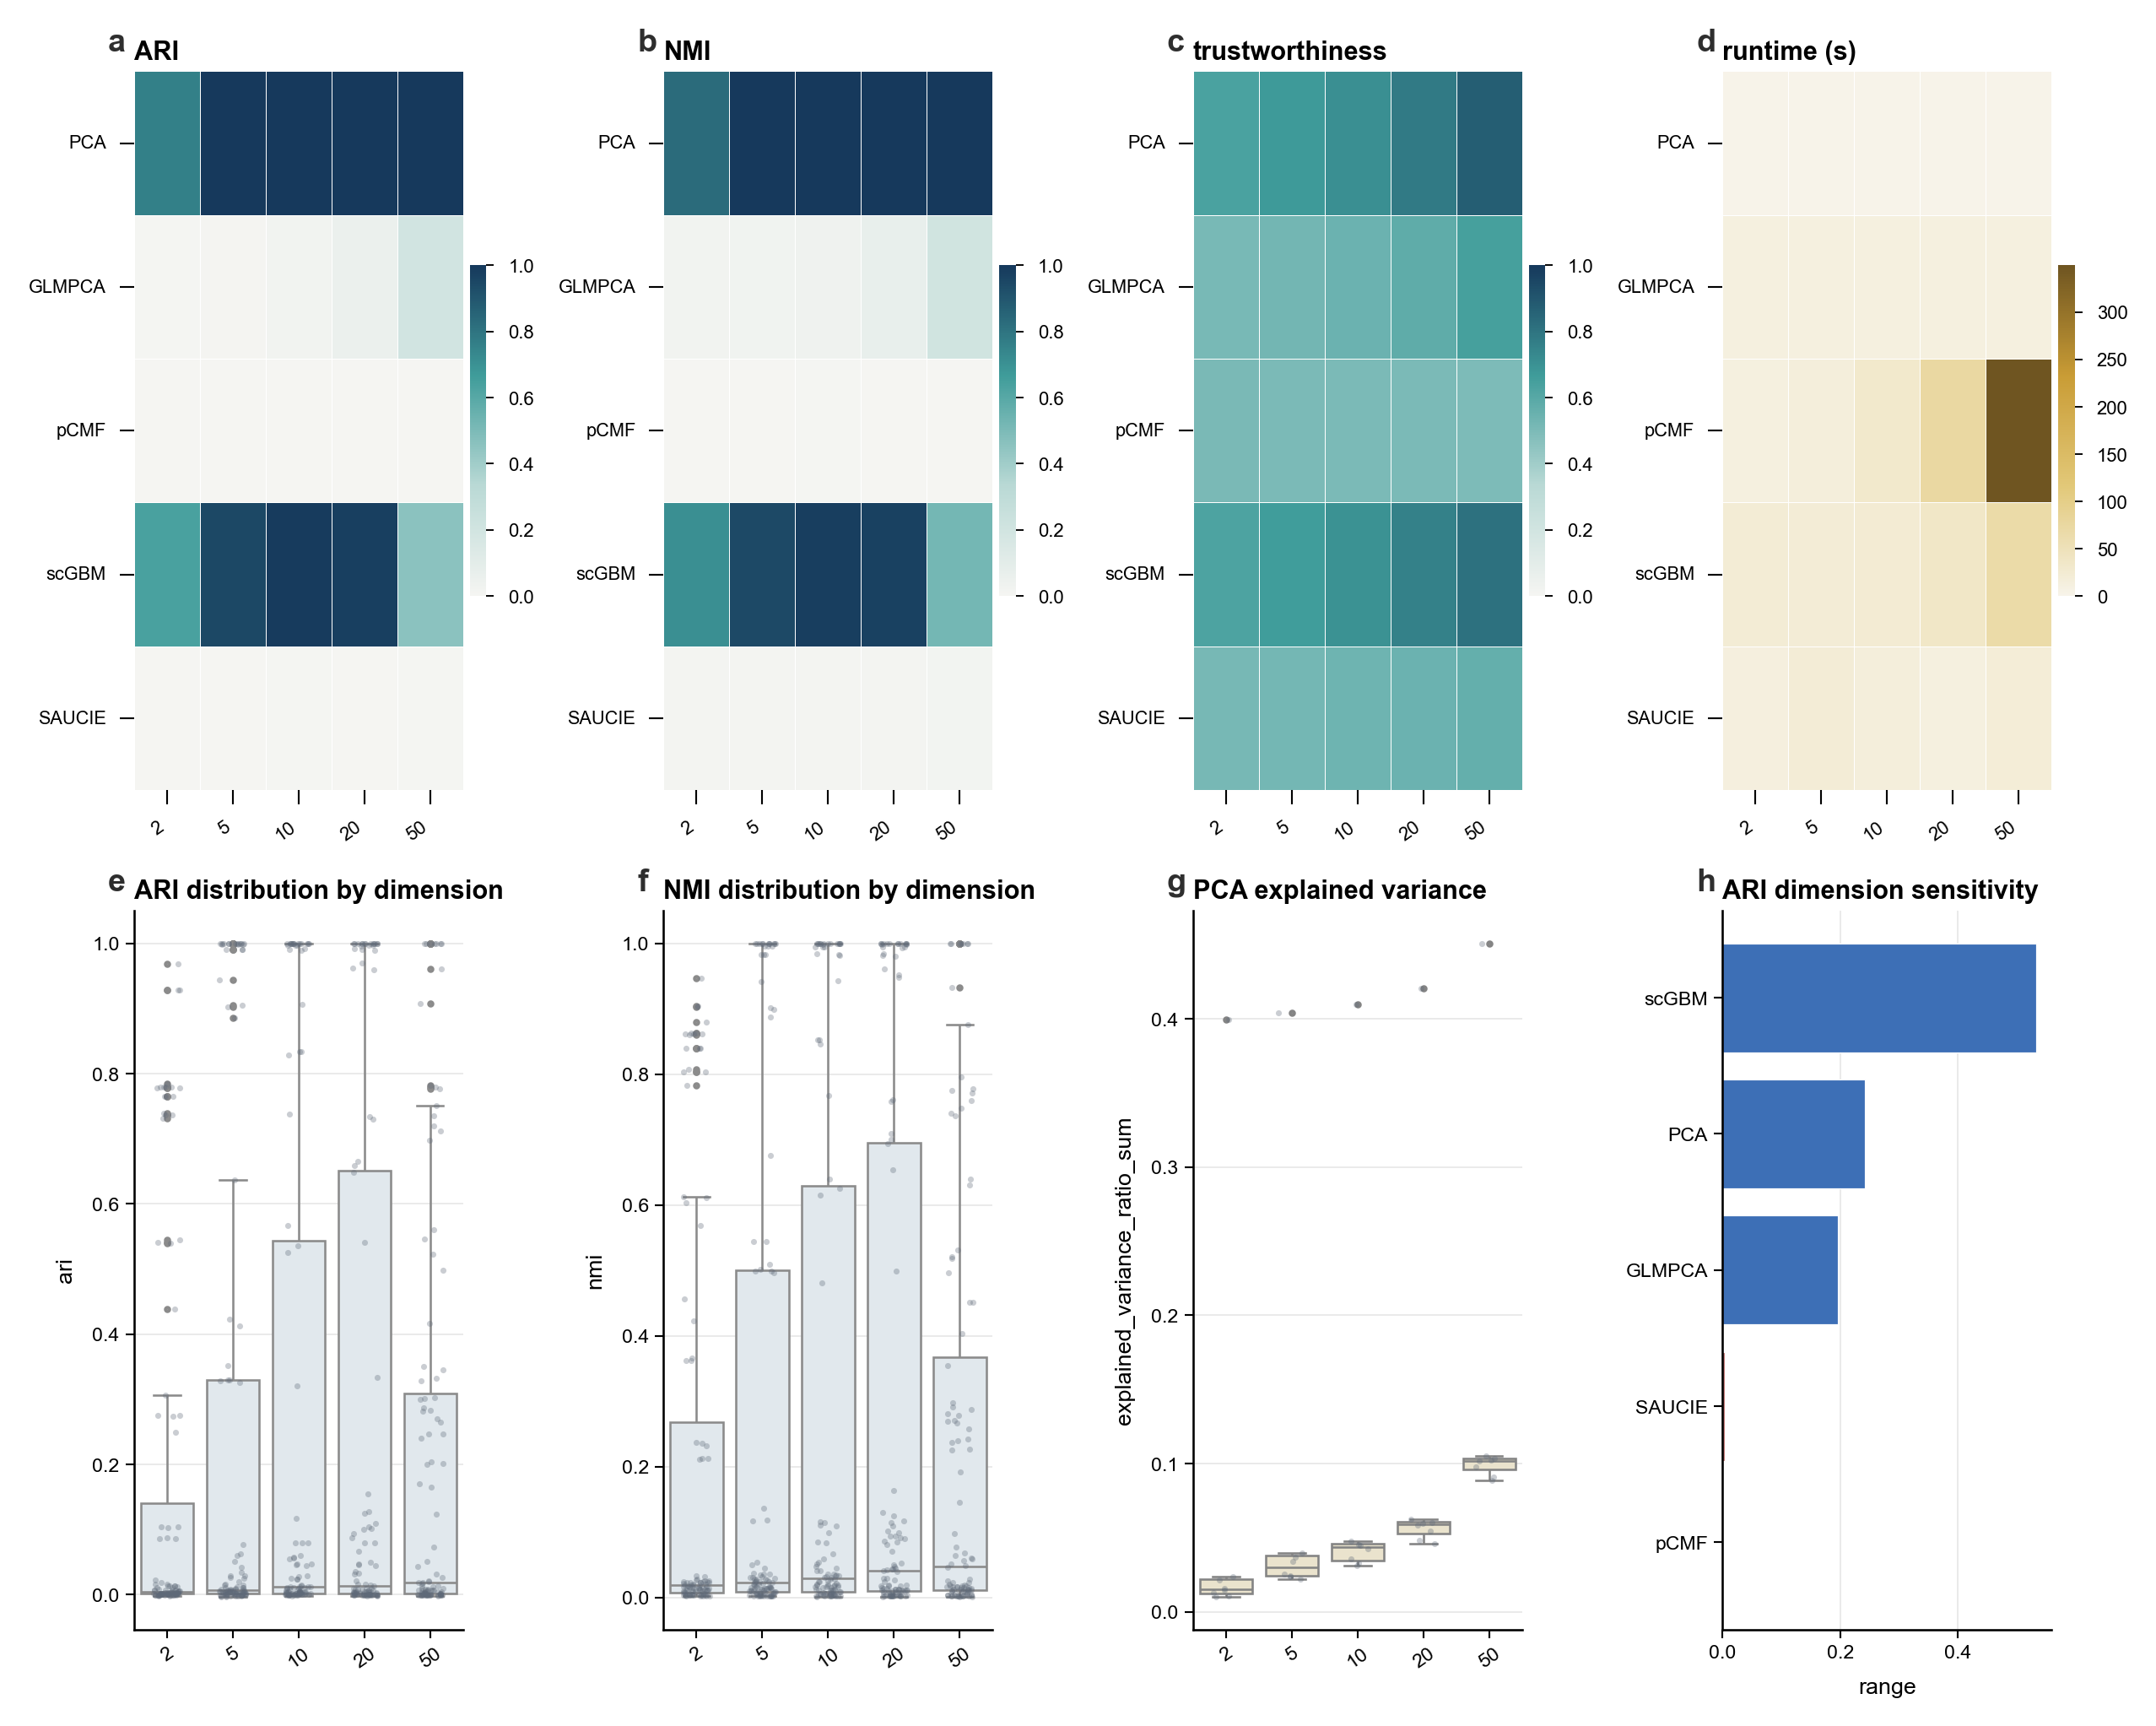
Supplementary Figure S12. Latent-dimension sensitivity atlas. Sensitivity analysis across latent dimensionalities, showing how rankings and metric profiles change when embeddings are evaluated beyond the primary two-dimensional visualization setting. Specifically, panel a shows ARI dimension matrix; panel b shows NMI dimension matrix; panel c shows trustworthiness dimension matrix; panel d shows runtime dimension matrix; panel e shows ARI distribution; panel f shows NMI distribution; panel g shows explained variance; panel h shows method sensitivity.

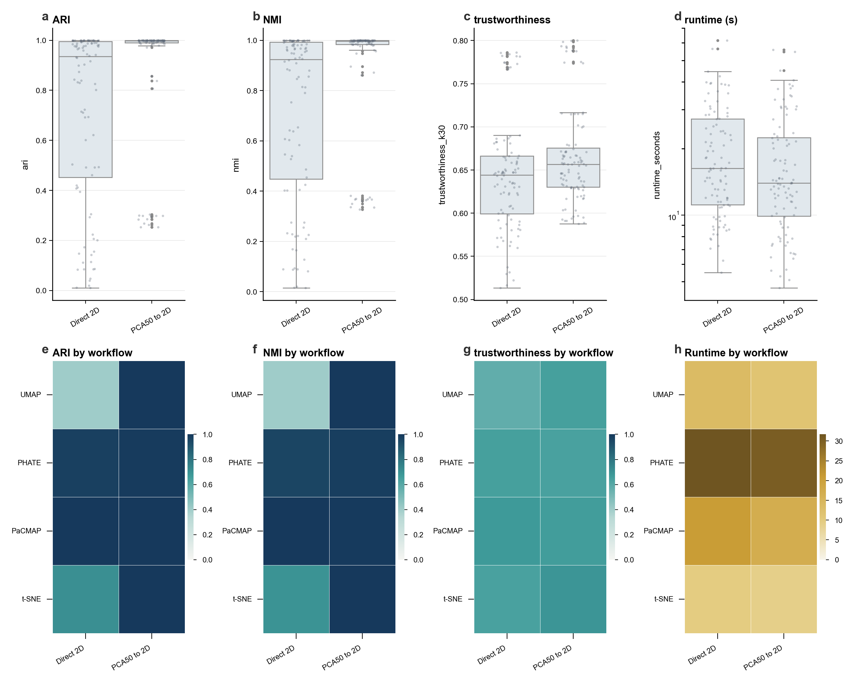
Supplementary Figure S13. Visualization-workflow comparison atlas. Comparison of alternative visualization workflows and downstream display choices, documenting how workflow choices affect the apparent separation, continuity, and interpretability of embeddings. Specifically, panel a shows ARI workflow; panel b shows NMI workflow; panel c shows trustworthiness workflow; panel d shows runtime workflow; panel e shows ARI method matrix; panel f shows NMI method matrix; panel g shows trustworthiness method matrix; panel h shows runtime method matrix.

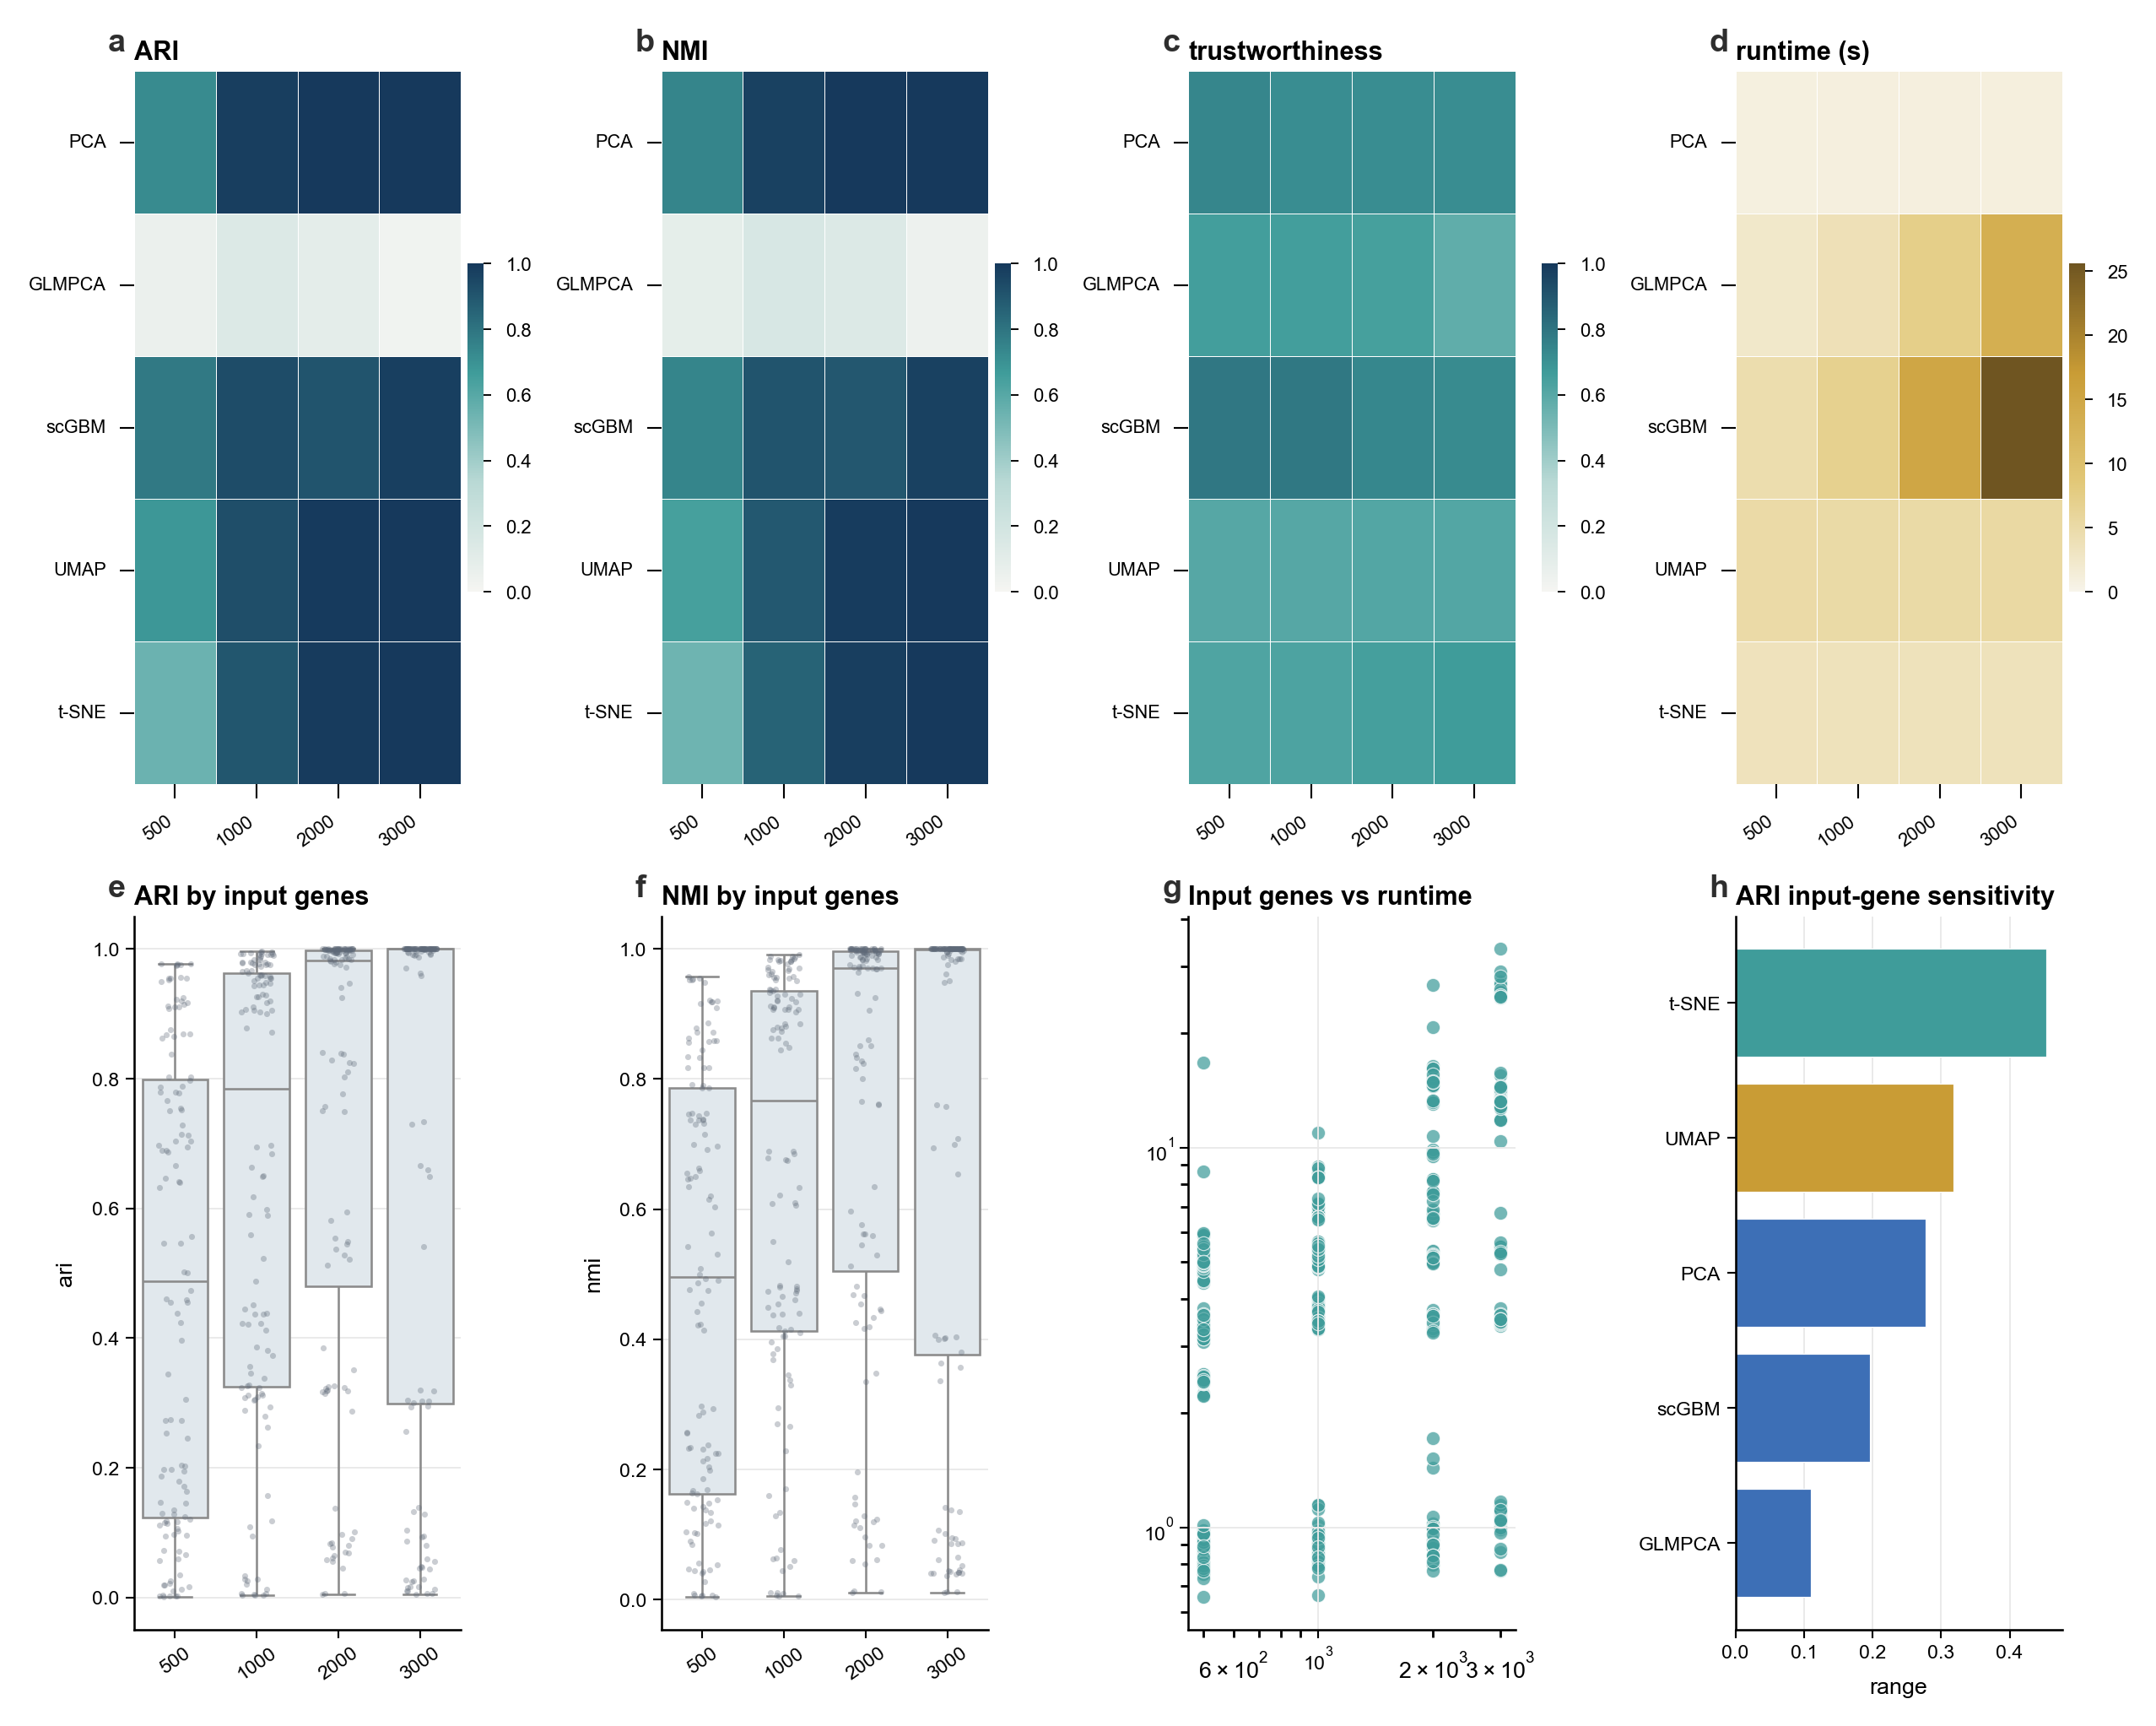
Supplementary Figure S14. Input-gene sensitivity atlas. Sensitivity analysis for input-gene selection. The panels summarize how feature-selection regimes affect method rankings, metric profiles, and robustness of benchmark conclusions. Specifically, panel a shows ARI gene matrix; panel b shows NMI gene matrix; panel c shows trustworthiness gene matrix; panel d shows runtime gene matrix; panel e shows ARI distribution; panel f shows NMI distribution; panel g shows runtime scaling; panel h shows method sensitivity.

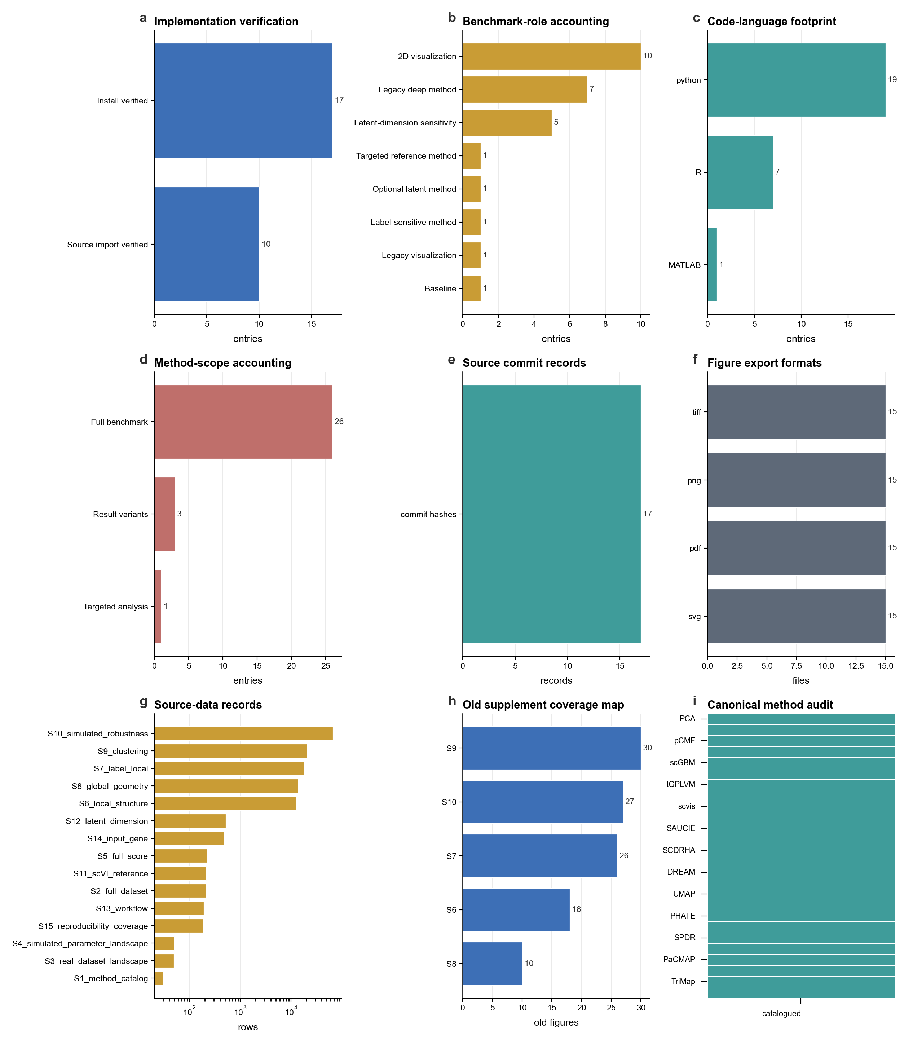
Supplementary Figure S15. Reproducibility and supplementary-coverage audit. Audit of reproducibility materials and supplementary-figure coverage. The figure documents how source data, scripts, panel roles, and evidence layers are mapped into the final figure atlas. Specifically, panel a shows implementation verification; panel b shows role accounting; panel c shows language footprint; panel d shows method scope; panel e shows commit records; panel f shows export formats; panel g shows source-data records; panel h shows old supplement coverage; panel i shows canonical method audit.

