Class Editor

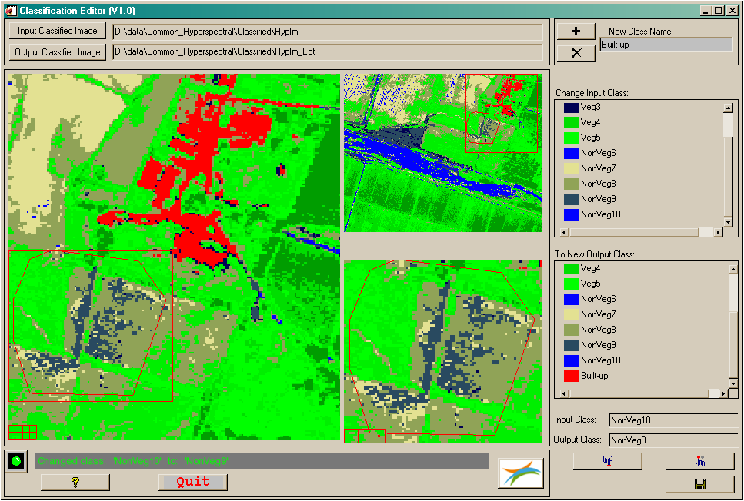

NAME:

**EOSap_ClassEditor**

PURPOSE:

This application allows you to edit and modify a classified image.

CATEGORY:

Applications - Classification

DESCRIPTION:

* Required input:
  + Use the [Input Classified Image] button to browse to the location of the classified image which you want to edit. The classified image must be in ENVI format.
  + Use the [Output Classified Image] button to select the output directory where the modified classified image must be stored. The default filename is the input filename with extension ‘_Edt’.
* Use:
  + Visualisation

Once an ENVI classified image file is selected it is opened and the classified image is visualized. The available classes are displayed in the ‘To New Output Class:’ list box.

* + Changing classified areas

Within the scroll, image or zoom window, right-click points around the area to be changed or hold down the right mouse button to draw a polygon around the area to be changed. The polygon must be closed by double clicking the right mouse button.

The existing polygon can be removed at any time by double clicking the right mouse button again.

Once the polygon is drawn and closed the classes which are found within the polygon are listed in the ‘Change Input Class:’ list-box.

To change a particular class within the polygon, firstly left-click the colour-box of the corresponding class in the ‘Change Input Class’ list-box. The class name will appear in the ‘Input Class’ text box and the status line will show the message ‘Class to change = *Input class’*. Subsequently, left-click the colour-box of the class you want to change to in the ‘To new Output Class’ list-box. The name of the class will appear in the ‘New Class’ list-box and the status line will show the message ‘Class to change to = *Output class’*. Finally press the ‘Set Class Changes’ button, select.bmp.

You can change classes in a faster way. After the polygon is drawn, first left-click the colour-box of the class you want to change to in the ‘To new Output Class:’ list-box. Change the desired class by double clicking the corresponding class colour-box in the ‘Change Input Class:’ list-box. In this way you can easily change a number of input classes to one output class.

* + Restoring changed areas

If areas were changed with the class editor but need to be restored to their original classes this can be easily done by drawing a polygon around the area to be restored as described before. Once the polygon is closed the area within the polygon can be restored by pressing the ‘Reset Class Changes’ button, reset.bmp.

* + Adding a new class

The user has the possibility to add new classes to the original classified image. Firstly, use the ‘Add new class’ button, plus.bmp , to add the new class name which you have entered in the ‘New Class Name’ text box. A pop-up window will appear that allows you to set the class color.

New classes can always be removed by the ‘Remove new class’ button, delete.bmp.

* + Storing the modified classified image is done by pressing the ‘Save Class Changes’ button, save.bmp.

MODIFICATION HISTORY:

- Written by: Luc Bertels, April 20, 2009 (V.03)

- Updated by L. Bertels, February 2013 (V1.0)

- First release for the ENVI /IDL Code Library OSI