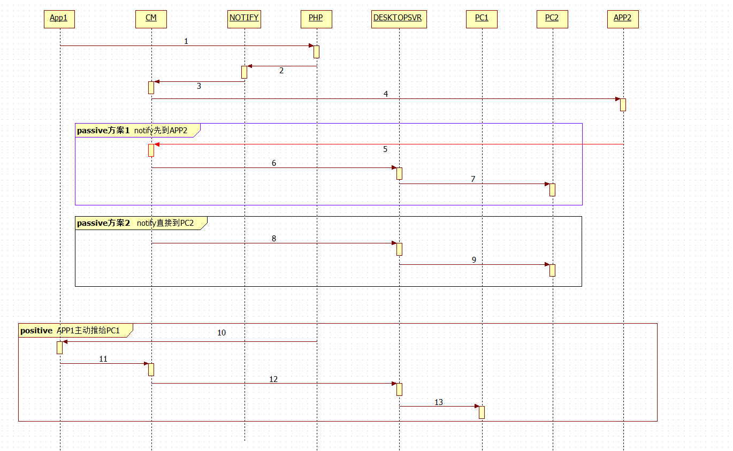
1~4: IM本身的通知逻辑
5~7与8~9：是被动通知消息同步到PC2的两种方案
5~7是通知先到APP2, 处理完后，再发出来同步给PC2。8~9则是在CM处直接就同步给PC2
10~13：是APP1同步给PC 1的逻辑

message MESGrpNotify
{
string sGrpId = 1; //
string sToId = 2; //
string sMsgId = 3; //
uint64 msgTime = 4; // server time,precision millisecond
string sOprUserId = 5; // *optional* operator user
repeated string sMnpledUserId = 6; // *optional* Manipulated user id
string sContent = 7; // notify contents
NotifyType notifyType = 8;
ErrCode errcode = 9; // *optional*, for some notify type this field is required
string extend = 10; // expand field
}
////////////////////////////////////////////////////////////////////////
//MES_GRPNOTIFY_DELIVER_ACK ： 0xb067 客户端响应通知消息
////////////////////////////////////////////////////////////////////////
message MESGrpNotifyDeliverAck
{
string sUserId = 1;
string sGrpId = 2;
string sMsgId = 3;
}

message MSGCommonNotify
{
string sFromId = 1; // 发送者
repeated string sToIds = 2; // 被通知的人(数组)
string sMsgId = 3; // 通知消息ID
CommonNotifyType notifyType = 4; // 通知类型
string sContent = 5; // 通知内容
uint64 msgTime = 6; // 消息时间
string sToId = 7; // 被通知的单人
}

////////////////////////////////////////////////////////////////////////
//MS_COMMONNOTIFY_ACK = 0xb0c2; msg消息服务器回应 通知消息
////////////////////////////////////////////////////////////////////////
message MSGCommonNotifyACK
{
string sUserId = 1; // telephone number or any other number binded. point to sFromId,tell cmSvr which client send to

string sMsgId = 2; // 通知ID
ErrCode errcode = 3; // 错误码
}

message MESAddFriend
{
string sFromId = 1; // telephone number or any other number binded.
string sToId = 2; // telephone number or any other number binded.
string sMsgId = 3; // Generated uuid by APP Id; used for distingulish requests
string sDesc = 4; // desc
string sMemoName = 5; // nick name
uint32 packetId = 6;
string sSelfIntroduce = 7; //
uint64 msgTime = 8; //server time,precision millisecond
string sOperId = 9; // 操作id
string extend = 10; // expand field
}

////////////////////////////////////////////////////////////////////////
//MES_ADDFRIEND_ACK ： 0xb032;
////////////////////////////////////////////////////////////////////////
message MESAddFriendAck
{
string sUserId = 1; // telephone number or any other number binded.
string sMsgId = 2; // Generated uuid by APP Id;
ErrCode errcode = 3; // such as same request(with same fromId&toId) already sent
}

message MESAddFriendAns
{
string sFromId = 1; // telephone number or any other number binded.
string sToId = 2; // telephone number or any other number binded.
string sMsgId = 3; // addfriendMsg's id
string sAns = 4; //
ErrCode errcode = 5; //
string sMemoName = 6; // use if agree to add
uint32 packetId = 7; // use if agree to add
uint64 msgTime = 8; // time--required
string extend = 9; // expand field
}

////////////////////////////////////////////////////////////////////////
//MES_ADDFRIEND_ANS_ACK ： 0xb036;
////////////////////////////////////////////////////////////////////////
message MESAddFriendAnsAck
{
string sUserId = 1; // telephone number or any other number binded.
string sMsgId = 2; // Generated uuid by APP Id;
ErrCode errcode = 3; //
}

enum NotifyType
{
NOTIFY_TYPE_UNKNOWN = 0;
NOTIFY_TYPE_GRP_INFO_CHANGED = 1; //群资料修改 包含修改 群名称 群昵称 群头像 群公告
NOTIFY_TYPE_GRPMEM_QUIT = 2; //退群通知，发送给管理员及群成员
NOTIFY_TYPE_GRPMEM_REMOVE = 3; //踢人通知，发送给被移除人及群成员
NOTIFY_TYPE_GRPAPPLY_RESULT = 4; //申请加群成功通知
NOTIFY_TYPE_GRPINVITE_RESULT = 5; //邀请加群成功通知
NOTIFY_TYPE_GRPMASTER_CHANGED = 6; //群管理员变更
NOTIFY_TYPE_GRP_ACTIVE = 7; //群激活（发送给群管理员）
}

enum CommonNotifyType
{
Notify_ModifyUserInfo = 0; // 个人信息更新通知最近联系人
}

enum SVRFriendRelationNotifyType
{

FRIEND_NOTIFY_TYPE_UNKNOWN = 0;
FRIEND_NOTIFY_TYPE_ADD = 1; // 对方需要验证
FRIEND_NOTIFY_TYPE_ANS = 2; // 对方同意
}

