准备初始镜像
[root@loaclhost redis-cluster-dockerfile1]# more Dockerfile
from grokzen/redis-cluster:3.2.0
COPY docker-entrypoint.sh /docker-entrypoint.sh
COPY redis-cluster-auth.tmpl /redis-conf/redis-cluster-auth.tmpl
RUN chmod 755 /docker-entrypoint.sh
EXPOSE 7000 7001 7002 7003 7004 7005 7006 7007

ENTRYPOINT ["/docker-entrypoint.sh"]
CMD ["redis-cluster"]

[root@loaclhost redis-cluster-dockerfile1]# more docker-entrypoint.sh
#!/bin/sh
port=7005
if [ -f /redis-data/${port}/start.conf ]; then
sleep 30
OLDIP=`cat /redis-data/${port}/start.conf`
echo "重启前的ip"$OLDIP
IP=$(hostname -I)
echo "重启后节点的ip："${IP}
PORT=${port} envsubst < /redis-conf/redis-cluster-auth.tmpl > /redis-data/${port}/redis.conf

sed -i "s/${OLDIP}/${IP}/g" /redis-data/7000/nodes.conf
#sed -i 's/[ ][ ]*\:/\:/g' /redis-data/7000/nodes.conf
sed -i "s/${OLDIP}/${IP}/g" /redis-data/7001/nodes.conf
sed -i "s/${OLDIP}/${IP}/g" /redis-data/7002/nodes.conf
sed -i "s/${OLDIP}/${IP}/g" /redis-data/7003/nodes.conf
sed -i "s/${OLDIP}/${IP}/g" /redis-data/7004/nodes.conf
sed -i "s/${OLDIP}/${IP}/g" /redis-data/7005/nodes.conf

sleep 30
echo '重写pod的ip到start.conf中'
echo ${IP} > /redis-data/${port}/start.conf
/usr/local/bin/redis-server /redis-data/${port}/redis.conf
fi
if [ ! -f /redis-data/start.conf ]; then
if [ "$1" = 'redis-cluster' ]; then
mkdir -p /redis-data/${port}
IP=$(hostname -I)
ls /redis-data/${port}/
echo "查看起使start.conf文件是否有内容"
cat /redis-data/${port}/start.conf
echo "初始创建pod 的ip："${IP}
echo ${IP} > /redis-data/${port}/start.conf
PORT=${port} envsubst < /redis-conf/redis-cluster.tmpl > /redis-data/${port}/redis.conf
sleep 30
/usr/local/bin/redis-server /redis-data/${port}/redis.conf
else
exec "$@"
fi
fi

二、安装service
一共6个service
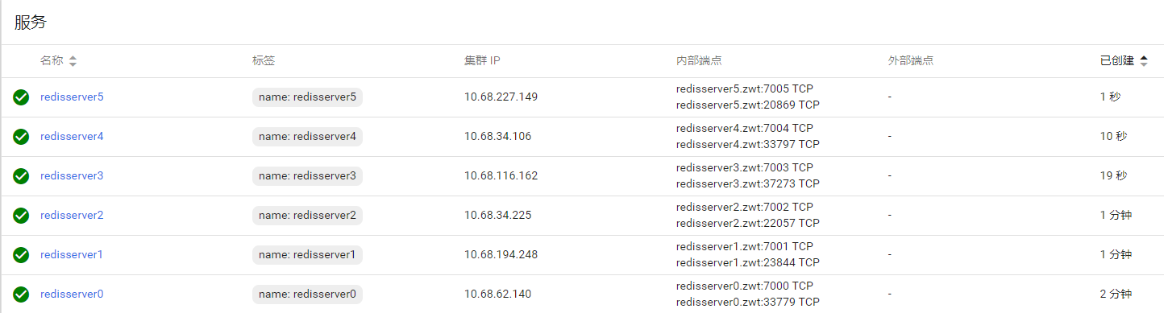
apiVersion: v1
kind: Service
metadata:
name: redisserver0
namespace: zwt
labels:
name: redisserver0
spec:
ports:
- port: 7000
targetPort: 7000
type: NodePort
selector:
name: redis0
---
apiVersion: v1
kind: Service
metadata:
name: redisserver1
namespace: zwt
labels:
name: redisserver1
spec:
ports:
- port: 7001
targetPort: 7001
type: NodePort
selector:
name: redis1
---
apiVersion: v1
kind: Service
metadata:
name: redisserver2
namespace: zwt
labels:
name: redisserver2
spec:
ports:
- port: 7002
targetPort: 7002
type: NodePort
selector:
name: redis2
---
apiVersion: v1
kind: Service
metadata:
name: redisserver3
namespace: zwt
labels:
name: redisserver3
spec:
ports:
- port: 7003
targetPort: 7003
type: NodePort
selector:
name: redis3
---
apiVersion: v1
kind: Service
metadata:
name: redisserver4
namespace: zwt
labels:
name: redisserver4
spec:
ports:
- port: 7004
targetPort: 7004
type: NodePort
selector:
name: redis4
---
apiVersion: v1
kind: Service
metadata:
name: redisserver5
namespace: zwt
labels:
name: redisserver5
spec:
ports:
- port: 7005
targetPort: 7005
type: NodePort
selector:
name: redis5

三、安装deploy
准备 nfs目录
[root@srvr1 redis-cluster]# pwd
/home/data/k8s_data/wangsj/redis-cluster

创建完成后结果如下：
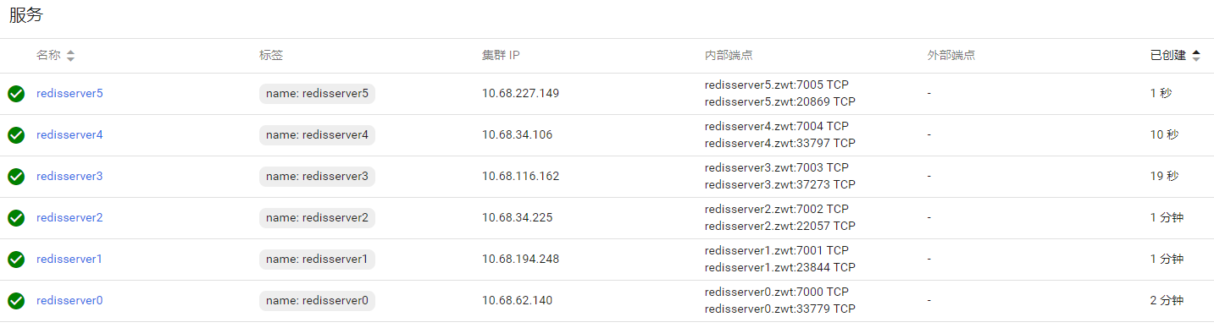
apiVersion: extensions/v1beta1
kind: Deployment
metadata:
name: redis0
spec:
replicas: 1
template:
metadata:
labels:
name: redis0
spec:
containers:
- name: redis0
image: 192.168.0.236:9001/wangsj/redis0:0.3
volumeMounts:
- name: data
mountPath: /redis-data
volumes:
- name: data
nfs:
server: 192.168.23.205
path: "/home/data/k8s_data/wangsj/redis-cluster"

创建完成后
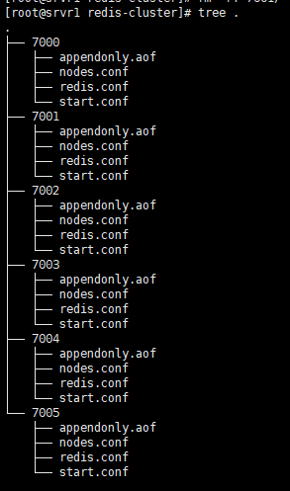

备注：
发现，启动redis，挂载的目录必须为空，否则会出现类型”该配置文件在另一个集群已经被使用”的报错
启动容器后，必须保证容器没有发生重启，因为容器二次重启会加载脚本的另一部分的替换命令，如发现有重启，清空挂载目录，重启容器

安装ubuntu创建集群
当前环境已经有了可用的镜像，直接安装使用就可以了
192.168.0.236:9001/library/ubuntu:redis
创建一个容器，如果没有打包好的镜像，那么你就需要使用官方的ubuntu镜像，然后安装一些必要的软件
apt-get update
apt-get install -y vim wget python2.7 python-pip redis-tools dnsutils
cat > /etc/apt/sources.list << EOF
deb http://mirrors.aliyun.com/ubuntu/ bionic main restricted universe multiverse
deb-src http://mirrors.aliyun.com/ubuntu/ bionic main restricted universe multiverse
deb http://mirrors.aliyun.com/ubuntu/ bionic-security main restricted universe multiverse
deb-src http://mirrors.aliyun.com/ubuntu/ bionic-security main restricted universe multiverse
deb http://mirrors.aliyun.com/ubuntu/ bionic-updates main restricted universe multiverse
deb-src http://mirrors.aliyun.com/ubuntu/ bionic-updates main restricted universe multiverse
deb http://mirrors.aliyun.com/ubuntu/ bionic-proposed main restricted universe multiverse
deb-src http://mirrors.aliyun.com/ubuntu/ bionic-proposed main restricted universe multiverse
deb http://mirrors.aliyun.com/ubuntu/ bionic-backports main restricted universe multiverse
deb-src http://mirrors.aliyun.com/ubuntu/ bionic-backports main restricted universe multiverse
EOF
pip install redis-trib
准备完成
此时nfs目录执行tree
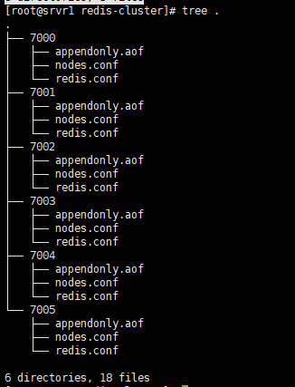
使用unbuntu创建集群
实际测试发现，不能使用service的ip，要使用pod的ip

redis-trib.py create 172.20.6.43:7000 172.20.12.107:7002 172.20.10.77:7004
redis-trib.py replicate --master-addr 172.20.6.43:7000 --slave-addr 172.20.3.80:7001
redis-trib.py replicate --master-addr 172.20.12.107:7002 --slave-addr 172.20.11.179:7003
redis-trib.py replicate --master-addr 172.20.10.77:7004 --slave-addr 172.20.8.248:7005
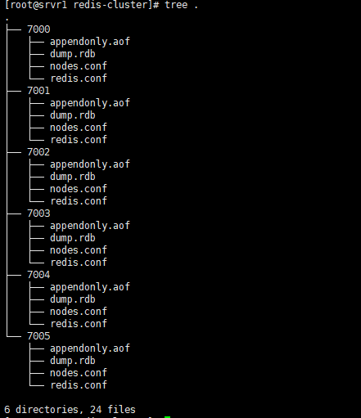

验证
查看cluster nodes
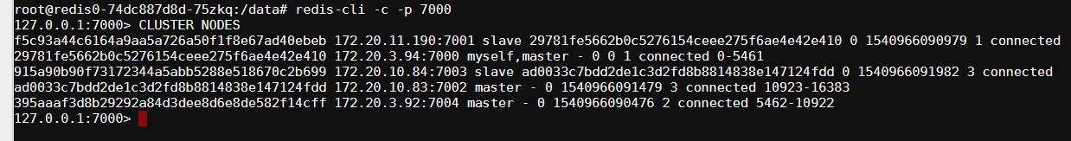
插入2条数据
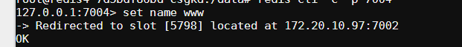然后对redis2进行重启
重启是调用脚本另一部分，见绿色部分
修改redis.conf文件 增加密码部分
替换nodes.conf文件的ip，替换6个节点
if [ -f /redis-data/${port}/start.conf ]; then
sleep 30
OLDIP=`cat /redis-data/${port}/start.conf`
echo "重启前的ip"$OLDIP
IP=$(hostname -I)
echo "重启后节点的ip："${IP}
PORT=${port} envsubst < /redis-conf/redis-cluster-auth.tmpl > /redis-data/${port}/redis.conf

sed -i "s/${OLDIP}/${IP}/g" /redis-data/7000/nodes.conf
#sed -i 's/[ ][ ]*\:/\:/g' /redis-data/7000/nodes.conf
sed -i "s/${OLDIP}/${IP}/g" /redis-data/7001/nodes.conf
sed -i "s/${OLDIP}/${IP}/g" /redis-data/7002/nodes.conf
sed -i "s/${OLDIP}/${IP}/g" /redis-data/7003/nodes.conf
sed -i "s/${OLDIP}/${IP}/g" /redis-data/7004/nodes.conf
sed -i "s/${OLDIP}/${IP}/g" /redis-data/7005/nodes.conf

sleep 30
echo '重写pod的ip到start.conf中'
echo ${IP} > /redis-data/${port}/start.conf
/usr/local/bin/redis-server /redis-data/${port}/redis.conf
fi

重启redis2之后
日志——可以看到ip已经更新
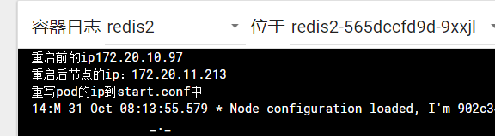
回到redis4的命令行界面
第一个红色：旧的ip已经替换成新的ip
第二个红色：不带密码，无法查询
第三个红色：查询成功
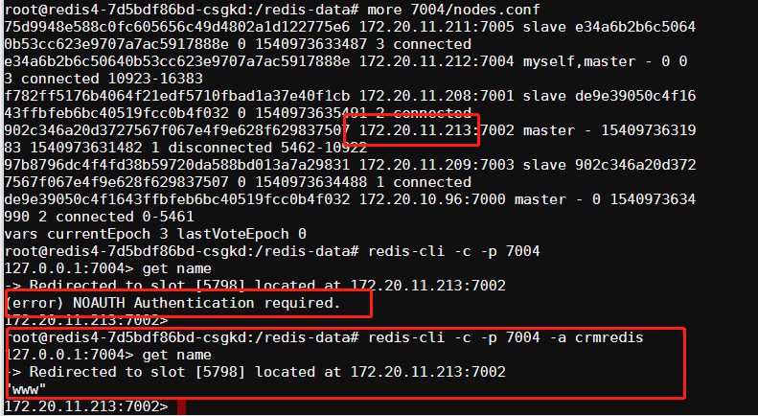
重启剩下的节点，登陆redis3
红色1：查询成功
红色2：信息ok
红色3：和上一个截图对比，除了redis2，ip都替换了
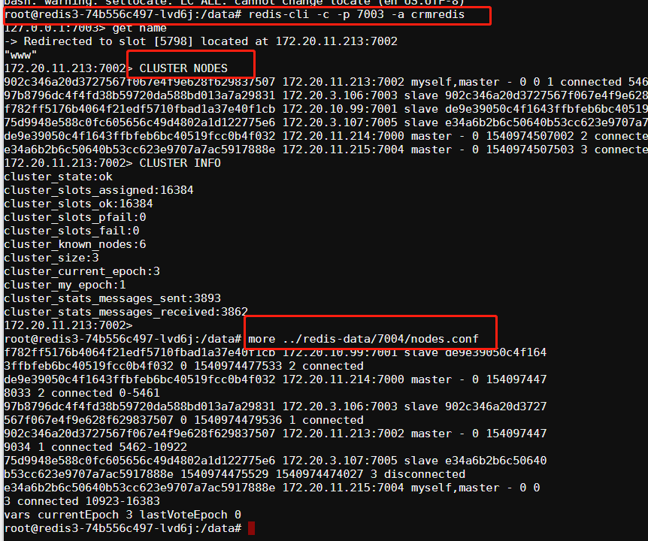
说明集群ok

