

Security Evaluation of Integrated eUICC based on PP-0117

Version 1.2

27 May 2025

Security Classification: Non-confidential
Access to and distribution of this document is restricted to the persons permitted by the security classification. This document is subject to copyright protection. This document is to be used only for the purposes for which it has been supplied and information contained in it must not be disclosed or in any other way made available, in whole or in part, to persons other than those permitted under the security classification without the prior written approval of the Association.
Copyright Notice
Copyright © 2025 GSM Association
Disclaimer
The GSM Association (“Association”) makes no representation, warranty or undertaking (express or implied) with respect to and does not accept any responsibility for, and hereby disclaims liability for the accuracy or completeness or timeliness of the information contained in this document. The information contained in this document may be subject to change without prior notice.
Compliance Notice
The information contain herein is in full compliance with the GSM Association’s antitrust compliance policy.
This Permanent Reference Document is classified by GSMA as an Industry Specification, as such it has been developed and is maintained by GSMA in accordance with the provisions set out in GSMA AA.35 - Procedures for Industry Specifications.

Table of Contents

1 Introduction 3
1.1 Overview 3
1.2 Scope 3
1.3 Definitions 3
1.4 Abbreviations 4
1.5 References 4
1.6 Conventions 5
2 Certification Process 6
2.1 Security Certification for the Integrated eUICC 6
2.2 Integrated TRE certification 6
2.2.1 Security Target Augmentation 6
2.2.2 Certification Report 7
2.2.3 Checklist to Support Compliance Verification 7
2.3 Integrated eUICC Composite Certification 7
Annex A Integrated eUICC Checklist (Informative) 8
Annex B Integrated eUICC Security Requirements (Normative) 8
Annex C Document Management 9
C.1 Document History 9
C.2 Other Information 9

Introduction

Overview
The Integrated eUICC consists of:
- An Integrated TRE: hardware sub-system within a System-on-Chip (SoC) and its low-level kernel and software services
- The eUICC OS software: executed inside the Integrated TRE hardware, is stored securely in TRE internal memories and/or in remote memories, typically the hosting device Non Volatile Memory and/or RAM.
The Integrated TRE consists of three parts:
- A kernel managing TRE hardware security functions.
- The services for communication, application management, and memory management.
- The hardware platform.
All the above mentioned parts of the Integrated eUICC have been taken into consideration in order to develop, in this document, the creation of the security certification framework for the Integrated eUICC.

Scope
This document describes the certification methodology for Integrated eUICC based on the Protection Profile PP-0117 [6] developed by Eurosmart and certified by BSI.
The certification methodology for Integrated eUICC based on the Protection Profile PP-0084 [18] is defined by SGP.08 [19].
This document covers the security certification framework for the Integrated eUICC and the process that SHALL be followed to perform the security evaluation of the Integrated eUICC that have been designed referencing GSMA PRD SGP.01 [1] and SGP.21 [9]. The associated Protection Profiles are described in GSMA PRD SGP.05 [2], and SGP.25 [10].
Integrated eUICCs assessed under these procedures are expected to be able to declare compliance to the eUICC security assurance requirements of the GSMA M2M and RSP compliance processes, respectively SGP.16 [3] and SGP.24 [11].

Definitions
Term | Description
Certification Report | Evaluation Report issued by the Certification Body to attest the certification.
EUCC | The Common Criteria based European cybersecurity certification scheme
eUICC | A removable or non-removable UICC which enables the remote and/or local management of Profiles in a secure way.  NOTE: The term originates from "embedded UICC".
Integrated eUICC | An eUICC implemented on a Tamper Resistant Element (TRE) that is integrated into a System-on-Chip (SoC), optionally making use of remote volatile/non-volatile memory (as per SGP.01 /SGP.21).
Integrated TRE | A TRE implemented inside a larger System-on-Chip (SoC)
GSMA Certification Body | Certification Body role, appointed by GSMA
Protection Profile | Implementation-independent statement of security needs for a TOE type (as per the Common Criteria methodology).
Security Target | Implementation-dependent statement of security needs for a specific identified TOE (as per the Common Criteria methodology).
Tamper Resistant Element | A security module consisting of hardware and low-level software providing resistance against software and hardware attacks, capable of securely hosting operating systems together with applications and their confidential and cryptographic data (as per SGP.01 /SGP.21).

Abbreviations
Term | Description
eSA | GSMA eUICC Security Assurance
CB | Certification Body
CC | Common Criteria
IC | Integrated Circuit
ITSEF | Information Technology Security Evaluation Facility
NVM | Non Volatile Memory
OS | Operating System
RAM | Random Access Memory
RMPF | Remote Memory Protection Function
SFR | Security Functional Requirement
SoC | System-on-Chip
SOG-IS | Senior Officials Group Information Systems Security
ST | Security Target
TOE | Target of Evaluation
TRE | Tamper Resistant Element
3S | Secure Subsystem in SoC

References
Ref | Doc Number | Title
 | SGP.01 | Embedded SIM Remote Provisioning Architecture
 | SGP.05 | Embedded UICC Protection Profile
 | SGP.16 | M2M Compliance Process
 | GSMA PRD AA.35 | Procedures for Industry Specifications
 | RFC2119 | “Key words for use in RFCs to Indicate Requirement Levels,” S. Bradner  http://www.ietf.org/rfc/rfc2119.txt
 | PP-0117 | Secure Sub-System in System-on-Chip (3S in SoC) Protection Profile, Version:  - v1.5 - BSI-CC-PP-0117-2022  - v1.8 – BSI-CC-PP-0117-v2-2023  References to [6] in this PP may be interpreted as any of the two versions of this document.  References to [6] version 1.8 (BSI-CC-PP-0117-v2-2023) shall be interpreted as only the version 1.8 (BSI-CC-PP-0117-v2-2023) of the document.
 | PP-0089 | BSI-CC-PP-0089-2015  Embedded UICC Protection Profile Version 1.1 / 25.08.2015, certified by Bundesamt fur Sicherheit in der Informationstechnik (BSI)
 | JIL-CCCE | Joint Interpretation Library  Composite product evaluation for Smart Cards and similar devices  Version 1.5.1 May 2018
 | SGP.21 | RSP Architecture
 | SGP.25 | eUICC for Consumer and IoT Devices Protection Profile
 | SGP.24 | RSP Compliance Process
 | PP-0100 | BSI-CC-PP-0100-2018
 | NIST SP 800-108 | Recommendation for Key Derivation Using Pseudorandom Functions
 | BSI TR-02102-1 | Cryptographic Mechanisms: Recommendations and Key Lengths
 | ANSSI RGS v2 B1 | Référentiel Général de Sécurité version 2.0 Annexe B1
 | NIST SP 800-175B | Guideline for Using Cryptographic Standards in the Federal Government: Cryptographic Mechanisms
 | NIST SP 800-53r4 | Security and Privacy Controls for Federal Information Systems and Organisations – Revision 4
 | PP-0084 | BSI-CC-PP-0084-2014  Security IC Platform Protection Profile with Augmentation Packages, Version 1.0, Eurosmart 2014, certified by Bundesamt fur Sicherheit in der Informationstechnik (BSI)
 | SGP.08 | Security Evaluation of Integrated eUICC based on PP-0084

Conventions
“The key words “MUST”, “MUST NOT”, “REQUIRED”, “SHALL”, “SHALL NOT”, “SHOULD”, “SHOULD NOT”, “RECOMMENDED”, “MAY”, and “OPTIONAL” in this document are to be interpreted as described in RFC2119 [5].”

Certification Process

Security Certification for the Integrated eUICC
In order to achieve the security certification of an Integrated eUICC, the process described in the following steps SHALL be executed:
1. Security certification of the Integrated TRE SHALL be obtained either with GSMA eSA or with a SOG-IS CC (EUCC) CB in the domain of ‘smartcard and similar devices’ according to PP-0117 [6] and a Security Target with the additional security requirements defined in Annex B.
2. Composite certification of the Integrated eUICC SHALL be done:
- Based on the Integrated TRE certified with the SOG-IS CC (EUCC) or the GSMA eSA CB, and
- According to either:
  - PP-0089 [7] or SGP.05 [2] using the assurance schemes authorised in SGP.16 [3]
  - PP-0100 [12] or SGP.25 [10] using the assurance schemes authorised in SGP.24 [11]
The validation of the Integrated eUICC integration into the device is out of the scope of this document.

Integrated TRE certification

Security Target Augmentation
The Integrated TRE Security Target SHALL claim compliance to the PP-0117 [6] and the additional security requirements defined in Annex B.

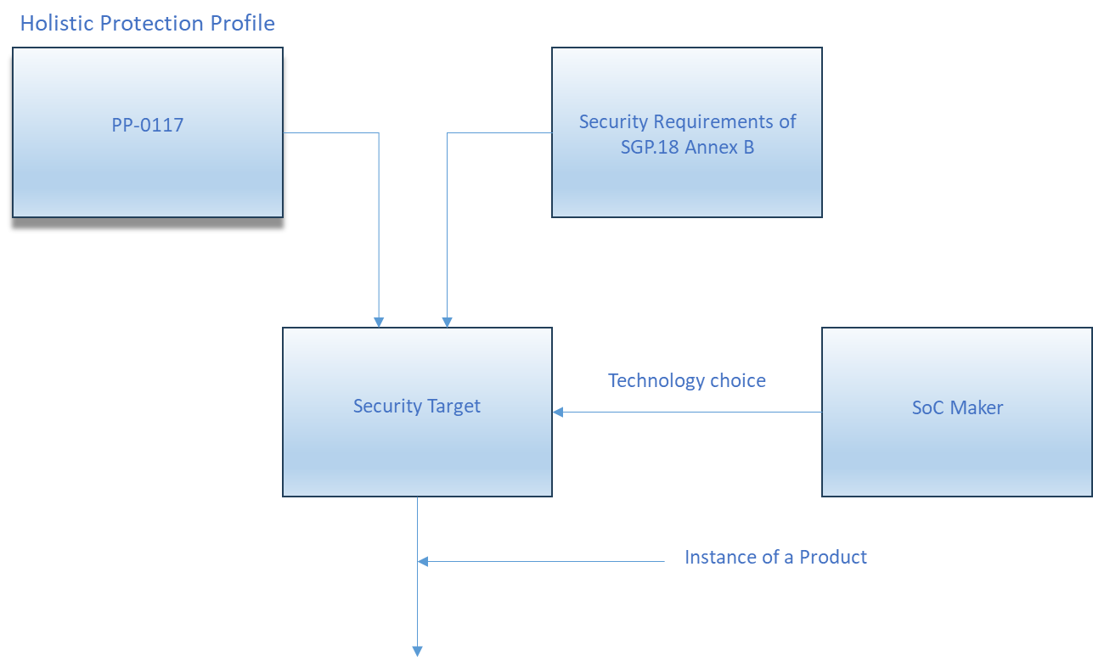
- Security Target for the Integrated eUICC TRE

Certification Report
The Certification Report SHALL attest that the evaluation of the integrated eUICC has been performed in compliance to the PP-0117 [6] .

Checklist to Support Compliance Verification

The SoC maker SHALL produce a checklist, as detailed in Annex A, that provides evidence that all requirements from Annex B have been taken into account during the definition of the Security Target.
This checklist SHALL be used during the Integrated eUICC security evaluation.

Integrated eUICC Composite Certification
The Integrated eUICC Security Target SHALL comply with the security objectives and requirements as defined in the Protection Profile SGP.05 [2] or SGP.25 [10].
The evaluation of the eUICC running on the Integrated TRE SHALL be handled through the Composite Evaluation framework (see JIL-CCCE [8]).

- Integrated eUICC Checklist (Informative)
The mandatory fields are Requirement from Annex B and “Covered”. The Field “Security Target” is mandatory when the Security Target is public.
NOTE: The Security Target column needs to be filled with the reference of the Security Target Objective / Requirement or a rationale explaining why this requirement was considered out of scope.
Requirement | Description | Covered (Yes/No) | Security Target (see Note) | Comments
Example:  SEC1 | Example:  TRE-unique seed(s) used by the RMPF SHALL be generated inside the TRE..
- Integrated eUICC Security Requirements (Normative)

Req no. | Description
Cryptographic Keys Requirements
SEC1 | TRE-unique seed(s) used by the RMPF SHALL be generated inside the TRE.
SEC2 | The entropy of the TRE-unique seed(s) used by the RMPF SHALL be at least 256 bits.
SEC3 | Randomly generated keys used by the RMPF SHALL be at least 256 bits.
SEC4 | The key derivation mechanism used by the RMPF SHALL be compliant with NIST SP 800-108 [13] and SHALL use:  - a block cipher with security strength equivalent to or greater than AES-256, or  - a hash function with security strength equivalent to or greater than SHA-256,
Confidentiality Requirements
SEC5 | The RMPF SHALL provide confidentiality based on encryption using a cipher with security strength equivalent to, or greater than AES-256 and using a suitable mode of operation approved by NIST in NIST SP 800-175B [16] [17] or recommended by BSI in BSI TR-02102-1 [14] or recommended by ANSSI RGS v2 B1 [15].
Integrity and Authenticity
SEC6 | The RMPF SHALL use a cryptographic integrity mechanism with security strength equivalent to, or greater than SHA-256.
SEC7 | The RMPF SHALL provide authentication using a MAC of at least 128 bits based  - on a block cipher using a cipher with security strength equivalent to or greater than AES-256, or  - on a hash function with security strength equivalent to or greater than SHA-256,  and using a mode of operation approved by NIST in NIST SP 800-175B [16] or recommended by BSI in BSI TR-02102-1 [14] or recommended by ANSSI RGS v2 B1 [15].
SEC8 | SEC5 and SEC7 MAY also be provided in combination by an authenticated encryption mode fulfilling both requirements.
- Document Management
  - Document History
Version | Date | Brief Description of Change | Approval Authority | Editor / Company
V1.0 | 19/09/2022 | CR0001R01 – SGP.18 v1.0 Adoption of PP-0117 (3S PP) | ISAG | Gloria Trujillo, GSMA
V1.0.1 | 02/01/2024 | Correction of broken references and minor editorials | eSIMWG5 | Gloria Trujillo, GSMA
V1.1 | 04/06/2024 | CR0002R02 - Update of PP0117 reference | eSIMWG5 | Gloria Trujillo, GSMA
V1.2 | 27/05/2025 | CR0003R01 - Add eSA for iTRE in SGP.18 | ISAG | Gloria Trujillo, GSMA
  - Other Information
Type | Description
Document Owner | eSIMWG
Editor / Company | Gloria Trujillo, GSMA

It is our intention to provide a quality product for your use. If you find any errors or omissions, please contact us with your comments. You may notify us at prd@gsma.com
Your comments or suggestions & questions are always welcome.

