Dear Editors,

Thanks for your mail attached with reports on our manuscript (XW10449B).

We appreciate the time and effort that you and the referees dedicated to providing feedback on our manuscript and are grateful for the insightful comments on and valuable improvements to our paper. We have incorporated most of the suggestions made by the referees. We sincerely hope that now both referees will find satisfactory in this version and recommend it for publication in PRB.

The replies to the questions raised by the referees and the main changes in the manuscript following the referees’ suggestions are listed below.

Best wishes,

Shi Wang, Zhongyuan Qi, Bin Xi, Wei Wang, Shun-Li Yu, and Jian-Xin Li

*********************************************************************

Main changes:

Main text:

In the “C. Classical Monte Carlo Method” sub-section in the revised manuscript, we include a brief introduction to the over-relaxation Monte Carlo method.

At the end of the fifth paragraph of sub-section “A. Global Phase Diagram” in the revised manuscript, we add a sentence “The difference between stripe-A, stripe-B and stripe-C lies in that they have different moment directions, which we will discuss in detail later”.

In the “B. FM Phases” sub-section in the revised manuscript, we add a paragraph about the order parameters of these magnetically ordered phases.Appendix:

We add a new appendix section “Appendix B: The effects of system size on the phase boundaries” in the revised manuscript to discuss the effects of system size.

Figures:

In the revised manuscript, we redraw Fig. 4(i) to explicitly mark the characteristic wave vectors for the FM, stripe, 120° Néel and dual Néel phases. The caption for Fig. 4(i) is changed from “Characteristic wave vectors for the FM and stripe phases” to “Characteristic wave vectors for the FM (blue circle), stripe (orange square), 120° Néel (red up-triangle) and dual Néel (purple down-triangle) phases”.

Following the referee’s suggestion, we redraw Fig. 8 with both vertical scales of the energy and of the second derivations are given.

Following the referee’s suggestion, we delete the point sites in Fig. 11, Fig. 12 and Fig. 12 for clarity (In previous version, Fig. 10, Fig. 11 and Fig.12).

Response to the referee A:

We thank the referee very much for his/her valuable comments and suggestions, which is very helpful for us to improve this manuscript. Following is our reply to the referee’s report.

1. Since the heat-bath method is explained, a few words about the over-relaxation MC method is also needed, just for the sake of self-containment and self-consistency.

We thank the referee for suggesting us to include an introduction to the over-relaxation MC method. We have added an explanation of the over-relaxation sampling in the section of the introduction of the classical Monte Carlo method.

1. What is the effect of an asymmetric system for the ED calculations? Phases which break a real-space symmetry (such as stripes) may have different GS energy in asymmetric cluster when compared to asymmetric one. Does it bias towards a stripe phase? Comments should be given in the main text.

To clarify the effect of asymmetry for the ED calculations, we also perform ED calculations on a 4×4 cluster with periodic boundary condition, which is more symmetric than the 4×6 cluster used in the paper. The per-site ground state energy for both 4×4 (blue solid lines) and 4×6 (orange dashed lines) clusters as well as the difference (green solid lines) between them are shown in Fig. 1. When the model parameters are located at the FM or stripe phases, the relative difference is very small which may originate from the finite-size effect, i.e., the 4×4 and 4×6 clusters have different system sizes. Both 4×4 and 4×6 clusters with periodic boundary condition are compatible with FM and stripe magnetic orders, so the asymmetric 4×6 cluster does not bias towards a stripe phase in our ED calculations. In addition, the 4×6 cluster is compatible with the 120° Néel and dual Néel order at least in one direction, however, the 4×4 cluster is incompatible with the 120° Néel and dual Néel order in any directions. In Fig. 2, we show the GS energies and their second derivatives versus β with α fixed to 0.3π, 0.5π and 0.75π. When α = 0.3π and α = 0.75π, the results for both 4×6 and 4×4 clusters are qualitatively consistent, i.e., the singularities corresponding to the quantum phase transitions are in one-to-one correspondence, see Fig. 2(a), 2(d) and Fig. 2(c), 2(f). However, when α = 0.5π, the results for 4×6 and 4×4 clusters are different. For the 4×6 cluster, there are singularities at β = 0.234π and β = 1.9π (indicated by black arrow in Fig. 2(b)) which reveal the phase transitions from Stripe-B to 120° Néel and from dual Néel to Stripe-B. On the other hand, for the 4×4 cluster, we can’t see these singularities. This is owning to the incompatibility between the 4×4 cluster and the magnetic orders. As for the other three peaks in both Fig. 2(b) and 2(e), they correspond one to one. In a word, under the premise that the current computing power allows, the asymmetric 4×6 cluster is better than the symmetric 4×4 cluster.

FIG. 1. Per-site ground state energies for 4×4 and 4×6 clusters. The abbreviations “STA”, “STB”, “STC” and “MS” correspond to stripe-A, stripe-B, stripe-C and modulated stripe, respectively. The vertical gray dashed lines mark the phase transitions. (a) - (c) The model parameter α is fixed to 0.3π, 0.5π and 0.75π, respectively.

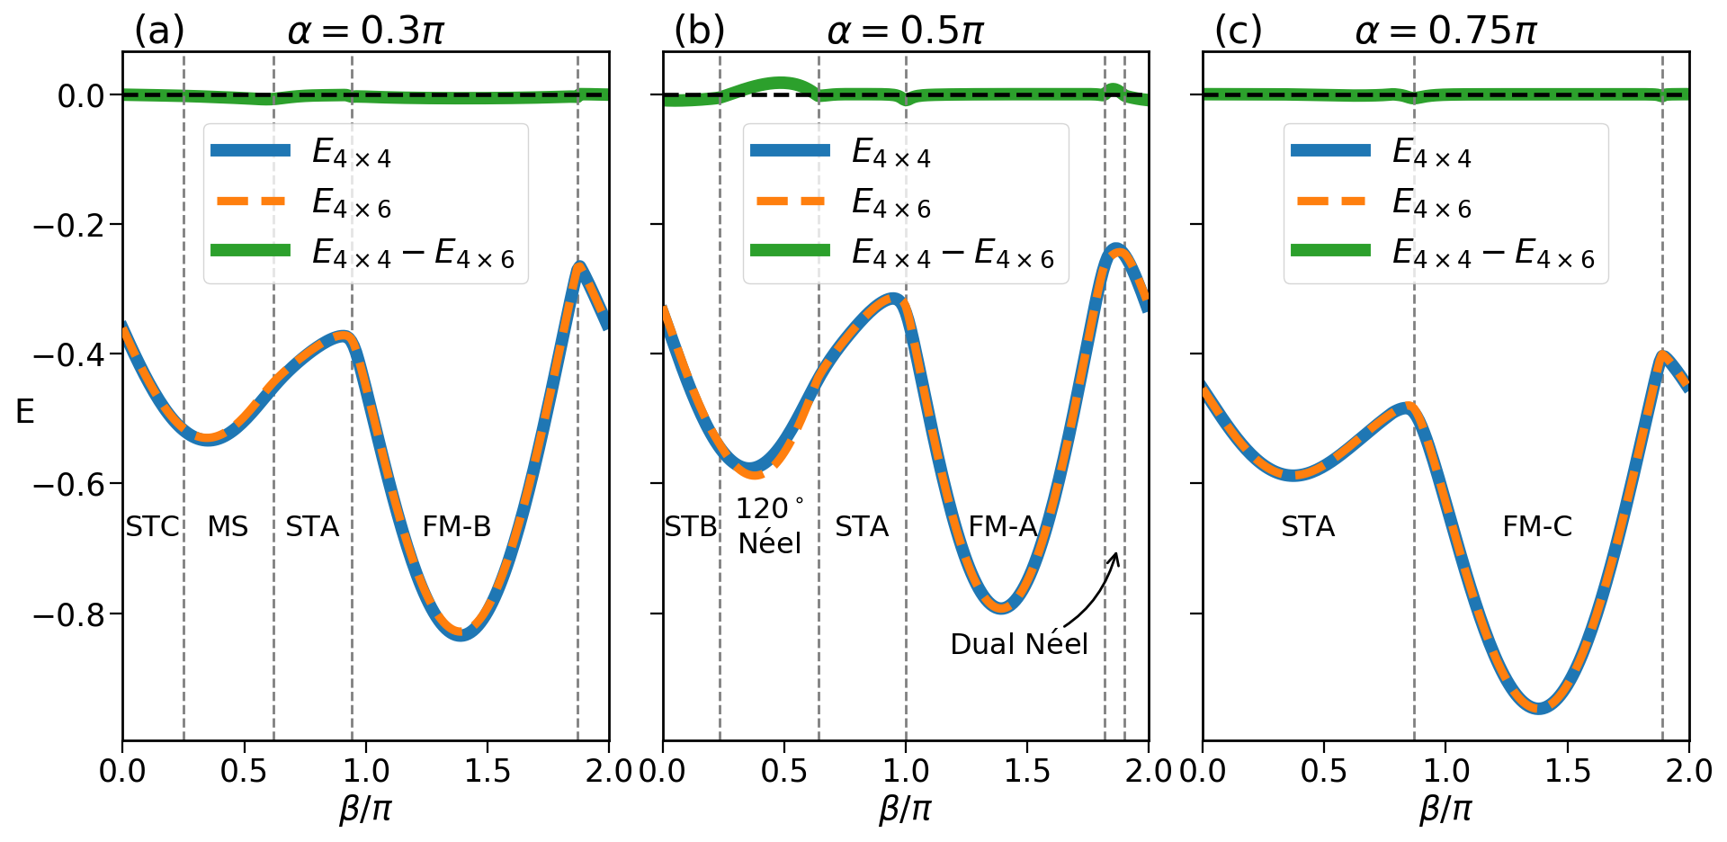

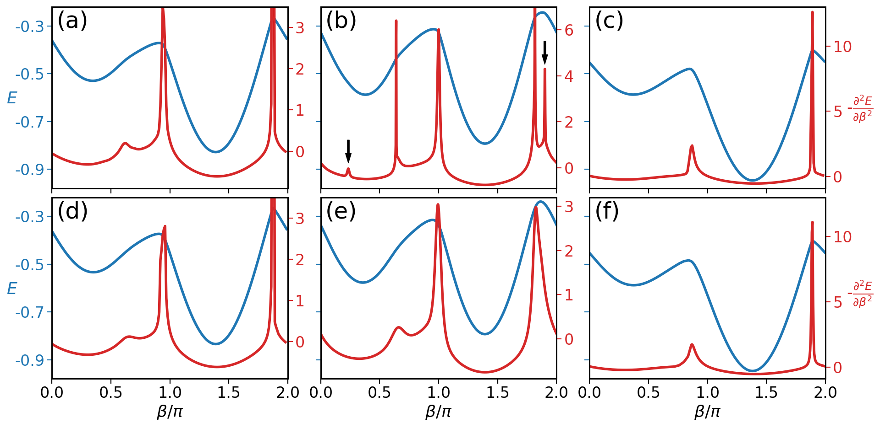

FIG. 2. GS energies and their second derivatives versus β with α fixed to 0.3π, 0.5π and 0.75π. The blue lines are the GS energies and the red lines are the second derivatives. (a) - (c) ED calculations are performed on a 4×6 cluster and α equals to 0.3π, 0.5π and 0.75π, respectively. (d) - (f) ED calculations are performed on a 4×4 cluster and α equals to 0.3π, 0.5π and 0.75π, respectively.

1. In Sec. 3A and in the caption of Fig. 2, use a more precise description. What is a quantum phase diagram? Is it the zero-T phase diagram or the finite-T phase diagram for the case of quantum spins? What are the triangles in Fig. 4(i)?

We are very grateful to the referee for pointing out these imprecise descriptions. The phase diagram we obtained is the ground state phase diagram, i.e., the zero-temperature phase diagram. In the main text, we change the description from “quantum phase diagram” to “zero-temperature quantum phase diagram”.

The red triangles in Fig. 4(i) mark the characteristic wave vectors for the 120° Néel order. In this version, we redraw Fig. 4(i) to explicitly mark the characteristic wave vectors for all of the magnetically ordered phases and add descriptions in the caption. See the main text for details.

1. In fig. 8, the ideal is that both vertical scales of the energy and of the second derivative are given. In the current version, it seems that the range of the former is small.

Following the referee’s nice suggestion, we redraw Fig. 8 with both vertical scales of the energy and of the second derivations are given.

1. Although the whole analysis is somewhat convincing, there is no consistent study on the second derivatives presented in Fig. 8. Could the authors state their findings of the peaks when compared to smaller systems? Is the finite-size effect consistent with a non-analyticity?

Following the referee’s suggestion, we carry out the ED calculations on a 2×6 cluster with periodic boundary condition to study the finite-size effect on the phase diagram. We find that all the peaks of the second derivatives appearing for the 4×6 cluster also exist for the 2×6 cluster. The results for different system size are consistent with only slightly shifted of the phase boundaries. To address this problem more clearly, we have added a new section in the appendix (Appendix B) to present the results for the 2×6 cluster.

1. The arrows are hard to read in Figs. 10 and 12. Maybe, for clarity, the point sites (which are not necessary) may be dropped out.

Following the referee’s nice suggestion, we delete the point sites in Fig. 11, Fig. 12 and Fig. 12 for clarity (In previous version, Fig. 10, Fig. 11 and Fig.12).

1. I find it important to precisely define the phases found here. What is the order parameter (nematic, stripe, etc)? The ordering vector?

The order parameter of FM, stripe, 120° Néel and dual Néel states can be defined as , where |Ω> is the ground state and ***Q*** is the characteristic wave vector of these magnetically ordered states. However, since the cluster ground state does not spontaneously break the symmetry and corresponds to a superposition of all possible degenerate orderings, the calculated ground state average may give no useful information. In our paper, we instead calculated the static structure factors to identify the wave vectors of these ordered phases. For these phases with the same type of classical orders, they have the same characteristic wave vectors. We can’t distinguish them only from static structure factors. By a combination of classical analysis and extract the moment direction of these magnetically ordered states from our ED cluster ground states, we clarify the phase transitions between these phases.

1. I could not see the difference between the SSF of Figs. 4(a), (b), and (d), which are reported to be in different phases. It is only mentioned that these phases are different due to distinct peaks at the M points. I find this vague and confusing. Only much later in the text, different arguments are provided in order to clarify this point. Probably the authors should point out that further arguments will be provided. (Maybe with the clarifications of criticism 7 will help here.)

Stripe-A (correspond to Fig. 4(b) and 4(c) in the main text), Stripe-B (correspond to Fig. 4(a) in the main text) and Stripe-C (correspond to Fig. 4(d) in the main text) have the same type of classical order, *i.e.,* stripe order, so they has the same characteristic wave vector and the calculated static structure factors are similar. The main difference between them is that they have different moment direction which has been discussed in sub-section “C. Stripe Phases” in the main text.

Following the referee’s suggestion, we made some changes to our paper, see the main text for detail.

Response to the referee B:

We thank the referee very much for his/her valuable comments and suggestions, which is very helpful for us to improve this manuscript. Following is our reply to the referee’s report.

An optional question is about the QSL phase. The claim that the observed QSL is a Z2 gapped spin liquid is rather weak. DSF is not a critical information for the determination. Can the authors do a parton mean-field theory calculation for this phase?

We have to admit that the referee’s criticism is justified, our proposal that the green area in the zero-temperature global phase diagram is a Z2 gapped spin liquid is weak. Parton mean-field theory calculation may provide further evidence for our proposal. However, this is beyond the main focus of this paper. As for the physical properties of that quantum phase, detailed investigations, such parton mean-field theory calculation, DMRG study, *etc.,* may be carried out in a separated paper.