----------------------------------------------------------------------

Report of Referee A -- LH16575/Zhu

----------------------------------------------------------------------

 This work reports the results of an experimental study of K doping of 1T-TaS2 surface, which leads to gradual suppression of the Mott gap while the CDW order is preserved, supplemented by a theoretical CPT study of the spectra of the doped Hubbard model with one site (in each finite cluster) having a reduced Hubbard parameter U. This calculation produces a spectrum with additional weight just above LHB, despite the fact that the system is electron doped, thus a peak just below UHB would be expected instead.

I think the work is timely, the question addressed is important, and the results being reported represent a significant advance. The persistence of the CDW order is a particularly nice feature of this setup.

**Re:** We thank the reviewer for giving the very positive comment. Below please find our point-to-point response to the questions. We wish our response is sufficient and satisfactory, and the revised manuscript is suitable to be published.

Before I can recommend this work for publication, the authors should however address the following concerns:

1. What exactly happens with the electron upon K deposition? In the standard picture, any finite charge doping of the correlated band will metalize the Mott insulator. This is not the case here and a rather large concentration of K atoms is required. The authors seem to suggest that the electrons are "trapped by surface impurities". But what surface impurities are those? Is their concentration sufficient, taking into account the significant K coverages necessary to bring about the transition?

**Re:** We thank the reviewer to bring out this concern so that we have the chance to address it more clearly.

The topmost layer of the TaS2 surface is a layer of S atoms, and underneath it is the Ta conduction layer. When deposited on the TaS2 surface, the K atoms are absorbed on the S atomic layer. In fact, only a fraction of the doping electrons from K atoms is transferred to the Ta conduction layer. So, the effective doping to the Mott insulator is less than the concentration of the deposited K atoms.

A charge doping to the Mott insulator will induce an additional excitation in the Mott gap locally, and in this case the system is not metalized. With the increase of doping amount, the spectral weight of the additional excitation increases and extends over the Mott gap. Until the whole Mott gap is filled up by these in-gap excitations, the system becomes metallic.

What we meant in the manuscript is that "the electrons are trapped by surface impurities" happens only at the initial stage of K deposition. In this stage, we observe no identifiable change in the dI/dV curve. To understand this phenomenon, we propose that the small amount of K electrons are trapped by surface impurities. These impurities are the intrinsic defects simultaneously formed during the crystal growth, as shown below in Fig. R1.Their concentration is typically ~0.008 ML, much lower than the explored K coverage of up to ~0.4 ML. So, the statement that "the electrons are trapped by surface impurities" is ***only*** used to explain the unchanged dI/dV at the very beginning of deposition. Such low concentration of impurities can only trap a very small amount of electrons. After this stage, the electrons dope the Mott insulator effectively by transferring to the correlated band, because the additional excitation starts to appear in the dI/dV curves.

To avoid the misunderstanding of the context and clarify that the surface impurities only impact at the initial deposition, we revised the manuscript. See **Summary of changes made**(8).

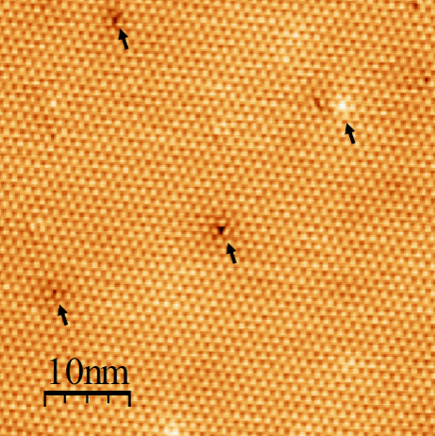

**Figure R1.** STM image (50×50 nm2) of the clean surface of 1T-TaS2.*U* = +1.0 V, *I*t = 100 pA. The black spots as marked by the arrows represent the intrinsic surface impurities formed during the crystal growth.

2. Related to above: The arguments for reduced U on the sites where K is absorbed is not very clear. In particular, I don't understand what the authors mean by "the electron concentration for the David stars with K+ ions is larger than those without K+ ions due to the Coulomb attraction of the positive charge of K+". If the system is a Mott insulator, the charge on each site should be exactly 1 (in the correlated band). Is this not the case? If the charge in the correlated band is 1, then to which other band is the additional charge transferred? Also, this assumption is in contradiction with the scenario of charge transfer to surface impurities. Which of the two possibilities is then the relevant one?Or could it be that the physics is more complex than simply charge transfer from K to 1T-TaS2? But if so, the model in Eq. (1) is probably inadequate and the interpretation of the results is not correct.

**Re:**Because the electrons are lost, the adsorbed K+ ions have net positive charges, so the additional attractive interaction provided by the K+ ions can counteract the repulsive interaction between electrons on the sites where the K+ ions are absorbed. This is equivalent to the reduction of the effective on-site repulsion *U* for the David stars with K+ ions. Because of the reduced *U*, it is more favorable in energy for the doping electrons to occupy the David stars with K+ ions. Therefore, the electron concentration for the David stars with K+ ions is larger than those without K+ ions.

Only in the case of half-filling, the charge on each site can be exactly 1 in a Mott insulator. However, upon doping, some sites will be doubly occupied with 2 electrons locally in real space. In a Mott insulator, the LHB denotes the band for single occupation and the UHB for double occupation, with the Mott gap in between. At half-filling, the LHB is fully occupied and the UHB is empty. When the Mott insulator is doped with extra electrons, both the possibilities of removing electrons from the LHB and adding electrons to the UHB are reduced, and the reduced spectral weights form additional excitations in the Mott gap(in-gap state). Therefore, the doping electrons will transfer to the in-gap state. Only when the in-gap states extend over the whole Mott gap by a sufficient amount of doping electrons, does the transition from Mott insulator to metal occur.

As we replied to the question 1), at the initial stage for a very small K coverage, the K electrons are trapped by surface impurities and very few are transferred into the conduction layer. It basically corresponds to the case that the Mott insulator is still at half-filling. After this stage, additional excitations start to appear in the Mott gap (not yet metallized), and the K deposition corresponds to the effective doping to the Mott insulator (in the correlated band).

The theoretical model we proposed can qualitatively reproduce our experimental results, therefore we believe it should be adequate to interpret the related physics.

3. There is a very prominent reduction of the amplitude of the UHB with increasing K coverage. What is its origin? Can the proposed theoretical model explain this trend?

**Re:**Our theoretical model can qualitatively explain this trend.The UHB corresponds to the double occupation of a site, which will lead to an increase in energy of *U* in comparison with the single occupation. In our site-dependent Hubbard model, the reduced effective interaction *U* for the David stars with K+ ions makes the energy cost for double occupancy very small, and thus most spectral weights are transferred to the low-energy part. Furthermore, the coupling between the David stars will also lead to the reduction of the amplitude of the UHB in those David stars without K+ ions.

In calculations, this trend can be manifested through comparing the numerical integral (*ρ*) of the spectral weightfor *ω*>0 and *ω*<0. At half-filling, the numerical integral *ρ* equals to 1 for both *ω*>0 and *ω*<0. However, in the case of K deposition, for the David stars with K+ ions, the calculated *ρ* for*ω*>0 (*ω*<0) is 0.18 (1.92), and for the David stars without K+ ions, the calculated *ρ* for*ω*>0 (*ω*<0) is 0.97 (1.03). For both of the two cases, the *ρ* value for*ω*>0 is smaller than 1, indicating that the spectral weight is transferred to low-energy part and the amplitude of UHB is reduced.

4. What exactly is plotted in Fig. 2(a)? Are these averaged spectra? Over how many spatial points? How are the points chosen? How strong are the spectrum to spectrum fluctuations (maybe show some full data sets in the supplementary)?

**Re:**The spectra plotted in Fig. 2(a) are not averaged. They are all the single-point data taken at the center of the David star. We purposely collected all the data at exactly the same position in the David star,to make a scientifically meaningful comparison among different K coverages. The spectra are uniform in the local scanned area. We plot some of the raw data in Fig. R2 for reference. The spectrum to spectrum fluctuations are reflected in the statistic results of Fig. 2(c).

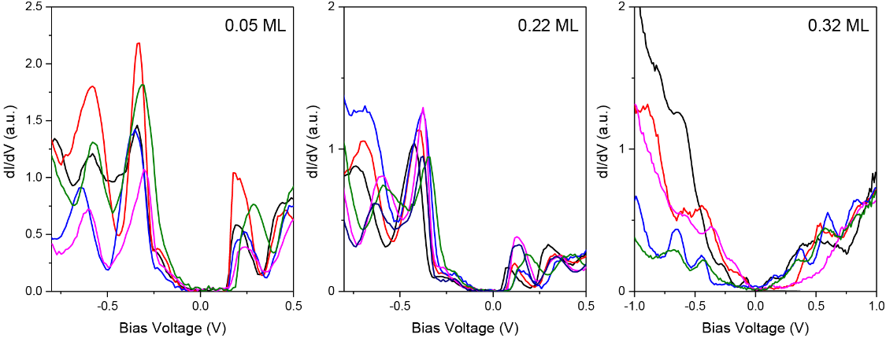

**Figure R2.**Some raw data of dI/dV spectra taken at K doped 1T-TaS2 surface. The K coverage is 0.05 ML (left), 0.22 ML (middle), and 0.32 ML (right), respectively.

5. Related to the above: How does the dI/dV curve change as a function of the distance from any given K adatom?

**Re:**In our experiments, we didn’t find the identifiable dependence of the dI/dV curves on the distance from the K adatom. In addition, we didn’t take any data in the David stars with adsorbed K+ ions, to avoid the interactions between STM tip and the K+ ions.

6. What is the occupancy for the spectral functions shown in Fig. 4(b)?

**Re:**The dotted blue line in Fig. 4(b) corresponds to the hall-filled system, and both of the dashed red and solid black lines correspond to the system with 1/13 electron doping. The spectra for *ω*<0 are the occupancy by electrons.

7. Why is the K atom adsorbed preferentially on the alpha site (the top of the David star)?

**Re:** According to our experimental results, we find that the K atoms are preferentially adsorbed on the alpha site (the top of the David star), as shown in Fig. 3 in the manuscript. We guess this preference results from the site-dependent adsorption energy of K. The first-principle DFT calculation should be useful to prove this assumption, which is however out of the focus of this study.

8. It would be of interest to readers to know more details about the doping procedure. At what temperature does the evaporation proceed? Are there any annealing steps following the deposition? How strongly do the atoms bind on the surface (do they spontaneously move at the given T, can they be controllably manipulated to different positions)?

**Re:**We thank the reviewer for this comment. In the revised manuscript, we added the detailed description of method. See **Summary of changes made**(5).

9. The authors should mention that their work is premised on the assumption that the insulating state in 1T-TaS2 is due to Mott gap opening in the narrow band crossing the Fermi level, and the assumption that the physics in essentially 2D. There is actually no consensus on this key questions and there are proposals that the metal-insulator transition is related to stacking order changes because of the strong inter-layer coupling [see e.g. the recent work PRL 112, 106404 (2019), although this has been discussed earlier].

**Re:**We thank the reviewer for this valuable suggestion and added these sentences in the revised manuscript. See **Summary of changes made**(9).

I will make my final assessment of this work after these questions are answered.

----------------------------------------------------------------------

Report of Referee B -- LH16575/Zhu

----------------------------------------------------------------------

 This work reports on the interesting experimental observation that thelow-temperature CDW of 1T-TaS2 can coexist with metallization producedby surface doping with K+ ions. The authors also provide a theoreticaljustification based on a site-dependent Hubbard model and clusterperturbation theory for the calculation of the electronic localdensity of states. In view of the broad interest in the still elusivenature of Mott transitions in CDW systems like 1T-TaS2, as welldocumented by the papers quoted in the introduction, I believe thispaper has enough novelty and importance for being considered for PRL.

**Re:** We thank the reviewer for giving the very positive comment. Below please find our point-to-point response to the questions. We wish our response is sufficient and satisfactory, and the revised manuscript is suitable to be published.

There are a few unclear sentences which need to be reworded, and a fewquestions that the authors should consider and possibly revise themanuscript accordingly. They are listed below:

- Abstract: “Mott insulator-metal transition in 1T-TaS2 is generallyinitiated at the domain boundary of charge density wave (CDW), at theexpense of its long-range order.” Is this a general statement, or doesit refer to a specific property of 1T-TaS2?

- Text, page 1, column 1, line 2: “a unique”

- lines 3,4: I suppose you mean “…of a Mott insulator…” and “…with acommensurate…”

- column 2, line 16: “persisting”?

- page 2, col. 1, line 8,9: “was deposited in situ onto”

- page 2, col. 1, line 7 from bottom: does the expression “Thecentered Ta” mean that the Ta atoms sit at the center of approximate Soctahedra? In this case the sentence “The Ta atoms sit at the centerof approximate S octahedra” would be clearer. But there are 3inequivalent Ta atoms in the 1313 structure, with two of them in siteswith no inversion symmetry. Thus they might not be exactly at theoctahedron center.

- page 2, col. 2: “The dI/dV spectrum…”; “… identified as the peaksmarked…”

**Re:** We very appreciate the reviewer’s careful reading. In the revised manuscript, we have corrected all of these errors as marked by red in the text. See **Summary of changes made** (1)-(3), (6), and (7).

An important clarification is needed at pages 2-3. The abscissa scaleof Fig. 2(a) should conveniently start from -0.9 V in order toconvince the reader that the CDW gap persists also for K coverages >0.1. The LHB peak for 0.32 (brown line) and negative voltage is notevident, nor any CDW gap can be inferred from this panel; one has tobelieve in panel (c), where the Mott and CDW data points above 0.35have a very small error bar! Is it so? This needs a clarification,consistently with the good evidence of CDW order persistence asappears from Fig. 3(d).

**Re:** We thank the reviewer for pointing it out. In the revised Fig. 2, we enlarged the abscissa scale to include the CDW peaks. The plot for 0.32 ML was replaced by a new one taken in a larger bias-range, and the CDW gap can be identified. As for the statistics of the Mott and CDW data points above 0.35, we included the data in which the peaks are distinguishable. Thedata in which the peaks cannot be precisely determined because of the broadening were not included in the statistics. See **Summary of changes made** (10).

A general question concerns the role of the electron-phononinteraction, which is normally ignored in many recent papersdiscussing the nature of the CDW in 1T-TaS2, although amass-enhancement factor of 1 has been reported for this material, anda large electron-phonon coupling has been demonstrated in the earlynineties with Helium-atom scattering measurements of the surfacephonon dispersion curves. The authors may have something (optional) toadd about this issue.

**Re:** We thank the reviewer for this valuable suggestion. In the revised manuscript, we added the sentence in the introduction part. See **Summary of changes made** (4).

**Summary of changes made**

1. In title, abstract and context, “persisted” is changed to “persisting”.
2. In abstract, 1stline, “Mott insulator-metal transition in 1*T*-TaS2…” is changed to “Metallization of 1*T*-TaS2…”
3. Page 1, left column, 1st paragraph,
   1. “as an unique” is changed to “as a unique”.
   2. “ground state of Mott insulator … with commensurate charge density wave (CDW)” is changed to “ground state of a Mott insulator… with a commensurate charge density wave (CDW)”.
4. Page 1, left column, 1st paragraph, the sentence of “, and a large electron-phonon coupling has been demonstrated in 1*T*-TaS2 which may be associated with the formation of the CDW state [7,8]” is added.
5. Page 2, left column, 2nd paragraph, more details are added, as “The sample was kept at ~4.2 K and then quickly transferred to the evaporation chamber prior to K deposition…Due to the strong enough bonding to the 1*T*-TaS2 surface, the K atoms are static during normal scan”.
6. Page 2, left column, 3rd paragraph, “The centered Ta atom is surrounded by six S atoms, forming an approximate octahedron” is changed to “In the normal state, the Ta atoms sit at the center of approximate S octahedra.”
7. Page 2, left column, 4th paragraph,
   1. “dI/dV spectrum” is changed to “The dI/dV spectrum”.
   2. “as the peaks as marked” is changed to “as the peaks marked”.
8. Page 2, left column, 5th paragraph,
   1. “as exemplified by the plot of 0.05 ML in Fig. 2(a)” is added.
   2. “trapped by the surface impurities” is changed to “trapped by the surface impurities for a small amount of K deposition”.
   3. “e.g., from 0.08 ML on in Fig. 2(a)” is added.
   4. “indicating that the K electrons dope the Mott insulator effectively. An important feature is that these additional excitations are close to the LHB” is added.
9. Page 4, right column, the paragraph of “*Note added.*—This work is premised on the assumption that the insulating state…stacking order changes because of the strong interlayer coupling [44]” is added.
10. Figure 2(a) is updated with the abscissa scale from -0.8V to +0.5V. In th the new plot for 0.32 ML, the CDW gap can be clearly identified.
11. The subtitle for each figure is removed from the figure caption considering the word length issue.