Theoretical Formalism

In the commensurate CDW(CCDW) phase, $1T-{TaS}_{2}$ undergoes a commensurate reconstruction into a $\sqrt{13}×\sqrt{13}$ super-lattice where 13 Ta atoms form a Star-of-David(SD) structure as illustrated in Fig. 1(a). There are three inequivalent types of Ta atoms in the unit cell designated as “A”, “B”, “C”. The interatomic distances between “AB” and “BC” within the SDs shrunk by 6.4 and 3.2%, respectively[1]. In our study, we have ignored the slight non-radial movements of the atoms “B” and “C”. After the reconstruction, the original nearest-neighbor bonds within the SDs are shorten and the inter-cluster bonds are elongated. It is reasonable to assign different hopping coefficients for bonds of different lengths. We also treat the center atoms specially, so the hopping coefficients on the “AB” bonds are independent from that on the “BB” bonds. To capture the essential physics, we propose the following Hubbard model for $1T-{TaS}_{2}$ in the CCDW phase:

$$H=-\sum_{<ij>α}{t_{ij}c_{iα}^{†}c_{jα}}+\sum_{iα}{μ_{i}c_{iα}^{†}c_{iα}}+U\sum_{i}{n_{i↑}n_{i↓}}$$

where $<ij>$ indicates nearest-neighbors before the reconstruction, $t_{ij}$ the hopping amplitudes, $μ_{i}$ the on-site energies and *U* the on-site Coulomb interaction. The hopping coefficients for different bonds are explained in Fig. 1(a) and the chemical potential for atoms “A”, “B”, “C” is $μ_{0}$, $μ_{1}$ and $μ_{2}$ respectively.

The values of these tight-binding model parameters can be obtained by simulating the first-principles bands in the vicinity of $E_{F}$: $t_{0}=0.2$, $t_{1}=0.2$, $t_{2}=0.8$, $t_{3}=1.0$, $t_{4}=1.0$, $t_{5}=1.0$, $μ_{0}=0.0$, $μ_{1}=-0.6$, $μ_{2}=-0.3$. The resulting bands and atomic-projected densities of states are shown in Fig. 1(b)~(e). It is seen that there is a distinct and very narrow band at the Fermi level shown in bold red in Fig. 1(b) and the atomic projected densities of states indicate that the states in the narrow split-off band are located preferentially on the central “A” atom of the Star-of-David cluster. As the band width is very small, the electron correlations may become dominant and the system is susceptible to a Mott-Hubbard transition.

To study the effects of electron correlation, we use cluster perturbation theory(CPT)[2,3] to process the Hubbard model. For our model, it is natural to choose the Star-of-David cluster as the CPT cluster and the effect of doping is reflected by putting different number of electrons into the cluster. Fig. 2 shows the calculated density of states for different electron number at U=1.6. The broad peak in Fig. 2 correspond to the LHB and UHB respectively. For electron number N=14, the spectral weight near the top of LHB is higher than the N=13 case, which correspond to additional excitation upon electron doping.

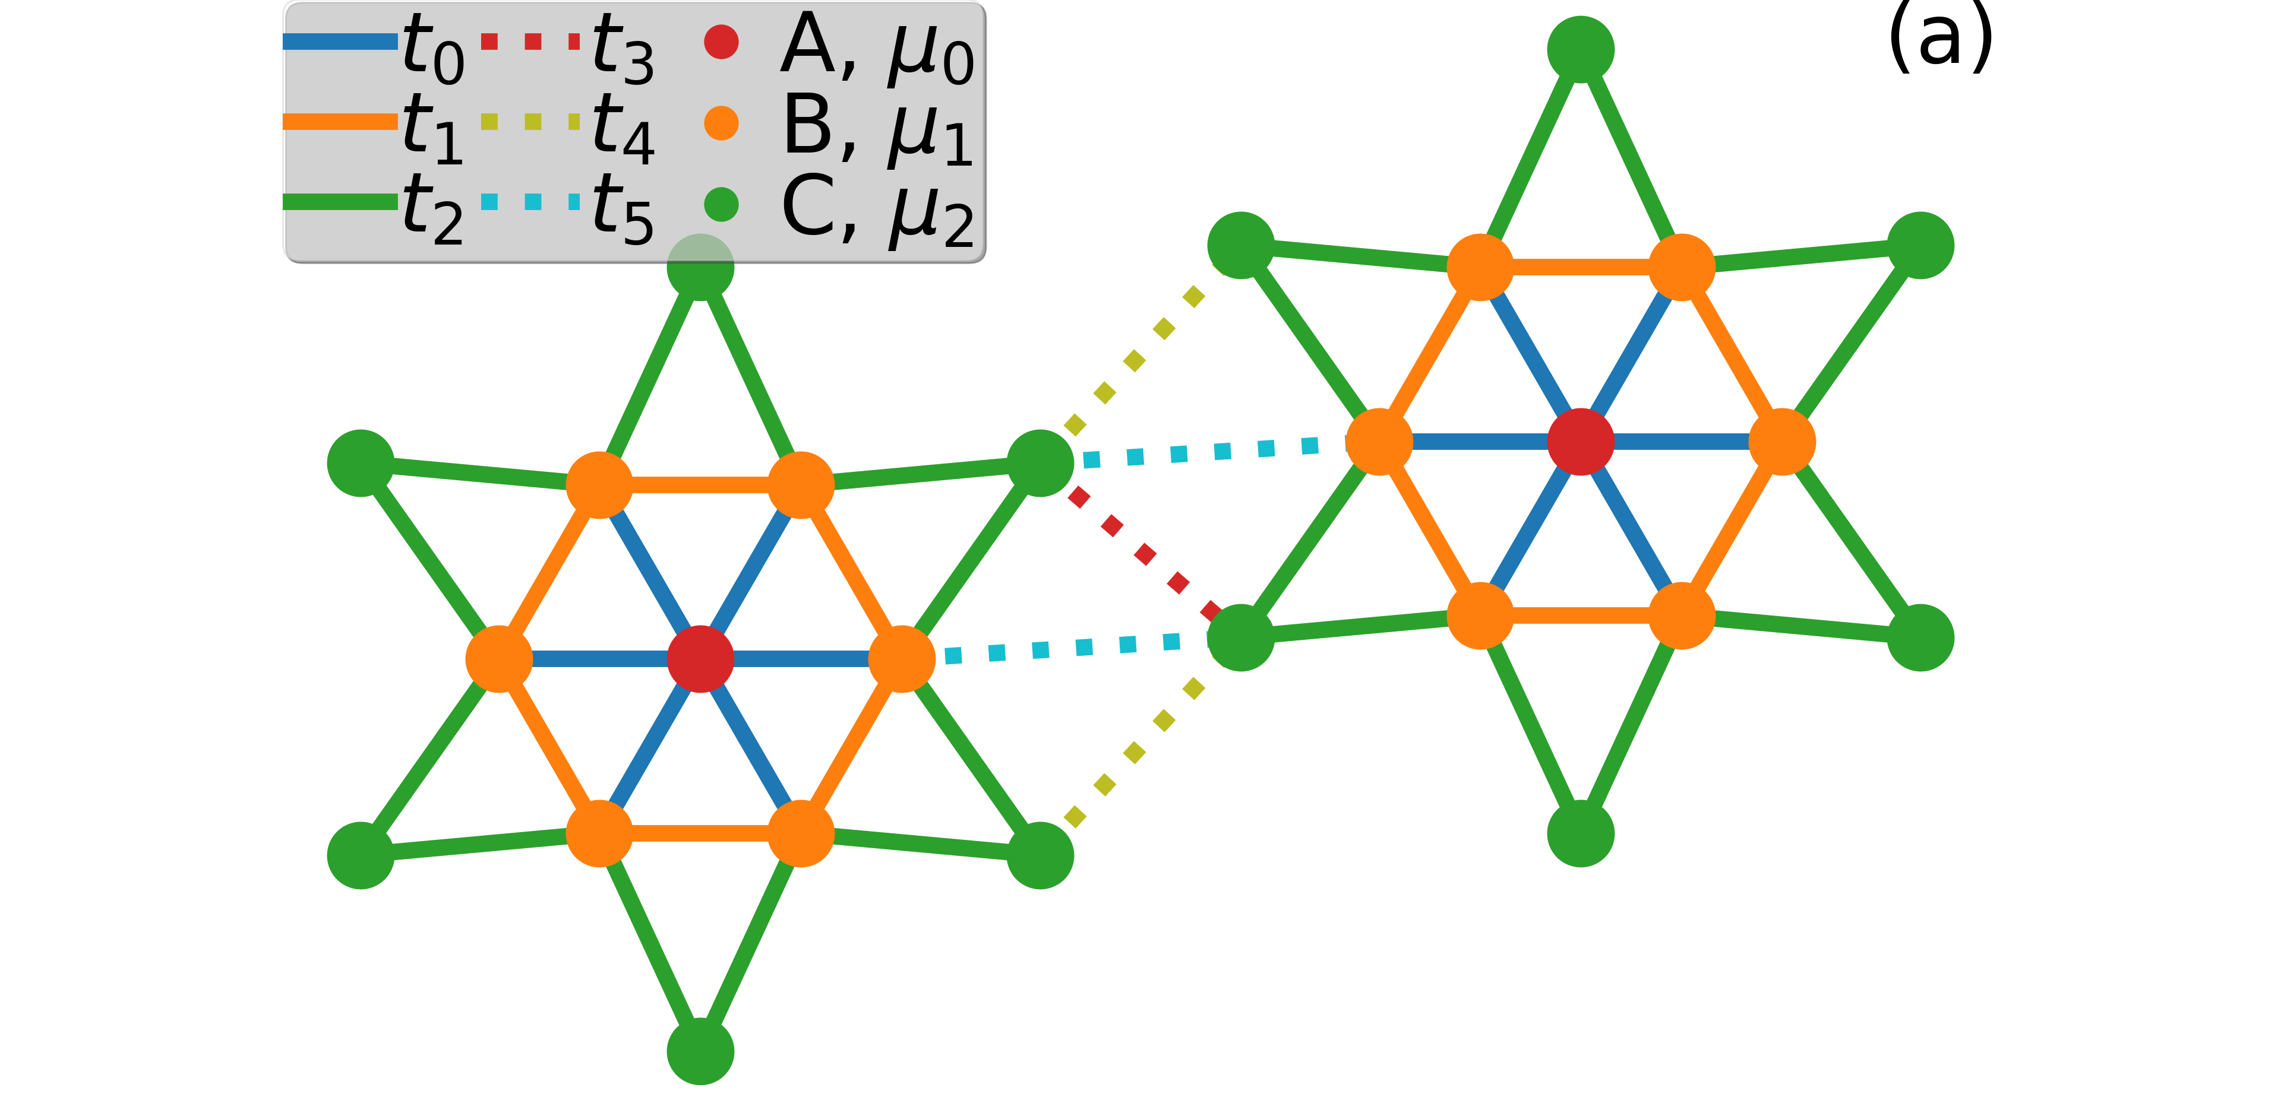

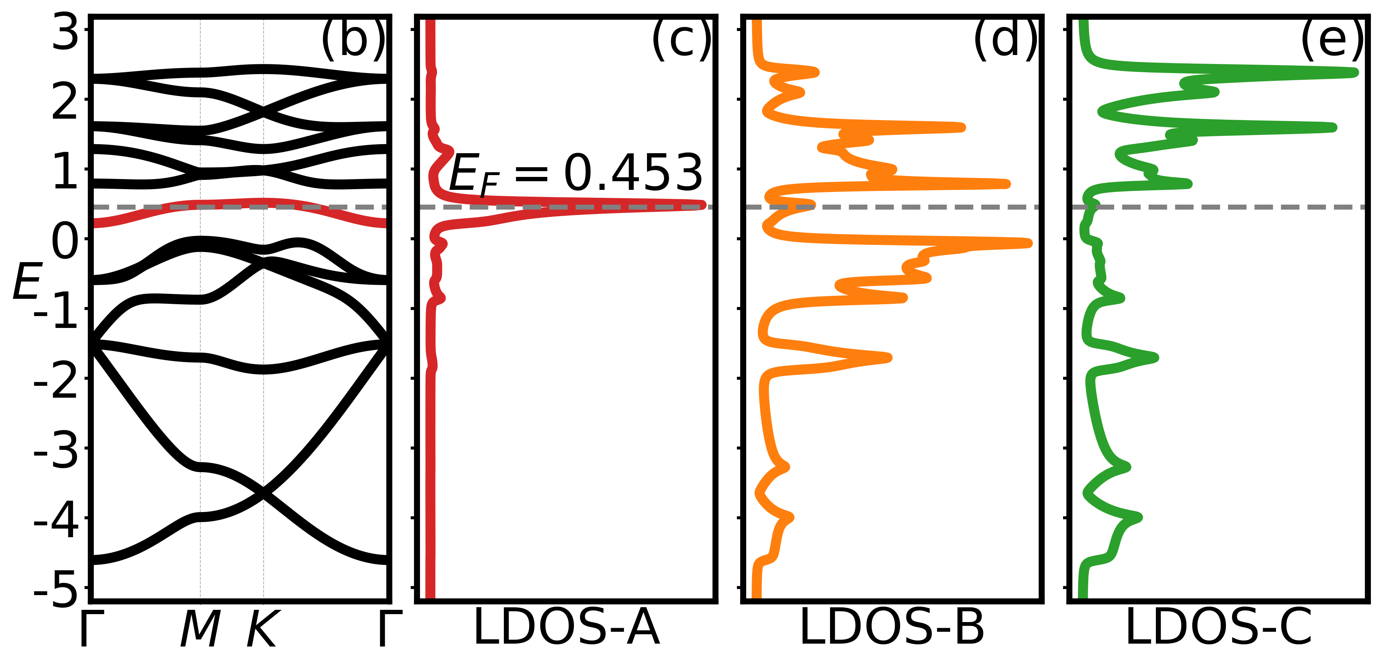

Fig.1 Model definition and band structure. (a) SD unit cell and model parameter definition. These bonds with the same color have the same length and hopping coefficients. (b) The energy band at $t_{0}=0.2$, $t_{1}=0.2$, $t_{2}=0.8$, $t_{3}=1.0$, $t_{4}=1.0$, $t_{5}=1.0$, $μ_{0}=0.0$, $μ_{1}=-0.6$, $μ_{2}=-0.3$. (c)~(e) The atomic projected densities of states for A-, B-, C-Type Ta atoms.

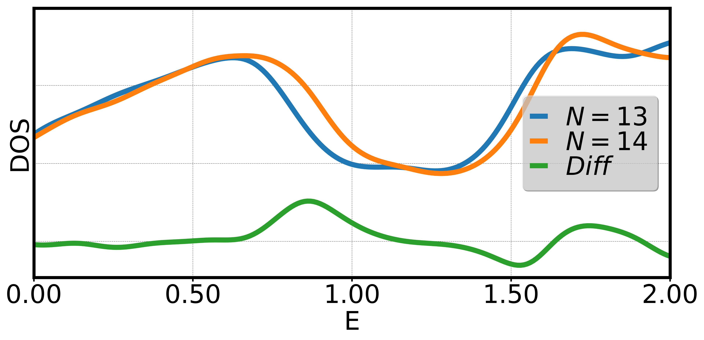

Fig. 2 DOS of the Hubbard model. The number of averaged electron per-unit-cell for the blue and orange line is 13 and 14, respectively. The green line shows the difference between the N=14 and N=13 case.

Reference:

1. R. Brouwer and F. Jellinek, Physica B & C **99**, 51 (1980).
2. C. Gros, R. Valenti, Phys. Rev. B **48**, 418 (1993).
3. D. Sénéchal, D. Perez, M. Pioro-Ladrière, Phys. Rev. Lett. **84**, 522 (2000).