1.For Age, Gender, Education Level, MonthlyIncome, such short questions Haveyouchangedyourmobileserviceproviderbefore with descriptive statistical analysis, mainly including the mean, variance and the number of samples,the results below

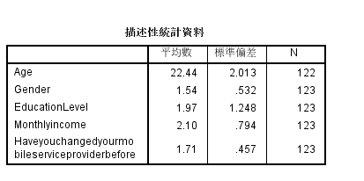

2.For Age, Gender, Education Level,MonthlyIncome, such short questions and Haveyouchangedyourmobileserviceproviderbefore correlation analysis,Results we only see short questions and Haveyouchangedyourmobileserviceproviderbefore correlation results,First of all, if we look at the significance, it is less than 0.05 that we think there is a certain correlation between the two variables,However, as shown in the following figure, the significance of the variables we considered was no less than 0.05, so these short questions were not considered as the main factors affecting the change mobile phone of operators.

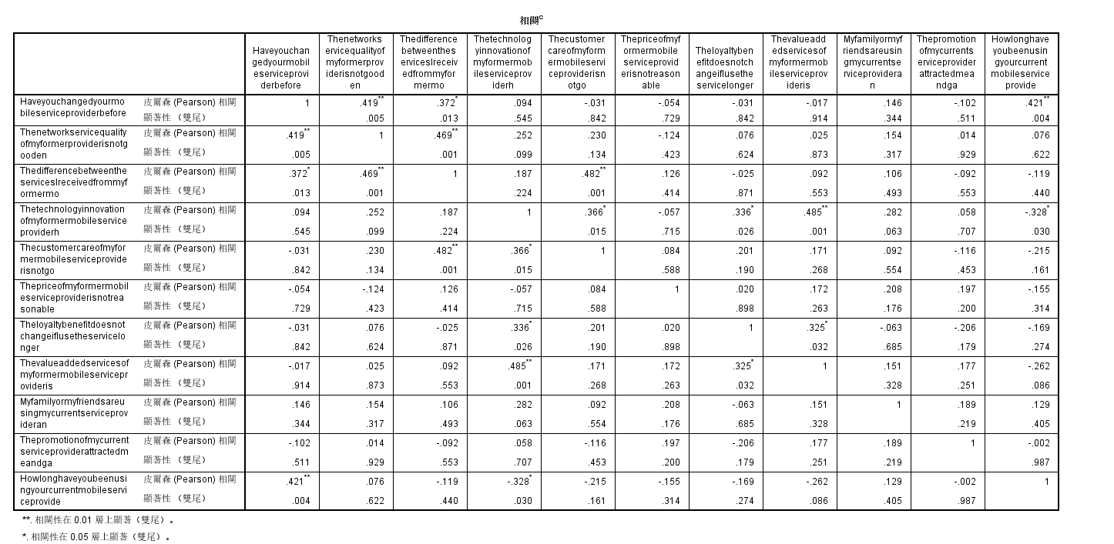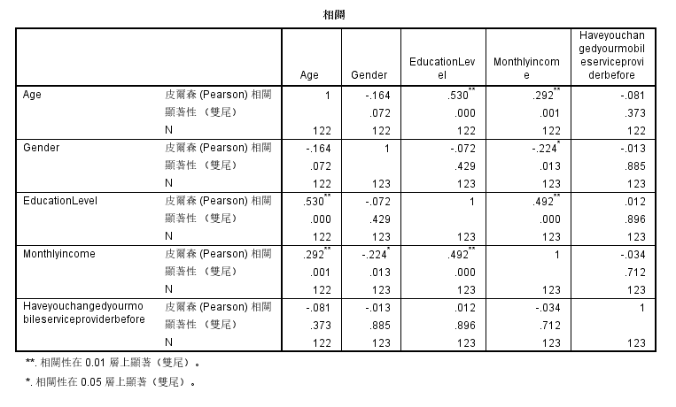

3.For Howlonghaveyoubeenusingyourcurrentmobileserviceprovide ,Thenetworkservicequalityofmyformerproviderisnotgooden, ThedifferencebetweentheservicesIreceivedfrommyformermo, Thecustomercareofmyformermobileserviceproviderisnotgo ,Thepriceofmyformermobileserviceproviderisnotreasonable, TheloyaltybenefitdoesnotchangeifIusetheservicelonger, Thevalueaddedservicesofmyformermobileserviceprovideris ,Myfamilyormyfriendsareusingmycurrentserviceprovideran, Thepromotionofmycurrentserviceproviderattractedmeandga, and Haveyouchangedyourmobileserviceproviderbefore do correlation analysis,We can find Thenetworkservicequalityofmyformerproviderisnotgooden Howlonghaveyoubeenusingyourcurrentmobileserviceprovide, ThedifferencebetweentheservicesIreceivedfrommyformermo factors of these three questions represent significant less than 0.05 and the replacement of mobile phone operators, Therefore, we consider these three factors as influencing factors for users to change mobile carriers, and their correlation is 0.419, 0.372, and 0.421, respectively,They are greater than zero, so the three factor positively correlated with the replacement of mobile phone operators, Thenetworkservicequalityofmyformerproviderisnotgooden Howlonghaveyoubeenusingyourcurrentmobileserviceprovide, ThedifferencebetweentheservicesIreceivedfrommyformermo enhancement, The higher the possibility that users change mobile phone carriers, and the positive correlation coefficient of all of them is between 0.3 and 0.6, the correlation degree shows a moderate correlation



4.For ‘The quality of network of my current mobile service provider is great’，‘The difference between the service I received from my current mobile service provider and my expectation is not big or the service I received from my current mobile service provider is even better than my expectation’，‘The customer care of my current mobile service provider is good enough.’，‘My mobile service provider has improved its technology enough compared with other mobile service providers.’，‘The switching cost is high. （Including non-money cost, eg. I didn't switch my mobile service provider because I don't want to spend my time to do so.) ’ ，‘The loyalty benefit becomes higher if I use the service longer. ( eg. The monthly price will decrease if I use longer.)’，‘The price is reasonable’，‘The value-added services of my current mobile service provider is good enough.’‘Have you changed your mobile service provider before?’ with descriptive statistical analysis, mainly including the mean, variance and the number of samples,the results below

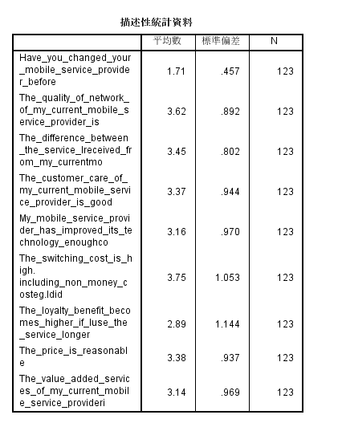

1. For ‘The quality of network of my current mobile service provider is great’，‘The difference between the service I received from my current mobile service provider and my expectation is not big or the service I received from my current mobile service provider is even better than my expectation’，‘The customer care of my current mobile service provider is good enough.’，‘My mobile service provider has improved its technology enough compared with other mobile service providers.’，‘The switching cost is high. （Including non-money cost, eg. I didn't switch my mobile service provider because I don't want to spend my time to do so.) ’ ，‘The loyalty benefit becomes higher if I use the service longer. ( eg. The monthly price will decrease if I use longer.)’，‘The price is reasonable’，‘The value-added services of my current mobile service provider is good enough.’‘Have you changed your mobile service provider before?’ with descriptive statistical analysis，We can see from the results, ‘The network service quality of my former provider is not good enough.’，‘The switching cost is high. I don't switch my mobile service provider because I don't want to spend my time to do so.)’，‘The loyalty benefit becomes higher if I use The service longer I use longer.)’，and The correlation with ‘The quality of network of my current mobile service provider is great ’is -0.61, showing a highly negative correlation, which indicates that The better The service provided by mobile carriers, The less likely users are to change mobile carriers，and ‘The correlation with The switching cost is high. (Including non-money cost, eg. I didn't switch my mobile service provider because I don't want to spend my time to do so) ’is 0.254, which is small. The correlation between ‘loyalty benefit and The loyalty benefit becomes higher if I use The service longer’ is -0.217，The negative correlation shows that the higher the loyalty revenue of users is, the less likely they are to change operators

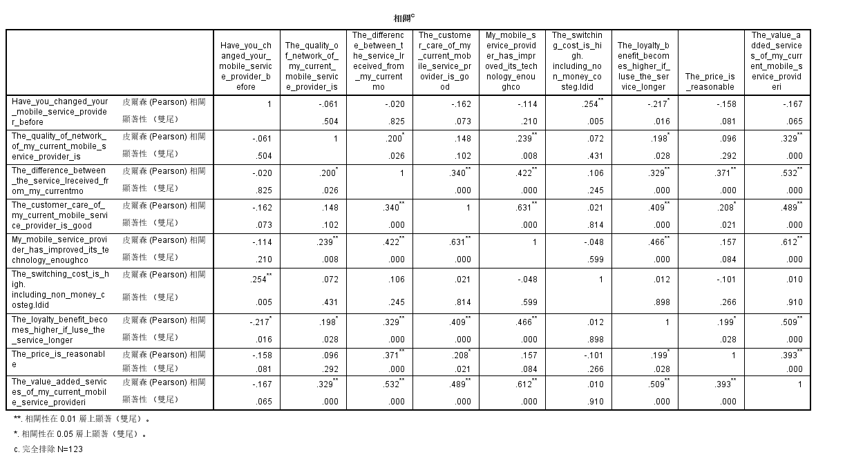

6.The survey sample is 123, but only 36 users have changed mobile phone operators. The following is the analysis of the main reasons for the 36 users who have changed mobile phone operators

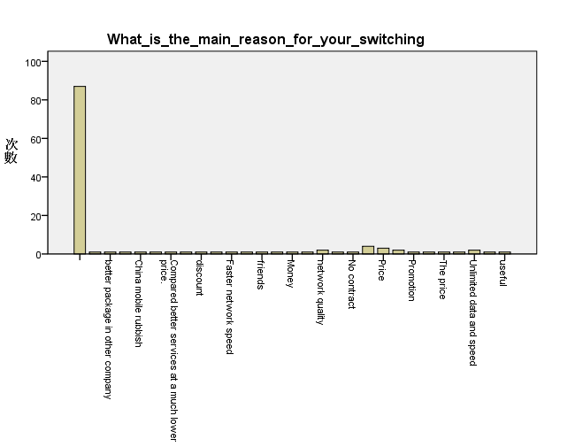

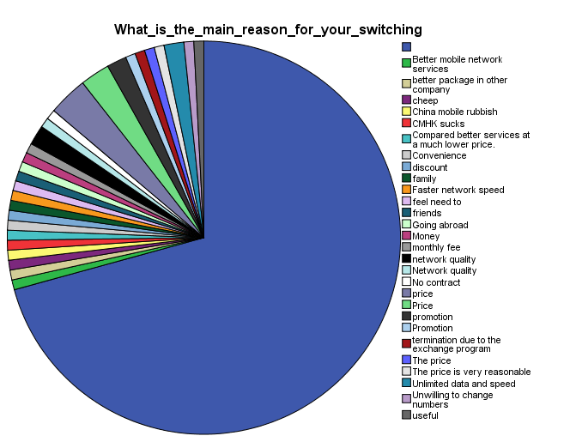

7.The survey sample is 123, but only 36 users have changed mobile phone operators. The reliability analysis of the following 36 samples of mobile phone operators is conducted, and the result is 0.814

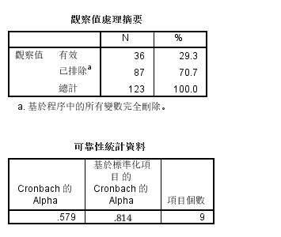

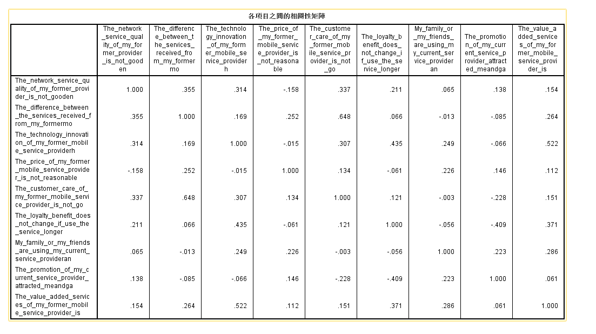

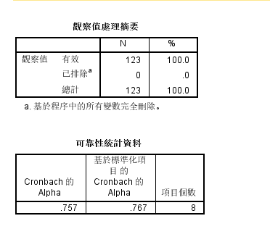  
8.We have conducted reason statistics on the users who have not replaced their mobile phones, and the reliability of the data is 0.767, which is highly reliable.

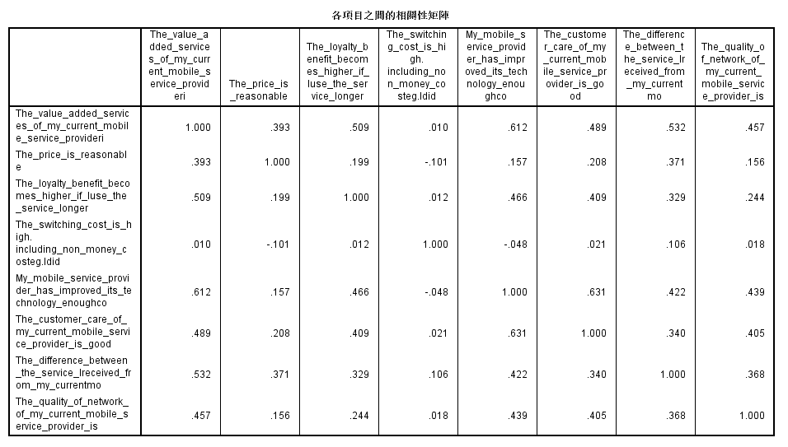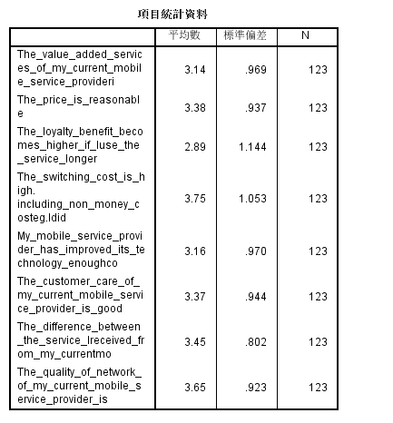

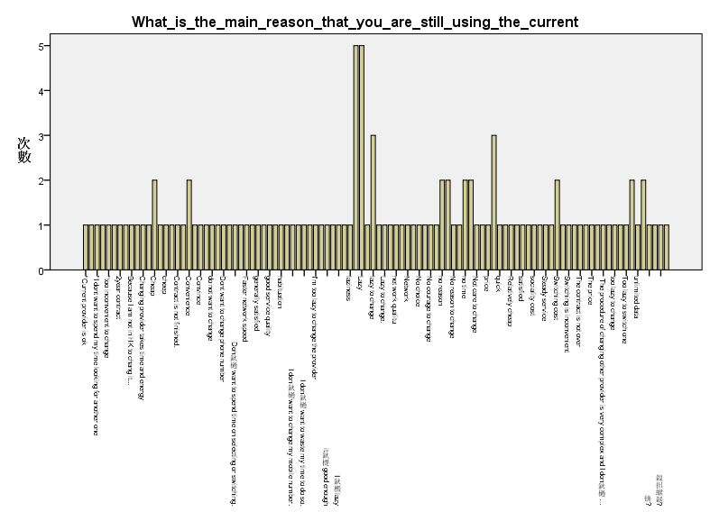9.the main reason that you are still using the current

