Advanced Computer Vision Homework1

生醫電資所 碩一 R07945029 王思敏

Objective:

Detect motions vectors between trucka.bmp (386×386) and truckb.bmp (386×386)

parameters:

1. trucka.bmp sampled by interval =1 – used as basis

(block size: 8×8, 11×11, 15×15, 21×21, 31×31)

1. truckb.bmp sampled by interval = block

(block size: 8×8, 11×11, 15×15, 21×21, 31×31)

1. Threshold of search range: 50 pixels

Method:

1. Read BMP file

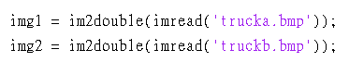

1. Set search range and parameters of block size



1. trucka.bmp sampled by interval =1 with sampled matrix = block size

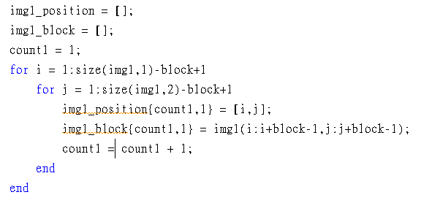

1. truckb.bmp sampled by interval = block with sampled matrix = block size

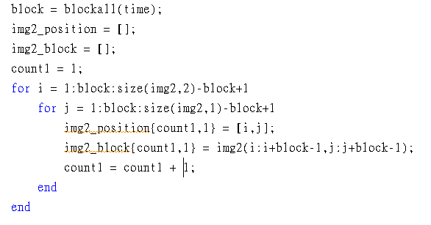

1. Calculate the motion vectors by searching the position of the closest blocks between trucka.bmp and truckb.bmp

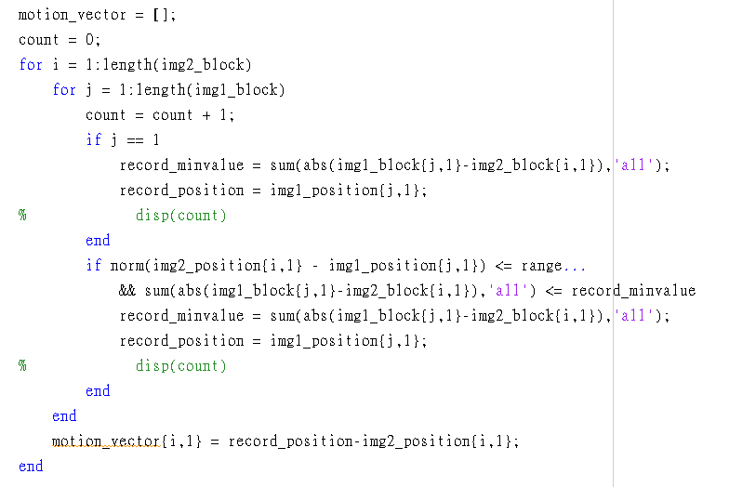

1. Quiver plot

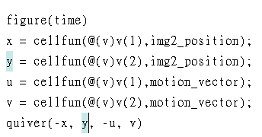

Result:

1. Block size = 8 x 8

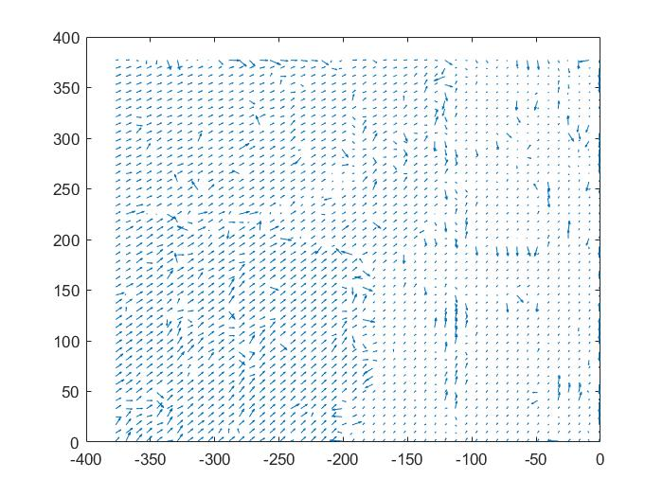

1. Block size = 11 x 11

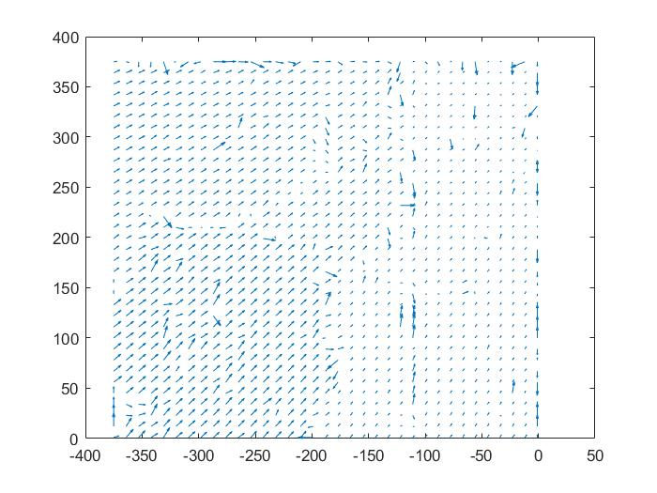

1. Block size = 15 x 15

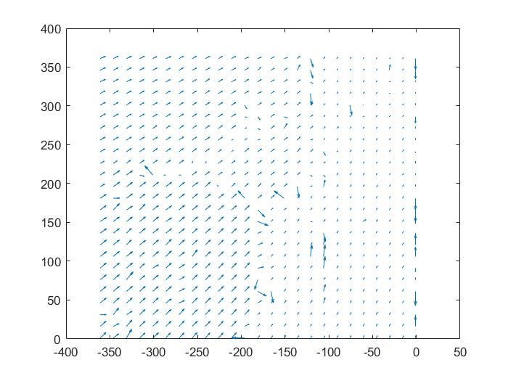

1. Block size = 21 x 21

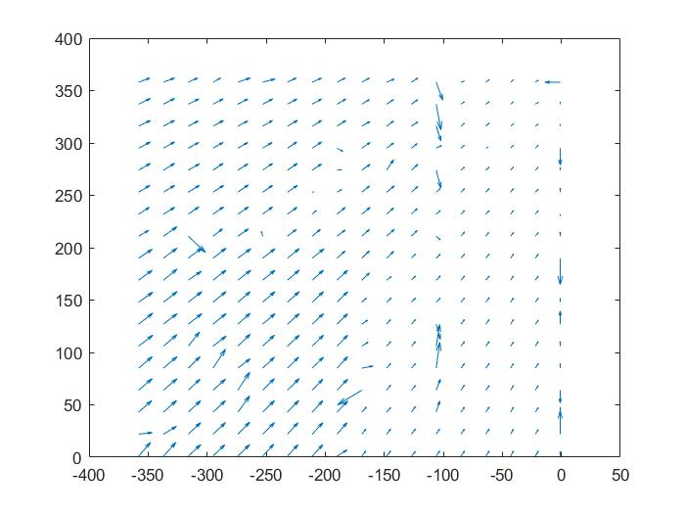

1. Block size = 31 x 31

