Advanced Computer Vision Homework3

生醫電資所 碩一 R07945029 王思敏

Objective:

Synthetically translate lena.im one pixel to the right and downward.

Implement Horn & Schunck optical flow estimation with λ of 0.1, 1, 10.

parameters:

1. λ = 0.1, 1, 10
2. iteration = 8, 80, 800, 1800

Method:

1. Read BMP file



1. Move lena.bmp one pixel right and down

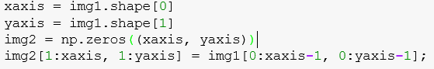

1. Set kernels of Horn & Schunck algorithm

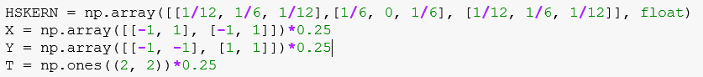

1. Initialization of velocities



1. Calculate the of derivatives

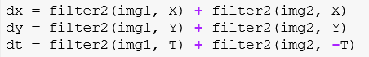

1. Estimation optical flow

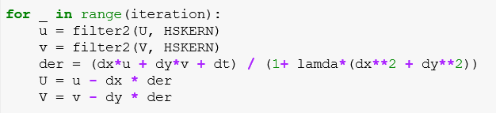

1. Plot

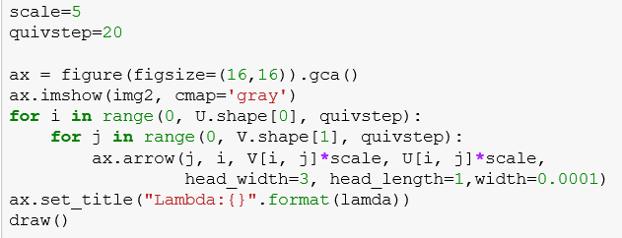

Result:

Results show that iteration of 8 seems enough for λ = 0.1 and λ = 1 but not λ = 10. For λ = 10, iteration of 80 shows better outcome. For λ = 0.1, iteration over 80 is too large and may even lead to multiply overflow.

1. λ = 0.1, iteration = 8

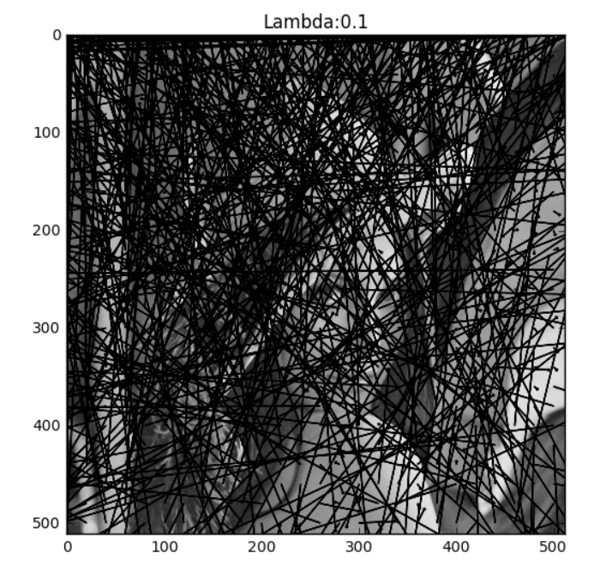

1. λ = 0.1, iteration = 80

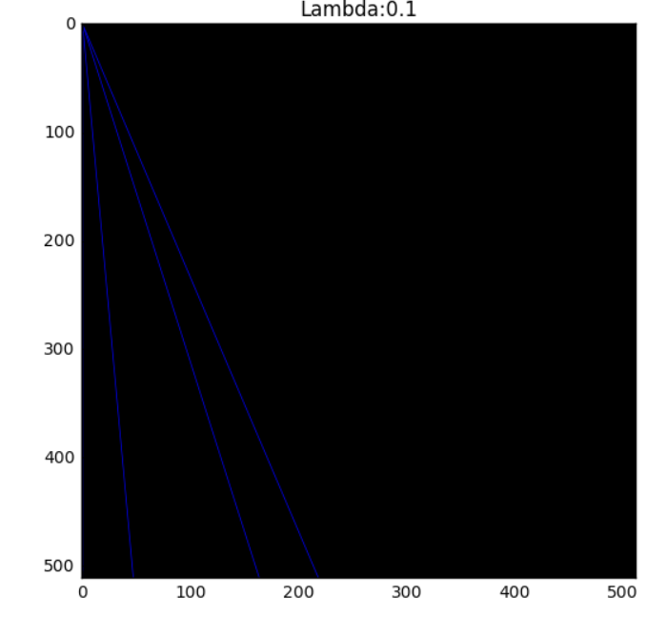

1. λ = 0.1, iteration = 800

multiply overflow

1. λ = 0.1, iteration = 1800

multiply overflow

1. λ = 1, iteration = 8

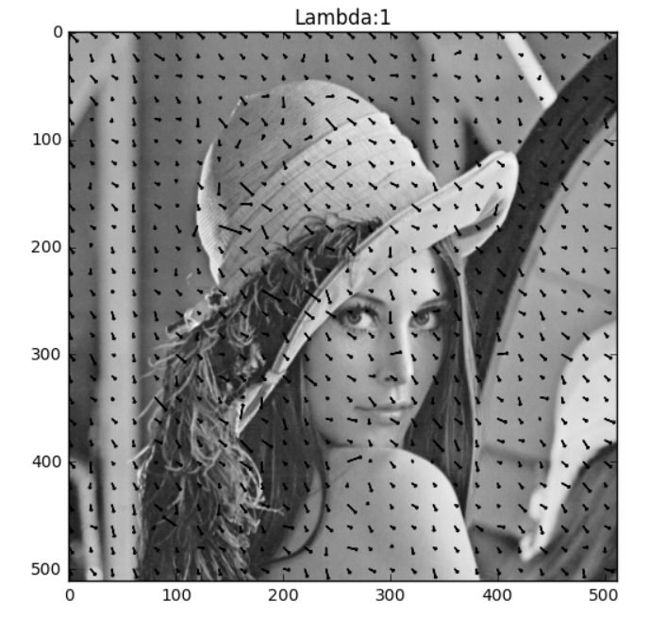

1. λ = 1, iteration = 80

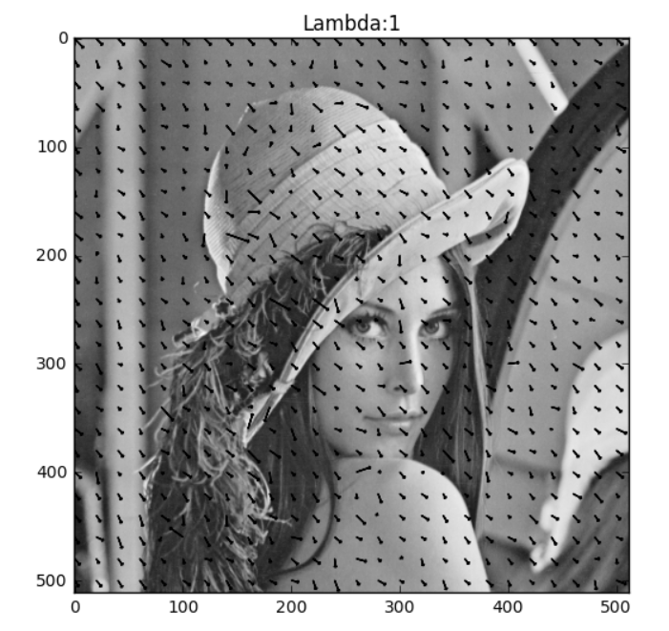

1. λ = 1, iteration = 800

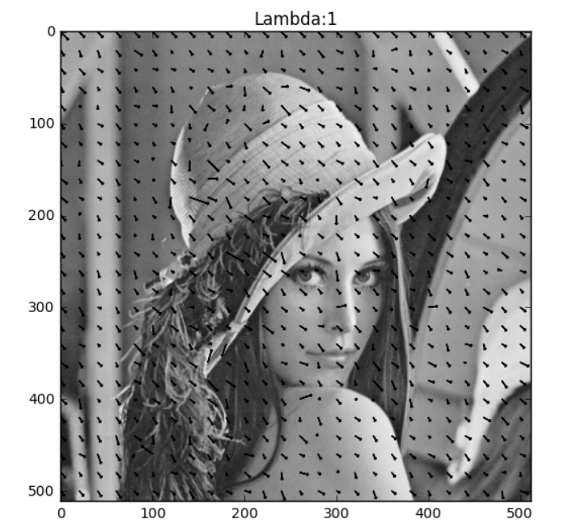

1. λ = 1, iteration = 1800

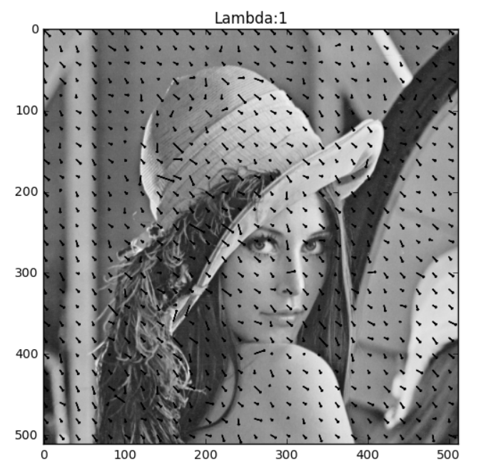

1. λ = 10, iteration = 8

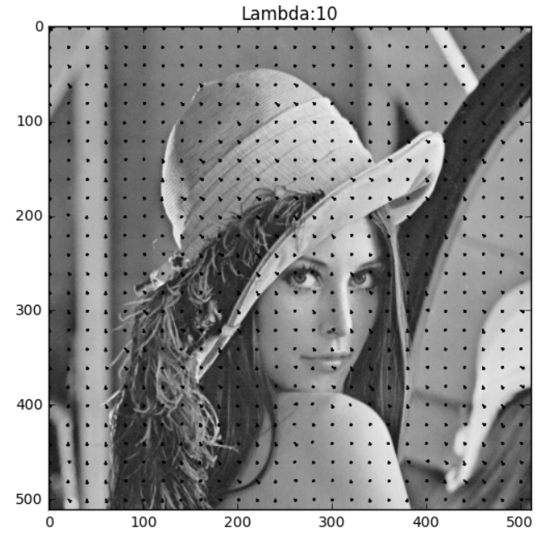

1. λ = 10, iteration = 80

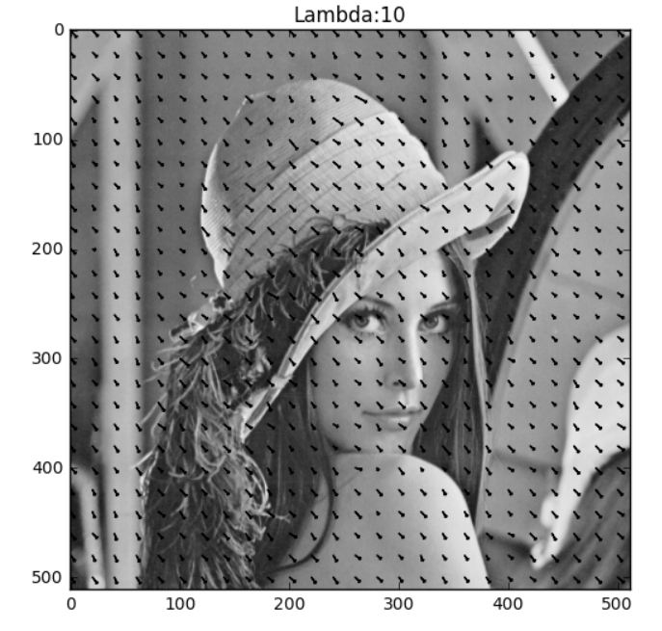

1. λ = 10, iteration = 800

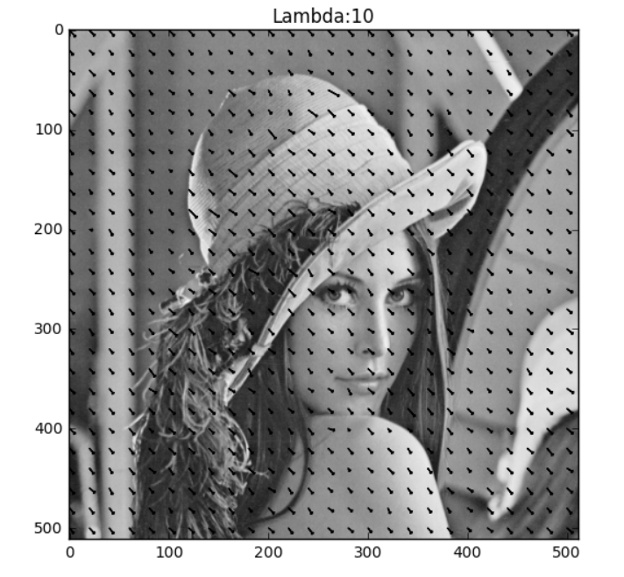

1. λ = 10, iteration = 1800

