嵌入式系統期中報告

醫工四10311001王思敏

1. 腳位:

|  |  |
| --- | --- |
| Nucleo-F767ZI | VL6180X |
| 3.3V | Vin |
| gnd | gnd |
| D14 | sda |
| D15 | scl |

1. Grafcet:

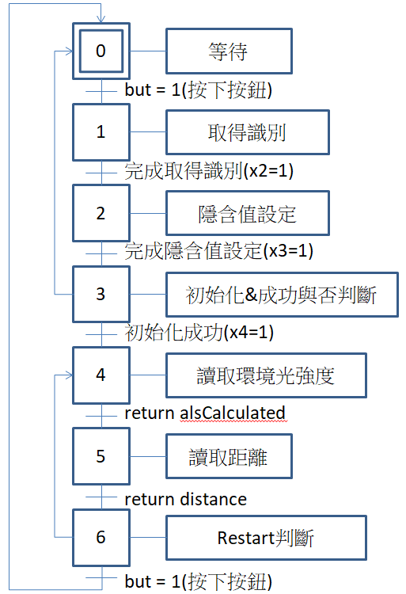

1. API定義:

|  |  |  |
| --- | --- | --- |
| 功能 | API | 參數 |
| 取得識別 | getIdentification | struct VL6180xIdentification *temp |
| 設預設值 | VL6180xDefautSettings | null |
| 初始化 | VL6180xInit | null |
| 讀取環境光強 | getAmbientLight | alsCalculated |
| 讀取距離 | getDistance | distance |

1. 結果:

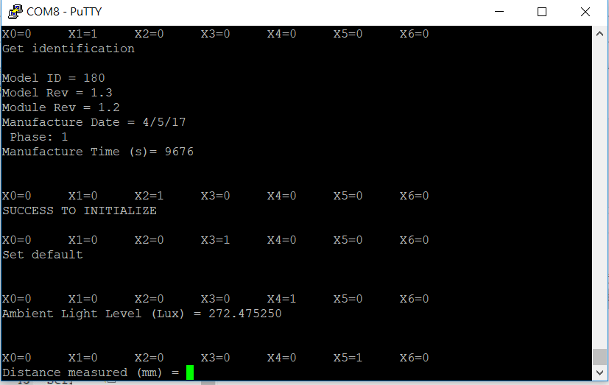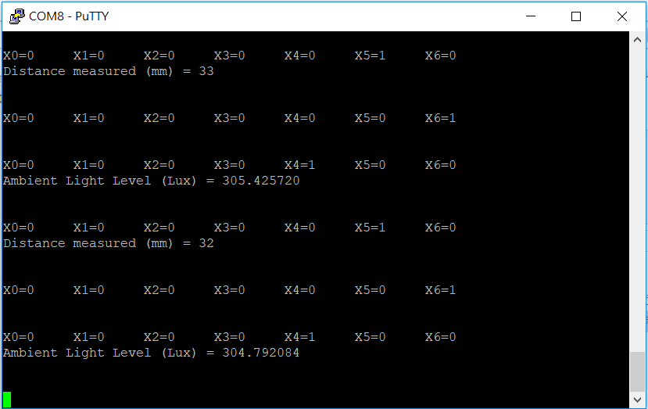

1. 程式碼:

#include "mbed.h"

#include "VL6180x.h"

#define VL6180X_ADDRESS 0x29

int x0, x1, x2, x3, x4, x5, x6, but;

Timer debounceTimer;

InterruptIn myButton(USER_BUTTON);

VL6180x::VL6180x(PinName sda, PinName scl, uint8_t addr) : m_i2c(sda, scl), m_addr(addr) {}

VL6180xIdentification identification;

Serial pc(USBTX, USBRX);

VL6180x sensor(D14, D15, VL6180X_ADDRESS<<1);

int VL6180x::VL6180xInit(void){

uint8_t data; //for temp data storage

data = VL6180x_getRegister(VL6180X_SYSTEM_FRESH_OUT_OF_RESET);

wait_ms(50);

if(data != 1) return VL6180x_FAILURE_RESET;

VL6180x_setRegister(0x0207, 0x01);

VL6180x_setRegister(0x0208, 0x01);

VL6180x_setRegister(0x0096, 0x00);

VL6180x_setRegister(0x0097, 0xfd);

VL6180x_setRegister(0x00e3, 0x00);

VL6180x_setRegister(0x00e4, 0x04);

VL6180x_setRegister(0x00e5, 0x02);

VL6180x_setRegister(0x00e6, 0x01);

VL6180x_setRegister(0x00e7, 0x03);

VL6180x_setRegister(0x00f5, 0x02);

VL6180x_setRegister(0x00d9, 0x05);

VL6180x_setRegister(0x00db, 0xce);

VL6180x_setRegister(0x00dc, 0x03);

VL6180x_setRegister(0x00dd, 0xf8);

VL6180x_setRegister(0x009f, 0x00);

VL6180x_setRegister(0x00a3, 0x3c);

VL6180x_setRegister(0x00b7, 0x00);

VL6180x_setRegister(0x00bb, 0x3c);

VL6180x_setRegister(0x00b2, 0x09);

VL6180x_setRegister(0x00ca, 0x09);

VL6180x_setRegister(0x0198, 0x01);

VL6180x_setRegister(0x01b0, 0x17);

VL6180x_setRegister(0x01ad, 0x00);

VL6180x_setRegister(0x00ff, 0x05);

VL6180x_setRegister(0x0100, 0x05);

VL6180x_setRegister(0x0199, 0x05);

VL6180x_setRegister(0x01a6, 0x1b);

VL6180x_setRegister(0x01ac, 0x3e);

VL6180x_setRegister(0x01a7, 0x1f);

VL6180x_setRegister(0x0030, 0x00);

return 0;

}

VL6180x::~VL6180x(void) {

};

void VL6180x::VL6180xDefautSettings(void){

VL6180x_setRegister(VL6180X_SYSTEM_INTERRUPT_CONFIG_GPIO, (4 <<

3)|(4) );

VL6180x_setRegister(VL6180X_SYSTEM_MODE_GPIO1, 0x10); VL6180x_setRegister(VL6180X_READOUT_AVERAGING_SAMPLE_PERIOD, 0x30);

VL6180x_setRegister(VL6180X_SYSALS_ANALOGUE_GAIN, 0x46); VL6180x_setRegister(VL6180X_SYSRANGE_VHV_REPEAT_RATE, 0xFF); VL6180x_setRegister(VL6180X_SYSALS_INTEGRATION_PERIOD, 0x63); VL6180x_setRegister(VL6180X_SYSRANGE_VHV_RECALIBRATE, 0x01);

VL6180x_setRegister(VL6180X_SYSRANGE_INTERMEASUREMENT_PERIOD,

0x09);

VL6180x_setRegister(VL6180X_SYSALS_INTERMEASUREMENT_PERIOD, 0x0A);

VL6180x_setRegister(VL6180X_SYSTEM_INTERRUPT_CONFIG_GPIO, 0x24);

VL6180x_setRegister(VL6180X_SYSRANGE_MAX_CONVERGENCE_TIME, 0x32);

VL6180x_setRegister(VL6180X_SYSRANGE_RANGE_CHECK_ENABLES, 0x10 |

0x01); VL6180x_setRegister16bit(VL6180X_SYSRANGE_EARLY_CONVERGENCE_ESTIMA

TE, 0x7B );

VL6180x_setRegister16bit(VL6180X_SYSALS_INTEGRATION_PERIOD, 0x64);

VL6180x_setRegister(VL6180X_READOUT_AVERAGING_SAMPLE_PERIOD,0x30);

VL6180x_setRegister(VL6180X_SYSALS_ANALOGUE_GAIN,0x40);

VL6180x_setRegister(VL6180X_FIRMWARE_RESULT_SCALER,0x01);

}

void VL6180x::getIdentification(struct VL6180xIdentification *temp){

temp->idModel = VL6180x_getRegister(VL6180X_IDENTIFICATION_MODEL_ID);

temp->idModelRevMajor =

VL6180x_getRegister(VL6180X_IDENTIFICATION_MODEL_REV_MAJOR);

temp->idModelRevMinor =

VL6180x_getRegister(VL6180X_IDENTIFICATION_MODEL_REV_MINOR);

temp->idModuleRevMajor =

VL6180x_getRegister(VL6180X_IDENTIFICATION_MODULE_REV_MAJOR);

temp->idModuleRevMinor =

VL6180x_getRegister(VL6180X_IDENTIFICATION_MODULE_REV_MINOR);

temp->idDate = VL6180x_getRegister16bit(VL6180X_IDENTIFICATION_DATE);

temp->idTime = VL6180x_getRegister16bit(VL6180X_IDENTIFICATION_TIME);

}

uint8_t VL6180x::changeAddress(uint8_t old_address, uint8_t new_address){

if( old_address == new_address) return old_address;

if( new_address > 127) return old_address;

VL6180x_setRegister(VL6180X_I2C_SLAVE_DEVICE_ADDRESS, new_address);

m_addr=new_address<<1;

return VL6180x_getRegister(VL6180X_I2C_SLAVE_DEVICE_ADDRESS);

}

uint8_t VL6180x::getDistance() {

uint8_t distance;

VL6180x_setRegister(VL6180X_SYSRANGE_START, 0x01);

wait_ms(10);

distance = VL6180x_getRegister(VL6180X_RESULT_RANGE_VAL);

VL6180x_setRegister(VL6180X_SYSTEM_INTERRUPT_CLEAR, 0x07);

return distance;

}

float VL6180x::getDistance_m() {

float distance;

VL6180x_setRegister(VL6180X_SYSRANGE_START, 0x01);

wait_ms(10);

distance = 0.001*(float)VL6180x_getRegister(VL6180X_RESULT_RANGE_VAL);

VL6180x_setRegister(VL6180X_SYSTEM_INTERRUPT_CLEAR, 0x07);

return distance;

}

float VL6180x::getAmbientLight(vl6180x_als_gain VL6180X_ALS_GAIN)

{

VL6180x_setRegister(VL6180X_SYSALS_ANALOGUE_GAIN, (0x40 |

VL6180X_ALS_GAIN));

VL6180x_setRegister(VL6180X_SYSALS_START, 0x01);

wait_ms(100);

VL6180x_setRegister(VL6180X_SYSTEM_INTERRUPT_CLEAR, 0x07);

unsigned int alsRaw = VL6180x_getRegister16bit(VL6180X_RESULT_ALS_VAL);

unsigned int alsIntegrationPeriodRaw =

VL6180x_getRegister16bit(VL6180X_SYSALS_INTEGRATION_PERIOD);

float alsIntegrationPeriod = 100.0 / alsIntegrationPeriodRaw ;

float alsGain = 0.0;

switch (VL6180X_ALS_GAIN){

case GAIN_20: alsGain = 20.0; break;

case GAIN_10: alsGain = 10.32; break;

case GAIN_5: alsGain = 5.21; break;

case GAIN_2_5: alsGain = 2.60; break;

case GAIN_1_67: alsGain = 1.72; break;

case GAIN_1_25: alsGain = 1.28; break;

case GAIN_1: alsGain = 1.01; break;

case GAIN_40: alsGain = 40.0; break;

}

float alsCalculated = (float)0.32 * ((float)alsRaw / alsGain) *alsIntegrationPeriod;

return alsCalculated;

}

uint8_t VL6180x::VL6180x_getRegister(uint16_t registerAddr)

{

uint8_t data;

char data_write[2];

char data_read[1];

data_write[0] = (registerAddr >> 8) & 0xFF;

data_write[1] = registerAddr & 0xFF;

m_i2c.write(m_addr, data_write, 2,0);

m_i2c.read(m_addr,data_read,1,1);

data=data_read[0];

return data;

}

uint16_t VL6180x::VL6180x_getRegister16bit(uint16_t registerAddr)

{

uint8_t data_low;

uint8_t data_high;

uint16_t data;

char data_write[2];

char data_read[2];

data_write[0] = (registerAddr >> 8) & 0xFF;

data_write[1] = registerAddr & 0xFF;

m_i2c.write(m_addr, data_write, 2,0);

m_i2c.read(m_addr,data_read,2,1);

data_high = data_read[0];

data_low = data_read[1];

data = (data_high << 8)|data_low;

return data;

}

void VL6180x::VL6180x_setRegister(uint16_t registerAddr, uint8_t data)

{

char data_write[3];

data_write[0] = (registerAddr >> 8) & 0xFF;

data_write[1] = registerAddr & 0xFF;

data_write[2] = data & 0xFF;

m_i2c.write(m_addr, data_write, 3);

}

void VL6180x::VL6180x_setRegister16bit(uint16_t registerAddr, uint16_t data)

{

char data_write[4];

data_write[0] = (registerAddr >> 8) & 0xFF;

data_write[1] = registerAddr & 0xFF;

data_write[2] = (data >> 8) & 0xFF;

data_write[3] = data & 0xFF;

m_i2c.write(m_addr, data_write, 4);

}

void printIdentification(struct VL6180xIdentification *temp){

pc.printf("Model ID = ");

pc.printf("%d\r\n",temp->idModel);

pc.printf("Model Rev = ");

pc.printf("%d",temp->idModelRevMajor);

pc.printf(".");

pc.printf("%d\r\n",temp->idModelRevMinor);

pc.printf("Module Rev = ");

pc.printf("%d",temp->idModuleRevMajor);

pc.printf(".");

pc.printf("%d\r\n",temp->idModuleRevMinor);

pc.printf("Manufacture Date = ");

pc.printf("%d",((temp->idDate >> 3) & 0x001F));

pc.printf("/");

pc.printf("%d",((temp->idDate >> 8) & 0x000F));

pc.printf("/1");

pc.printf("%d\r\n",((temp->idDate >> 12) & 0x000F));

pc.printf(" Phase: ");

pc.printf("%d\r\n",(temp->idDate & 0x0007));

pc.printf("Manufacture Time (s)= ");

pc.printf("%d\r\n",(temp->idTime * 2));

pc.printf("\r\n\r\n");

}

void released(){

if(debounceTimer.read_ms() > 50){

but = 1;

}

}

void pressed(){

debounceTimer.reset();

debounceTimer.start();

}

void Button(){

myButton.rise(&pressed);

myButton.fall(&released);

}

void action0(){

pc.printf("X0=%d X1=%d X2=%d X3=%d X4=%d

X5=%d X6=%d\r\n",x0,x1,x2,x3,x4,x5,x6);

Button();

pc.printf("Wait to Start\r\n\r\n");

if (but == 1){

pc.printf("Start\r\n\r\n");

but = 0;

x0 = 0;

x1 = 1;

}

wait_ms(500);

}

void action1(){

pc.printf("X0=%d X1=%d X2=%d X3=%d X4=%d

X5=%d X6=%d\r\n",x0,x1,x2,x3,x4,x5,x6);

wait_ms(100); // delay .1s

pc.printf("Get identification\r\n\r\n");

sensor.getIdentification(&identification);

printIdentification(&identification);

x1 = 0;

x2 = 1;

wait_ms(500);

}

void action2(){

int i = sensor.VL6180xInit();

pc.printf("X0=%d X1=%d X2=%d X3=%d X4=%d

X5=%d X6=%d\r\n",x0,x1,x2,x3,x4,x5,x6);

if(i != 0){

pc.printf("FAILED TO INITALIZE\r\n\r\n");

x2 = 0;

x0 = 1;

}

else{

pc.printf("SUCCESS TO INITIALIZE\r\n\r\n");

x2 = 0;

x3 = 1;

}

wait_ms(500);

}

void action3(){

pc.printf("X0=%d X1=%d X2=%d X3=%d X4=%d

X5=%d X6=%d\r\n",x0,x1,x2,x3,x4,x5,x6);

pc.printf("Set default\r\n\r\n\r\n");

sensor.VL6180xDefautSettings();

x3 = 0;

x4 = 1;

wait_ms(500);

}

void action4(){

pc.printf("X0=%d X1=%d X2=%d X3=%d X4=%d

X5=%d X6=%d\r\n",x0,x1,x2,x3,x4,x5,x6);

pc.printf("Ambient Light Level (Lux) = ");

pc.printf("%f\r\n\r\n\r\n",sensor.getAmbientLight(GAIN_1) );

x4 = 0;

x5 = 1;

wait_ms(500);

}

void action5(){

pc.printf("X0=%d X1=%d X2=%d X3=%d X4=%d

X5=%d X6=%d\r\n",x0,x1,x2,x3,x4,x5,x6);

pc.printf("Distance measured (mm) = ");

pc.printf("%d\r\n\r\n\r\n", sensor.getDistance() );

x5 = 0;

x6 = 1;

wait_ms(500); // delay 1s

}

void action6(){

pc.printf("X0=%d X1=%d X2=%d X3=%d X4=%d

X5=%d X6=%d\r\n\r\n\r\n",x0,x1,x2,x3,x4,x5,x6);

Button();

if (but == 1){

pc.printf("Restart!\r\n\r\n");

but = 0;

x6 = 0;

x0 = 1;

wait_ms(500); // delay 1s

}

else {

x6 = 0;

x4 = 1;

}

}

void grafcet(){

while (1){

if (x0 == 1) action0();

if (x1 == 1) action1();

if (x2 == 1) action2();

if (x3 == 1) action3();

if (x4 == 1) action4();

if (x5 == 1) action5();

if (x6 == 1) action6();

}

}

int main() {

x0 = 1; x1 = 0; x2 = 0; x3 = 0; x4 = 0; x5 = 0; x6 = 0; but = 0;

grafcet();

}