You can choose to submit either A5 (worth 150 points), AD5 (worth 180), or both (worth 180) for 5th assignment you will get a score for this assignment either 150 points base or 180 points base.

Grading Criteria:
- If the submitted program cannot be compiled or run on the Microsoft visual studio 2017 C# compiler, the assignment will not get any credit.
- If the file name does not follow the naming instruction as stated in syllabus, the assignment will get 5 to 15 points deduction.
- If the header section of the submitted file does not include personal information and purpose of the file, the assignment will get 5 to 30 points deduction.
- Late assignments will not get any credit for the assignment.
- A submission does not follow the instructions of the assignment will get little credit.
- A portion of the assignment is not finished or incomplete will get little or no credit.
- Submit an assignment to a wrong drop box. The wrong drop box one will not get any credit.
- If use A for AD or AD for A assignments in the file name, the student will not get any credit for the assignments.
- If the submitted file(s) cannot be opened by the instructor’s software (WinZip, Visual Studio, or text editor) the assignment will have little credit.
- If the submission file does not include all necessary programming files to run the program, the program will get little credit.
- If the program does not separate into several files (driver, header file, implementation file, etc.) as describe in the assignment, the program will get little credit.
- If the displaying result of the program is not exactly match with the graphic in the assignment description or the displaying result of the executable file which comes with the assignment, the assignment will get little credit.
- If the program does not have enough detail documentation in the programming area the program will get 5 to 30 points deduction.
- If the program includes some unrelated documentation the program will get some points deduction.

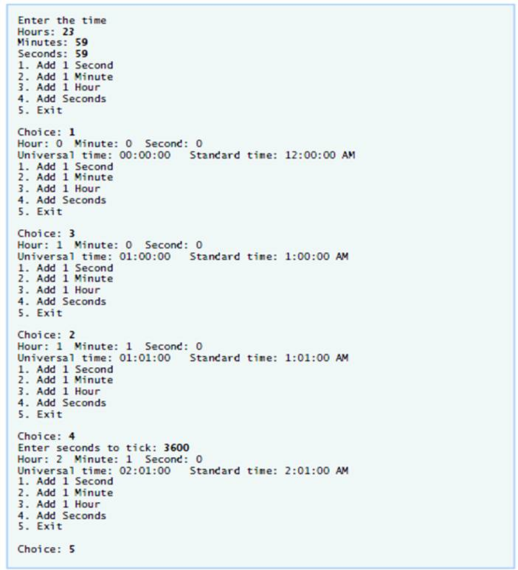
A5
Use extension methods to extend class Time of Fig. 10.1 to provide the Tick method that increments the time stored in a Time object by one second. Also provide method IncrementMinute to increment the minute and method IncrementHour to increment the hour. The Time object should always remain in a consistent state. The Tick method, the IncrementMinute method and the IncrementHour method should be called when you click the Add 1 to Second button, the Add 1 to Minute button and the Add 1 to Hour button, respectively. Be sure to test the following cases:
a) incrementing into the next minute.
b) incrementing into the next hour.
c) incrementing into the next day (i.e., 11:59:59 PM to 12:00:00 AM).
This assignment comes with a CISP405V6A5.zip file. It includes two files, CISP405V6A5.exe and Time1.cs (Fig. 10.1). The CISP405V6A5.exe file is an executable file. You can double click the file to get to the expecting results of this assignment.

After you finish your implementation for the this program please document your .cs files properly (Please refer to news area (example of good standard assignment files and etc.) of the class website for more detail) and zip the whole program into a properly named zip file for this assignment (refer to the assignment section of the class syllabus) and submit it to the A5 dropbox of the D2L Website.

Worth 150 points

AD5

Create an inheritance hierarchy that a bank might use to represent customers’ bank accounts. All customers at this bank can deposit (i.e., credit) money into their accounts and withdraw (i.e., debit) money from their accounts. More specific types of accounts also exist. Savings accounts, for instance, earn interest on the money they hold. Checking accounts, on the other hand, charge a fee per transaction.
Create base class Account and derived classes SavingsAccount and CheckingAccount that inherit from class Account. Base class Account should include one private instance variable of type decimal to represent the account balance. The class should provide a constructor that receives an initial balance and uses it to initialize the instance variable with a public property. The property should validate the initial balance to ensure that it is greater than or equal to 0.0. If not, the balance should be set to 0.0, and the set accessor should display an error message, indicating that the initial balance was invalid. The class should provide two public methods. Method Credit should add an amount to the current balance. Method Debit should withdraw money from the Accountand ensure that the debit amount does not exceed the Account’s balance. If it does, the balance should be left unchanged, and the method should print the message "Debit amount exceeded account balance." The class should also provide a get accessor in property Balance that returns the current balance.
Derived class SavingsAccount should inherit the functionality of an Account, but also include a decimal instance variable indicating the interest rate (percentage) assigned to the Account. SavingsAccount’s constructor should receive the initial balance, as well as an initial value for the interest rate. SavingsAccount should provide public method CalculateInterest that returns a decimal indicating the amount of interest earned by an account. Method CalculateInterest should determine this amount by multiplying the interest rate by the account balance. [Note: SavingsAccount should inherit methods Credit and Debit without redefining them.] Derived class CheckingAccount should inherit from base class Account and include a decimal instance variable that represents the fee charged per transaction. CheckingAccount’s constructor should receive the initial balance, as well as a parameter indicating a fee amount. Class CheckingAccount should redefine methods Credit and Debit so that they subtract the fee from the account balance whenever either transaction is performed successfully. CheckingAccount’s versions of these methods should invoke the base-class Account version to perform the updates to an account balance. CheckingAccount’s Debit method should charge a fee only if money is actually withdrawn (i.e., the debit amount does not exceed the account balance). [Hint: Define Account’s Debit method so that it returns a bool indicating whether money was withdrawn. Then use the return value to determine whether a fee should be charged.]
After defining the classes in this hierarchy, write an application that creates objects of each class and tests their methods. Add interest to the SavingsAccount object by first invoking its CalculateInterest method, then passing the returned interest amount to the object’s Credit method.

Use the following test program to test the classes created.

// AccountHierarchyTest.cs
// Account hierarchy test program.
using System;

class AccountHierarchyTest
{
public static void Main(string[] args)
{
Account account1 = new Account(50.0M);
SavingsAccount account2 = new SavingsAccount(25.0M, .03M);
CheckingAccount account3 = new CheckingAccount(80.0M, 1.0M);

// display initial balance of each object
Console.WriteLine("account1 balance: {0:C}", account1.Balance);
Console.WriteLine("account2 balance: {0:C}", account2.Balance);
Console.WriteLine("account3 balance: {0:C}", account3.Balance);

// debit each account and show new balance
Console.WriteLine("\nAttempting to debit account1 by {0:C}.", 25);
account1.Debit(25.0M);
Console.WriteLine("account1 balance: {0:C}", account1.Balance);
Console.WriteLine("\nAttempting to debit account2 by {0:C}.", 30);
account2.Debit(30.0M);
Console.WriteLine("account2 balance: {0:C}", account2.Balance);
Console.WriteLine("\nAttempting to debit account3 by {0:C}.", 40);
account3.Debit(40.0M);
Console.WriteLine("account3 balance: {0:C}", account3.Balance);

// credit each account and show new balance
Console.WriteLine("\nCrediting {0:C} to account1.", 40);
account1.Credit(40.0M);
Console.WriteLine("account1 balance: {0:C}", account1.Balance);
Console.WriteLine("\nCrediting {0:C} to account2.", 65);
account2.Credit(65.0M);
Console.WriteLine("account2 balance: {0:C}", account2.Balance);
Console.WriteLine("\nCrediting {0:C} to account3.", 20);
account3.Credit(20.0M);
Console.WriteLine("account3 balance: {0:C}", account3.Balance);

// add interest to SavingsAccount object account2
decimal interestEarned = account2.CalculateInterest();
Console.WriteLine("\nAdding {0:C} interest to account2.",
interestEarned);
account2.Credit(interestEarned);
Console.WriteLine("New account2 balance: {0:C}",
account2.Balance);
Console.ReadLine();
} // end Main
}//end class

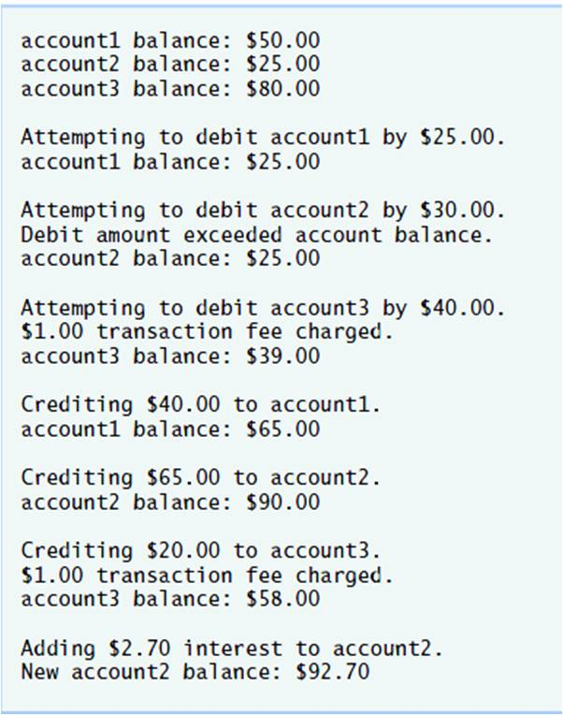
This assignment comes with a CISP405V6AD5.zip file. It includes one file, CISP405V6AD5.exe. The CISP405V6AD5.exe file is an executable file. You can double click the file to get to the expecting results of this assignment.

After you finish your implementation for the this program please document your .cs files properly (Please refer to news area (example of good standard assignment files and etc.) of the class website for more detail) and zip the whole program into a properly named zip file for this assignment (refer to the assignment section of the class syllabus) and submit it to the A5 dropbox of the D2L Website.

Worth 180 points

