You can choose to submit either A2 (worth 150 points), AD2 (worth 180), or both (worth 180) for 2nd assignment you will get a score for this assignment either 150 points base or 180 points base.

Grading Criteria:
- If the submitted program cannot be compiled or run on Microsoft Visual Studio Community 2017 C# compiler, the assignment will not get any credit.
- If the file name does not follow the naming instruction as stated in syllabus, the assignment will get 5 to 15 points deduction.
- If the header section of the submitted file does not include personal information and purpose of the file, the assignment will get 5 to 30 points deduction.
- Late assignments will not get any credit for the assignment.
- A submission does not follow the instructions of the assignment will get little credit.
- A portion of the assignment is not finished or incomplete will get little or no credit.
- Submit an assignment to a wrong drop box. The wrong drop box one will not get any credit.
- If use A for AD or AD for A assignments in the file name, the student will not get any credit for the assignments.
- If the submitted file(s) cannot be opened by the instructor’s software (WinZip, Visual Studio, or text editor) the assignment will have little credit.
- If the submission file does not include all necessary programming files to run the program, the program will get little credit.
- If the program does not separate into several files (driver, header file, implementation file, etc.) as describe in the assignment, the program will get little credit.
- If the displaying result of the program is not exactly match with the graphic in the assignment description or the displaying result of the executable file which comes with the assignment, the assignment will get little credit.
- If the program does not have enough detail documentation in the programming area the program will get 5 to 30 points deduction.
- If the program includes some unrelated documentation the program will get some points deduction.

A2.

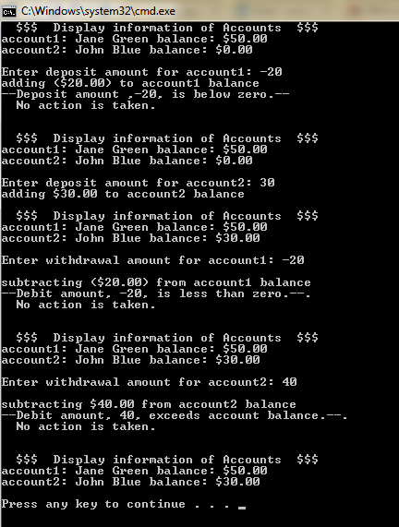
Modify class Account (Fig. 4.11) to provide a method called Debit that withdraws money from an Account. Ensure that the debit amount does not exceed the Account’s balance and not below zero. If it does, the balance should be left unchanged and the method should display a message indicating "--Debit amount, $$ , exceeds account balance--. No action is taken." and “--Debit amount, $$, is less than zero--. No action is taken." Also need to modify the Deposit function to detect a negative deposit, the balance stays the same and will display "--Deposit amount , $$, is below zero--. No action is taken."

Modify class AccountTest (Fig. 4.12) to test method Debit and Deposit to display results as the right side of the picture.

This assignment comes with a CISP405V6A2.zip file. It includes three files (CISP405V6A2.exe, Account.cs and AccountTest.cs). The CISP405V6A2.exe file is an executable file. You can double click the file and providing proper information to get to the expecting result (see the picture on the right) of this assignment. The Account.cs and AccountTest.cs are the files (Fig. 4.11, and Fig. 4.12) coming from the text book.

After you finish your implementation for the this program please document your .cs files properly (Please refer to news area (example of good standard assignment files and etc.) of the class website for more detail) and zip the whole program into a properly named zip file for this assignment (refer to the assignment section of the class syllabus) and submit it to the A2 dropbox of the D2L Website.

Worth 150 points
AD2

Writing three classes to display shapes and a test program to test them is the main focus for this program.

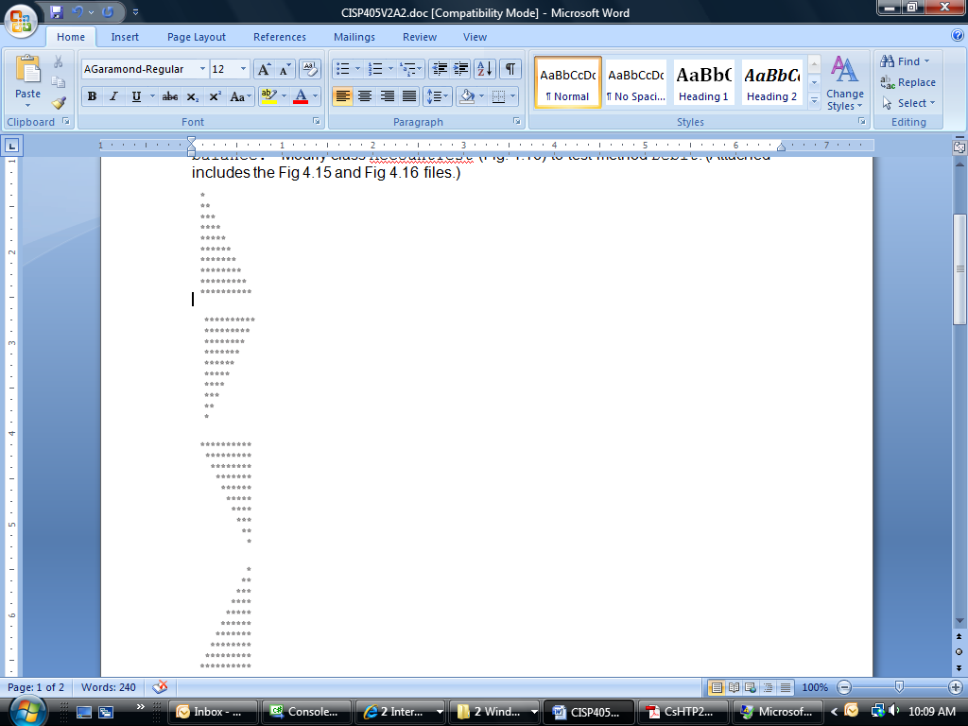
First, write a class application that displays the following patterns separately, one below the other.

Use for loops to generate the patterns. All asterisks (*) should be printed by a single statement of the form Console.Write( '*' ); which causes the asterisks to print side by side. A statement of the form Console.WriteLine(); can be used to move to the next line. A statement of the form Console.Write( ' ' ); can be used to display a space for the last two patterns. There should be no other output statements in the application.

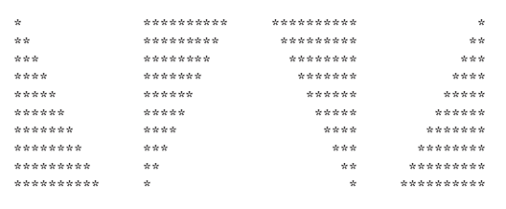
Second class should print four patterns side by side. You can combine your code from the four separate triangles of asterisks in the first class. Make clever use of nested for loops.
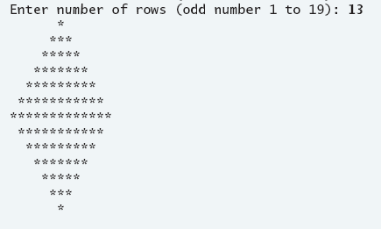
Third class reads an odd number in the range 1 to 19 to specify the number of rows in the diamond. Your application should then display a diamond of the appropriate size.

The test program should have the following selection:

Enter a selection from the following list:
a. Display all Triangle shapes one below the other.
b. display all Triangle shapes side by side.
c. display a diamond of the appropriate size
e. Exit this program

When a selection is chose a proper class will be instantiated or exit the program. If not a proper selection is inputted the program should display a message and allow user to reenter.

This assignment comes with a CISP405V6AD2.zip file. It includes one file,CISP405V6AD2.exe. The CISP405V6AD2.exe file is an executable file. You can double click the file to get to the expecting result of this assignment, see pictures below:
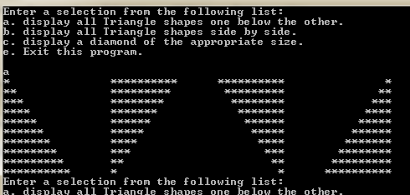 | 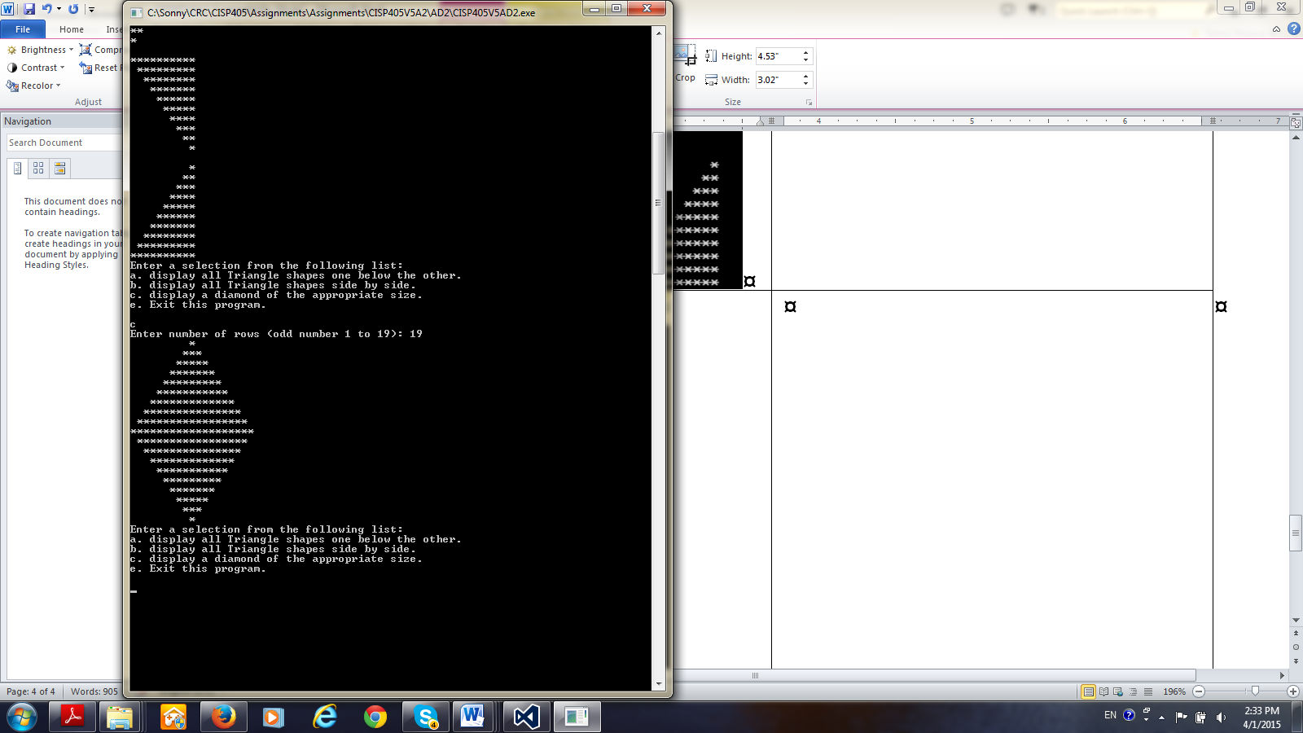
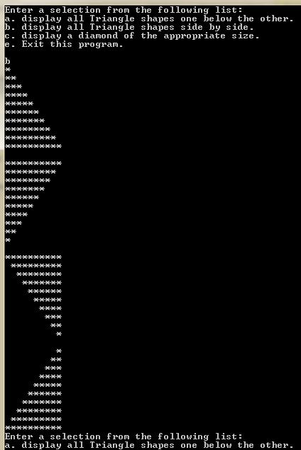 | 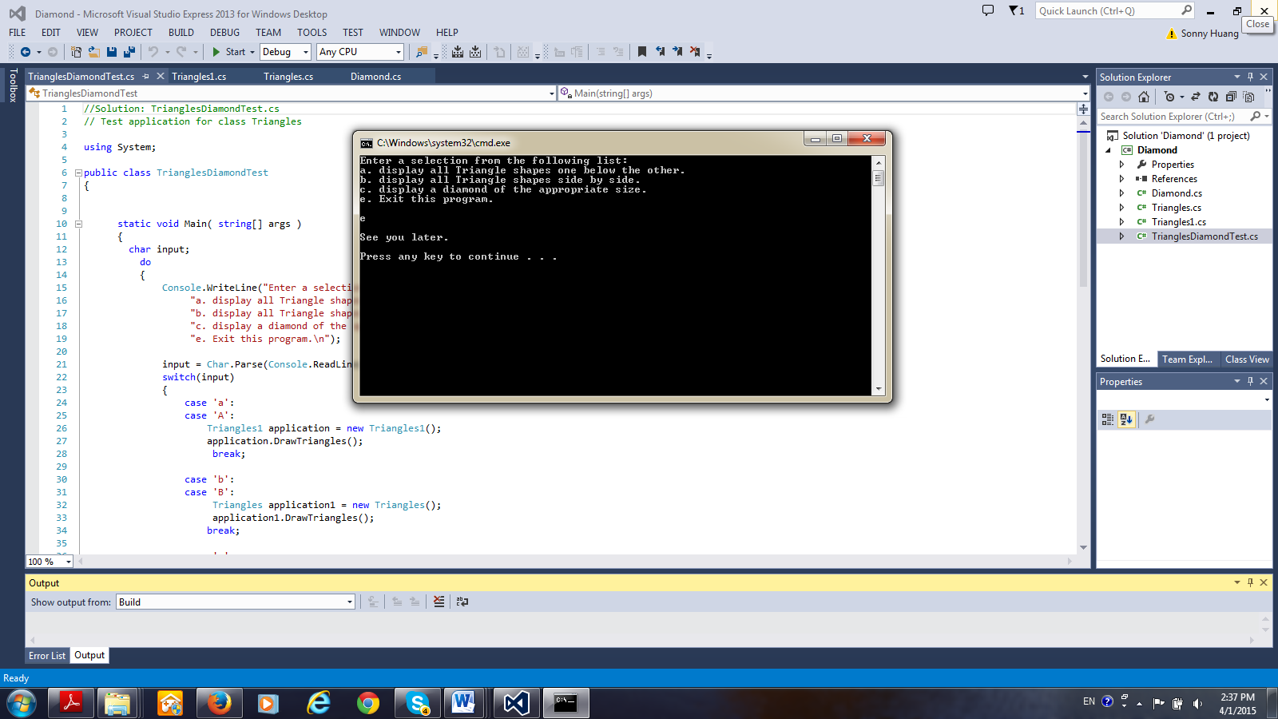

After you finish your implementation for the this program please document your .cs files properly (Please refer to news area (example of good standard assignment files and etc.) of the class website for more detail) and zip the whole program into a properly named zip file for this assignment (refer to the assignment section of the class syllabus) and submit it to the A2 dropbox of the D2L Website.

Worth 180 points

