You can choose to submit either A1 (worth 150 points), AD1 (worth 180), or both (worth 180) for 1st assignment you will get a score for this assignment either 150 points base or 180 points base.

Grading Criteria:
- If the submitted program cannot be compiled or run on a Microsoft Visual Studio Community 2017 C# compiler, the assignment will not get any credit.
- If the file name does not follow the naming instruction as stated in syllabus, the assignment will get 5 to 15 points deduction.
- If the header section of the submitted file does not include personal information and purpose of the file, the assignment will get 5 to 30 points deduction.
- Late assignments will not get any credit for the assignment.
- A submission does not follow the instructions of the assignment will get little credit.
- A portion of the assignment is not finished or incomplete will get little or no credit.
- Submit an assignment to a wrong drop box. The wrong drop box one will not get any credit.
- If use A for AD or AD for A assignments in the file name, the student will not get any credit for the assignments.
- If the submitted file(s) cannot be opened by the instructor’s software (WinZip, Visual Studio, or text editor) the assignment will have little credit.
- If the submission file does not include all necessary programming files to run the program, the program will get little credit.
- If the program does not separate into several files (driver, header file, implementation file, etc.) as describe in the assignment, the program will get little credit.
- If the displaying result of the program is not exactly match with the graphic in the assignment description or the displaying result of the executable file which comes with the assignment, the assignment will get little credit.
- If the program does not have enough detail documentation in the programming area the program will get 5 to 30 points deduction.
- If the program includes some unrelated documentation the program will get some points deduction.

A1

Create the GUI for the calendar and appointments as in the following picture.
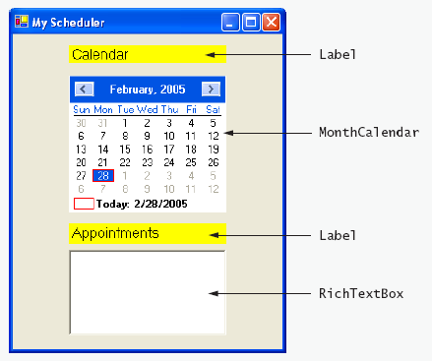
a) Manipulating the Form’s properties. Change the Text property of the Form to My Scheduler. Set the Form’s Size property to 332, 470.
b) Adding Labels to the Form. Add two Labels to the Form. Set the Labels’ AutoSize properties to False. Both should be of equal size (178, 21) and should be centered in the Form horizontally, as shown. Set the Label’s Text properties to match the figure as shown, using 12-point font size. Also set the BackColor property to Yellow.
c) Adding a MonthCalendar control to the Form. Add this control to the Form and center it horizontally in the appropriate place between the two Labels.
d) Adding a RichTextBox control to the Form. Add a RichTextBox control to the Form and center it below the second Label. Resize the RichTextBox accordingly.
e) Using a text box to add your name below the RichTextBox.

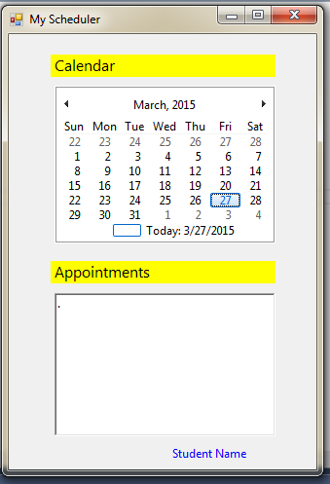
This assignment comes with a CISP405V6A1.zip file. It includes one file (CISP405V6A1.exe). The CISP405V6A1.exe file is an executable file. You can double click the file to get to the expecting result (see the picture on the right) of this assignment.
After you finish your implementation for the this program please document your .cs files properly (Please refer to news area (example of good standard assignment files and etc.) of the class website for more detail) and zip the whole program into a properly named zip file for this assignment (refer to the assignment section of the class syllabus) and submit it to the A1 dropbox of the D2L Website.

Worth 150 points

AD1

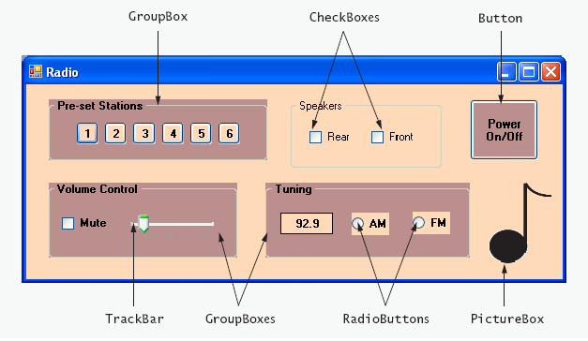
Create the GUI for the radio as shown in the following picture. [Note: All colors used in this exercise are from the Web palettes and you can search for any image for the note picture.
a) Manipulating the Form’s properties. Change the Form’s Text property to Radio and the Size to 576, 240. Set BackColor to PeachPuff.
b) Adding the Pre-set Stations GroupBox and Buttons. Set the GroupBox’s Size to 232, 64, its Text to Pre-set Stations, its ForeColor to Black and its BackColor to RosyBrown. Change its Font to bold. Finally, set its Location to 24, 16. Add six Buttons to the GroupBox. Set each BackColor to PeachPuff and each Size to 24, 23. Change the Buttons’ Text properties to 1, 2, 3, 4, 5 and 6, respectively.
c) Adding the Speakers GroupBox and CheckBoxes. Set the GroupBox’s AutoSize property to False, then set its Size to 160, 72, its Text to Speakers and its ForeColor to Black. Set its Location to 280, 16. Add two CheckBoxes to the GroupBox. Set each CheckBox’s Size to 56, 24. Set the Text properties for the CheckBoxes to Rear and Front.
d) Adding the Power On/Off Button. Add a Button to the Form. Set its Text to Power On/Off, its BackColor to RosyBrown, its ForeColor to Black and its Size to 72, 64. Change its Font style to Bold.
e) Adding the Volume Control GroupBox, the Mute CheckBox and the Volume TrackBar. Add a GroupBox to the Form. Set its Text to Volume Control, its BackColor to RosyBrown, its ForeColor to Black and its Size to 200, 80. Set its Font style to Bold. Add a CheckBox to the GroupBox. Set its Text to Mute, its AutoSize property to False and its Size to 56,24. Add a TrackBar to the GroupBox.
f) Adding the Tuning GroupBox, the radio station Label and the AM/FM RadioButtons. Add a GroupBox to the Form. Set its Text to Tuning, its ForeColor to Black and its BackColor to RosyBrown. Set its Font style to Bold and its Size to 216, 80. Add a Label to the GroupBox. Set its BackColor to PeachPuff, its ForeColor to Black, its BorderStyle to FixedSingle, its Font style to Bold, its TextAlign to MiddleCenter, its AutoSize to False and its Size to 56, 23. Set its Text to 92.9. Place the Label as shown in the figure.
Add two RadioButtons to the GroupBox. Change the BackColor to PeachPuff, set the AutoSize to False and change the Size to 46,24. Set the Text of one to AM and the other’s to FM.
g) Add a PictureBox to the Form. Set its SizeMode to StretchImage and its Size to 55, 70. Set the Image property to MusicNote.gif (or an image you can locate to represent music).
h) Using a text box to add your name below the music node.

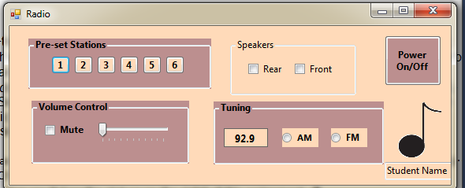
This assignment comes with a CISP405V6AD1.zip file. It includes one file (CISP405V6AD1.exe). The CISP405V6AD1.exe file is an executable file. You can double click the file to get to the expecting result (see the picture on the right) of this assignment.
After you finish your implementation for the this program please document your .cs files properly (Please refer to news area (example of good standard assignment files and etc.) of the class website for more detail) and zip the whole program into a properly named zip file for this assignment (refer to the assignment section of the class syllabus) and submit it to the A1 dropbox of the D2L Website.

Worth 180 points

