You can choose to submit either A5 (worth 150 points), AD5 (worth 180), or both (worth 180) for 5th assignment you will get a score for this assignment either 150 points base or 180 points base.

Grading Criteria:
- If the submitted program cannot be compiled or run on the Microsoft visual studio 2017 C# compiler, the assignment will not get any credit.
- If the file name does not follow the naming instruction as stated in syllabus, the assignment will get 5 to 15 points deduction.
- If the header section of the submitted file does not include personal information and purpose of the file, the assignment will get 5 to 30 points deduction.
- Late assignments will not get any credit for the assignment.
- A submission does not follow the instructions of the assignment will get little credit.
- A portion of the assignment is not finished or incomplete will get little or no credit.
- Submit an assignment to a wrong drop box. The wrong drop box one will not get any credit.
- If use A for AD or AD for A assignments in the file name, the student will not get any credit for the assignments.
- If the submitted file(s) cannot be opened by the instructor’s software (WinZip, Visual Studio, or text editor) the assignment will have little credit.
- If the submission file does not include all necessary programming files to run the program, the program will get little credit.
- If the program does not separate into several files (driver, header file, implementation file, etc.) as describe in the assignment, the program will get little credit.
- If the displaying result of the program is not exactly match with the graphic in the assignment description or the displaying result of the executable file which comes with the assignment, the assignment will get little credit.
- If the program does not have enough detail documentation in the programming area the program will get 5 to 30 points deduction.
- If the program includes some unrelated documentation the program will get some points deduction.

A6

Modify the payroll system of Figs. 12.4–12.9 to include private instance variable birthDate in class Employee. Use class Date of Fig. 10.7 to represent an employee’s birthday. Assume that payroll is processed once per month. Create an array of Employee variables to store references to the various employee objects. In a loop, calculate the payroll for each Employee (polymorphically), and add a $100.00 bonus to the person’s payroll amount if the current month is the month in which the Employee’s birthday occurs. Use the following code to test your classes.

// Solution: PayrollSystemTest.cs
// Employee hierarchy test program.
using System;

public class PayrollSystemTest
{
public static void Main( string[] args )
{
// create derived class objects
SalariedEmployee salariedEmployee1 = new SalariedEmployee( "John",
"Smith", "111-11-1111", 6, 15, 1944, 800M );
HourlyEmployee hourlyEmployee1 = new HourlyEmployee( "Karen",
"Price", "222-22-2222", 12, 29, 1960, 16.75M, 40M );
CommissionEmployee commissionEmployee1 =
new CommissionEmployee( "Sue", "Jones", "333-33-3333",
9, 8, 1954, 10000M, .06M );
BasePlusCommissionEmployee basePlusCommissionEmployee1 =
new BasePlusCommissionEmployee( "Bob", "Lewis", "444-44-4444",
3, 2, 1965, 5000M, .04M, 300M );

SalariedEmployee salariedEmployee2 = new SalariedEmployee( "Afatarli",
"Valeri", "511-11-1111", 1, 5, 1915, 600M );
HourlyEmployee hourlyEmployee2 = new HourlyEmployee( "Henry",
"Buris", "622-22-2222", 2, 9, 1970, 14.75M, 36M );
CommissionEmployee commissionEmployee2 =
new CommissionEmployee( "Anthony", "Doss", "733-33-3333",
4, 18, 1944, 10045M, .07M );
BasePlusCommissionEmployee basePlusCommissionEmployee2 =
new BasePlusCommissionEmployee( "Bob", "Lewis", "844-44-4444",
5, 1, 1960, 4300M, .05M, 290M );

SalariedEmployee salariedEmployee3 = new SalariedEmployee( "Linda",
"Ha", "911-11-1111", 7, 25, 1968, 400M );
HourlyEmployee hourlyEmployee3 = new HourlyEmployee( "Brian",
"Louie", "122-22-2222", 8, 6, 1966, 18.85M, 60M );
CommissionEmployee commissionEmployee3 =
new CommissionEmployee( "Leon", "Powell", "233-33-3333",
10, 22, 1959, 10100M, .07M );
BasePlusCommissionEmployee basePlusCommissionEmployee3 =
new BasePlusCommissionEmployee( "David", "Tong", "344-44-4444",
11, 8, 1970, 5080M, .08M, 400M );

Console.WriteLine( "Employees processed individually:\n" );

Console.WriteLine( "{0}\n{1}: {2:C}\n",salariedEmployee1, "earned", salariedEmployee1.Earnings() );
Console.WriteLine( "{0}\n{1}: {2:C}\n",hourlyEmployee1, "earned", hourlyEmployee1.Earnings() );
Console.WriteLine( "{0}\n{1}: {2:C}\n",commissionEmployee1, "earned", commissionEmployee1.Earnings() );
Console.WriteLine( "{0}\n{1}: {2:C}\n",basePlusCommissionEmployee1,"earned", basePlusCommissionEmployee1.Earnings() );

Console.WriteLine( "{0}\n{1}: {2:C}\n",salariedEmployee2, "earned", salariedEmployee2.Earnings() );
Console.WriteLine( "{0}\n{1}: {2:C}\n",hourlyEmployee2, "earned", hourlyEmployee2.Earnings() );
Console.WriteLine( "{0}\n{1}: {2:C}\n",commissionEmployee2, "earned", commissionEmployee2.Earnings() );
Console.WriteLine( "{0}\n{1}: {2:C}\n",basePlusCommissionEmployee2, "earned", basePlusCommissionEmployee2.Earnings() );

Console.WriteLine( "{0}\n{1}: {2:C}\n", salariedEmployee3, "earned", salariedEmployee3.Earnings() );
Console.WriteLine( "{0}\n{1}: {2:C}\n",hourlyEmployee3, "earned", hourlyEmployee3.Earnings() );
Console.WriteLine( "{0}\n{1}: {2:C}\n",commissionEmployee3, "earned", commissionEmployee3.Earnings() );
Console.WriteLine( "{0}\n{1}: {2:C}\n",basePlusCommissionEmployee3, "earned", basePlusCommissionEmployee3.Earnings() );

// create four-element Employee array
Employee[] employees = new Employee[ 12 ];

// initialize array with Employees
employees[ 0 ] = salariedEmployee1;
employees[ 1 ] = hourlyEmployee1;
employees[ 2 ] = commissionEmployee1;
employees[ 3 ] = basePlusCommissionEmployee1;

employees[ 4 ] = salariedEmployee2;
employees[ 5 ] = hourlyEmployee2;
employees[ 6 ] = commissionEmployee2;
employees[ 7 ] = basePlusCommissionEmployee2;

employees[ 8 ] = salariedEmployee3;
employees[ 9 ] = hourlyEmployee3;
employees[ 10 ] = commissionEmployee3;
employees[ 11 ] = basePlusCommissionEmployee3;

int currentMonth;

// get and validate current month
do
{
Console.Write( "Enter the current month (1 - 12): " );
currentMonth = Convert.ToInt32( Console.ReadLine() );
Console.WriteLine();
} while ( ( currentMonth < 1 ) || ( currentMonth > 12 ) );

Console.WriteLine( "Employees processed polymorphically:\n" );

// generically process each element in array employees
foreach ( var currentEmployee in employees )
{
Console.WriteLine( currentEmployee ); // invokes ToString

// determine whether element is a BasePlusCommissionEmployee
if ( currentEmployee is BasePlusCommissionEmployee )
{
// downcast Employee reference to
// BasePlusCommissionEmployee reference
BasePlusCommissionEmployee employee =
( BasePlusCommissionEmployee ) currentEmployee;

employee.BaseSalary *= 1.1M;
Console.WriteLine(
"new base salary with 10% increase is: {0:C}",
employee.BaseSalary );
} // end if

// if month of employee's birthday, add $100 to salary
if ( currentMonth == currentEmployee.BirthDate.Month )
Console.WriteLine(
"earned {0:C} {1}\n", currentEmployee.Earnings(),
"plus $100.00 birthday bonus" );
else
Console.WriteLine(
"earned {0:C}\n", currentEmployee.Earnings() );
} // end for

// get type name of each object in employees array
for ( int j = 0; j < employees.Length; j++ )
Console.WriteLine( "Employee {0} is a {1}", j,
employees[ j ].GetType() );
} // end Main
} // end class PayrollSystemTest

This assignment comes with a CISP405V6A6.zip file. It includes eight files, CISP405V6A6.exe, Fig. 10.7: Date.cs, Fig. 12.4: Employee.cs, Fig. 12.5: SalariedEmployee.cs, Fig. 12.6: HourlyEmployee.cs, Fig. 12.7: CommissionEmployee.cs, Fig. 12.8: BasePlusCommissionEmployee.cs, and Fig. 12.9: PayrollSystemTest.cs. The CISP405V6A6.exe file is an executable file. You can double click the file to get to the expecting results of this assignment. The following is a display of the result.
.

1  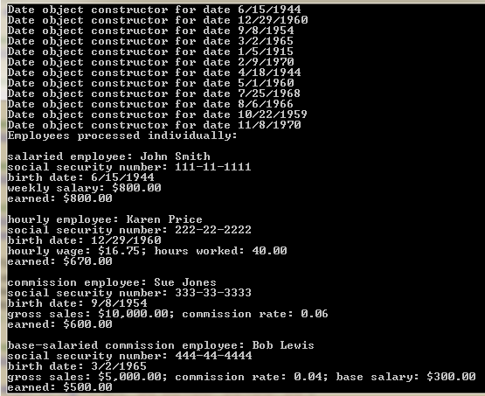 | 2  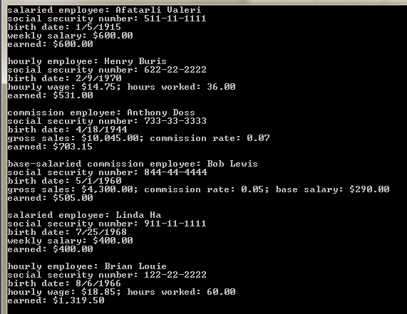
3  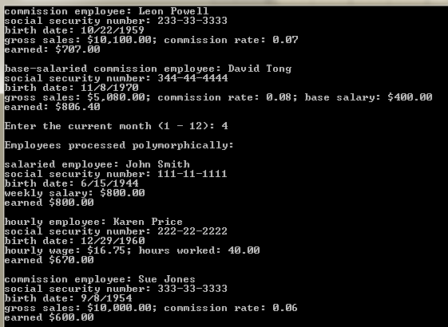 | 4  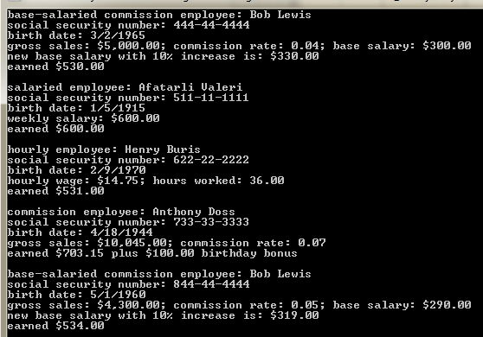
5
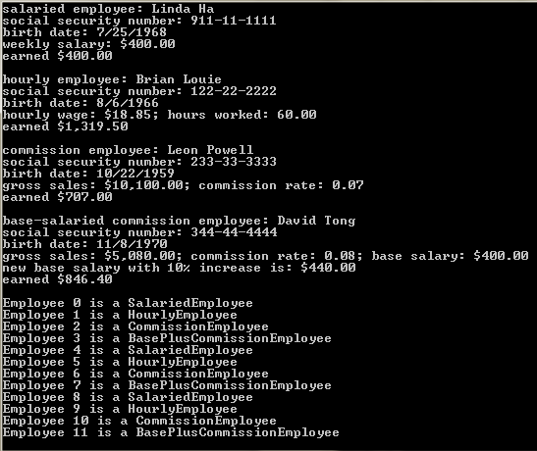

The Fig. 10.7: Date.cs, Fig. 12.4: Employee.cs, Fig. 12.5: SalariedEmployee.cs, Fig. 12.6: HourlyEmployee.cs, Fig. 12.7: CommissionEmployee.cs, Fig. 12.8: BasePlusCommissionEmployee.cs, and Fig. 12.9: PayrollSystemTest.cs are textbook files that you can use for this program.

After you finish your implementation for the this program please document your .cs files properly (Please refer to news area (example of good standard assignment files and etc.) of the class website for more detail) and zip the whole program into a properly named zip file for this assignment (refer to the assignment section of the class syllabus) and submit it to the A6
dropbox of the D2L Website.

Worth 150 points

AD6

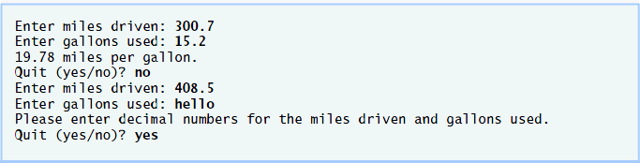
Create an application that inputs miles driven and gallons used, and calculates miles per gallon. The example should use exception handling to process the FormatExceptions that occur when converting the input strings to doubles. If invalid data is entered, display a message informing the user.

This assignment comes with a CISP405V6AD6.zip file. It includes one file, CISP405V6AD6.exe. The CISP405V6AD6.exe file is an executable file. You can double click the file to get to the expecting results of this assignment.

After you finish your implementation for the this program please document your .cs files properly (Please refer to news area (example of good standard assignment files and etc.) of the class website for more detail) and zip the whole program into a properly named zip file for this assignment (refer to the assignment section of the class syllabus) and submit it to the A6 dropbox of the D2L Website.

Worth 180 points

