You can choose to submit either A4 (worth 150 points), AD4 (worth 180), or both (worth 180) for 4th assignment you will get a score for this assignment either 150 points base or 180 points base.

Grading Criteria:
- If the submitted program cannot be compiled or run on the Microsoft Visual Studio Community 2017 C# compiler, the assignment will not get any credit.
- If the file name does not follow the naming instruction as stated in syllabus, the assignment will get 5 to 15 points deduction.
- If the header section of the submitted file does not include personal information and purpose of the file, the assignment will get 5 to 30 points deduction.
- Late assignments will not get any credit for the assignment.
- A submission does not follow the instructions of the assignment will get little credit.
- A portion of the assignment is not finished or incomplete will get little or no credit.
- Submit an assignment to a wrong drop box. The wrong drop box one will not get any credit.
- If use A for AD or AD for A assignments in the file name, the student will not get any credit for the assignments.
- If the submitted file(s) cannot be opened by the instructor’s software (WinZip, Visual Studio, or text editor) the assignment will have little credit.
- If the submission file does not include all necessary programming files to run the program, the program will get little credit.
- If the program does not separate into several files (driver, header file, implementation file, etc.) as describe in the assignment, the program will get little credit.
- If the displaying result of the program is not exactly match with the graphic in the assignment description or the displaying result of the executable file which comes with the assignment, the assignment will get little credit.
- If the program does not have enough detail documentation in the programming area the program will get 5 to 30 points deduction.
- If the program includes some unrelated documentation the program will get some points deduction.

A4

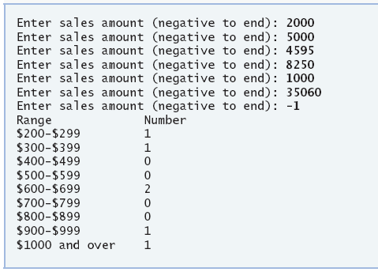
Use a one-dimensional array to solve the following problem: A company pays its salespeople on a commission basis. The salespeople receive $200 per week plus 9% of their gross sales for that week. For example, a salesperson who grosses $5000 in sales in a week receives
$200 plus 9% of $5000, or a total of $650.Write an application (using an array of counters)
that determines how many of the salespeople earned salaries in each of the following ranges (assume that each salesperson’s salary is truncated to an integer amount):
a) $200–299
b) $300–399
c) $400–499
d) $500–599
e) $600–699
f) $700–799
g) $800–899
h) $900–999
i) $1000 and over
Summarize the results in tabular format.
This assignment comes with a CISP405V6A4.zip file. It includes one file (CISP405V6A4.exe). The CISP405V6A4.exe file is an executable file. You can double click the file to get to the expecting results of this assignment.

After you finish your implementation for the this program please document your .cs files properly (Please refer to news area (example of good standard assignment files and etc.) of the class website for more detail) and zip the whole program into a properly named zip file for this assignment (refer to the assignment section of the class syllabus) and submit it to the A4 dropbox of the D2L Website.

Worth 150 points

AD4
Write a console application that inserts 30 random letters into a List< string >. The letters are less than 10 characters long. Perform the following queries on the List and display your results: [Hint: Strings can be indexed like arrays to access a character at a specific index.]
a) Use LINQ to sort the List in ascending order.
b) Use LINQ to sort the List in descending order.
c) Display the List in ascending order with duplicates removed.
This assignment comes with a CISP405V6AD4.zip file. It includes one file (CISP405V6AD4.exe). The CISP405V6AD4.exe file is an executable file. You can double click the file to get to the expecting results of this assignment.
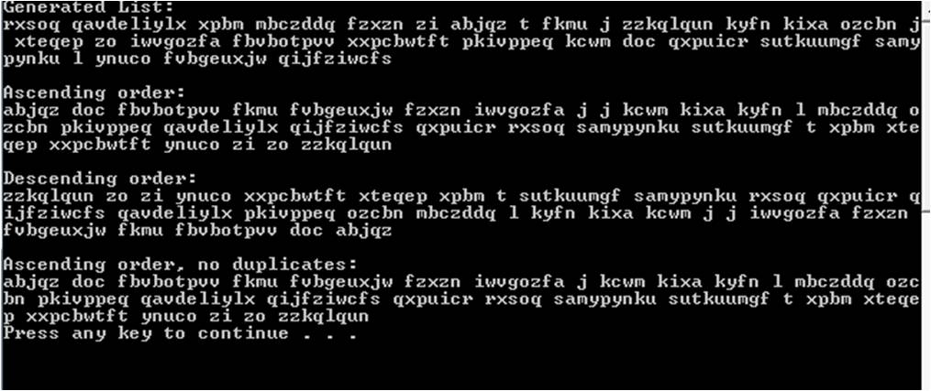
After you finish your implementation for the this program please document your .cs files properly (Please refer to news area (example of good standard assignment files and etc.) of the class website for more detail) and zip the whole program into a properly named zip file for this assignment (refer to the assignment section of the class syllabus) and submit it to the A4 dropbox of the D2L Website.

Worth 180 Points

