You can choose to submit either A3 (worth 150 points), AD3 (worth 180), or both (worth 180) for 3rd assignment you will get a score for this assignment either 150 points base or 180 points base.

Grading Criteria:
- If the submitted program cannot be compiled or run on Microsoft Visual Studio Community 2017 C# compiler, the assignment will not get any credit.
- If the file name does not follow the naming instruction as stated in syllabus, the assignment will get 5 to 15 points deduction.
- If the header section of the submitted file does not include personal information and purpose of the file, the assignment will get 5 to 30 points deduction.
- Late assignments will not get any credit for the assignment.
- A submission does not follow the instructions of the assignment will get little credit.
- A portion of the assignment is not finished or incomplete will get little or no credit.
- Submit an assignment to a wrong drop box. The wrong drop box one will not get any credit.
- If use A for AD or AD for A assignments in the file name, the student will not get any credit for the assignments.
- If the submitted file(s) cannot be opened by the instructor’s software (WinZip, Visual Studio, or text editor) the assignment will have little credit.
- If the submission file does not include all necessary programming files to run the program, the program will get little credit.
- If the program does not separate into several files (driver, header file, implementation file, etc.) as describe in the assignment, the program will get little credit.
- If the displaying result of the program is not exactly match with the graphic in the assignment description or the displaying result of the executable file which comes with the assignment, the assignment will get little credit.
- If the program does not have enough detail documentation in the programming area the program will get 5 to 30 points deduction.
- If the program includes some unrelated documentation the program will get some points deduction.

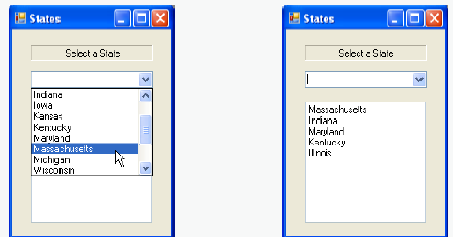
A3

Write a program with a ComboBox and a ListBox. The program displays the names of 15 states in a ComboBox first and the ListBox is empty. When an item is selected from the ComboBox removes the item from the ComboBox and add it to the ListBox. Your program should check to ensure that the ComboBox contains at least one item. If it does not, print a message, using a message box, then terminate program execution when the user dismisses the message box.
The first screen of the program run. 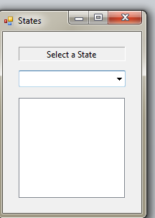 | Click on the dropdown box to display first 8 of the 15 states in the ComboBox.  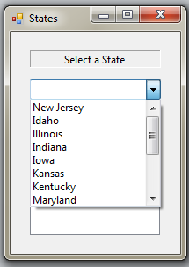
Click on any of the state listed in the Combox, in this example we choose Indiana.  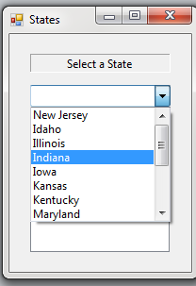 | Then the Indiana appears in the ListBox and disappear in the ComboBox.  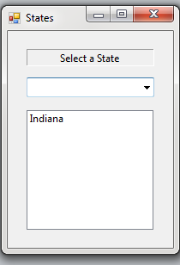

After click on all the 15 state listed in the ComboBox, an “Empty” appears to show there are no more states in the ComboBox.
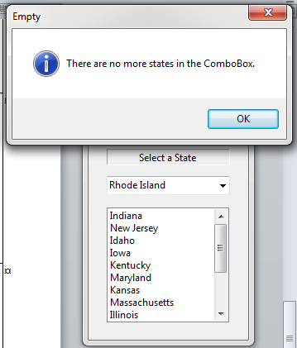

This assignment comes with a CISP405V6A3.zip file. It includes one file (CISP405V6A3.exe). The CISP405V6A3.exe file is an executable file. You can double click the file to get to the expecting results of this assignment. The above are some of the displays.

After you finish your implementation for the this program please document your .cs files properly (Please refer to news area (example of good standard assignment files and etc.) of the class website for more detail) and zip the whole program into a properly named zip file for this assignment (refer to the assignment section of the class syllabus) and submit it to the A3 dropbox of the D2L Website.

Worth 150 points

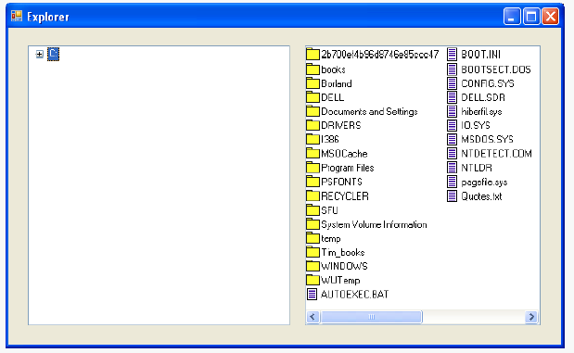
AD3

Create a file browser (similar to Windows Explorer) based on the programs in Figs. 15.14, 15.28 and 15.31. The file browser should have a TreeView, which allows the user to browse directories. There should also be a ListView, which displays the contents (all subdirectories and files) of the directory being browsed. Double clicking a file in the ListView should open it, and double clicking a directory in either the ListView or the TreeView should browse it. If a file or directory cannot be accessed because of its permission settings, notify the user.

This assignment comes with a CISP405V6AD3.zip file. It includes four files,CISP405V6AD3.exe, LinkLabelTestForm.cs, ListViewTestForm.cs, and TreeViewDirectoryStructureForm.cs. The CISP405V6AD3.exe file is an executable file. You can double click the file to get to the expecting result of this assignment.

The LinkLabelTestForm.cs is the Fig. 15.14, the TreeViewDirectoryStructureForm.cs is the Fig. 15.28, and the ListViewTestForm.cs is the Fig. 15.31.

After you finish your implementation for the this program please document your .cs files properly (Please refer to news area (example of good standard assignment files and etc.) of the class website for more detail) and zip the whole program into a properly named zip file for this assignment (refer to the assignment section of the class syllabus) and submit it to the A3 dropbox of the D2L Website.

Worth 180 points

