## Springboot整合MarkDown

### 1添加依赖

<properties>

<commonmark.version>0.15.0</commonmark.version>

</properties>

<!--引入atlassian（将markdown形式转成html格式的）-->

<dependency>

<groupId>com.atlassian.commonmark</groupId>

<artifactId>commonmark</artifactId>

<version>${commonmark.version}</version>

</dependency>

<dependency>

<groupId>com.atlassian.commonmark</groupId>

<artifactId>commonmark-ext-gfm-tables</artifactId>

<version>${commonmark.version}</version>

</dependency>

<dependency>

<groupId>com.atlassian.commonmark</groupId>

<artifactId>commonmark-ext-heading-anchor</artifactId>

<version>${commonmark.version}</version>

</dependency>

### 2.下载Markdown插件

Markdown官网：

<https://pandao.github.io/editor.md/>

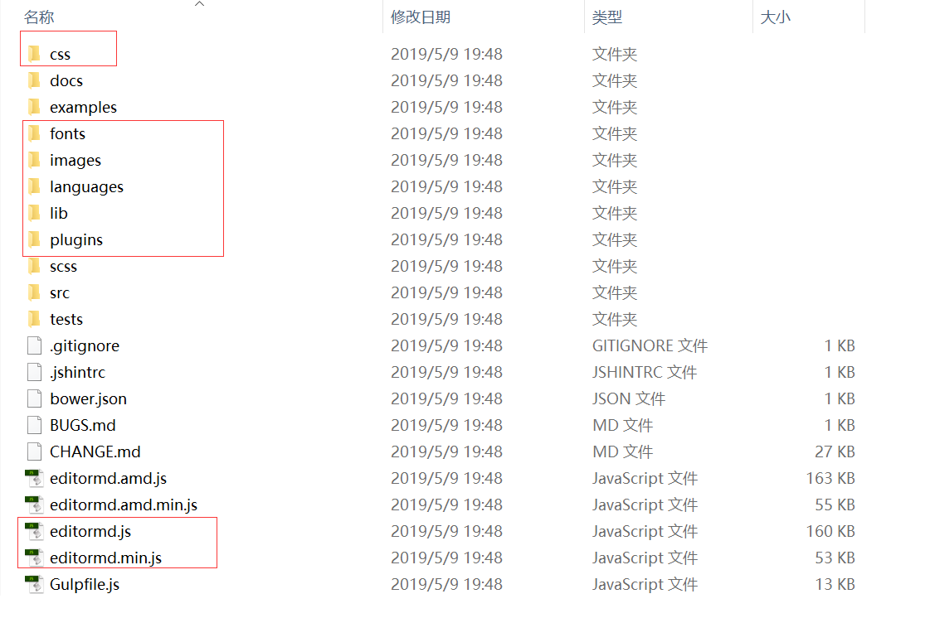

将css、fonts、images、languages、lib、plugins文件夹,editormd.js和editormd.min.js文件放入静态资源存放目录；

3.前端页面引用

<link rel=*"stylesheet"* href=*"${ctxPath}/md/css/editormd.min.css"* />

<script type=*"text/javascript"* src=*"${ctxPath}/md/editormd.min.js"* ></script>