云端服务器安装手册 2
修改IP 2
安裝中文 2
一 搭建mongo集群 3
1 下载、安装MongoDB 4
2环境变量配置 5
3 创建目录 5
4 Config server配置 6
5 Shard server配置 6
6 mongos server路由服务器 9
7 启动服务并初始化 9
8启动命令汇总 12
二 搭建mongo单机版集群 12
0. 环境变量配置 12
1. 安装mongodb 13
2创建数据目录 13
3. 配置节点 14
4 分片节点 17
4.1 配置 17
5 mongos节点 22
6 清除数据 24
三 APPServer 24
1. 安装mysql jdk 24
2. 主从备份 28
3 NGINX配置主从备份 33
4. 安装kafka 34
5. 安装nginx 35
6. 安装svn 36
四 Redis 36
1.安装 36
1.1 在线安装 36
1.2 离线安装 36
2.启动 Redis 37
3. 修改配置文件 38
4. 远程访问 39
5.开机自启 39
五 设置开机自启 40
1. 启动kafka和平台、云端服务 （mysql版） 40
2. 启动kafka和平台、云端服务 （mongo版） 41
六 设置定时任务 43
1. 系统定时 43
2 设置定时任务查看mysql状态 44
七 设置关机清理 45
八 常用指令 47
1. 指令1 47
2. second查看数据 49
九 可视化工具PMM 49
十：Nginx代理http和websocket 50
注： 50
1.无法启动问题 50
2. 无法删除问题 54
3.创建索引问题 54
4. 指定配置文件运行 56
5.mongo分片挂掉 57
6.chunk太大，无法迁移 60

云端服务器安装手册

修改IP
Root用户下 修改/etc/network/ interfaces
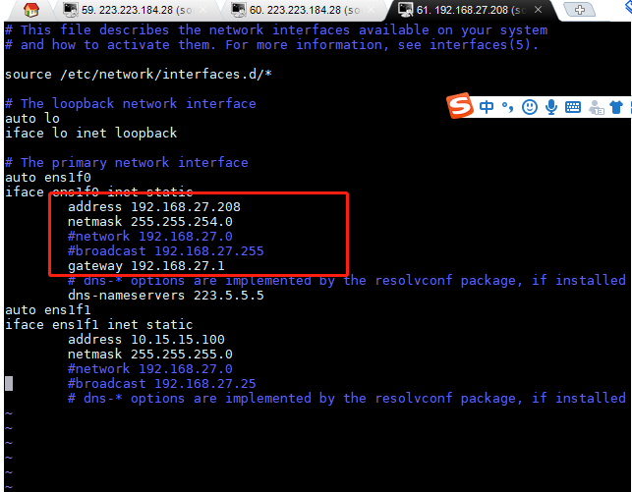

安裝中文
sudo apt-get install language-pack-zh-hans
然后，修改/etc/environment（在文件的末尾追加）：

LANG="zh_CN.UTF-8"
LANGUAGE="zh_CN:zh:en_US:en"

再修改/var/lib/locales/supported.d/local(没有这个文件就新建，同样在末尾追加)：
en_US.UTF-8 UTF-8
zh_CN.UTF-8 UTF-8
zh_CN.GBK GBK
zh_CN GB2312

最后，执行命令：
sudo locale-gen

对于中文乱码是空格的情况，安装中文字体解决。

sudo apt-get install fonts-droid-fallback ttf-wqy-zenhei ttf-wqy-microhei fonts-arphic-ukai fonts-arphic-uming

一 搭建mongo集群
参考：
https://blog.csdn.net/warrah/article/details/84107049
https://www.jianshu.com/p/e1855a1d38b7

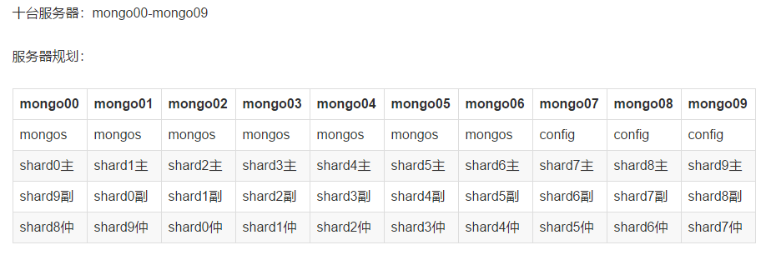

端口分配：
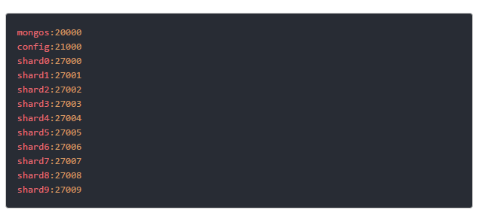

准备：
关闭防火墙
# 停止firewall
systemctl stop firewalld.service
# 禁止firewall开机启动
systemctl disable firewalld.service
# 查看防火墙状态
firewall-cmd –state

1 下载、安装MongoDB
安装包
链接：https://pan.baidu.com/s/1OHJHweNyQAqLJD0i5d9J0g
提取码：h8g3

解压重命名到usr/local 下
#解压
tar -xzvf mongodb-linux-x86_64-rhel70-4.0.2.tgz -C /usr/local/
cd /usr/local
mv mongodb-linux-x86_64-rhel70-4.0.2 mongodb

2环境变量配置
vim /etc/profile
#加入以下内容
export MONGODB_HOME=/usr/local/mongodb
export PATH=$MONGODB_HOME/bin:$PATH
#立即生效
source /etc/profile
使用命令mongod -v输出信息版本信息验证环境变量是否配置成功

3 创建目录
每个机子上创建目录，比如10台机器，找3台机器当初配置服务器，建立每个机器上都建立/data/mongodb/config/data /data/mongodb/mongos/log 目录；每台机器都当成分片节点，建立shard目录，但是分片规则使得每台机子上建立的目录也不一样，前3台机器都建立shard1,shard2,shard3目录，第4-6台建立shard4,shard5,shard6目录，以此类推，3台机器互相作为批次的副节点和仲裁节点；选取几台机器当作路由几点，建立/data/mongodb/mongos/log 目录。

#建立mongos及日志目录
mkdir -p /data/mongodb/mongos/log
#建立config server 数据文件存放目录
mkdir -p /data/mongodb/config/data
#建立config server 日志文件存放目录
mkdir -p /data/mongodb/config/log
#建立shard1 数据文件存放目录
mkdir -p /data/mongodb/shard1/data
#建立shard1 日志文件存放目录
mkdir -p /data/mongodb/shard1/log
#建立shard2 数据文件存放目录
mkdir -p /data/mongodb/shard2/data
#建立shard2 日志文件存放目录
mkdir -p /data/mongodb/shard2/log
#建立shard3 数据文件存放目录
mkdir -p /data/mongodb/shard3/data
#建立shard3 日志文件存放目录
mkdir -p /data/mongodb/shard3/log

4 Config server配置
执行vi /data/mongodb/config/config.conf

# config.conf
# where to write logging data.
systemLog:
destination: file
logAppend: true
path: /data/mongodb/config/log/config.log

# Where and how to store data.
storage:
dbPath: /data/mongodb/config/data
journal:
enabled: true

# how the process runs
processManagement:
fork: true
pidFilePath: /data/mongodb/config/log/configsrv.pid

# network interfaces
net:
port: 21000
bindIp: 0.0.0.0

#operationProfiling:
replication:
replSetName: configs

sharding:
clusterRole: configsvr

5 Shard server配置
vi /data/mongodb/shard1/ shard1.conf

Shard 1副本集

# shared1.conf
systemLog:
destination: file
logAppend: true
path: /data/mongodb/shard1/log/shared1.log

# Where and how to store data.
storage:
dbPath: /data/mongodb/shard1/data
journal:
enabled: true

# how the process runs
processManagement:
fork: true
pidFilePath: /data/mongodb/shard1/log/shard1.pid

# network interfaces
net:
port: 27001
bindIp: 0.0.0.0

#operationProfiling:
replication:
replSetName: shard1

sharding:
clusterRole: shardsvr

Shard 2副本集

# shared2.conf
systemLog:
destination: file
logAppend: true
path: /data/mongodb/shard2/log/shared2.log

# Where and how to store data.
storage:
dbPath: /data/mongodb/shard2/data
journal:
enabled: true

# how the process runs
processManagement:
fork: true
pidFilePath: /data/mongodb/shard2/log/shard2.pid

# network interfaces
net:
port: 27002
bindIp: 0.0.0.0

#operationProfiling:
replication:
replSetName: shard2

sharding:
clusterRole: shardsvr

Shard 3副本集

# shared3.conf
systemLog:
destination: file
logAppend: true
path: /data/mongodb/shard3/log/shared3.log

# Where and how to store data.
storage:
dbPath: /data/mongodb/shard3/data
journal:
enabled: true

# how the process runs
processManagement:
fork: true
pidFilePath: /data/mongodb/shard3/log/shard3.pid

# network interfaces
net:
port: 27003
bindIp: 0.0.0.0

#operationProfiling:
replication:
replSetName: shard3

sharding:
clusterRole: shardsvr

6 mongos server路由服务器
vi /data/mongodb/mongos/ mongos.conf

# mongo.conf
systemLog:
destination: file
logAppend: true
path: /data/mongodb/mongos/log/mongodbmongos.log
processManagement:
fork: true
# network interfaces
net:
port: 20000
bindIp: 0.0.0.0
#监听的配置服务器,只能有1个或者3个 configs为配置服务器的副本集名字
sharding:
configDB: configs/192.168.3.140:21000,192.168.3.241:21000,192.168.3.200:21000

7 启动服务并初始化
启动配置服务器，3台都要启动
mongod -f /data/mongodb/config/config.conf
在任何一台config server执行命令mongo --port 21000，进入配置窗口，注意host要改成你自己的

config = {
_id : "configs",
members : [
{_id : 0, host : "172.16.10.227:21000" },
{_id : 1, host : "172.16.10.231:21000" },
{_id : 2, host : "172.16.10.232:21000" }
]
}

#初始化副本集
rs.initiate(config)
#查看分区状态
rs.status();

启动分片服务器
在三台机器上都执行
mongod -f /data/mongodb/shard1/shard1.conf

在任意一台机器上执行mongo --port 27001,接着输入.需要注意的是我在test99上执行，那么就不能在test99上设置arbiterOnly :true，否则就会报章节5.2的错误。
注：priority 越大，为主节点

config = {
_id : "shard1",
members : [
{_id : 0, host : "172.16.10.227:27001", priority : 2 },
{_id : 1, host : "172.16.10.231:27001" , priority : 1},
{_id : 2, host : "172.16.10.232:27001", arbiterOnly :true }
]
}
rs.initiate(config)

另外两个副本按此模式执行，就可以。这样就实现三个仲裁节点的shard

mongod -f /data/mongodb/shard2/shard2.conf
mongo --port 27002
config = {
_id : "shard2",
members : [
{_id : 0, host : "172.16.10.231:27002", priority : 1 },
{_id : 1, host : "172.16.10.232:27002" , priority : 2},
{_id : 2, host : "172.16.10.227:27002", arbiterOnly :true }
]
}
rs.initiate(config)

mongod -f /data/mongodb/shard3/shard3.conf
mongo --port 27003
config = {
_id : "shard3",
members : [
{_id : 0, host : "172.16.10.232:27003", priority : 1 },
{_id : 1, host : "172.16.10.227:27003" , priority : 2},
{_id : 2, host : "172.16.10.231:27003", arbiterOnly :true }
]
}
rs.initiate(config)

mongos server
注意：启动mongodb时，先启动配置服务器和分片服务器，最后启动路由服务器

mongos -f /data/mongodb/mongos/mongos.conf
# 在任意一台路由服务器执行
mongo --port 20000
use admin
sh.addShard("shard1/172.16.10.227:27001, 172.16.10.231:27001, 172.16.10.232:27001")
sh.addShard("shard2/172.16.10.227:27002, 172.16.10.231:27002, 172.16.10.232:27002")
sh.addShard("shard3/172.16.10.227:27003, 172.16.10.231:27003, 172.16.10.232:27003")

如果在上述操作中抛出类似如下的错误信息：
in seed list shard1/192.168.56.191:27017,192.168.56.168:27017,192.168.56.169:27017, host 192.168.56.191:27017 does not belong to replica set shard1
那么将“192.168.56.191:27017”去掉再试试，笔者试过，可以成功，但原因目前还不太清楚。

#查看集群状态
sh.status()

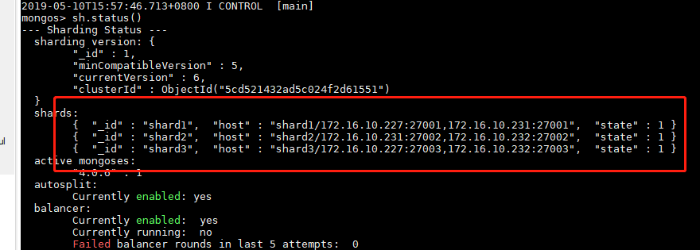
不显示的是每个的arbiterOnly

删除分片
db.runCommand({ removeshard: "shard1" })

# 新建数据manpower
sh.enableSharding('manpower')

8启动命令汇总

mongod -f /data/mongodb/config/config.conf
mongod -f /data/mongodb/shard1/shard1.conf
mongod -f /data/mongodb/shard2/shard2.conf
mongod -f /data/mongodb/shard3/shard3.conf
mongos -f /data/mongodb/mongos/mongos.conf

二 搭建mongo单机版集群
参考
https://blog.csdn.net/weixin_36492969/article/details/81009298

root账号下，进入/opt目录下，下载并解压soft目录

0. 环境变量配置
export JAVA_HOME=/opt/soft/jdk1.8.0_131
export JRE_HOME=$JAVA_HOME/jre
export CLASSPATH=.:$JAVA_HOME/lib:$JRE_HOME/lib:$CLASSPATH
export PATH=$JAVA_HOME/bin:$JRE_HOME/bin:$PATH
export MONGODB_HOME=/opt/mongodb
export PATH=$MONGODB_HOME/bin:$PATH
export LD_LIBRARY_PATH=/usr/local/libpronet/lib:/usr/local/libpromsg/lib:$LD_LIBRARY_PATH

配置完source /etc/profile，以后用root账号前都要执行此操作

安装mongodb
root账号下，进入/opt目录下，下载并解压mongodb目录
sudo apt install mongodb-server

2创建数据目录
root账号下，进入/opt目录下，mkdir data,将下面的压缩包解压，重命名成mongodb




Conf: (c1\c2\c3目录结构一样)


s1: s1代表机器1，下面有3个shard， s2 、s3同理


Mongos: 只需要启动一个mongos即可


3. 配置节点

3.1 配置文件
mongod1.conf：

# config.conf
# where to write logging data.
systemLog:
destination: file
logAppend: true
path: /opt/data/mongodb/conf/c1/log/config.log

# Where and how to store data.
storage:
dbPath: /opt/data/mongodb/conf/c1/data
journal:
enabled: true

# how the process runs
processManagement:
fork: true
pidFilePath: /opt/data/mongodb/conf/c1/data/configsrv.pid

# network interfaces
net:
port: 21001
bindIp: 0.0.0.0

#operationProfiling:
replication:
replSetName: configs

sharding:
clusterRole: configsvr

mongod2.conf：

# config.conf
# where to write logging data.
systemLog:
destination: file
logAppend: true
path: /opt/data/mongodb/conf/c2/log/config.log

# Where and how to store data.
storage:
dbPath: /opt/data/mongodb/conf/c2/data
journal:
enabled: true

# how the process runs
processManagement:
fork: true
pidFilePath: /data/mongodb/conf/c2/data/configsrv.pid

# network interfaces
net:
port: 21002
bindIp: 0.0.0.0

#operationProfiling:
replication:
replSetName: configs

sharding:
clusterRole: configsvr

mongod3.conf：

# config.conf
# where to write logging data.
systemLog:
destination: file
logAppend: true
path: /opt/data/mongodb/conf/c3/log/config.log

# Where and how to store data.
storage:
dbPath: /opt/data/mongodb/conf/c3/data
journal:
enabled: true

# how the process runs
processManagement:
fork: true
pidFilePath: /opt/data/mongodb/conf/c3/data/configsrv.pid

# network interfaces
net:
port: 21003
bindIp: 0.0.0.0

#operationProfiling:
replication:
replSetName: configs

sharding:
clusterRole: configsvr

3.2. 启动配置
mongod --config /opt/data/mongodb/conf/c1/config/mongod.conf
mongod --config /opt/data/mongodb/conf/c2/config/mongod.conf
mongod --config /opt/data/mongodb/conf/c3/config/mongod.conf

3.3. 初始化副本集
mongo --port 21001

cfg={
_id:'configs',
members:[
{_id:0,host:'192.168.2.35:21001'},
{_id:1,host:'192.168.2.35:21002'},
{_id:2,host:'192.168.2.35:21003' }
]
}

rs.initiate(cfg)
执行rs.status()查看集群信息：

4 分片节点

4.1 配置
S1/shard1.conf:

# config.conf
# where to write logging data.
systemLog:
destination: file
logAppend: true
path: /opt/data/mongodb/conf/c1/log/config.log

# Where and how to store data.
storage:
dbPath: /opt/data/mongodb/conf/c1/data
journal:
enabled: true

# how the process runs
processManagement:
fork: true
pidFilePath: /opt/data/mongodb/conf/c1/data/configsrv.pid

# network interfaces
net:
port: 21001
bindIp: 0.0.0.0

#operationProfiling:
replication:
replSetName: configs

sharding:
clusterRole: configsvr

S1/shard2.conf:

#shard2.conf
systemLog:
destination: file
logAppend: true
path: /opt/data/mongodb/s1/shard2/log/shard2.log

# Where and how to store data.
storage:
dbPath: /opt/data/mongodb/s1/shard2/data
journal:
enabled: true

# how the process runs
processManagement:
fork: true
pidFilePath: /opt/data/mongodb/s1/shard2/log/shard2.pid

# network interfaces
net:
port: 27002
bindIp: 0.0.0.0

#operationProfiling:
replication:
replSetName: shard2

sharding:
clusterRole: shardsvr

S1/shard3.conf:

#shard3.conf
systemLog:
destination: file
logAppend: true
path: /opt/data/mongodb/s1/shard3/log/shard3.log

# Where and how to store data.
storage:
dbPath: /opt/data/mongodb/s1/shard3/data
journal:
enabled: true

# how the process runs
processManagement:
fork: true
pidFilePath: /opt/data/mongodb/s1/shard3/log/shard3.pid

# network interfaces
net:
port: 27003
bindIp: 0.0.0.0

#operationProfiling:
replication:
replSetName: shard3

sharding:
clusterRole: shardsvr

S2/shard1.conf:

#shard1.conf
systemLog:
destination: file
logAppend: true
path: /opt/data/mongodb/s2/shard1/log/shard1.log

# Where and how to store data.
storage:
dbPath: /opt/data/mongodb/s2/shard1/data
journal:
enabled: true

# how the process runs
processManagement:
fork: true
pidFilePath: /opt/data/mongodb/s2/shard1/log/shard1.pid

# network interfaces
net:
port: 28001
bindIp: 0.0.0.0

#operationProfiling:
replication:
replSetName: shard1

sharding:
clusterRole: shardsvr

S3/shard1.conf:

#shard1.conf
systemLog:
destination: file
logAppend: true
path: /opt/data/mongodb/s3/shard1/log/shard1.log

# Where and how to store data.
storage:
dbPath: /opt/data/mongodb/s3/shard1/data
journal:
enabled: true

# how the process runs
processManagement:
fork: true
pidFilePath: /opt/data/mongodb/s3/shard1/log/shard1.pid

# network interfaces
net:
port: 29001
bindIp: 0.0.0.0

#operationProfiling:
replication:
replSetName: shard1

sharding:
clusterRole: shardsvr

4.2 启动服务

Shar1:
mongod -f /opt/data/mongodb/s1/shard1/shard1.conf --wiredTigerCacheSizeGB 5
mongod -f /opt/data/mongodb/s2/shard1/shard1.conf --wiredTigerCacheSizeGB 5
mongod -f /opt/data/mongodb/s3/shard1/shard1.conf --wiredTigerCacheSizeGB 5

注意：如果启动27001则不能将27001设置成仲裁节点，既加入arbiterOnly :true属性

mongo --port 27001
config = {
_id : "shard1",
members : [
{_id : 0, host : "192.168.2.35:27001", priority : 2 },
{_id : 1, host : "192.168.2.35:28001" , priority :1},
{_id : 2, host : "192.168.2.35:29001", arbiterOnly :true }
]
}

rs.initiate(config)

Shar2:

mongod -f /opt/data/mongodb/s1/shard2/shard2.conf --wiredTigerCacheSizeGB 5
mongod -f /opt/data/mongodb/s2/shard2/shard2.conf --wiredTigerCacheSizeGB 5
mongod -f /opt/data/mongodb/s3/shard2/shard2.conf --wiredTigerCacheSizeGB 5

mongo --port 28002

config = {
_id : "shard2",
members : [
{_id : 0, host : "192.168.2.35:27002", arbiterOnly :true },
{_id : 1, host : "192.168.2.35:28002", priority : 2},
{_id : 2, host : "192.168.2.35:29002" , priority : 1 }
]
}

rs.initiate(config)

Shar3:

mongod -f /opt/data/mongodb/s1/shard3/shard3.conf --wiredTigerCacheSizeGB 5
mongod -f /opt/data/mongodb/s2/shard3/shard3.conf --wiredTigerCacheSizeGB 5
mongod -f /opt/data/mongodb/s3/shard3/shard3.conf --wiredTigerCacheSizeGB 5

mongo --port 29003

config = {
_id : "shard3",
members : [
{_id : 0, host : "192.168.2.35:27003", priority : 1 },
{_id : 1, host : "192.168.2.35:28003" , arbiterOnly :true },
{_id : 2, host : "192.168.2.35:29003", priority : 2}
]
}

rs.initiate(config)

5 mongos节点

5.1 配置文件
/opt/data/mongodb/mongos/mongos.conf：

# mongo.conf
systemLog:
destination: file
logAppend: true
path: /opt/data/mongodb/mongos/log/mongodbmongos.log
processManagement:
fork: true
# network interfaces
net:
port: 20000
bindIp: 0.0.0.0
#监听的配置服务器,只能有1个或者3个 configs为配置服务器的副本集名字
sharding:
configDB: configs/192.168.3.239:21001, 192.168.3.239:21002, 192.168.3.239:21003

5.2 启动
mongos -f /opt/data/mongodb/mongos/mongos.conf

mongo --port 20000
use admin
sh.addShard("shard1/192.168.3.239:27001, 192.168.3.239:28001, 192.168.3.239:29001")
sh.addShard("shard2/192.168.3.239:27002, 192.168.3.239:28002, 192.168.3.239:29002")
sh.addShard("shard3/192.168.3.239:27003, 192.168.3.239:28003, 192.168.3.239:29003")

sh.addShard("shard1/192.168.2.35:27001")
sh.addShard("shard2/192.168.2.35:28002")
sh.addShard("shard3/192.168.2.35:29003")

如果在上述操作中抛出类似如下的错误信息：
in seed list shard1/192.168.56.191:27017,192.168.56.168:27017,192.168.56.169:27017, host 192.168.56.191:27017 does not belong to replica set shard1
那么将“192.168.56.191:27017”去掉再试试，笔者试过，可以成功，但原因目前还不太清楚,哪个又问他就去掉哪个。

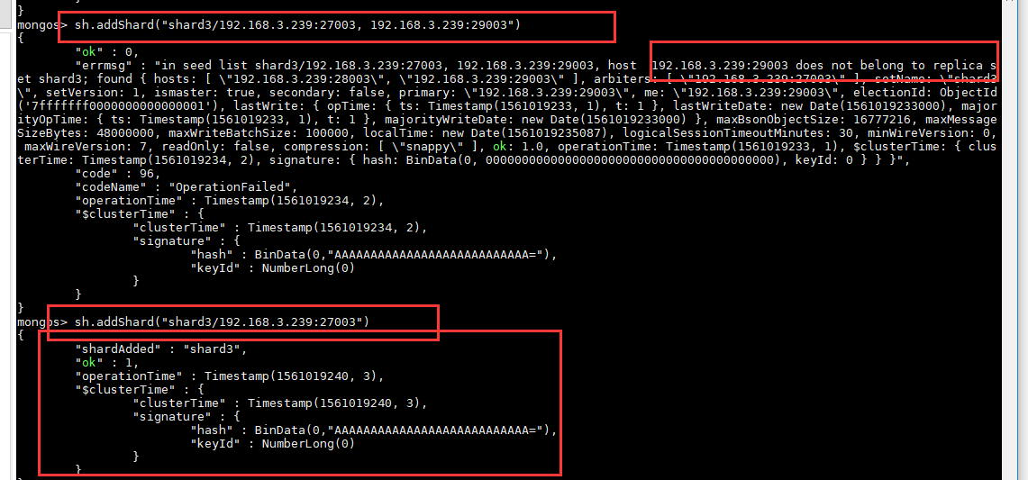

#查看集群状态
sh.status()



删除分片
db.runCommand({ removeshard: "shard1" })

# 新建数据manpower
sh.enableSharding('manpower')

6 清除数据


：

三 APPServer

1. 安装mysql jdk
1.1 解压jdk-8u131-linux-x64.tar.gz
1.2 配置环境变量
export JAVA_HOME=/home/soc/soft/jdk1.8.0_131
export JRE_HOME=$JAVA_HOME/jre
export CLASSPATH=.:$JAVA_HOME/lib:$JRE_HOME/lib:$CLASSPATH
export PATH=$JAVA_HOME/bin:$JRE_HOME/bin:$PATH

1.3 在线安装服务
sudo apt-get install mysql-server
sudo apt-get install mysql-client
sudo apt-get install libmysqlclient-dev

1.3-2 离线安装
参考https://blog.csdn.net/liuhuoxingkong/article/details/80696574
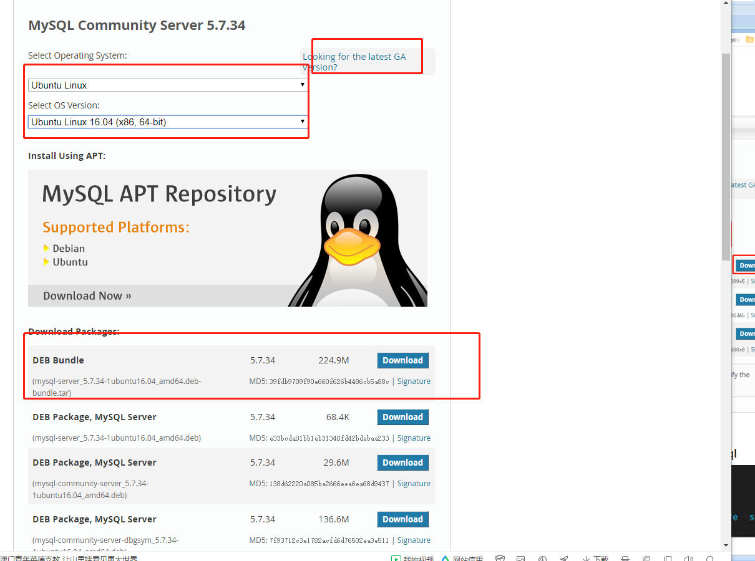
链接：https://pan.baidu.com/s/1mu_e7E-aVQMsKh58vbr9ZA
提取码：1234

sudo dpkg -i mysql-common_5.7.22-1ubuntu16.04_amd64.deb
sudo dpkg-preconfigure mysql-community-server_5.7.22-1ubuntu16.04_amd64.deb
sudo dpkg -i libmysqlclient20_5.7.22-1ubuntu16.04_amd64.deb
sudo dpkg -i libmysqlclient-dev_5.7.22-1ubuntu16.04_amd64.deb
sudo dpkg -i libmysqld-dev_5.7.22-1ubuntu16.04_amd64.deb

sudo dpkg -i libc6_2.19-0ubuntu6_amd64.deb
sudo dpkg -i libaio1_0.3.110-2_amd64.deb

sudo dpkg -i mysql-community-client_5.7.22-1ubuntu16.04_amd64.deb
sudo dpkg -i mysql-client_5.7.22-1ubuntu16.04_amd64.deb
sudo dpkg -i mysql-common_5.7.22-1ubuntu16.04_amd64.deb
sudo dpkg -i libmecab2_0.996-1.2ubuntu1_amd64.deb
sudo dpkg -i mysql-community-server_5.7.22-1ubuntu16.04_amd64.deb

1.4 修改配置文件
sudo vi /etc/mysql/mysql.conf.d/mysqld.cnf
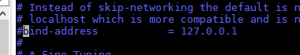
注释掉绑定本机ip这一行

1.5 启动mysql服务
sudo service mysql start

1.6 设置允许远程登录
mysql -uroot -pmy1898sql
use mysql;
grant all privileges on *.* to root@'%' identified by "my1898sql";
flush privileges;

1.7 导入数据库

1.8 设置事件
新建查询 show variables like '%sche%'; 查看事件是否开启
set global event_scheduler =1; 开启事件
创建事件（数据库中已创建好），由于事件是创建3天后的，所以手动创建当前天及明、后天、大后天的表

在my.cnf中的[mysqld]部分添加如下内容，然后重启mysql(mysql重启命令：service mysqld restart)即可永久开启事件：
event_scheduler=ON

1.9 开机自启
执行sysv-rc-conf --level 2345 mysql on，如果提示没有sysv-rc-conf命令，先下载，下载命令：apt-get install sysv-rc-conf
查看服务列表sysv-rc-conf --list mysql，如果看到2345都是on，则设置成功

2.0 设置最大文件打开数
show variables like '%files%';
查看当前数量
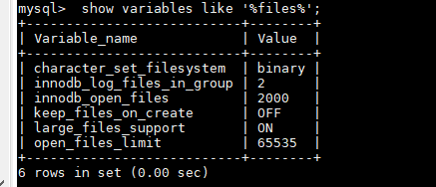

修改配置文件，增加一行，防止mysql自动挂掉；
open_files_limit=65535
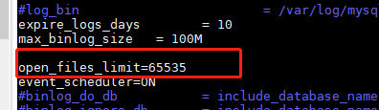
修改/lib/systemd/system/mysql.service
加入LimitNOFILE=65535
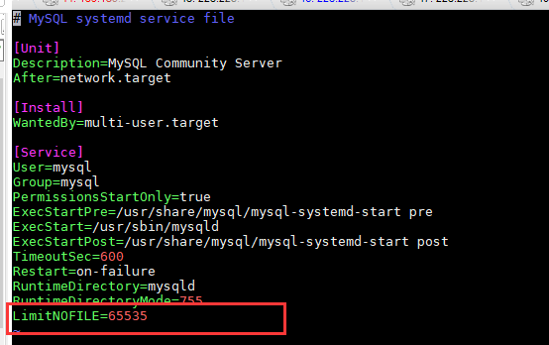

2.11 Mysql8.0安装及设置远程访问
1）下载源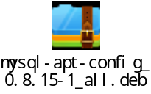
2）安装 参考https://www.cnblogs.com/logBlog/p/11997038.html
注意：第一个是确认密码（设置数据库密码）

另一个是选择加密方式，工具较新选第一个，较老选第二个
3）配置
mysql -uroot –proot
use mysql;
更改加密方式 ALTER USER 'root'@'localhost' IDENTIFIED WITH mysql_native_password BY 'my1898sql';
create user 'root'@'%' identified by 'my1898sql';
grant all privileges on *.* to 'root'@'%';
flush privileges;

4）如果想配置大小写不敏感，先修改配置文件
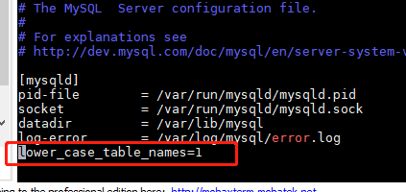
然后清除数据，重启服务
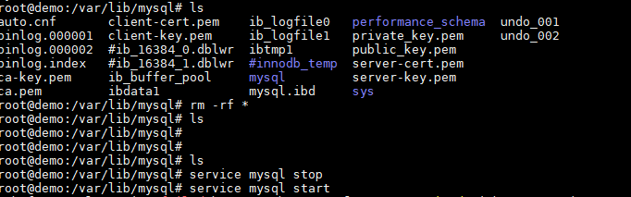

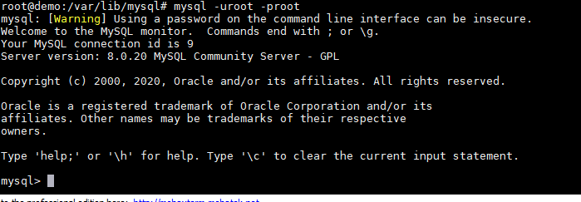
重新进行一遍3步骤即可
mysql -uroot –proot
use mysql;
更改加密方式 ALTER USER 'root'@'localhost' IDENTIFIED WITH mysql_native_password BY 'my1898sql';
create user 'root'@'%' identified by 'my1898sql';
grant all privileges on *.* to 'root'@'%';
flush privileges;

备注：删除用DELETE FROM user Where User='root' and Host='%';
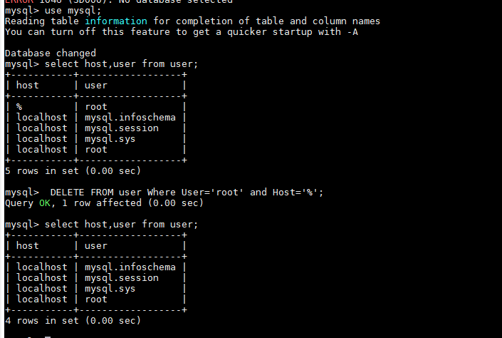

2. 主从备份
参考mysql集群操作，Mysql 主从备份，异地容灾
参考https://blog.csdn.net/qq_22929803/article/details/51254480

安装好以后在192.168.3.239（主）上面的my.cnf文件上面打开一下置灰的参数
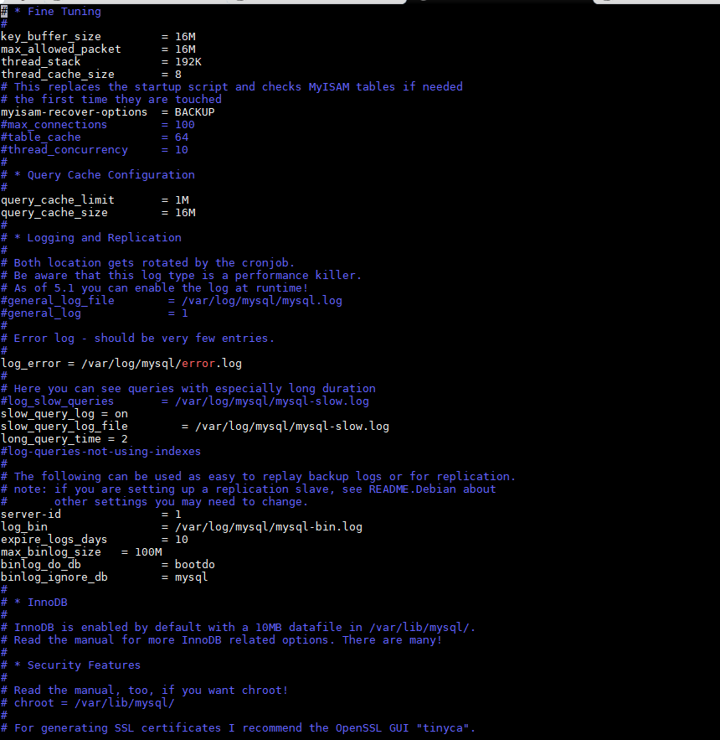

log_error = /var/log/mysql/error.log
#
# Here you can see queries with especially long duration
#log_slow_queries = /var/log/mysql/mysql-slow.log
slow_query_log = on
slow_query_log_file = /var/log/mysql/mysql-slow.log
long_query_time = 2
#log-queries-not-using-indexes
#
# The following can be used as easy to replay backup logs or for replication.
# note: if you are setting up a replication slave, see README.Debian about
# other settings you may need to change.
server-id = 1
log_bin = /var/log/mysql/mysql-bin.log
expire_logs_days = 10
max_binlog_size = 100M
binlog_do_db = bootdo
binlog_ignore_db = mysql

192.168.3.226（从）上面的my.cnf文件加入一下参数

注意：：：：：：：：：： serverid 不能和主一样!!!!!!!!!!!!!!!!!!!!!!!!
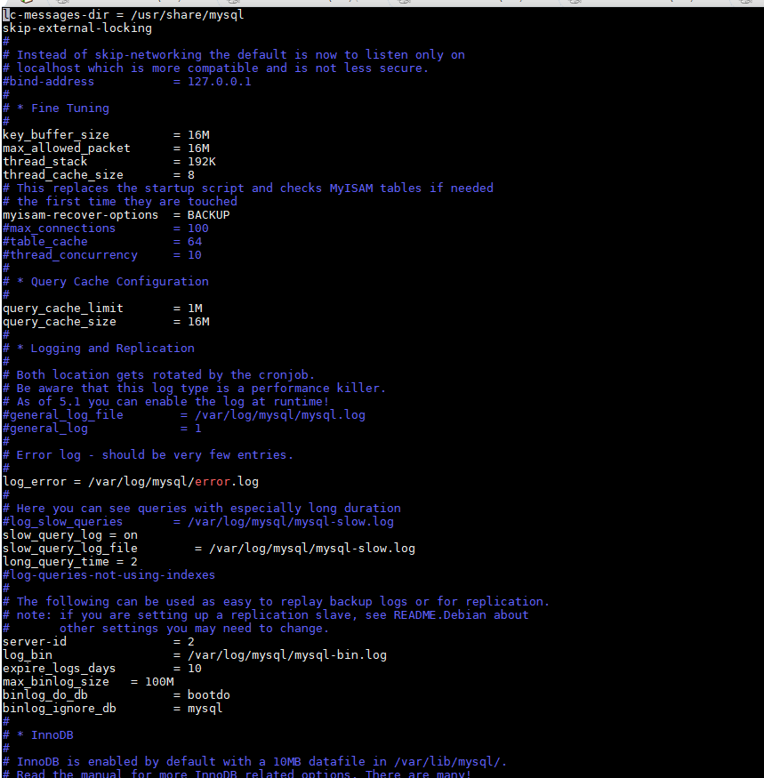

log_error = /var/log/mysql/error.log
#
# Here you can see queries with especially long duration
#log_slow_queries = /var/log/mysql/mysql-slow.log
slow_query_log = on
slow_query_log_file = /var/log/mysql/mysql-slow.log
long_query_time = 2
#log-queries-not-using-indexes
#
# The following can be used as easy to replay backup logs or for replication.
# note: if you are setting up a replication slave, see README.Debian about
# other settings you may need to change.
server-id = 2
log_bin = /var/log/mysql/mysql-bin.log
expire_logs_days = 10
max_binlog_size = 100M
binlog_do_db = bootdo
binlog_ignore_db = mysql

主：
创建用户
CREATE USER 'slaveuser'@'192.168.3.226' IDENTIFIED BY '123456';
#分配权限
GRANT REPLICATION SLAVE ON *.* TO 'slaveuser'@'192.168.3.226';

grant all privileges on *.* TO 'slaveuser'@'192.168.3.226' IDENTIFIED BY '123456' with grand option;
#刷新权限
flush privileges;

先锁表
FLUSH TABLES WITH READ LOCK;

查找postion
主执行：
flush logs;
show master status;
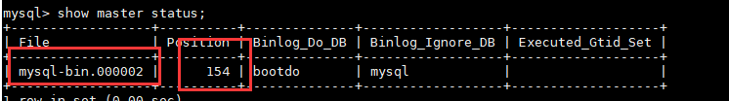
记下File, Position。

使用navicate导入数据库到从库

解锁：
UNLOCK TABLES;
配置从Mysql服务器（192.168.1.90）

停止同步
stop slave;
#执行同步语句
change master to master_host='192.168.3.239',master_user='slaveuser', master_password='123456',
master_port=3306,master_log_file='mysql-bin.000021',master_log_pos=194;

开始同步
start slave;

#查看slave同步信息，出现以下内容
SHOW slave STATUS \G

检查 tail /data/mysql3306/localhost.localdomain.err日志发现提示master and slave have equal MySQL server ids。
my.cnf中确定设置了server_id 分别为1 和2，什么情况呢！！
mysql> show variables like 'server_id'; # 查看server id
单纯的修改my.cnf 和重启无法解决此问题。
最后发现是按照目录下有另外的 my.cnf存在的原因，删除之，解决。
大家一定要留心这样多余的配置文件。

小知识点
1.登陆mysql如果提示错误 Can't connect to local MySQL server through socket '/tmp/mysql.sock'
执行命令 ln /var/lib/mysql/mysql.sock /tmp/mysql.sock 后再登陆

3. 安装kafka
下载解压
修改接收端的server.properties
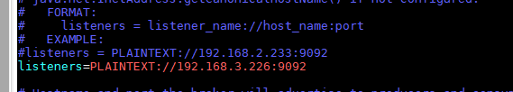

注：如果跨机器访问，则生产者的机器按如上配置，消费者配置成自己IP，只是在创建的时候指向生产者IP即可。如：在226上接收239上的消息bin/kafka-console-consumer.sh --bootstrap-server 192.168.3.23:9092 --topic homepage --from-beginning

bin/zookeeper-server-start.sh config/zookeeper.properties &
bin/kafka-server-start.sh config/server.properties >/dev/null 2>&1 &

创建topic 172.19.152.235
bin/kafka-topics.sh --create --zookeeper 172.16.10.226:2181 --replication-factor 1 --partitions 1 --topic homepage
bin/kafka-topics.sh --create --zookeeper 10.111.254.178:2181 --replication-factor 1 --partitions 1 --topic
bin/kafka-topics.sh --create --zookeeper 47.99.49.244:2181 --replication-factor 1 --partitions 1 --topic alarm1

查看列表
bin/kafka-topics.sh --list --zookeeper 192.168.3.140:2181
bin/kafka-topics.sh --list --zookeeper 10.111.254.178:2181
bin/kafka-topics.sh --list --zookeeper 47.99.49.244:2181

//host.name=192.168.2.233

删除
bin/kafka-topics.sh --delete --zookeeper 192.168.3.140:2181 --topic 主题名称
bin/kafka-topics.sh --delete –zookeeper 47.99.49.244:2181 --topic 主题名称

创建生产者，注意不能写localhost，根据server.propertitys 里的实际ip写
bin/kafka-console-producer.sh --broker-list 47.99.49.244:9092 --topic alarm
创建消费者
bin/kafka-console-consumer.sh --bootstrap-server 192.168.2.233:9092 --topic homepage --from-beginning
bin/kafka-console-consumer.sh --bootstrap-server 192.168.1.34:9092 --topic detail --from-beginning
bin/kafka-console-consumer.sh --bootstrap-server 223.223.184.28:9092 --topic detail --from-beginning
bin/kafka-console-consumer.sh --bootstrap-server 10.111.254.178:9092 --topic white_list_out --from-beginning
bin/kafka-console-consumer.sh --bootstrap-server 10.111.254.178:9092 --topic vehicle_out --from-beginning

4. 安装nginx

4.1 在线安装
https://www.cnblogs.com/EasonJim/p/7806879.html
sudo apt-get install nginx
安装好的文件位置：
/usr/sbin/nginx：主程序
/etc/nginx：存放配置文件
/usr/share/nginx：存放静态文件
/var/log/nginx：存放日志

安装，其中配置文件参考下面配置修改，创建/data/nginx 目录


/usr/sbin/nginx -c /etc/nginx/nginx_cloud.conf

4.2 离线版安装

链接：https://pan.baidu.com/s/1lN02t86aszVqJabD_zfjEw
提取码：1234

./configure --sbin-path=/usr/local/nginx/nginx --conf-path=/usr/local/nginx/nginx.conf --pid-path=/usr/local/nginx/nginx.pid --with-http_ssl_module --with-pcre=/opt/soft/ubuntu16_nginx_offline/pcre-8.38 --with-zlib=/opt/soft/ubuntu16_nginx_offline/zlib-1.2.11 --with-openssl=/opt/soft/ubuntu16_nginx_offline/openssl-1.0.2n

4.3 nginx常用命令
启动 ./nginx
关闭 ./nginx -s stop
重新加载配置 ./nginx -s reload
检查配置文件是否正确nginx -t

4.4 NGINX配置主从备份
新建一个nginx_web.conf
修改端口为8088，增加如下参数

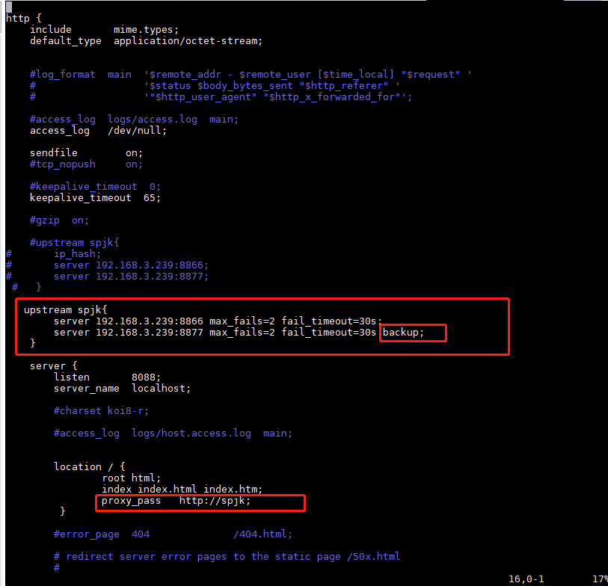
upstream 后面跟着的“spjk”要和 location下 proxy_pass 的 一致，配置完启动nginx
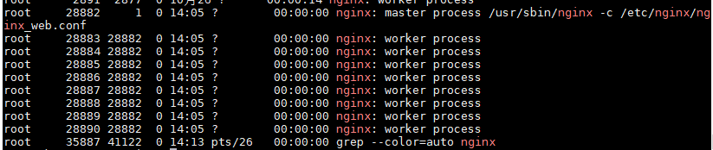
使用 192.168.3.239:8088即可

5. 安装svn
sudo apt-get install subversion

四 Redis
在WEBAPP 226上安装redis服务端，在云端239上远程连接226的redis

1.安装

1.1 在线安装
在 Ubuntu 系统安装 Redis 可以使用以下命令:
$sudo apt-get update
$sudo apt-get install redis-server

1.2 离线安装
wget https://download.redis.io/releases/redis-6.2.3.tar.gz
tar xzf redis-6.2.3.tar.gz
cd redis-6.2.3
make
make install

修改配置文件
/opt/soft/redis-6.2.3/redis.conf
修改以下参数
daemonize yes //是否以后台daemon方式运行，默认不是后台运行
bind 0.0.0.0 //绑定主机IP，默认值为127.0.0.1，我这需要从主机连接虚拟机，所以需要更改

// 启动 redis
redis-server /root/redis/redis.conf
// 连接 redis 服务器
redis-cli

// 连接之后会进入redis操作区
127.0.0.1:6379> set a b
OK
127.0.0.1:6379> get a
"b"
127.0.0.1:6379> exit

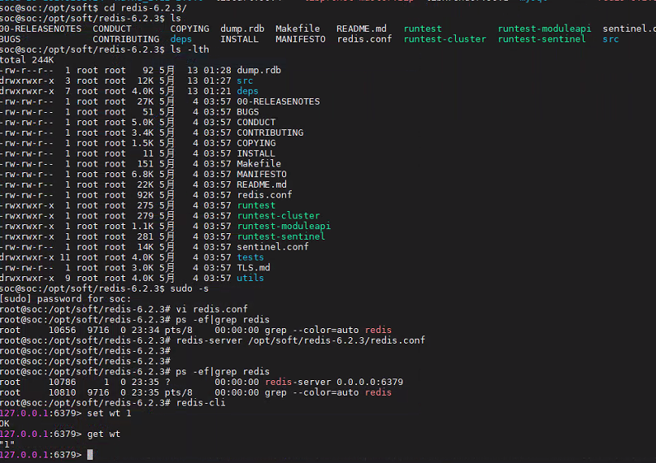

2.启动 Redis
$ redis-server
查看 redis 是否启动？
$ redis-cli
以上命令将打开以下终端：
redis 127.0.0.1:6379>
127.0.0.1 是本机 IP ，6379 是 redis 服务端口。现在我们输入 PING 命令。
redis 127.0.0.1:6379> ping
PONG
测试：
redis> set foo bar
OK
redis> get foo
"bar"

3. 修改配置文件
/etc/redis/ redis.conf
找到bind配置节点，注释此节点，表示不绑定任何目标ip,允许所有ip访问此redis服务。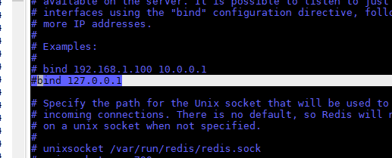
注释掉slave-read-only yes
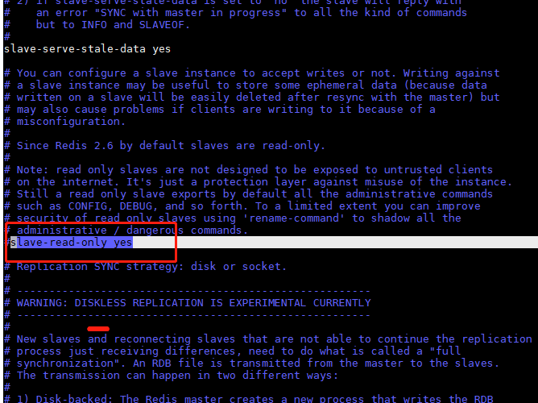
重启服务
/etc/init.d/redis-server restart

4. 远程访问
客户端也安装redis服务，远程访问
redis-cli -h 192.168.3.226 -p 6379
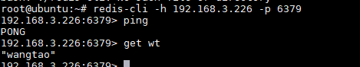

5.开机自启
增加到rc.local里即可

五 设置开机自启

1. 启动kafka和平台、云端服务 （mysql版）
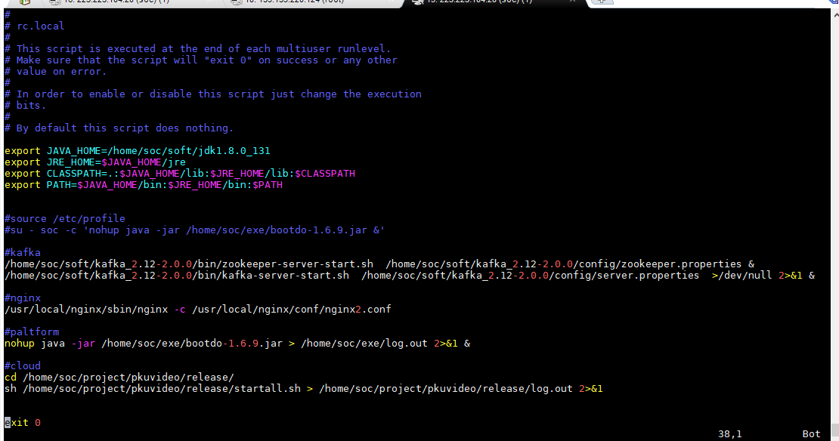

#
# rc.local
#
# This script is executed at the end of each multiuser runlevel.
# Make sure that the script will "exit 0" on success or any other
# value on error.
#
# In order to enable or disable this script just change the execution
# bits.
#
# By default this script does nothing.

export JAVA_HOME=/home/soc/soft/jdk1.8.0_131
export JRE_HOME=$JAVA_HOME/jre
export CLASSPATH=.:$JAVA_HOME/lib:$JRE_HOME/lib:$CLASSPATH
export PATH=$JAVA_HOME/bin:$JRE_HOME/bin:$PATH

#source /etc/profile
#su - soc -c 'nohup java -jar /home/soc/exe/bootdo-1.6.9.jar &'

#kafka
/home/soc/soft/kafka_2.12-2.0.0/bin/zookeeper-server-start.sh /home/soc/soft/kafka_2.12-2.0.0/config/zookeeper.properties &
/home/soc/soft/kafka_2.12-2.0.0/bin/kafka-server-start.sh /home/soc/soft/kafka_2.12-2.0.0/config/server.properties >/dev/null 2>&1 &

#nginx
/usr/local/nginx/sbin/nginx -c /usr/local/nginx/conf/nginx2.conf

#paltform
#nohup java -jar /home/soc/exe/bootdo-1.6.9.jar > /home/soc/exe/log.out 2>&1 &
#nohup java -jar /home/soc/exe/bootdo-1.6.9.jar > /dev/null 2>&1 &
nohup java -jar /home/soc/exe/bootdo-1.6.9.jar --spring.config.location=/home/soc/exe/application.yml > /dev/null 2>&1 &

#cloud
cd /home/soc/project/pkuvideo/release/
sh /home/soc/project/pkuvideo/release/startall.sh > /home/soc/project/pkuvideo/release/log.out 2>&1
exit 0

2. 启动kafka和平台、云端服务 （mongo版）
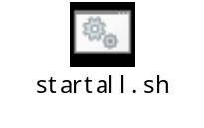
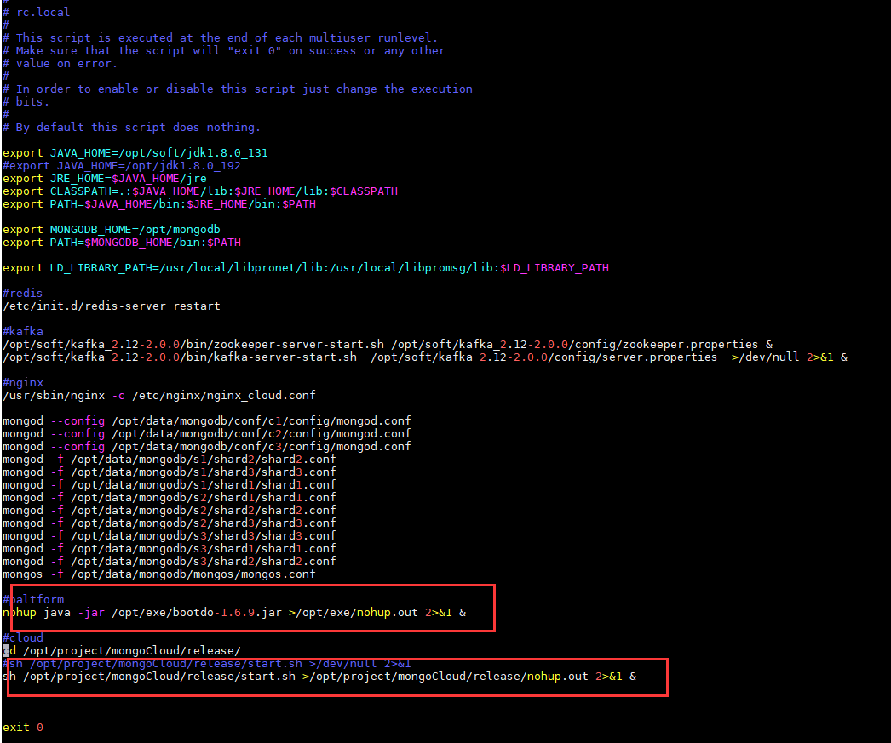

export JAVA_HOME=/opt/soft/jdk1.8.0_131
#export JAVA_HOME=/opt/jdk1.8.0_192
export JRE_HOME=$JAVA_HOME/jre
export CLASSPATH=.:$JAVA_HOME/lib:$JRE_HOME/lib:$CLASSPATH
export PATH=$JAVA_HOME/bin:$JRE_HOME/bin:$PATH

export MONGODB_HOME=/opt/mongodb
export PATH=$MONGODB_HOME/bin:$PATH

export LD_LIBRARY_PATH=/usr/local/libpronet/lib:/usr/local/libpromsg/lib:$LD_LIBRARY_PATH

#redis
/etc/init.d/redis-server restart

#kafka
/opt/soft/kafka_2.12-2.0.0/bin/zookeeper-server-start.sh /opt/soft/kafka_2.12-2.0.0/config/zookeeper.properties &
/opt/soft/kafka_2.12-2.0.0/bin/kafka-server-start.sh /opt/soft/kafka_2.12-2.0.0/config/server.properties >/dev/null 2>&1 &

#nginx
/usr/sbin/nginx -c /etc/nginx/nginx_cloud.conf

mongod --config /opt/data/mongodb/conf/c1/config/mongod.conf --wiredTigerCacheSizeGB 20
mongod --config /opt/data/mongodb/conf/c2/config/mongod.conf --wiredTigerCacheSizeGB 20
mongod --config /opt/data/mongodb/conf/c3/config/mongod.conf --wiredTigerCacheSizeGB 20
mongod -f /opt/data/mongodb/s1/shard2/shard2.conf --wiredTigerCacheSizeGB 20
mongod -f /opt/data/mongodb/s1/shard3/shard3.conf --wiredTigerCacheSizeGB 20
mongod -f /opt/data/mongodb/s1/shard1/shard1.conf --wiredTigerCacheSizeGB 20
mongod -f /opt/data/mongodb/s2/shard1/shard1.conf --wiredTigerCacheSizeGB 20
mongod -f /opt/data/mongodb/s2/shard2/shard2.conf --wiredTigerCacheSizeGB 20
mongod -f /opt/data/mongodb/s2/shard3/shard3.conf --wiredTigerCacheSizeGB 20
mongod -f /opt/data/mongodb/s3/shard3/shard3.conf --wiredTigerCacheSizeGB 20
mongod -f /opt/data/mongodb/s3/shard1/shard1.conf --wiredTigerCacheSizeGB 20
mongod -f /opt/data/mongodb/s3/shard2/shard2.conf --wiredTigerCacheSizeGB 20
mongos -f /opt/data/mongodb/mongos/mongos.conf

#paltform
nohup java -jar /opt/exe/bootdo-1.6.9.jar >/opt/exe/nohup.out 2>&1 &

#cloud
cd /opt/project/mongoCloud/release/
#sh /opt/project/mongoCloud/release/start.sh >/dev/null 2>&1
sh /opt/project/mongoCloud/release/start.sh >/opt/project/mongoCloud/release/nohup.out 2>&1 &

exit 0

六 设置定时任务

1. 系统定时

执行
crontab -e
选择 3vim
输入以下命令

待实现
Mysql版
0 0 * * * rm -r /home/soc/exe/applog/$(date --date='2 days ago' +%Y-%m-%d)

Mongo版

Su用户执行， crontab –e
在两个根目录下建立mylog文件夹，每天0点0分复制log到mylog文件夹并清空nohup.out
0 0 * * * cp /opt/exe/nohup.out /opt/exe/mylog/$(date -d yesterday +\%Y\%m\%d).log; cat /dev/null > /opt/exe/nohup.out
0 0 * * * cp /opt/project/mongoCloud/release/nohup.out /opt/project/mongoCloud/release/mylog/$(date -d yesterday +\%Y\%m\%d).log; cat /dev/null > /opt/project/mongoCloud/release/nohup.out

2 设置定时任务查看mysql状态
sudo –s 必须登录root用户
第一步，添加定时任务，使用crontab。
crontab -e
*/1 * * * * /opt/monitor_mysql.sh
#表示每分钟执行一次 sh 文件
第二步，编写shell执行文件，代码如下：
sudo vi monitor_mysql.sh
#!/bin/bash
echo "begin mysql check---" >> /opt/mysqlmonitor.log
pgrep -x mysqld &> /dev/null
if [ $? -ne 0 ]
then
echo “`date` MySQL is stop .” >> /opt/mysqlmonitor.log
/etc/init.d/mysql start
#service mysql start
else
echo “`date` MySQL server is running .” >> /opt/mysqlmonitor.log
fi
echo "end mysql check---" >> /opt/mysqlmonitor.log
增加权限 sudo chmod 777 monitor_mysql.sh


七 设置关机清理
https://blog.csdn.net/xiaohu50/article/details/79268538

我们需要的是系统关机自动启动，这个时候有两种选择，假设我们的执行脚本是/usr/local/bin/cleanup.sh

Mysql版
ps -ef | grep QuorumPeerMain | awk '{print $2}' | xargs kill -9
ps -ef | grep Kafka | awk '{print $2}' | xargs kill -9
ps -ef | grep mqRespStruct | awk '{print $2}' | xargs kill -9
ps -ef | grep mqResposeCifOri | awk '{print $2}' | xargs kill -9
ps -ef | grep MyHttpServer | awk '{print $2}' | xargs kill -9
ps -ef | grep manageSystem | awk '{print $2}' | xargs kill -9
ps -ef | bootdo-1.6.9.jar | awk '{print $2}' | xargs kill -9

mongo版
ps -ef | grep QuorumPeerMain | awk '{print $2}' | xargs kill -9
ps -ef | grep Kafka | awk '{print $2}' | xargs kill -9
ps -ef | mqRespStructMongo | awk '{print $2}' | xargs kill -9
ps -ef | bootdo-1.6.9.jar | awk '{print $2}' | xargs kill -9

option1: 将执行脚本直接放在/lib/systemd/system-shutdown/目录下
option2: 在/lib/systemd/system/目录下添加cleanup.service这样一个systemd的配置文件，去调用cleanup.sh
根据说明 /lib/systemd/system-shutdown/目录下的脚本的执行时机会非常靠后，文件系统已经挂载只读，网络服务可能也已经关闭，仅仅在系统halt之前。所以这个时候执行很多任务都是受限的。这样的话，我们选择option2来完成我们的任务

[Unit]
Description=Run command at shutdown
Requires=network.target
DefaultDependencies=no
Conflicts=reboot.target
Before=shutdown.target

[Service]
Type=oneshot
RemainAfterExit=true
ExecStart=/bin/true
ExecStop=/bin/bash /usr/local/bin/cleanup.sh

[Install]
WantedBy=multi-user.target

解释一下，由于其DefaultDependencies=no,这个脚本开机就会启动（enable之后），脚本在启动的时候调用/bin/true什么也不做 ,然后在系统调用shutdown.target的时候，会执行退出操作，就是我们希望的运行脚本/bin/bash /usr/local/bin/cleanup.sh。也就达到了我们希望的效果。

然后重新加载systemd配置
sudo systemctl daemon-reload
链接service以使其开启启动
sudo systemctl enable cleanup.service
本次不关机手动启动service(当然如果你重启电脑了当然就不需要这一步了，会自动启)
sudo systemctl start cleanup.service
这个时候sudo poweroff应该就能正确的执行你的叫脚本了

八 常用指令

1. 指令1
https://www.cnblogs.com/chenmh/p/8963215.html
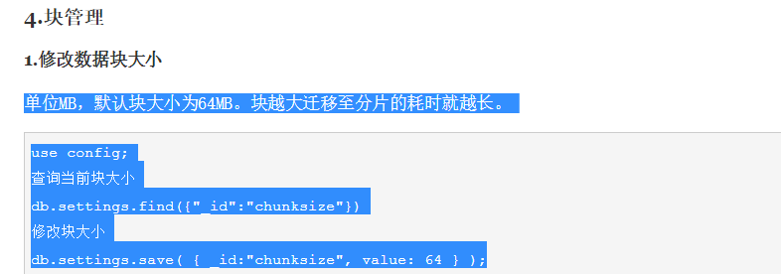
use config;
db.settings.find({"_id":"chunksize"})
db.settings.save( { _id:"chunksize", value: 64 } );

https://www.cnblogs.com/wxzhe/p/9927952.html
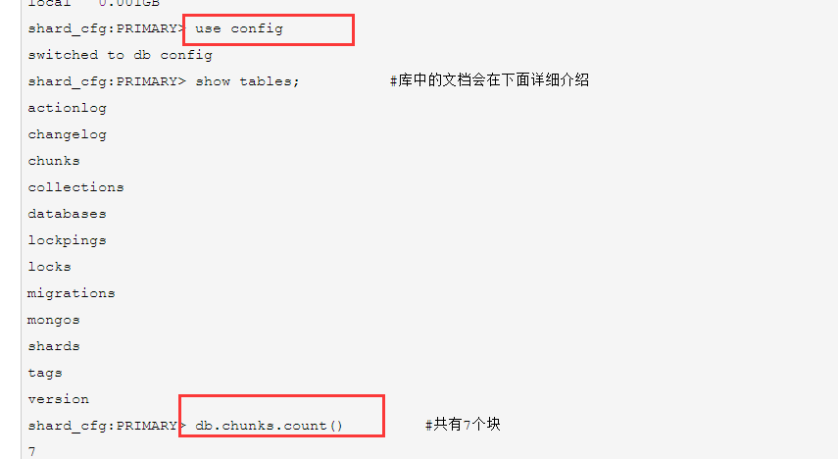
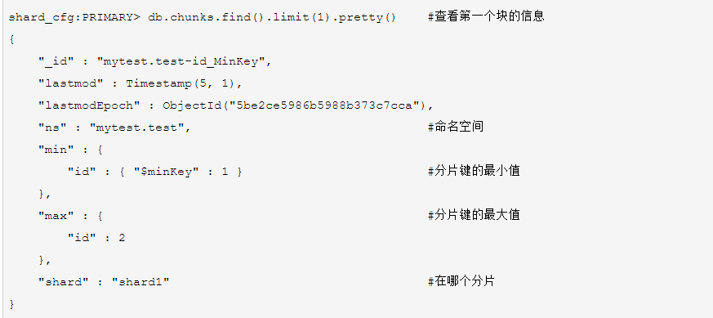
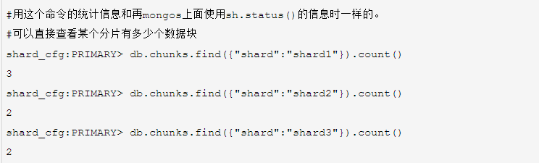
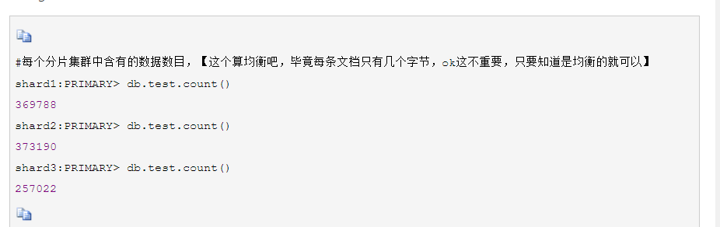
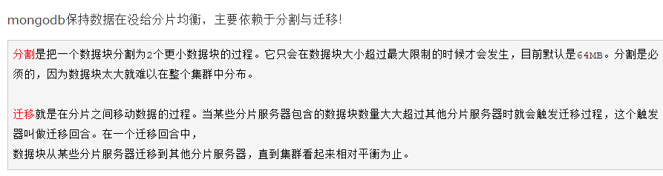
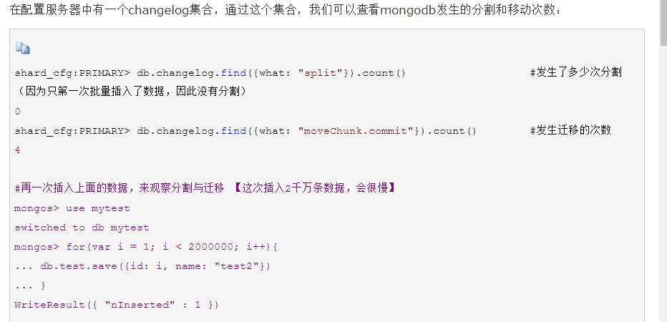

2. second查看数据
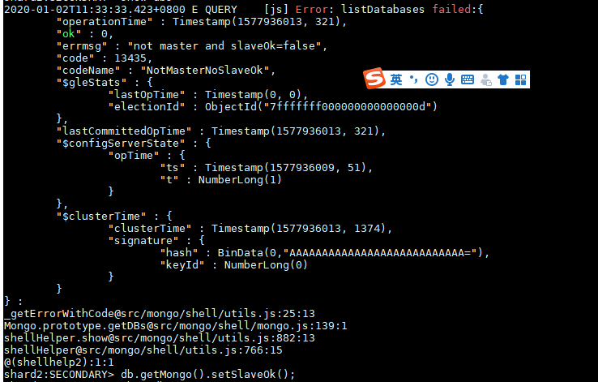

九 可视化工具PMM
参考
https://www.cnblogs.com/xiao987334176/p/11202029.html
https://blog.csdn.net/ant98002/article/details/102248241
https://blog.csdn.net/qq_26913333/article/details/88733699

1. apt-get install docker.io
2. service docker status
3. docker create -v /opt/prometheus/data -v /opt/consul-data -v /var/lib/mysql -v /var/lib/grafana --name pmm-data percona/pmm-server:latest /bin/true
4. docker images
5. docker save -o pmm1.1.2.tar percona/pmm-server
6. docker load < pmm1.1.2.tar
7. docker images
8. docker create -v /opt/prometheus/data -v /opt/consul-data -v /var/lib/mysql -v /var/lib/grafana --name pmm-data percona/pmm-server:1.1.2 /bin/true
9. docker run -d -p 80:80 --volumes-from pmm-data --name pmm-server --restart always percona/pmm-server:1.1.2
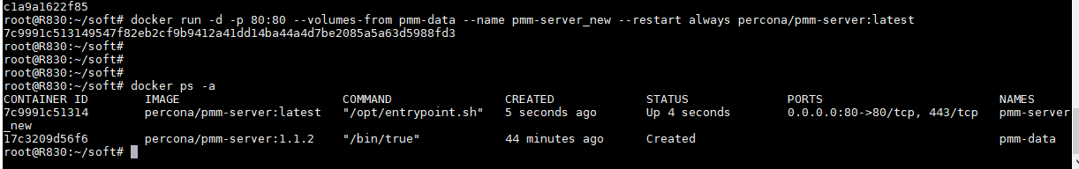

十：Nginx代理http和websocket


常见错误：

1.无法启动问题
当数据量过大时可能出现分片断掉的现象，查看响应的log，如
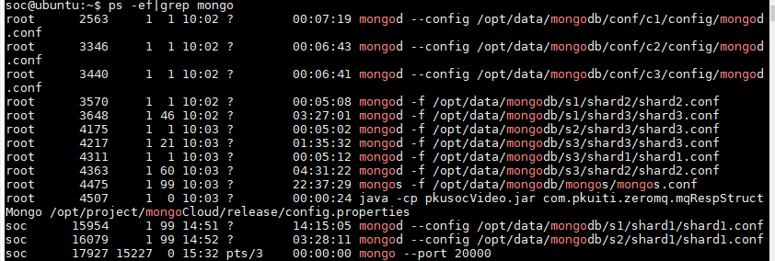
缺少s2的shard2,重启无法启动

则查看log
缺少权限
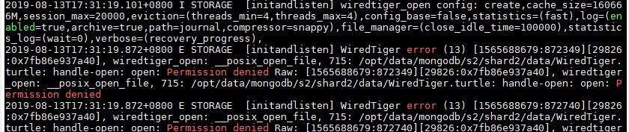
查看权限
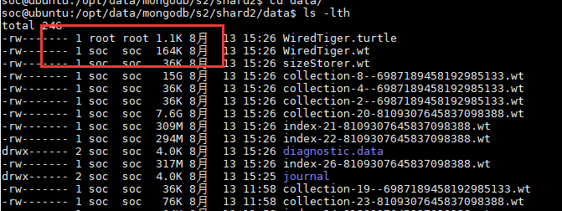
某些情况下会把权限置为root，修改整个文件夹的soc权限，重启即可
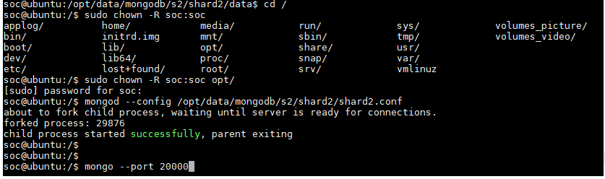

修改/tmp/下的权限
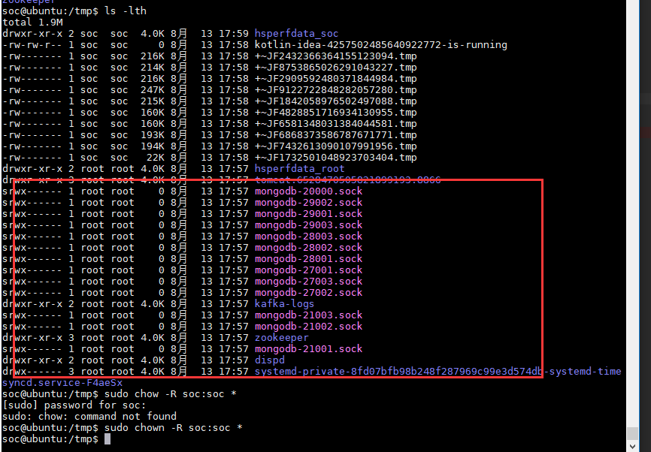

cd /opt/data/mongodb/s1/shard1/data
rm -rf *
cd /opt/data/mongodb/s1/shard1/log
rm -rf *
cd /opt/data/mongodb/s1/shard2/data
rm -rf *
cd /opt/data/mongodb/s1/shard2/log
rm -rf *
cd /opt/data/mongodb/s1/shard3/data
rm -rf *
cd /opt/data/mongodb/s1/shard3/log
rm -rf *

cd /opt/data/mongodb/s2/shard1/data
rm -rf *
cd /opt/data/mongodb/s2/shard1/log
rm -rf *
cd /opt/data/mongodb/s2/shard2/data
rm -rf *
cd /opt/data/mongodb/s2/shard2/log
rm -rf *
cd /opt/data/mongodb/s2/shard3/data
rm -rf *
cd /opt/data/mongodb/s2/shard3/log
rm -rf *

cd /opt/data/mongodb/s3/shard1/data
rm -rf *
cd /opt/data/mongodb/s3/shard1/log
rm -rf *
cd /opt/data/mongodb/s3/shard2/data
rm -rf *
cd /opt/data/mongodb/s3/shard2/log
rm -rf *
cd /opt/data/mongodb/s3/shard3/data
rm -rf *
cd /opt/data/mongodb/s3/shard3/log
rm -rf *

cd /opt/data/mongodb/conf/c1/data
rm -rf *
cd /opt/data/mongodb/conf/c1/log
rm -rf *
cd /opt/data/mongodb/conf/c2/data
rm -rf *
cd /opt/data/mongodb/conf/c2/log
rm -rf *
cd /opt/data/mongodb/conf/c3/data
rm -rf *
cd /opt/data/mongodb/conf/c3/log
rm -rf *

cd /opt/data/mongodb/mongos/log
rm -rf *

2. 无法删除问题
手动删除了文件后，登入数据库发现无法彻底删除数据库，
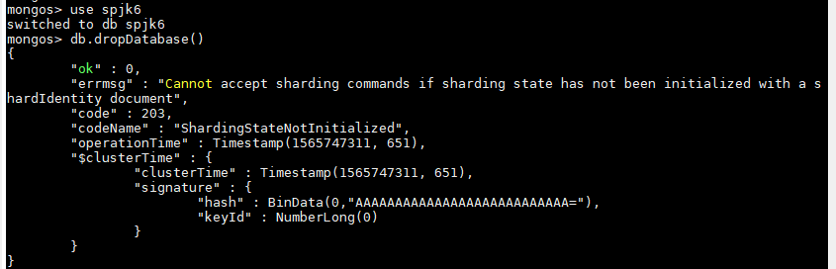
先使其可分片再删除sh.enableSharding('spjk6')
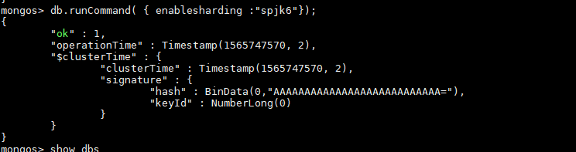

3.创建索引问题
查看用时及 查询条目
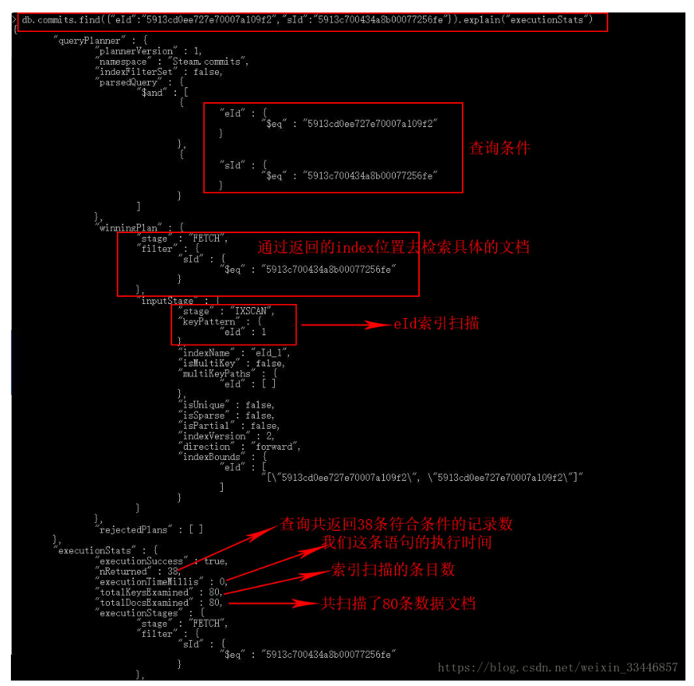

创建索引不是一起创建，而是每个创建一次
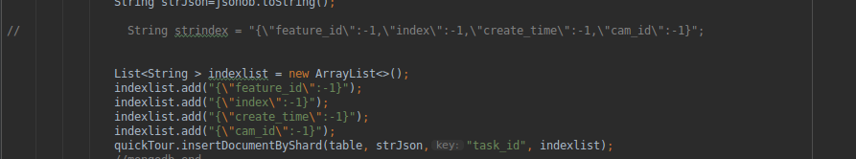
创建完成如下图
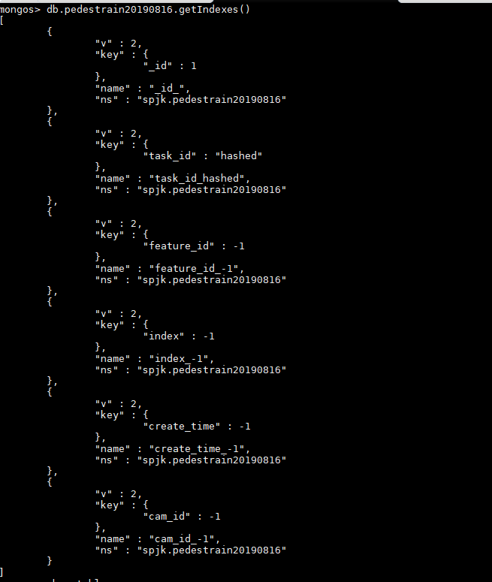
而不是这样
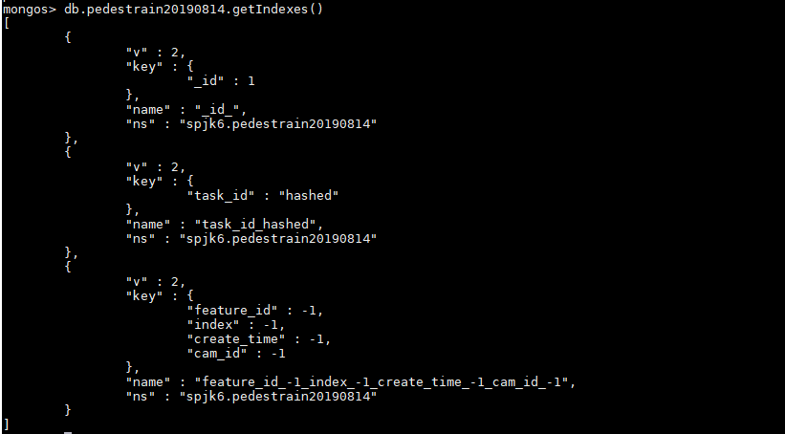

4. 指定配置文件运行
nohup java -jar /home/soc/exe/bootdo-1.6.9.jar --spring.config.location=/home/soc/exe/application.yml &

5.mongo分片挂掉
分片中主、从节点都挂掉了，导致整个分片不能使用，启动后，一个节点处于roolback状态，可以等待其回滚完，也可以除该节点下数据，重新启动，让其重新备份
https://blog.csdn.net/feinifi/article/details/80654328



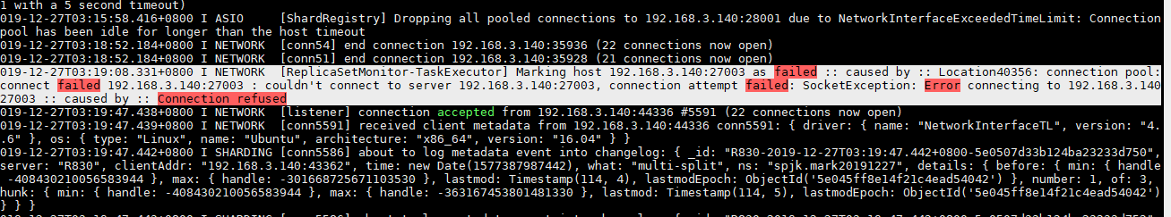

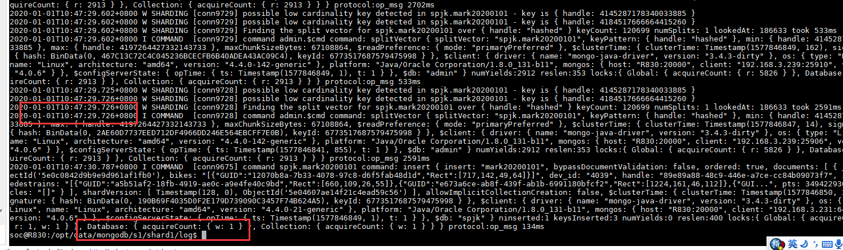
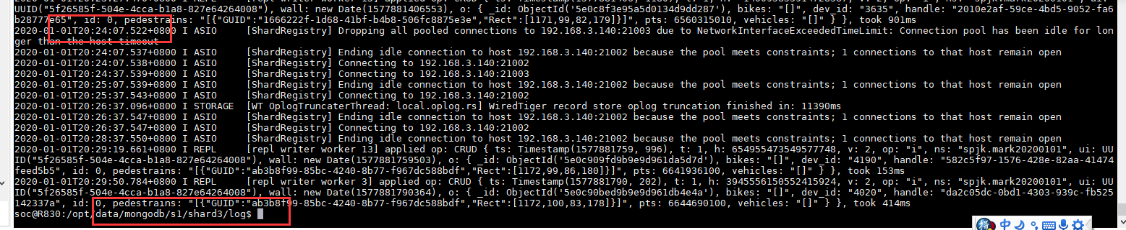
查看系统日志
egrep -i -r 'killed process' /var/log
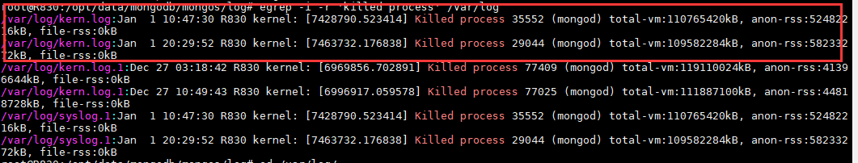
发现是内存过大而OOM KILLER
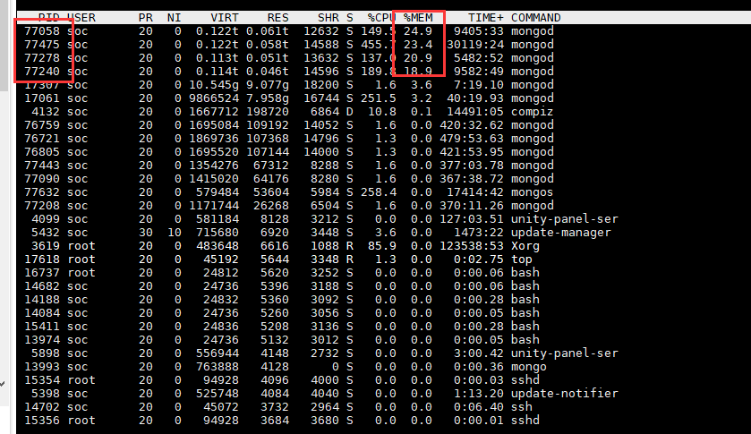
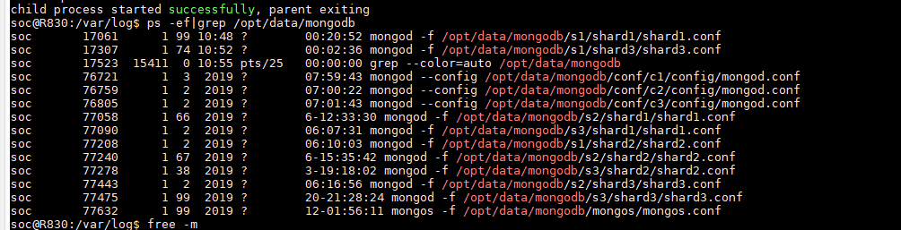
分片节点 限制内存，理论上是50%的内存-1GB，是总的可配置内存，有多少mongod，就除以多少
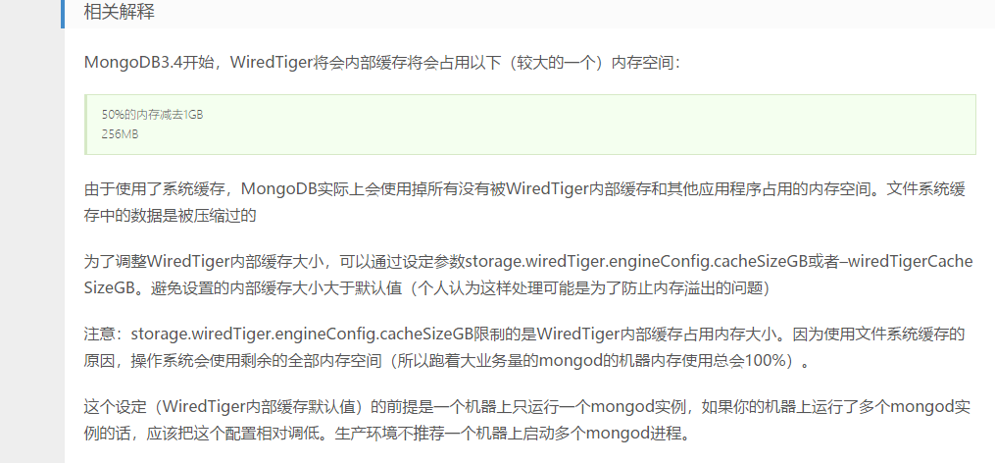
https://www.ipcpu.com/2017/01/mongodb-oom/
本机内存256G 128-1 = 127G 6个mongod,每个20G 一共120G
--wiredTigerCacheSizeGB 20

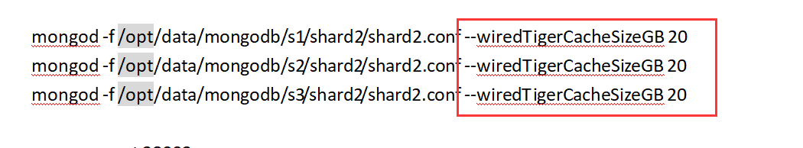
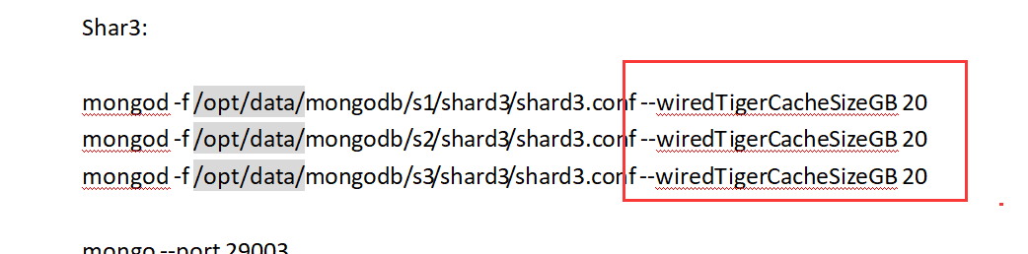

配置后启动，观察内存情况
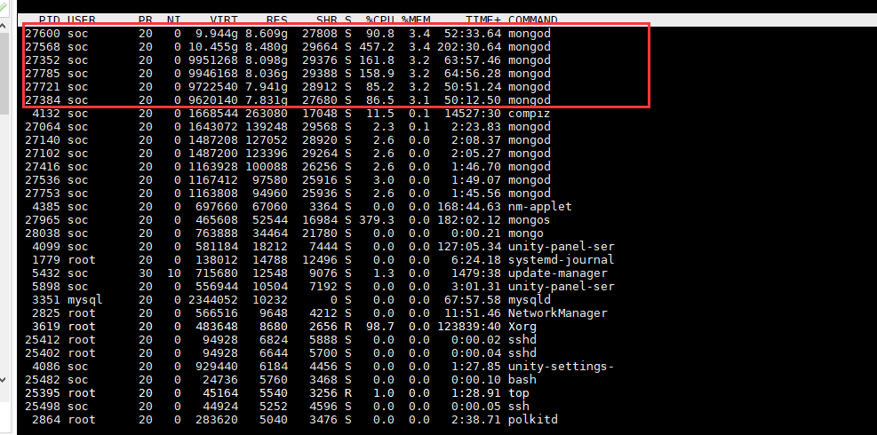
主、附节点占用内存，仲裁节点不占用，持续一段时间，看内存消耗
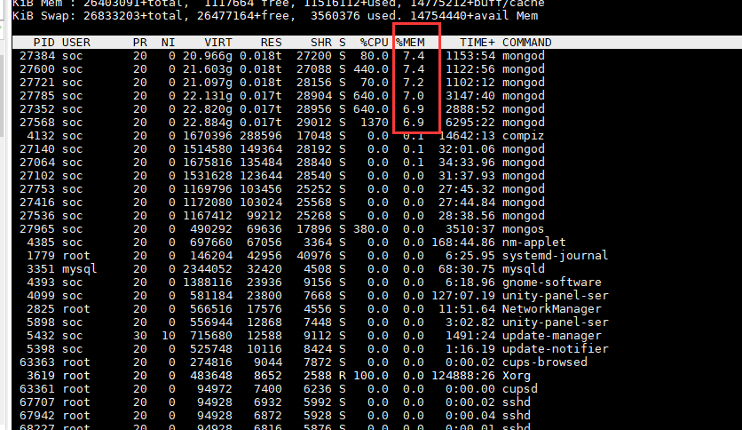
过去十几个小时，最大到7.8%，即20 / 256 = 7.8% ，线程也没自动杀掉，问题解决

6.chunk太大，无法迁移
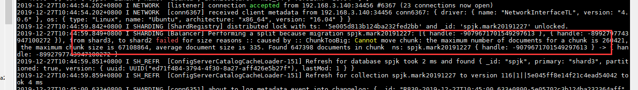

以任务ID为片键，出现上述问题，后来改成以_id的哈希算法为片键，但是查找效率很低，只能改回去
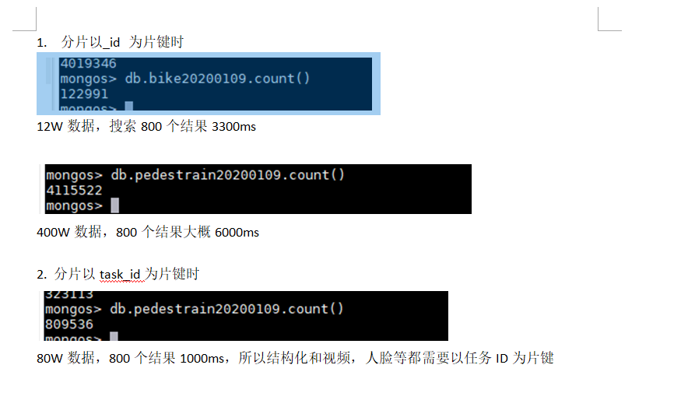
等待看是否还有chunk太大无法迁移的情况

7.分片挂掉，文件打开数超界
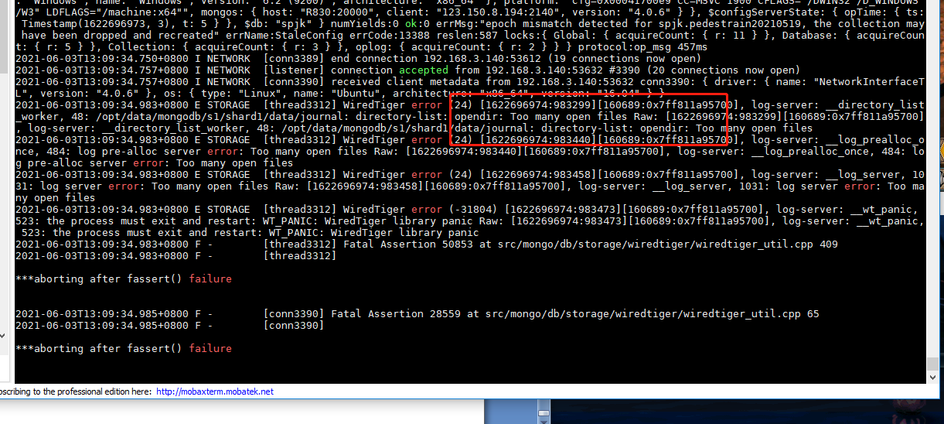
https://blog.csdn.net/qq_24343479/article/details/112630861

修改linux的软硬件限制文件/etc/security/limits.conf.
在文件尾部添加如下代码：
* soft nofile 10240
* hard nofile 10240
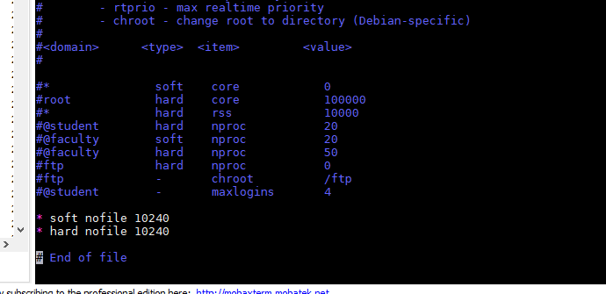
重新打开终端即可

