# CHAPTER 4 Aspect-oriented Spring

编写pointcut

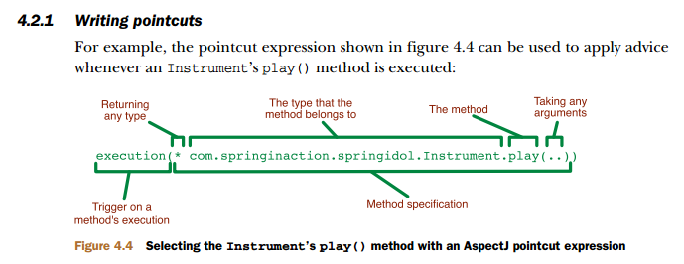

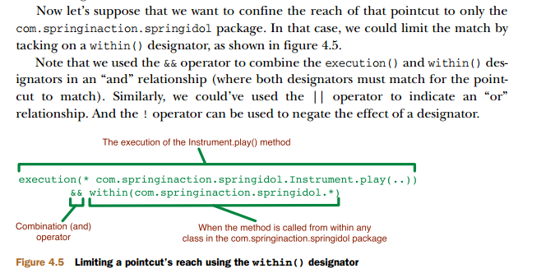

execution(* com.springinaction.springidol.Instrument.play())and bean(eddie)

Here we’re saying that we want to apply aspect advice to the execution of an Instruments play() method, but limited to the bean whose ID is eddie. Narrowing a pointcut to a specific bean may be valuable in some cases, but we can also use negation to apply an aspect to all beans that don’t have a specific ID:

execution(* com.springinaction.springidol.Instrument.play()) and !bean(eddie)