实验1 ............................................. 1

实验2 ............................................. 3

实验3 ............................................. 5

实验4 ............................................. 19

实验5 ............................................. 23

实验7 ............................................. 27

实验9 ............................................. 65

实验10 ............................................. 73

实验1
- 实验题目：二分法求函数的根
- 问题分析：用二分法求方程的解
- 开发环境：JDK8 eclipse 4.6.0（neon）
- 完整代码
package homework;

public class Dichotomy {
static double g(double middle){
return middle * middle * middle - 10 * middle + 23;
}
static double f(double low, double high, double delta) {
double middle = (high + low) / 2;
if ((high - low) < delta)
return middle;
if (g(middle)*g(low) < 0)
return f(low, middle, delta);
else if (g(middle)*g(high) < 0)
return f(middle, high, delta);
else
return middle;
}

public static void main(String[] args) {
System.out.println(f(-10, 5, 0.001));
}
}

- 实验结果

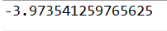
实验2

- 实验题目：求 10,000,000内的最大素数
- 问题分析：用 Eratoshenes筛法（平凡除法）判别该数是不是素数
- 开发环境：JDK8 eclipse 4.6.0（neon）
- 完整代码
package homework;

public class Prime {
static boolean isPrime(int a) {
for (int i = 2; i * i < a; i++)
if (a % i == 0)
return false;
return true;
}

public static void main(String[] args) {
for (int i = 10000000; i >= 2; i--)
if (isPrime(i)) {
System.out.println(i);
break;
}
}
}

- 实验结果

实验三

- 实验题目：K-Means算法实现对数据的聚类分析
- 问题分析：
选择K个点作为初始质心(随机选择)
Repeat
计算数据集中每个点到各个簇的质心的距离，将数据点分配到距离最近的簇
重新计算每个簇中所有点的均值并将该均值作为质心
Until 簇不发生变化或达到最大迭代次数

- 开发环境：JDK8 eclipse 4.6.0（neon）
类的设计
class Point//点
class Bunch//簇（包含中心及其包含的点）
public class KMeans//将点分到簇中
- 完整代码
package homework;

import java.util.*;
import java.io.*;

class Point {
private double x;
private double y;

public void setX(double x) {
this.x = x;
}

public void setY(double y) {
this.y = y;
}

public double getX() {
return x;
}

public double getY() {
return y;
}

public Point() {
}

public Point(double x, double y) {
this.x = x;
this.y = y;
}

}

class Bunch {
final private ArrayList<Point> bunch;
final private Point center;
final int base = 1000000000;

public Point getCenter() {
return center;
}

public ArrayList<Point> getBunch() {
return bunch;
}

public Bunch() {
bunch = new ArrayList<Point>();
center = new Point();
}

boolean equal() {
double allX = 0, allY = 0;
for (Point point : bunch) {
allX += point.getX();
allY += point.getY();
}
double x = (double) (Math.round(allX * base / bunch.size())) / base;
double y = (double) (Math.round(allY * base / bunch.size())) / base;
if ((x == center.getX()) && (y == center.getY()))
return true;
center.setX(x);
center.setY(y);
return false;
}

void clear() {
bunch.clear();
}

void add(Point point) {
bunch.add(point);
}
}

public class KMeans {
static void init(ArrayList<Point> list, String file) throws Exception {
BufferedReader br = new BufferedReader(new FileReader(new File(file)));
String s;
while ((s = br.readLine()) != null) {
double x = Double.parseDouble(s.substring(0, s.indexOf(" ")));
double y = Double.parseDouble(s.substring(s.indexOf(" ") + 1, s.length()));
Point point = new Point(x, y);
list.add(point);
}
br.close();
}

static void kmeans(ArrayList<Bunch> bunches, ArrayList<Point> points) {
do {
for (Bunch bunch : bunches)
bunch.clear();
for (Point point : points)
bunches.get(getMin(bunches, point)).add(point);
} while (!unchange(bunches));

}

static boolean unchange(ArrayList<Bunch> bunches) {
int sign = 0;
for (Bunch bunch : bunches)
if (!bunch.equal())
sign++;
if (sign != 0)
return false;
return true;
}

static void createKBunch(int k, ArrayList<Bunch> bunches) {
for (int i = 0; i < k; i++) {
Bunch bunch = new Bunch();
bunches.add(bunch);
}
}

static void initCenter(int k, ArrayList<Bunch> bunches, ArrayList<Point> points) {
for (int i = 0; i < k; i++) {
Point point = points.get(new Random().nextInt(points.size()));
bunches.get(i).getCenter().setX(point.getX());
bunches.get(i).getCenter().setY(point.getY());
}
}

static int getMin(ArrayList<Bunch> bunches, Point point) {
double min = 1000000.00;
int index = 0;
double x = point.getX(), y = point.getY();
for (Bunch bunch : bunches) {
double disX = x - bunch.getCenter().getX(), disY = y - bunch.getCenter().getY();
double dis = Math.sqrt(disX * disX + disY * disY);
if (min > dis) {
min = dis;
index = bunches.indexOf(bunch);
}
}
return index;
}

static void print(ArrayList<Point> points) {
int i = 0;
for (Point point : points)
System.out.println(++i + " " + "(" + point.getX() + "," + point.getY() + ")");
}

static void printBunches(ArrayList<Bunch> bunches) {
int i = 0;
for (Bunch bunch : bunches) {
i++;
Point center = bunch.getCenter();
System.out.println("第" + i + "簇的中心是：(" + center.getX() + "," + center.getY() + ")");
System.out.println("该簇包含的数据：");
print(bunch.getBunch());
}
}

public static void main(String[] args) throws Exception {
ArrayList<Point> points = new ArrayList<Point>();
init(points, "src/KMeans_Set.txt");
System.out.println("请输入簇的个数：");
Scanner scanner = new Scanner(System.in);
int k = scanner.nextInt();
scanner.close();
ArrayList<Bunch> bunches = new ArrayList<Bunch>();
createKBunch(k, bunches);
initCenter(k, bunches, points);
kmeans(bunches, points);
printBunches(bunches);
}
}

- 实验结果
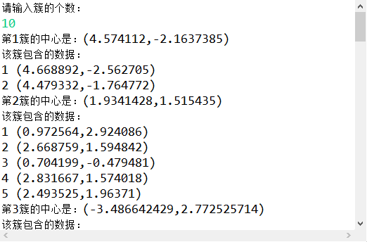
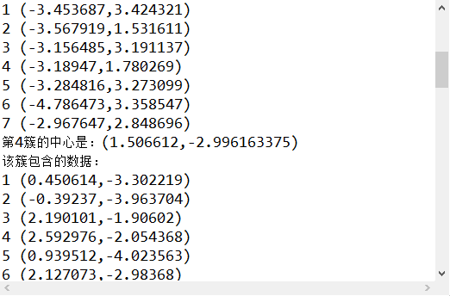
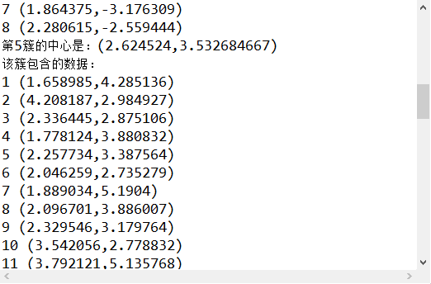
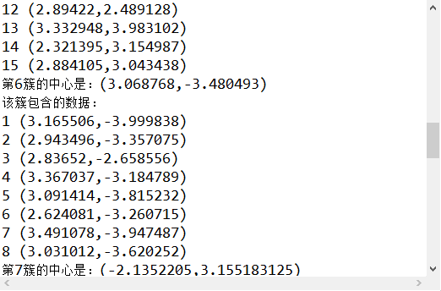
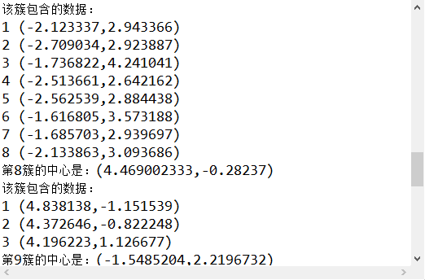
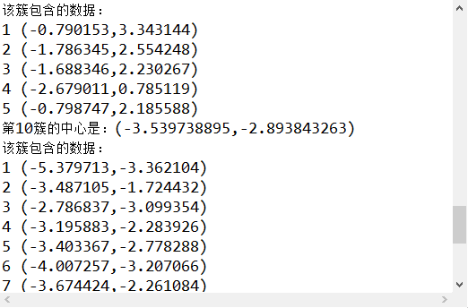
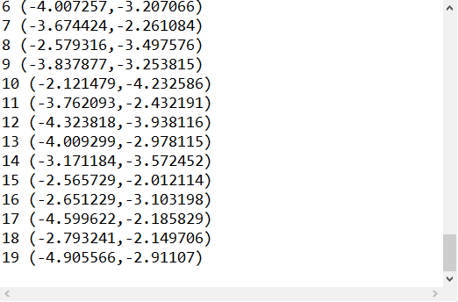

实验4

1.实验题目：线性回归找到最佳拟合直线
2.问题分析：用线性回归方程求直线y=Ax+B
3.开发环境：JDK8 eclipse 4.6.0（neon）
4.完整代码
package homework;

import java.io.*;
import java.util.ArrayList;

class Point {
private double x;
private double y;

public double getX() {
return x;
}

public void setX(double x) {
this.x = x;
}

public double getY() {
return y;
}

public void setY(double y) {
this.y = y;
}

public Point(double x, double y) {
this.x = x;
this.y = y;
}
}

public class LinearRegression {
static void init(ArrayList<Point> points) throws Exception {
BufferedReader reader = new BufferedReader(new FileReader("src/LR_ex0.txt"));
String string;
while ((string = reader.readLine()) != null) {
double x = Double.parseDouble(string.substring(string.indexOf(" ") + 1, string.lastIndexOf(" ")));
double y = Double.parseDouble(string.substring(string.lastIndexOf(" ") + 1));
points.add(new Point(x, y));
}
reader.close();
}

static void compute(ArrayList<Point> points) {
double sumXY = 0, sumXSqu = 0, sumX = 0, sumY = 0;
for (Point point : points) {
sumXY += point.getX() * point.getY();
sumX += point.getX();
sumY += point.getY();
sumXSqu += point.getX() * point.getX();
}
double a = (sumXY - sumX * sumY / points.size()) / (sumXSqu - sumX * sumX / points.size());
double b = sumY / points.size() - a * sumX / points.size();
System.out.println("A=" + a + " B=" + b);
}

public static void main(String[] args) throws Exception {
ArrayList<Point> points = new ArrayList<>();
init(points);
compute(points);
}
}

5.实验结果

实验5

1.实验题目：统计学生成绩
2.问题分析：从文件中读取学生成绩再进行处理
3.开发环境：JDK8 eclipse 4.6.0（neon）
4.完整代码
package homework;

import java.io.*;

public class StudentScores {
public static void main(String[] args) throws Exception {
BufferedReader br = new BufferedReader(new FileReader(new File("src/score.csv")));
String s;
int[] scores = new int[60];
int len = 0;
while ((s = br.readLine()) != null)
scores[len++] = Integer.parseInt(s.substring(s.indexOf(';') + 1, s.length()));
br.close();
int max = 0, min = 100, num1 = 0, num2 = 0, num3 = 0, num4 = 0, total = 0, ave;
for (int i = 0; i < len; i++) {
total += scores[i];
if (max < scores[i])
max = scores[i];
if (min > scores[i])
min = scores[i];
if (scores[i] >= 60 && scores[i] < 70)
num1++;
else if (scores[i] >= 70 && scores[i] < 80)
num2++;
else if (scores[i] >= 80 && scores[i] < 90)
num3++;
else if (scores[i] >= 90)
num4++;
}
ave = total / len;
BufferedWriter bw = new BufferedWriter(new FileWriter(new File("src/studentScores.txt")));
String str = "最高成绩：" + max + ";" + "最低成绩：" + min + ";" + "平均成绩：" + ave + ";" + "60~69：" + num1 + ";" + "70~79："
+ num2 + ";" + "80~89：" + num3 + ";" + "90~99：" + num4;
String[] ch = str.split(";");
for (String string : ch) {
bw.write(string);
bw.newLine();
}
bw.close();
}
}

5.实验结果

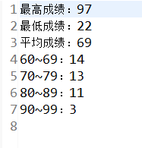

studentScores.txt中内容

实验7
1.实验题目：JDBC 操作数据库
2.问题分析： 用jdbc处理mysql数据库，实现增添删改的功能，为了操作方便，采用Java GUI编程。
3.开发环境：创建数据库
CREATE TABLE students (
id varchar(255) CHARACTER SET latin1 NOT NULL,
name varchar(255) ,
age tinyint(4) ,
PRIMARY KEY (id)
) ENGINE=InnoDB DEFAULT CHARSET=utf8;

JDK8 eclipse 4.6.0（neon） jxl.jar（java处理表格工具类库）mysql java 驱动程序

类的设计
class StudentSql//JDBC初始化
class StuAdd extends JPanel implements ActionListener
//添加信息
class StuQuery extends JPanel //查询信息
class StuUpdate extends JPanel implements ActionListener
//修改信息
class StuDelete extends JPanel implements ActionListener
//删除信息
class FileDeal extends JPanel implements ActionListener
//文件导入导出
public class StudentMessage extends JFrame implements ActionListener
//总控制
4.完整代码
package homework;

import java.sql.*;
import jxl.*;
import jxl.write.*;
import jxl.write.Label;
import javax.swing.*;
import java.awt.*;
import java.awt.Font;
import java.awt.event.*;
import java.io.*;

class StudentSql {
Connection connection;
Statement statement;

private StudentSql() throws Exception {
Class.forName("com.mysql.jdbc.Driver");
connection = DriverManager.getConnection(
"jdbc:mysql://localhost:3306/test?useSSL=false&useUnicode=true&characterEncoding=UTF-8", "root",
"1234");
statement = connection.createStatement();
}

ResultSet query(String s) throws SQLException {
return statement.executeQuery(s);
}

void exe(String s) throws SQLException {
statement.executeUpdate(s);
}

static StudentSql getInstance() throws Exception {
return new StudentSql();
}
}

class StuAdd extends JPanel implements ActionListener {
private JTextField id;
private JTextField name;
private JTextField age;
private JLabel label;
private JLabel label2;
private JLabel label3;
private JButton button1;
private JButton button2;

public StuAdd() {
setLayout(null);

label = new JLabel("学号");
label.setBounds(72, 57, 54, 15);
add(label);

label2 = new JLabel("姓名");
label2.setBounds(72, 99, 54, 15);
add(label2);

label3 = new JLabel("年龄");
label3.setBounds(72, 140, 54, 15);
add(label3);

id = new JTextField();
id.setBounds(136, 54, 141, 21);
add(id);
id.setColumns(10);

name = new JTextField();
name.setBounds(136, 96, 141, 21);
add(name);
name.setColumns(10);

age = new JTextField();
age.setBounds(136, 137, 141, 21);
add(age);
age.setColumns(10);

button1 = new JButton("确定");
button1.setBounds(81, 205, 93, 23);
button1.addActionListener(this);
add(button1);

button2 = new JButton("重置");
button2.setBounds(194, 205, 93, 23);
button2.addActionListener(this);
add(button2);
}

boolean isExist(String str) {
String s = "SELECT * FROM students WHERE id=" + str;
try {
ResultSet set = StudentSql.getInstance().query(s);
if (set.next()) {
JOptionPane.showMessageDialog(this, "该学生已存在!", "提示对话框", JOptionPane.ERROR_MESSAGE);
return true;
}
} catch (Exception e1) {
e1.printStackTrace();
}
return false;
}

public void actionPerformed(ActionEvent e) {
if (e.getSource() == button1) {
try {
String s1 = id.getText().trim();
String s2 = name.getText().trim();
String s3 = age.getText().trim();
if (!isExist(s1)) {
StudentSql.getInstance().exe("INSERT INTO students VALUES ('" + s1 + "','" + s2 + "'," + s3 + ")");
JOptionPane.showMessageDialog(this, "数据已入库!", "提示对话框", JOptionPane.INFORMATION_MESSAGE);
}
} catch (Exception ee) {
ee.printStackTrace();
}
} else if (e.getSource() == button2) {
id.setText(" ");
name.setText(" ");
age.setText(" ");
}
}
}

class StuQuery extends JPanel {
private JTextField id;
private JTextField name;
private JTextField age;
private JLabel label;
private JLabel label2;
private JLabel label3;
private JButton button1;

public StuQuery() {
setLayout(null);

label = new JLabel("请输入学号");
label.setBounds(43, 57, 72, 15);
add(label);

label2 = new JLabel("姓名");
label2.setBounds(72, 124, 54, 15);
add(label2);

label3 = new JLabel("年龄");
label3.setBounds(72, 163, 54, 15);
add(label3);

id = new JTextField();
id.setBounds(136, 54, 141, 21);
add(id);
id.setColumns(10);

name = new JTextField();
name.setEditable(false);
name.setBounds(136, 121, 141, 21);
add(name);
name.setColumns(10);

age = new JTextField();
age.setEditable(false);
age.setBounds(136, 160, 141, 21);
add(age);
age.setColumns(10);

button1 = new JButton("查询");
button1.setBounds(307, 53, 93, 23);
add(button1);

button1.addActionListener(new ActionListener() {
public void actionPerformed(ActionEvent e) {
query(id, name, age);
}
});
}

void query(JTextField id, JTextField name, JTextField age) {
String s = "SELECT * FROM students WHERE id=" + id.getText().trim();
try {
ResultSet set = StudentSql.getInstance().query(s);
if (set.next()) {
name.setText(set.getString(2));
age.setText(set.getString(3));
} else
JOptionPane.showMessageDialog(null, "没有该学生!", "提示对话框", JOptionPane.ERROR_MESSAGE);
} catch (Exception e1) {
e1.printStackTrace();
}

}
}

class StuUpdate extends JPanel implements ActionListener {
private JTextField id;
private JTextField name;
private JTextField age;
private JLabel label;
private JLabel label2;
private JLabel label3;
private JButton button1;
private JButton button2;
private JButton button3;

public StuUpdate() {
setLayout(null);

label = new JLabel("请输入学号");
label.setBounds(43, 57, 72, 15);
add(label);

label2 = new JLabel("姓名");
label2.setBounds(72, 124, 54, 15);
add(label2);

label3 = new JLabel("年龄");
label3.setBounds(72, 163, 54, 15);
add(label3);

id = new JTextField();
id.setBounds(136, 54, 141, 21);
add(id);
id.setColumns(10);

name = new JTextField();
name.setBounds(136, 121, 141, 21);
add(name);
name.setColumns(10);

age = new JTextField();
age.setBounds(136, 160, 141, 21);
add(age);
age.setColumns(10);

button1 = new JButton("查询");
button1.setBounds(307, 53, 93, 23);
button1.addActionListener(this);
add(button1);

button2 = new JButton("保存");
button2.setBounds(91, 217, 93, 23);
button2.addActionListener(this);
add(button2);

button3 = new JButton("重置");
button3.setBounds(250, 217, 93, 23);
button3.addActionListener(this);
add(button3);

}

public void actionPerformed(ActionEvent e) {
if (e.getSource() == button1) {
new StuQuery().query(id, name, age);
} else if (e.getSource() == button2) {
try {
String s1 = id.getText().trim();
String s2 = name.getText().trim();
String s3 = age.getText().trim();
StudentSql.getInstance().exe("UPDATE students SET name ='" + s2 + "', age=" + s3 + " WHERE id=" + s1);
JOptionPane.showMessageDialog(this, "修改成功!", "提示对话框", JOptionPane.INFORMATION_MESSAGE);
} catch (Exception ee) {
ee.printStackTrace();
}
} else if (e.getSource() == button3) {
name.setText(" ");
age.setText(" ");
}
}
}

class StuDelete extends JPanel implements ActionListener {
private JTextField id;
private JTextField name;
private JTextField age;
private JLabel label;
private JLabel label2;
private JLabel label3;
private JButton button1;
private JButton button2;
private JButton button3;

public StuDelete() {
setLayout(null);

label = new JLabel("请输入学号");
label.setBounds(43, 57, 72, 15);
add(label);

label2 = new JLabel("姓名");
label2.setBounds(72, 124, 54, 15);
add(label2);

label3 = new JLabel("年龄");
label3.setBounds(72, 163, 54, 15);
add(label3);

id = new JTextField();
id.setBounds(136, 54, 141, 21);
add(id);
id.setColumns(10);

name = new JTextField();
name.setBounds(136, 121, 141, 21);
name.setEditable(false);
add(name);
name.setColumns(10);

age = new JTextField();
age.setBounds(136, 160, 141, 21);
age.setEditable(false);
add(age);
age.setColumns(10);

button1 = new JButton("查询");
button1.setBounds(307, 53, 93, 23);
button1.addActionListener(this);
add(button1);

button2 = new JButton("删除");
button2.setBounds(150, 217, 93, 23);
button2.addActionListener(this);
add(button2);
}

public void actionPerformed(ActionEvent e) {
if (e.getSource() == button1) {
new StuQuery().query(id, name, age);
} else if (e.getSource() == button2) {
try {
String s1 = id.getText().trim();
StudentSql.getInstance().exe("DELETE FROM students WHERE id=" + s1);
JOptionPane.showMessageDialog(this, "删除成功!", "提示对话框", JOptionPane.INFORMATION_MESSAGE);
id.setText(" ");
name.setText(" ");
age.setText(" ");

} catch (Exception ee) {
ee.printStackTrace();
}
}
}
}

class FileDeal extends JPanel implements ActionListener {
private JTextField fileName;
private JLabel label;
private JButton button1;
private JButton button2;
private JButton button3;
JFileChooser chooser;
File file;
ResultSet set;

public FileDeal() {
setLayout(null);

label = new JLabel("文件：");
label.setBounds(58, 79, 41, 15);
add(label);

fileName = new JTextField();
fileName.setBounds(136, 76, 141, 21);
add(fileName);
fileName.setColumns(10);

button1 = new JButton("请选择文件：");
button1.setBounds(303, 75, 114, 23);
button1.addActionListener(this);
add(button1);

button2 = new JButton("导入");
button2.setBounds(113, 182, 93, 23);
button2.addActionListener(this);
add(button2);

button3 = new JButton("导出");
button3.setBounds(258, 182, 93, 23);
button3.addActionListener(this);
add(button3);

chooser = new JFileChooser();
}

public void actionPerformed(ActionEvent e) {
if (e.getSource() == button1) {
chooser.showOpenDialog(this);
file = chooser.getSelectedFile();
fileName.setText(file.getName());
} else if (e.getSource() == button2)
import1();
else if (e.getSource() == button3)
export();
}

void import1() {
try {
Workbook book = Workbook.getWorkbook(file);
Sheet sheet = book.getSheet(0);
for (int i = 1; i < sheet.getRows(); i++) {
String s1 = sheet.getCell(0, i).getContents();
String s2 = sheet.getCell(1, i).getContents();
String s3 = sheet.getCell(2, i).getContents();
if (!new StuAdd().isExist(s1))
StudentSql.getInstance().exe("INSERT INTO students VALUES ('" + s1 + "','" + s2 + "'," + s3 + ")");
}
book.close();
JOptionPane.showMessageDialog(this, "导入成功!", "提示对话框", JOptionPane.INFORMATION_MESSAGE);
} catch (Exception e) {
e.printStackTrace();
}
}

void export() {
try {
WritableWorkbook book = Workbook.createWorkbook(file);
WritableSheet sheet = book.createSheet("学生信息", 1);
ResultSet set = StudentSql.getInstance().query("SELECT * FROM students");
Label label1 = new Label(0, 0, "学号");
Label label2 = new Label(1, 0, "姓名");
Label label3 = new Label(2, 0, "年龄");
sheet.addCell(label1);
sheet.addCell(label2);
sheet.addCell(label3);
int r = 1;
while (set.next()) {
for (int c = 1; c <= 3; c++) {
Label label = new Label(c - 1, r, set.getString(c));
sheet.addCell(label);
}
r++;
}
book.write();
book.close();
JOptionPane.showMessageDialog(this, "导出成功!", "提示对话框", JOptionPane.INFORMATION_MESSAGE);
} catch (Exception e2) {
e2.printStackTrace();
}
}
}

public class StudentMessage extends JFrame implements ActionListener {
JMenuBar bar = null;
JMenu menu1, menu2, menu3, menu4, menu5, menu6;
JMenuItem item1, item2, item3, item4, item5, item6;
StuAdd add;
StuQuery query;
StuUpdate update;
StuDelete delete;
FileDeal fd;

public StudentMessage() {
super("学生信息管理系统");
add = new StuAdd();
query = new StuQuery();
update = new StuUpdate();
delete = new StuDelete();
fd = new FileDeal();
bar = new JMenuBar();
menu1 = new JMenu("信息录入");
menu2 = new JMenu("信息查询");
menu3 = new JMenu("信息修改");
menu4 = new JMenu("信息删除");
menu5 = new JMenu("选择文件");
menu6 = new JMenu("退出系统");
item1 = new JMenuItem("录入");
item2 = new JMenuItem("查询");
item3 = new JMenuItem("修改");
item4 = new JMenuItem("删除");
item5 = new JMenuItem("文件");
item6 = new JMenuItem("退出");
menu1.add(item1);
menu2.add(item2);
menu3.add(item3);
menu4.add(item4);
menu5.add(item5);
menu6.add(item6);
bar.add(menu1);
bar.add(menu2);
bar.add(menu3);
bar.add(menu4);
bar.add(menu5);
bar.add(menu6);
setJMenuBar(bar);
item1.addActionListener(this);
item2.addActionListener(this);
item3.addActionListener(this);
item4.addActionListener(this);
item5.addActionListener(this);
item6.addActionListener(this);
JLabel label = new JLabel("学生信息管理系统", JLabel.CENTER);
String s = " ";
Font f = new Font(s, Font.BOLD, 22);
label.setFont(f);
label.setBackground(Color.green);
label.setForeground(Color.BLUE);
add(label, "Center");
setBounds(400, 200, 450, 400);
setVisible(true);
setDefaultCloseOperation(JFrame.EXIT_ON_CLOSE);
}

public void actionPerformed(ActionEvent e) {
if (e.getSource() == item1) {
this.getContentPane().removeAll();
this.getContentPane().add(add, "Center");
this.getContentPane().repaint();
this.getContentPane().validate();
} else if (e.getSource() == item2) {
this.getContentPane().removeAll();
this.getContentPane().add(query, "Center");
this.getContentPane().repaint();
this.getContentPane().validate();
} else if (e.getSource() == item3) {
this.getContentPane().removeAll();
this.getContentPane().add(update, "Center");
this.getContentPane().repaint();
this.getContentPane().validate();
} else if (e.getSource() == item4) {
this.getContentPane().removeAll();
this.getContentPane().add(delete, "Center");
this.getContentPane().repaint();
this.getContentPane().validate();
} else if (e.getSource() == item5) {
this.getContentPane().removeAll();
this.getContentPane().add(fd, "Center");
this.getContentPane().repaint();
this.getContentPane().validate();

} else if (e.getSource() == item6)
System.exit(0);
}

public static void main(String[] args) {
new StudentMessage();
}
}
- 实验结果
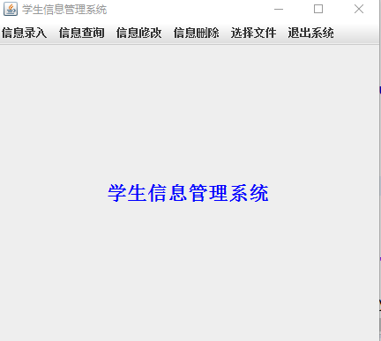
主界面

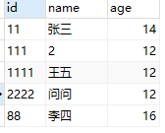
表的初始信息

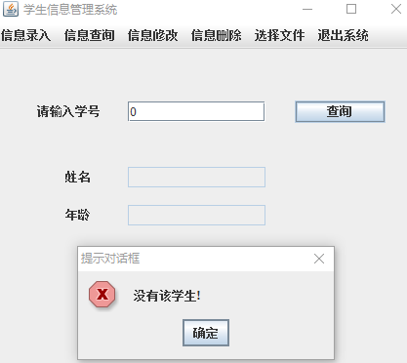

没有改学生信息时
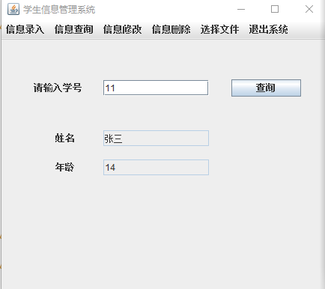
有该学生信息

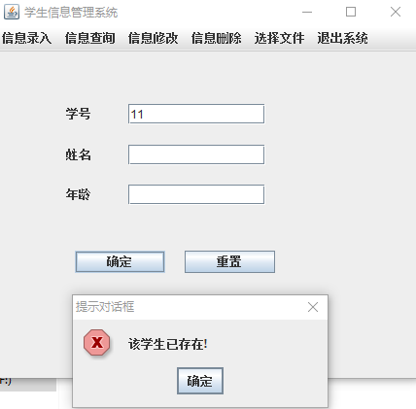
增加记录时学生学号已存在

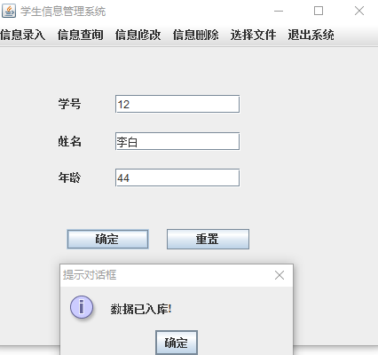
增加一条记录

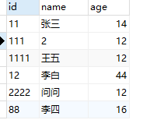
增加完记录的表
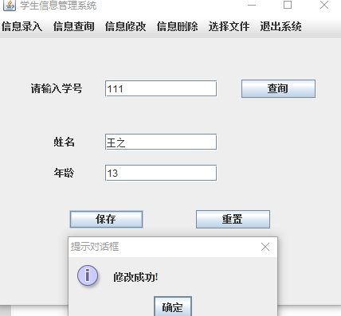
修改记录

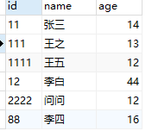
修改完的表
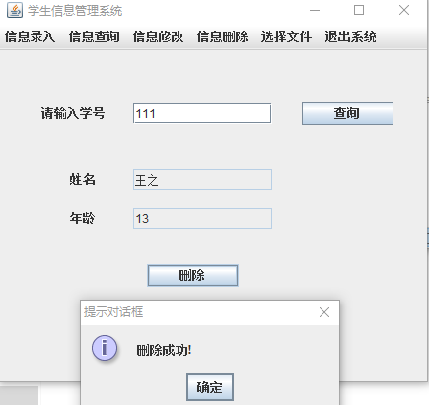
删除记录

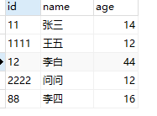
删除一条信息后的表
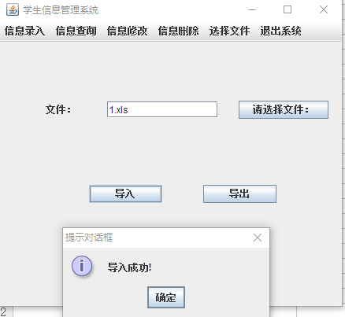
导入文件

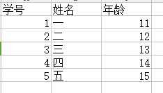
导入的Excel内容
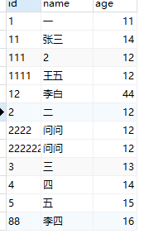
导入文件后的表

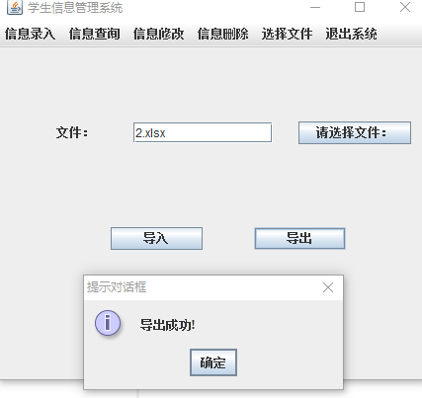
导出表格
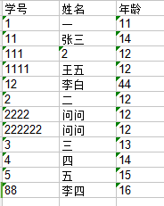
导出Excel的信息

综上，可知道运行结果是正确的！

实验9

1.实验题目：二维码的编码和解码

2.问题分析：用开源QR库，实现一个简单的二维码的编码和解码
3.开发环境：JDK8 eclipse 4.6.0（neon） zxing开源库
4.完整代码
（编码）
package homework;

import java.io.*;
import java.nio.file.*;
import java.util.*;

import com.google.zxing.*;

import com.google.zxing.client.j2se.MatrixToImageWriter;
import com.google.zxing.common.BitMatrix;

public class Encoder {

public static void main(String[] args) {
System.out.println("请输入需要编码的字符：");
Scanner scanner = new Scanner(System.in);
String contents = scanner.nextLine();
scanner.close();

Hashtable<EncodeHintType, String> hints = new Hashtable<EncodeHintType, String>();

hints.put(EncodeHintType.CHARACTER_SET, "GBK");

BitMatrix matrix = null;

try {

matrix = new MultiFormatWriter().encode(contents, BarcodeFormat.QR_CODE, 300, 300, hints);

} catch (WriterException e) {

e.printStackTrace();

}
try {

MatrixToImageWriter.writeToPath(matrix, "png", Paths.get("E://z.png"));

} catch (IOException e) {

e.printStackTrace();

}

}
}

（解码）
package homework;

import java.awt.image.BufferedImage;
import java.io.File;
import java.io.IOException;
import java.util.Hashtable;

import javax.imageio.ImageIO;

import com.google.zxing.*;
import com.google.zxing.client.j2se.BufferedImageLuminanceSource;
import com.google.zxing.common.HybridBinarizer;

public class Decoder {

public static void main(String[] args) {
System.out.println("解析得到的字符串为：");
BufferedImage bufferedImage = null;
try {

bufferedImage = ImageIO.read(new File("E://z.png"));

} catch (IOException e) {

e.printStackTrace();

}

LuminanceSource source = new BufferedImageLuminanceSource(bufferedImage);

BinaryBitmap bitmap = new BinaryBitmap(new HybridBinarizer(source));

Hashtable<DecodeHintType, String> hints = new Hashtable<DecodeHintType, String>();

hints.put(DecodeHintType.CHARACTER_SET, "GBK");

Result result = null;

try {

result = new MultiFormatReader().decode(bitmap, hints);

} catch (NotFoundException e) {

e.printStackTrace();

}

System.out.println(result.toString());

}

}

5.实验结果

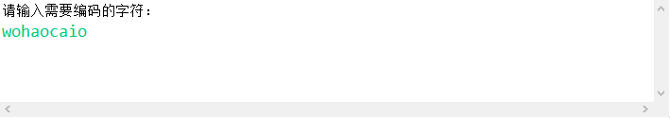


字符串转化的二维码图片

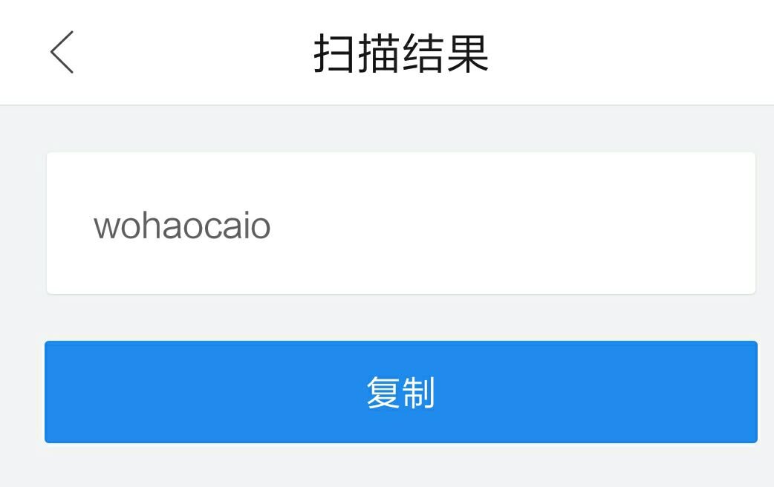

手机扫描结果

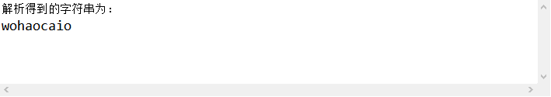

图片解析得到的字符串
实验10

1.实验题目：重复文件查询
2.问题分析：用MessageDigest类获取文件MD5 checksum值，当值相同时，用FileInputStream读取这两个文件，比较这两个文件的字节是否相同，若相同，则是相同文件。
3.开发环境：JDK8 eclipse 4.6.0（neon）
4.完整代码
package homework;

import java.io.*;
import java.security.*;
import java.util.*;

public class DupFileQuery {
static HashMap<File, String> map = new HashMap<>();

static void fileTra(File file) throws Exception {
File[] files = file.listFiles();
if (files == null)
return;
for (File file2 : files) {
if (file2.isFile()) {
String MD5 = getMD5Checksum(file2);
File file3 = isSameMD5(MD5);
if (file3 != null)
if (isRealSame(file3, file2))
print(file3, file2);
map.put(file2, MD5);
} else
fileTra(file2);
}
}

static File isSameMD5(String MD5) {
for (Map.Entry<File, String> entry : map.entrySet())
if (entry.getValue().equals(MD5))
return entry.getKey();
return null;
}

static boolean isRealSame(File file, File file2) {
if (file.length() != file2.length())
return false;
try (InputStream is = new FileInputStream(file); InputStream is2 = new FileInputStream(file2);) {
int b;
while ((b = is.read()) != -1)
if (b != is2.read())
return false;
} catch (Exception e) {
e.printStackTrace();
}
return true;
}

static void print(File file, File file2) {
System.out.println("文件1路径：" + file.getAbsolutePath());
System.out.println("文件1名字：" + file.getName());
System.out.println("文件2路径：" + file2.getAbsolutePath());
System.out.println("文件2名字：" + file2.getName());
System.out.println();
}

static byte[] getByte(File file) throws Exception {
FileInputStream fis = new FileInputStream(file);
MessageDigest digest = MessageDigest.getInstance("MD5");
byte[] b = new byte[1024];
int len;
while ((len = fis.read(b)) != -1)
digest.update(b, 0, len);
fis.close();
return digest.digest();
}

static String getMD5Checksum(File file) throws Exception {
byte[] b = getByte(file);
StringBuilder sb = new StringBuilder();
for (byte c : b)
sb.append(Integer.toHexString(c & 0xff));
return sb.toString();
}

public static void main(String[] args) throws Exception {
System.out.println("请输入需要查询的文件目录：");
Scanner scanner = new Scanner(System.in);
String string = scanner.nextLine();
scanner.close();
fileTra(new File(string.replaceAll("\\\\", "/")));
}
}

5.实验结果
