# Dubbo

Dubbo |ˈdʌbəʊ| is a high-performance, java based RPC framework open-sourced by Alibaba. As in many RPC systems, dubbo is based around the idea of defining a service, specifying the methods that can be called remotely with their parameters and return types. On the server side, the server implements this interface and runs a dubbo server to handle client calls. On the client side, the client has a stub that provides the same methods as the server.

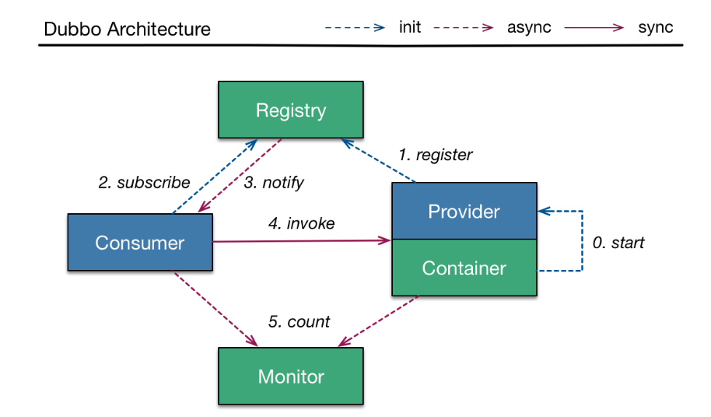

Dubbo offers three key functionalities, which include interface based remote call, fault tolerance & load balancing, and automatic service registration & discovery. Dubbo framework is widely adopted inside Alibaba and outside by other companies including jingdong, dangdang, qunar, kaola, and many others.

# 入门案例（按照官网搭建：<http://dubbo.io/>）

项目目录结构：

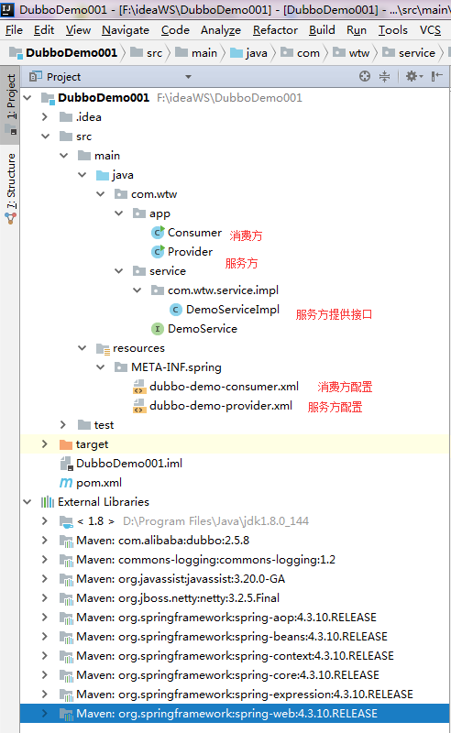

使用时需要先开启服务端，再开启客户端，运行结果如图：

