Multi robot SLAM uses a kind of multi robot SLAM method based on an improved particle swarm optimization algorithm, which considers the factors of avoiding obstacles and arriving end position quickly. This master includes some parameters, as follows: , , , . is calculated by this equation: . And,  is calculated by this equation: . This master integrates the improved particle swarm optimization method into the original multi robot SLAM exploration framework. The result is shown in the Fig.2.

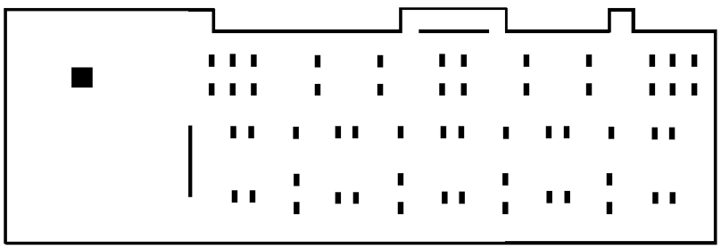

Fig.1 The original map we intend to explore

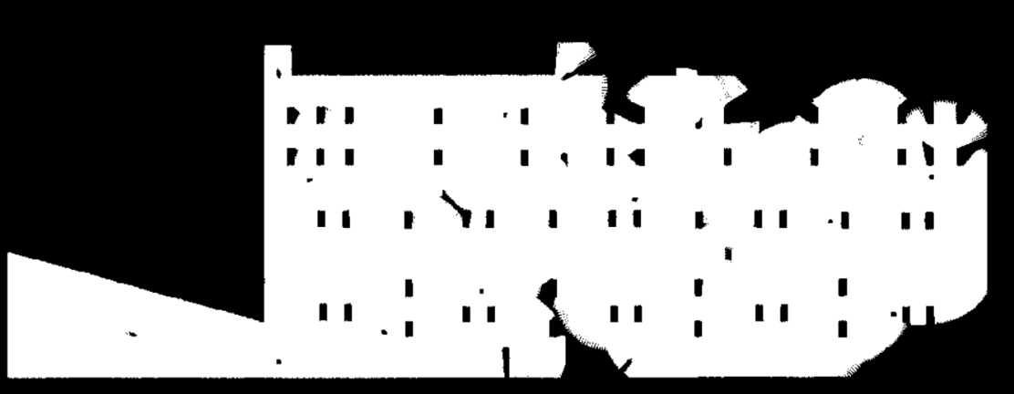

Fig.2 Explored area after 1000 iteration using improved algorithm with fixed weights