This master is an implementation of Rao-Blackwellised particle filter SLAM method.

Requiremnets: Eigen3(sudo apt-get install libeigen3-dev), Qt4(sudo apt-get install libat4-core libqt4-dev), QCustomPlot.

Compile: make

Usage: examples: ./fastslam.e -method FAST2 -mode waypoints -m data/example_webmap.mat(FASTSLAM2, following waypoints, map is "example_webmap.mat")

Platform: Ubuntu 14.04.

Results are shown in the below:

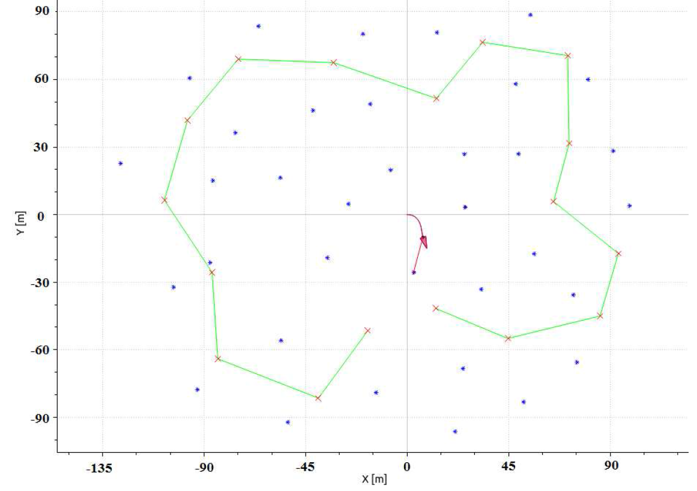

Fig.1 Trajectory when simulation begins

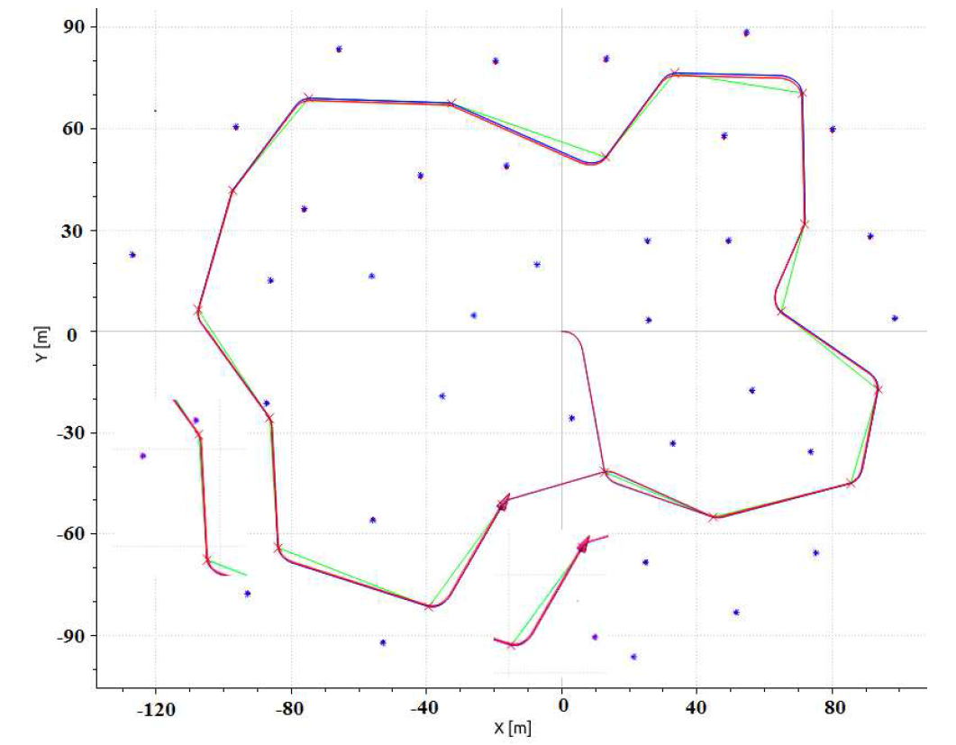

Fig.2 RBPF-SLAM method