

BUSTIX — DIGITAL BUS TICKETING SYSTEM

SYSTEM DOCUMENTATION

SUBMITTED BY,

VIONA WANGUI NJERI
DIT-01-0191/2025

A SYSTEM DOCUMENTATION SUBMITTED IN PARTIAL FULFILMENT FOR THE AWARD
OF DIPLOMA IN INFORMATION TECHNOLOGY BY ZETECH UNIVERSITY

APRIL 2026

DECLARATION
I, Viona Wangui Njeri, declare that this system documentation is my own original work and has not been submitted for examination to any other institution of higher learning. All information and sources that were used during the development of this project and the writing of this documentation have been properly acknowledged and referenced according to the APA 7th edition referencing format.

I further declare that this work has been carried out under the supervision of my assigned project supervisor at Zetech University, and all findings and results presented herein are genuine and accurately represent the work done during the project period.

Student Name: VIONA WANGUI NJERI
Admission Number: DIT-01-0191/2025

Signature: ___________________________________ Date: ________________

Supervisor Name: ___________________________________
Signature: ___________________________________ Date: ________________

DEDICATION
I dedicate this work to my family and friends who supported me with patience, encouragement, and motivation throughout the entire period of this project. Your belief in me kept me going during the difficult moments.

I also dedicate this documentation to my lecturers and project supervisor at Zetech University, who provided me with the knowledge, tools, and guidance needed to successfully plan, develop, and document the BusTix digital bus ticketing system. Your time and advice were truly valuable.

Finally, I dedicate this project to all future Zetech University students who will read this documentation as a reference. May it help you understand what is possible when you combine hard work with the right technology tools and proper planning.

ABSTRACT
BusTix is a digital bus ticketing system developed using Python and the Flask web framework. The system was built to solve the problems caused by manual, paper-based ticketing in the bus transport industry. Conductors using the system can issue digital tickets to passengers in real time, while managers can monitor trip revenue, track fleet performance, and generate reports from a central dashboard.

The system has two user roles: Manager and Conductor. The Manager Dashboard displays today's revenue, total tickets issued, active trips, and a 7-day revenue chart. The Conductor Dashboard allows conductors to start trips and issue tickets by recording the passenger name, seat number, fare, and payment method. Tickets are assigned unique numbers in the format TKT-XXXXXXXX and stored in a SQLite database immediately.

The technology stack includes Python 3 and Flask for the backend, SQLite for the database, HTML, CSS, and JavaScript for the frontend, and Chart.js for data charts. The system was deployed on PythonAnywhere and is accessible from any browser. This documentation covers all four stages of the project: planning, design and modelling, implementation and testing, and conclusion and recommendations.

DEFINITION OF KEY TERMS
Trip: A scheduled bus journey assigned to a specific bus, route, and conductor. A trip can have the status of scheduled, active, or completed.

Ticket: A digital record of a passenger's fare payment for a specific trip. Each ticket has a unique number in the format TKT-XXXXXXXX, and is linked to the conductor who issued it, the trip, and the passenger.

Conductor: A bus staff member who is assigned trips and is responsible for issuing digital tickets to passengers boarding the bus.

Manager: An administrative user who has full access to the system. The manager can add buses, routes, and conductors, schedule trips, and view financial reports.

Route: A named path connecting two towns with a defined base fare and distance, for example Nairobi–Mombasa Express at KSh 1,500 for 480 km.

Session: A secure login state saved by the Flask backend that identifies whether the currently logged-in user is a manager or a conductor and keeps them logged in as they move between pages.

REST API: A set of backend endpoints (web addresses) that return data in JSON format when called by the frontend using the Fetch API in JavaScript.

ABBREVIATIONS AND ACRONYMS
API — Application Programming Interface
CSS — Cascading Style Sheets
CSV — Comma-Separated Values
DB — Database
DIT — Diploma in Information Technology
HTML — HyperText Markup Language
HTTP — HyperText Transfer Protocol
IDE — Integrated Development Environment
JS — JavaScript
JSON — JavaScript Object Notation
PK — Primary Key
FK — Foreign Key
REST — Representational State Transfer
SQL — Structured Query Language
SQLite — Structured Query Language Lite
UI — User Interface
URL — Uniform Resource Locator
WSGI — Web Server Gateway Interface

LIST OF FIGURES
Figure 2.2.1 — Login Page Wireframe Design ........................................................ 9
Figure 2.2.2 — Manager Dashboard Wireframe Design ............................................ 10
Figure 2.2.3 — Conductor Dashboard Wireframe Design ........................................... 11
Figure 2.2.4 — Reports Page Wireframe Design ................................................... 12
Figure 2.3.1 — System Architecture Diagram ...................................................... 13
Figure 2.3.2 — Login Process Flowchart ........................................................... 14
Figure 2.3.3 — Ticket Issuance Flowchart ........................................................ 15
Figure 2.3.4 — Report Generation Flowchart ...................................................... 16
Figure 2.3.5 — Database Schema Diagram .......................................................... 17

LIST OF TABLES
Table 1.4 — Functional Requirements Table ......................................................... 5
Table 1.5 — Breakdown of Tools and Resources ..................................................... 6
Table 1.6 — Project Schedule Breakdown ............................................................ 7
Table 3.4 — System Testing Results Table .......................................................... 22

TABLE OF CONTENTS
Table of Contents
CHAPTER ONE: PROJECT PLANNING AND ANALYSIS 1
1.1 Statement of Problem 1
1.2 Study Justification 1
1.3 System Objectives 1
1.3.1 General Objective 2
1.3.2 Specific Objectives 2
1.4 Functional Requirements 2
1.5 Breakdown of Tools and Resources to Be Used 2
1.6 Project Schedule Breakdown 3
CHAPTER TWO: DESIGN AND MODELLING 5
2.1 Introduction to Modelling 5
2.2 User Interface Models 5
2.2.1 Login Page 5
2.2.2 Manager Dashboard 6
2.2.3 Conductor Dashboard 7
2.2.4 Reports Page 8
2.3 Logic Models 9
2.3.1 System Architecture Diagram 9
2.3.2 Login Process Flowchart 10
2.3.3 Ticket Issuance Flowchart 10
2.3.4 Report Generation Flowchart 11
2.3.5 Database Schema Diagram 12
CHAPTER THREE: SYSTEM IMPLEMENTATION 13
3.1 Introduction 13
3.2 User Interface Development 13
3.2.1 Login Page Development 13
3.2.2 Manager Dashboard Development 13
3.2.3 Conductor Dashboard Development 14
3.2.4 Reports Page Development 14
3.3 Logic Development 14
3.3.1 Authentication and Session Management Logic 14
3.3.2 Ticket Issuance Logic 14
3.3.3 Revenue and Report Generation Logic 15
3.4 Testing 15
3.5 Deployment 16
CHAPTER FOUR: CONCLUSION AND RECOMMENDATION 17
4.1 Conclusion 17
4.2 Recommendation 17

CHAPTER ONE: PROJECT PLANNING AND ANALYSIS
(WORKPLAN)

1.1 Statement of Problem
Bus companies operating across Kenyan towns still depend heavily on paper-based ticketing systems. Conductors write out ticket details by hand, and managers have no way to track how many passengers have boarded a given bus or how much revenue has been collected during the day. This leads to several serious problems that affect both the bus company and its passengers.

Paper tickets can easily get lost, be written incorrectly, or even be duplicated and used fraudulently. At the end of each trip, conductors must manually count all collected fares and hand over cash to the manager, a process that is slow and prone to errors or theft. Managers cannot make informed decisions in real time because they only receive reports at the end of the day or week.

Passengers receive no proper proof of payment and cannot trace their ticket if something goes wrong. There is also no way to know in real time how full a bus is, which routes are performing well, and which conductors are collecting the most revenue. BusTix was developed specifically to solve all these problems by replacing the paper process with a fast, reliable, and fully digital ticketing platform.

1.2 Study Justification
The BusTix system is needed because the existing manual ticketing process creates financial losses, operational inefficiencies, and a lack of accountability across the bus transport chain. The system is justified on multiple grounds, all of which directly benefit the bus company, conductors, managers, and passengers.

First, the system improves financial accuracy. Every ticket issued is saved to the database immediately with the exact fare, payment method, and timestamp, leaving no room for human counting errors. Second, it improves accountability by linking every ticket to a specific conductor and trip. Managers can see exactly who issued how many tickets and when, making it impossible for revenue to go unrecorded. Third, the manager dashboard gives real-time visibility with live stats cards showing today's revenue, active trips, and ticket count at a glance.

Fourth, the system is easy to use — conductors can issue a ticket in seconds using any web browser, with no special hardware required. Fifth, it supports three payment methods: Cash, M-Pesa, and Card, which matches how passengers in Kenya actually pay. The system is lightweight, free to deploy, and runs on any device with internet access.

1.3 System Objectives

1.3.1 General Objective
(i) To develop a digital bus ticketing system that enables conductors to issue passenger tickets in real time and allows managers to monitor trip operations, revenue performance, and fleet activities from a central dashboard.

1.3.2 Specific Objectives
(i) To implement a secure role-based login system that separates manager and conductor access, ensuring each user can only access features and data that belong to their assigned role.

(ii) To implement a ticket issuance feature that allows conductors to record passenger payments, assign seat numbers, select payment methods, and generate unique ticket numbers linked to specific trips.

(iii) To implement a manager dashboard that shows real-time revenue totals, ticket counts, active trips, and data charts including a 7-day revenue bar chart and a route revenue doughnut chart.

(iv) To implement a reporting and analytics feature that allows managers to filter trip and revenue data by date range and route, view a revenue trend chart, and export results as a downloadable CSV file.

1.4 Functional Requirements
The table below outlines the two main user roles in the BusTix system, what each user can do, and what features the system provides to support them.

User Role | User Activities | System Features
Manager | - View today's revenue, ticket count, and active trips - Schedule trips by assigning bus, route, conductor, and departure time - Manage buses, routes, and staff accounts - View and export trip reports | - Manager Dashboard with live stats cards - 7-day revenue bar chart and route doughnut chart - Live Trips Table with capacity progress bars - Reports page with date range and route filters
Conductor | - View all assigned trips (active and scheduled) - Start a scheduled trip to change its status to active - Issue tickets to passengers with name, seat, and payment method - Track personal revenue and passenger count | - Conductor Dashboard showing My Trips list - Start Trip button - Ticket Issuance Form with auto-filled fare - Live Ticket Feed showing recently issued tickets
Table 1.4 Functional Requirements Table

1.5 Breakdown of Tools and Resources to Be Used
The following table lists all the tools and technologies used during the development of the BusTix system, along with the category each tool belongs to and a brief explanation of how it was used in the project.

Tool / Technology | Category | How It Was Used
Python 3 + Flask | Backend / Application Layer | Handles all server-side logic, routing, session management, and REST API endpoints. Flask is the web framework.
SQLite (sqlite3) | Database | Lightweight file-based database built into Python. Stores all users, routes, buses, trips, and tickets with no additional setup.
HTML5 + CSS3 | Frontend Structure & Styling | Used to build all pages including the login page, manager dashboard, conductor dashboard, and reports page.
JavaScript (Vanilla) | Frontend Interactivity | Powers all API calls using the Fetch API, updates the UI dynamically without page reloads, and handles form submissions.
Chart.js 4.4 | Data Visualisation | Renders the 7-day revenue bar chart, route doughnut chart, and revenue trend line chart on the dashboard and reports page.
Google Fonts (Syne + DM Sans) | Typography | Provides clean, professional fonts used throughout the BusTix interface.
Visual Studio Code | IDE (Development Tool) | Used to write, edit, and debug all code files including app.py, HTML, CSS, and JavaScript.
Git + GitHub | Version Control | Tracks all changes made during development and allows safe backup and rollback of code.
PythonAnywhere | Deployment / Web Hosting | Free cloud hosting platform used to deploy the BusTix Flask application and make it accessible via a public URL.
Table 1.5 Breakdown of Tools and Resources

1.6 Project Schedule Breakdown
The table below shows the project timeline broken down into milestones. Green cells indicate milestones that have already been completed. Empty cells represent upcoming work. This schedule helped the developer stay on track throughout the project period and monitor progress against the planned timeline.

WEEKS | Project Planning & Analysis (Ch.1) | Design & Modelling (Ch.2) | Development & Testing (Ch.3) | Deployment & Documentation | Final Touches & References | Presentation
7–9 Jan | ✓
12–16 Jan | ✓
19–23 Jan |  | ✓
26–30 Jan |  | ✓
2–6 Feb |  |  | ✓
9–13 Feb |  |  | ✓
16–20 Feb |  |  | ✓
23–27 Feb |  |  |  | ✓
2–6 Mar |  |  |  | ✓
9–13 Mar |  |  |  |  | ✓
16–20 Mar |  |  |  |  | ✓
23–27 Mar |  |  |  |  |  | ✓
3rd April |  |  |  |  |  | ✓
Table 1.6 Project Schedule Breakdown

Note: This page was printed in landscape format during the project. Green-filled cells mean the milestone was completed. The schedule spans from January 2026 to April 2026 and covers all four chapters of the documentation.

CHAPTER TWO: DESIGN AND MODELLING

2.1 Introduction to Modelling
This chapter presents all the design work that was done before development of BusTix began. Modelling is the process of drawing and planning how a system will look and how it will work before writing any code. It helps the developer think clearly about what screens to create, how users will interact with the system, and how data will move between the different parts of the application.

For BusTix, modelling involved two types of work. The first type was User Interface modelling, where wireframes were drawn to show what each page of the system would look like before building it. The pages modelled include the Login Page, Manager Dashboard, Conductor Dashboard, and Reports Page. The second type was Logic modelling, where process diagrams were drawn to show how the system would handle specific tasks like user login, ticket issuance, report generation, and data storage.

The benefit of modelling before coding is that it exposes design problems early, saves development time, and gives a clear blueprint to follow. All diagrams in this chapter represent the final versions of the designs used during development. Each diagram is accompanied by an explanation and a caption for clarity.

2.2 User Interface Models
The wireframes below show the planned layout of each page in the BusTix system. They were drawn to visualise the structure of the system before HTML and CSS were written. Each wireframe is explained briefly before the diagram, with a caption below it.

2.2.1 Login Page
The login page is the very first screen a user sees when they open BusTix in a browser. It uses a centred card layout placed in the middle of a dark background. The BusTix logo and system name appear at the top of the card. Below them are two input fields for the username and password. A blue login button sits at the bottom of the card. When the user submits the form, JavaScript sends the credentials to the backend using a POST request. If the login is successful, the user is automatically redirected to their correct dashboard based on their role. If the login fails, a red error message appears below the input fields without reloading the page, giving a smooth and instant user experience.

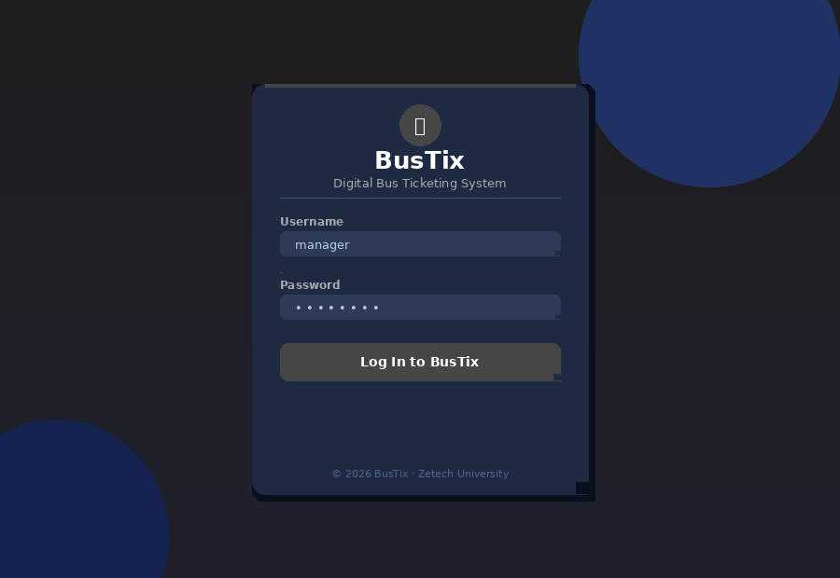
Figure 2.2.1 Login Page Wireframe Design

2.2.2 Manager Dashboard
The manager dashboard is accessed only by managers after a successful login. It uses a two-column layout. The left side is a fixed dark blue sidebar with navigation links to Dashboard, Fleet, Routes, Staff, Schedule, and Reports. The right side is the main content area. At the very top of the content area are four summary cards showing Today's Revenue, Today's Tickets, Active Trips, and Total Passengers, all loaded from the API in real time. Below the cards is a 7-day revenue bar chart with a ticket volume overlay, and a doughnut chart showing revenue distribution across routes. At the bottom is a live trips table that shows each active or scheduled trip with a progress bar indicating how full the bus is. Clicking any trip row opens a modal showing all the tickets issued for that trip.

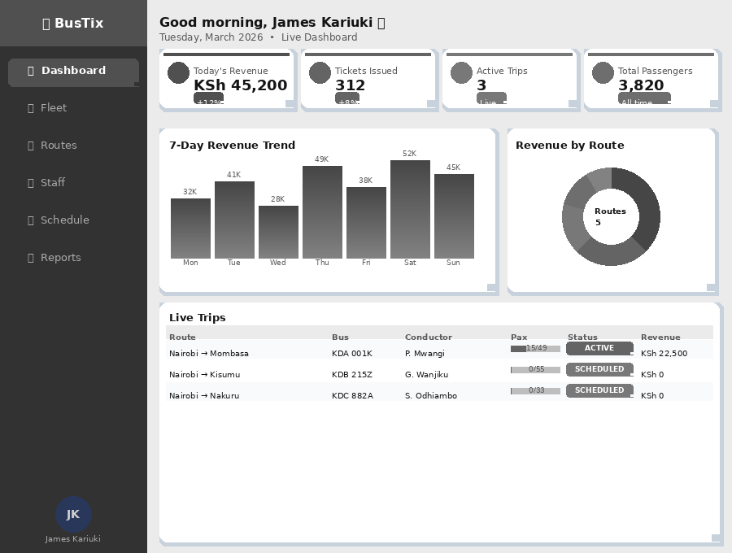
Figure 2.2.2 Manager Dashboard Wireframe Design

2.2.3 Conductor Dashboard
The conductor dashboard is designed to be simple and fast to use, since conductors may be on a moving bus. After login, the conductor sees only their own assigned trips listed as individual cards. Each trip card shows the route, bus registration number, departure time, number of passengers already boarded, and the current trip status. There are two buttons per trip: Start Trip, which changes the status from scheduled to active, and Issue Ticket, which opens the ticket form inline. The ticket form has fields for passenger name, seat number, payment method, and fare. The fare is auto-filled from the route. After the ticket is submitted, the form clears and the new ticket number is shown so the conductor can confirm the record was saved. A Live Ticket Feed at the bottom shows the most recently issued tickets.

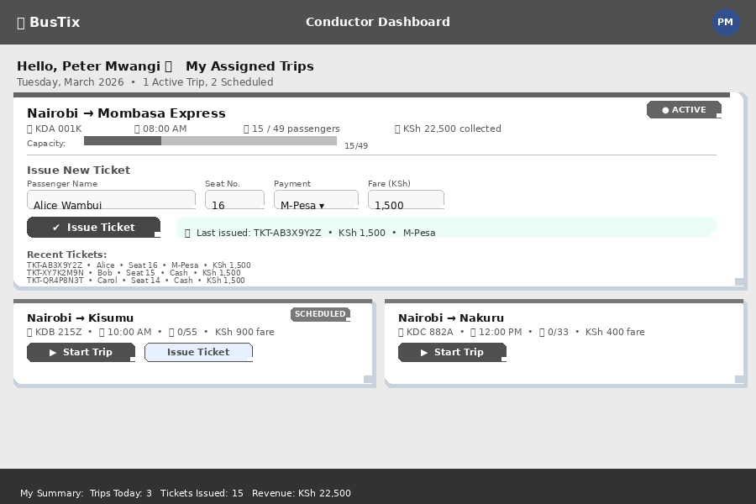
Figure 2.2.3 Conductor Dashboard Wireframe Design

2.2.4 Reports Page
The reports page is available to managers only and is accessed from the sidebar navigation. At the top of the page are filter controls: a From date picker, a To date picker, and a Route dropdown. Clicking Apply runs the query on the backend and refreshes the results below. A summary bar immediately below the filters shows the total revenue and total passengers for the selected period. A revenue trend line chart fills the centre of the page, showing daily revenue over either the last 30 or 90 days depending on the toggle selected. Below the chart is a detailed trip table listing every trip with its code, route, bus, conductor, departure date, passenger count, and revenue. A green Export CSV button in the top right of the table allows the manager to download the entire filtered report as a CSV spreadsheet file.

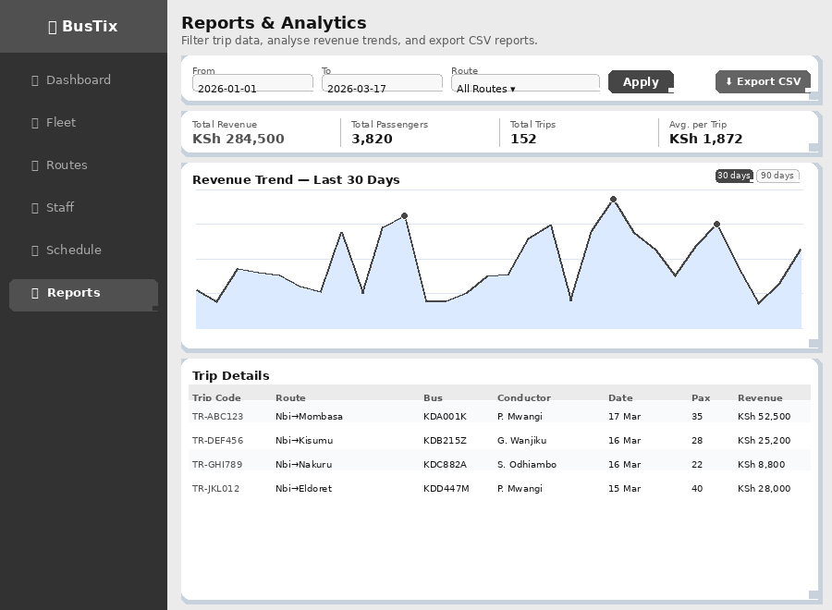
Figure 2.2.4 Reports Page Wireframe Design

2.3 Logic Models
The logic models below show how the BusTix system works on the inside. They include the system architecture, process flowcharts for login and ticket issuance, and the database schema. Each diagram is explained before it is shown, and a caption is placed below.

2.3.1 System Architecture Diagram
BusTix follows a standard three-tier web application architecture. The first tier is the Presentation Layer, which is the browser where users see and interact with the HTML pages. JavaScript runs in this layer and makes API calls to the backend. The second tier is the Application Layer, which is the Flask server running in Python. This layer handles all business logic including login checks, ticket generation, data retrieval, and report calculations. It communicates with the database and returns results to the browser in JSON format. The third tier is the Data Layer, which is the SQLite database file that stores all records for users, routes, buses, trips, and tickets. The diagram below illustrates these three tiers and the components that live in each one.

BUSTIX — THREE-TIER SYSTEM ARCHITECTURE
LAYER 1 — PRESENTATION (Browser): HTML · CSS · JavaScript · Chart.js
login.html Login Page | manager.html Manager Dashboard | conductor.html Conductor Dashboard | reports.html Reports Page
LAYER 2 — APPLICATION (Flask / Python): app.py — Routes · Sessions · Business Logic · REST API
Auth & Session Management login_required · manager_required · conductor_required |  | REST API Endpoints /api/stats · /api/trips · /api/tickets · /api/reports
LAYER 3 — DATA (SQLite): users · routes · buses · trips · tickets
Figure 2.3.1 System Architecture Diagram

2.3.2 Login Process Flowchart
The login process begins when a user opens BusTix and enters their username and password on the login page. JavaScript sends these details to the Flask backend at the /login endpoint using a POST request. The backend retrieves the user record from the database and hashes the entered password using the SHA-256 algorithm. It then compares the hashed password to the stored hash. If they do not match or the username does not exist, a 401 error is returned and the frontend displays a red error message. If the credentials are correct, the user's ID, role, and full name are saved in a Flask session. The backend then checks the role and the frontend redirects the user — managers go to /manager and conductors go to /conductor. The flowchart below shows every step in this process.

START
▼
User opens BusTix in browser
▼
User enters username and password
▼
System hashes password using SHA-256 and checks database
▼
Credentials WRONG? → Show error message on screen → User tries again
▼ Credentials CORRECT?
Check user role from session
Role = manager → Redirect to /manager | Role = conductor → Redirect to /conductor
END
Figure 2.3.2 Login Process Flowchart

2.3.3 Ticket Issuance Flowchart
Ticket issuance is the core feature of BusTix. The process begins when a conductor clicks the Issue Ticket button on their assigned trip. A form opens where the conductor fills in the passenger's name, seat number, payment method (Cash, M-Pesa, or Card), and confirms the fare. When the form is submitted, JavaScript sends a POST request to the /api/tickets endpoint. The Flask backend first checks whether the selected trip exists and whether its status is active or scheduled. If the trip is completed or does not exist, the system returns an error message. If the trip is valid, the system uses Python's random module to generate a unique 8-character ticket number in the format TKT-XXXXXXXX. The ticket is saved to the tickets table in the database with the current timestamp and the conductor's user ID. The ticket number is then returned to the browser and shown to the conductor.

START
Conductor logs in and opens their Conductor Dashboard
Conductor selects an assigned trip from the My Trips list
Conductor clicks [Issue Ticket] button
Ticket form opens: Passenger Name · Seat Number · Payment Method · Fare
Is trip status ACTIVE or SCHEDULED?
NO → Return error: 'Trip not active'. Conductor cannot issue ticket.
YES → System generates unique Ticket Number: TKT-XXXXXXXX
Ticket saved to database with timestamp, fare, payment method, and conductor ID
Ticket number shown on conductor screen. Live Ticket Feed updates automatically.
END
Figure 2.3.3 Ticket Issuance Flowchart

2.3.4 Report Generation Flowchart
The report generation process allows managers to view trip and revenue data filtered by date and route. It begins when the manager navigates to the Reports page and selects a date range using the From and To date pickers. Optionally, the manager can also select a specific route from the dropdown to narrow down the results. After clicking Apply Filters, JavaScript sends a GET request to the /api/reports/trips endpoint with the filter values as query parameters. The Flask backend queries the trips and tickets tables using SQL with the provided date range and optional route filter. The results are returned as JSON and the frontend populates the summary bar, the revenue trend chart, and the trip table. If the manager clicks Export CSV, JavaScript converts the JSON data into a CSV string and triggers a file download directly in the browser without any server involvement.

START
Manager logs in and navigates to Reports page
Manager selects date range (From / To) and optionally selects a route
Manager clicks [Apply Filters]
System queries trips and tickets tables using the selected date range and route
Results shown: Total Revenue · Total Passengers · Revenue Trend Chart · Trip Table
Manager clicks [Export CSV] → CSV file downloaded to manager's device
END
Figure 2.3.4 Report Generation Flowchart

2.3.5 Database Schema Diagram
The BusTix database consists of five tables that are linked together using primary keys (PK) and foreign keys (FK). The Users table stores all staff accounts including their username, hashed password, role, and full name. The Routes table holds each route's name, origin, destination, base fare, and distance. The Buses table stores bus registration numbers, model, and seating capacity. The Trips table is the central linking table — it connects a route, a bus, and a conductor together for a specific departure time and tracks the trip status. The Tickets table records every passenger ticket and links it to a trip through a foreign key. All five tables are shown in the diagram below with their column names.

USERS  id (PK) username password_hash role full_name active | ROUTES  id (PK) name origin destination base_fare distance_km | BUSES  id (PK) reg_number model capacity active | TRIPS  id (PK) trip_code route_id (FK) bus_id (FK) conductor_id (FK) departure_time status | TICKETS  id (PK) ticket_number trip_id (FK) passenger_name seat_number fare_paid payment_method issued_at issued_by (FK)
Figure 2.3.5 Database Schema Diagram

CHAPTER THREE: SYSTEM IMPLEMENTATION
(DEVELOPMENT, TESTING AND DEPLOYMENT)

3.1 Introduction
This chapter describes the complete journey of how the BusTix system was built, tested, and deployed. Development started with setting up the environment by installing Python 3 and the Flask library using pip. A single file, app.py, was created to hold all backend code including database setup, route handlers, session management, and REST API endpoints. The database was initialised automatically when the app runs for the first time using the init_db() function, which creates all five tables if they do not already exist. Demo data was then seeded into the database using the seed_data() function.

The frontend was built page by page using HTML, CSS, and vanilla JavaScript. Chart.js was loaded via a CDN link and used to render the revenue charts on the manager dashboard and reports page. No JavaScript framework was used — all dynamic updates were handled by writing Fetch API calls and updating the DOM directly. Styling was done using custom CSS variables stored in the base.html template, which all other pages extend.

Testing was carried out manually by logging in with three different accounts (manager, conductor1, conductor2) and performing every available action. Deployment was done on PythonAnywhere, a free Python hosting platform. The following sections describe each stage in detail, with explanations of the code and the decisions made during development.

3.2 User Interface Development
The BusTix interface was built using raw HTML, CSS, and JavaScript without any frontend framework. All pages share a common layout defined in base.html, which includes the sidebar navigation, global CSS variables, and Chart.js CDN import. Individual pages extend this base template using Flask's Jinja2 templating engine.

3.2.1 Login Page Development
The login page (login.html) was the first page built. It uses a centred flexbox card positioned in the middle of a full-height dark background. The card contains the BusTix logo, a heading, two input fields, and a login button. All styling was written in a style block inside the HTML file. When the button is clicked, a JavaScript function prevents the default form submission and instead sends a fetch POST request to the /login endpoint with the username and password as a JSON body. If the response comes back with ok: true, the JavaScript reads the role from the response and redirects to either /manager or /conductor. If ok is false, a red error paragraph is made visible below the form. This gives a fast, app-like login experience without a full page reload.

3.2.2 Manager Dashboard Development
The manager dashboard (manager.html) uses a two-column CSS grid layout. The left column is a fixed sidebar with navigation links. The right column is a scrollable main area that displays content in sections. When the page loads, JavaScript immediately calls three API endpoints: /api/stats/overview to get today's summary numbers, /api/trips/live to get the live trips table, and then uses the stats data to draw the bar and doughnut charts using Chart.js. The four summary cards were built as styled divs that receive their values from the API response. The revenue bar chart uses a canvas element and is configured with two datasets — one for revenue and one for ticket count. The live trips table is built dynamically by looping through the API results and inserting table rows using innerHTML.

3.2.3 Conductor Dashboard Development
The conductor dashboard (conductor.html) was designed to be simple and load fast. On page load, it calls /api/conductor/my_trips with the current session to get only the trips assigned to the logged-in conductor. These are displayed as styled cards, each with a Start Trip button and an Issue Ticket button. The ticket form is a hidden div that slides open when the Issue Ticket button is clicked. The form auto-fills the fare from the trip data. When the form is submitted, JavaScript sends a POST request to /api/tickets. If the response is successful, the ticket number is shown in a confirmation message inside the card and the form fields are reset so the conductor can immediately issue the next ticket without scrolling or reloading the page.

3.2.4 Reports Page Development
The reports page (reports.html) was built last as it required the most complex data handling. It has three sections: a filter bar at the top, a revenue trend chart in the middle, and a trip detail table at the bottom. The filter bar uses two date input elements and a route select dropdown populated from the /api/routes endpoint. When the manager clicks Apply, JavaScript builds a query string from the filter values and sends it to /api/reports/trips and /api/reports/revenue. The trend chart is rendered using Chart.js as a line graph. The trip table is populated dynamically from the API results. The CSV export function iterates over the trip data array, formats each row as a comma-separated string, joins all rows with newline characters, creates a Blob object, and triggers a file download using a temporary anchor element.

3.3 Logic Development
The logic side of BusTix is handled entirely in app.py, which contains all Flask routes, database query functions, and session management. The following subsections explain the three most important logic components.

3.3.1 Authentication and Session Management Logic
When a user registers, their password is hashed using Python's hashlib.sha256 function and the resulting hex digest is stored in the users table. Plain text passwords are never stored anywhere in the system. When a user logs in, the entered password is hashed the same way and the result is compared to the stored hash. If they match, the user's ID, role, and full name are saved into the Flask session using session['user_id'], session['role'], and session['name']. Every protected route uses a decorator to check the session before serving the page. The login_required decorator checks that user_id is in the session. The manager_required decorator also checks that the role is manager. The conductor_required decorator accepts either conductor or manager. If the session check fails, the user is immediately redirected to the login page.

3.3.2 Ticket Issuance Logic
The ticket issuance logic lives in the api_issue_ticket() function in app.py, which handles POST requests to the /api/tickets endpoint. When a conductor submits the ticket form, the function first extracts the trip_id from the request body and queries the trips table to check whether the trip exists and whether its status is active or scheduled. If the trip status is completed or the trip does not exist, the function returns a JSON error response with HTTP status 400. If the trip is valid, the gen_ticket() function generates a random ticket number by calling random.choices() on a string of uppercase letters and digits to produce 8 characters, prefixed with TKT-. The ticket is then inserted into the tickets table with the passenger name, seat number, fare paid, payment method, the current UTC timestamp, and the conductor's user ID from the session.

3.3.3 Revenue and Report Generation Logic
The revenue report logic handles two API endpoints. The /api/reports/revenue endpoint loops through each day in the requested range (30 or 90 days) and runs two SQL queries per day: one to sum all fare_paid values for tickets issued on that day, and another to count the number of tickets. These results are assembled into a list of daily objects returned as JSON for the Chart.js line chart. The /api/reports/trips endpoint builds a dynamic SQL query that joins the trips, routes, buses, users, and tickets tables. It accepts optional date range parameters (from and to) and an optional route_id parameter. If route_id is provided, a WHERE clause is added to the query. Results are ordered by departure_time in descending order and returned as a JSON list that the frontend renders in the trip table and exports as CSV.

3.4 Testing
Testing was carried out manually after each feature was built. The following table shows the ten test cases that were executed to verify all features of the BusTix system are working correctly.

Test ID | Test Action | Expected Result | Actual Result | Status
TC-01 | Login with correct manager credentials | Manager Dashboard opens | Manager Dashboard opened | PASS
TC-02 | Login with correct conductor credentials | Conductor Dashboard opens | Conductor Dashboard opened | PASS
TC-03 | Login with wrong password | Error message displayed on screen | Error message shown correctly | PASS
TC-04 | Conductor issues ticket on an active trip | Ticket number generated and saved | Ticket TKT-XXXXXXXX generated | PASS
TC-05 | Conductor issues ticket on a completed trip | Error: Trip not active | Error returned correctly | PASS
TC-06 | Conductor clicks Start Trip on scheduled trip | Trip status changes to active | Status updated to active | PASS
TC-07 | Manager views 7-day revenue chart | Bar chart loads with correct data | Chart loaded correctly | PASS
TC-08 | Manager views route revenue doughnut chart | Doughnut chart shows all 5 routes | Chart displayed all routes | PASS
TC-09 | Manager filters reports by date range | Only trips in range shown | Filtered results correct | PASS
TC-10 | Manager exports report as CSV | CSV file downloads to device | CSV downloaded successfully | PASS
Table 3.4 System Testing Results Table

All ten test cases passed. During testing, one bug was identified: the ticket issuance endpoint was initially returning a 400 error for trips with the status scheduled. This was because the original condition only checked for active. The fix was to update the condition in app.py to accept both active and scheduled. A second issue found was that the conductor dashboard was not updating the passenger count after a ticket was issued. This was fixed by calling the loadTrips() function again after each successful ticket submission so the card refreshes automatically.

3.5 Deployment
BusTix was deployed on PythonAnywhere, a free web hosting platform that natively supports Python and Flask applications. The deployment process involved the following steps.

Step 1: A free PythonAnywhere account was created at www.pythonanywhere.com. The account provides a Linux server environment with Python 3.10 pre-installed and enough free resources to run the BusTix application.

Step 2: All project files were uploaded to the PythonAnywhere server using their built-in file manager. The files uploaded included app.py, requirements.txt, the templates folder containing all five HTML files, and the static folder containing the background image.

Step 3: A new web application was created through the PythonAnywhere Web tab. Flask was selected as the framework and Python 3.10 was chosen as the Python version. PythonAnywhere automatically generated a WSGI configuration file, which was then edited to import the app variable from app.py correctly.

Step 4: The web application was reloaded using the green Reload button. The BusTix system became live and accessible from any browser at the public PythonAnywhere URL. The SQLite database file is stored on the PythonAnywhere server and persists across sessions. Any device with internet access can now open and use BusTix without installing anything locally.

CHAPTER FOUR: CONCLUSION AND RECOMMENDATION

4.1 Conclusion
This project successfully delivered a fully working digital bus ticketing system called BusTix. Chapter One identified the core problem: bus companies in Kenya use manual, paper-based ticketing that leads to lost records, revenue leakage, and zero real-time visibility for managers. A set of four specific objectives was defined to address these problems through technology.

Chapter Two presented all the design work done before development. Wireframes were drawn for four pages: the Login Page, Manager Dashboard, Conductor Dashboard, and Reports Page. Logic diagrams including the system architecture, login flowchart, ticket issuance flowchart, report generation flowchart, and database schema were also created to guide the development work.

Chapter Three described how the system was built from scratch using Python, Flask, SQLite, HTML, CSS, JavaScript, and Chart.js. All features were implemented successfully and ten test cases were passed. The system was deployed live on PythonAnywhere.

Through this project, the developer learned how to build a complete full-stack web application, how to design and query a relational database, how to protect routes using session-based authentication, how to use the Fetch API to build dynamic pages without page reloads, and how to deploy a Python application to a live server. The main challenge was handling real-time data updates without a JavaScript framework, which was solved by manually refreshing API calls after each user action.

4.2 Recommendation
BusTix is a complete and working system that handles the core digital ticketing needs of a bus company. However, as a developer who has worked on it closely, I recommend the following improvements to whoever picks it up next.

First, the current login system uses only a username and password. I recommend adding Two-Factor Authentication (2FA), where a one-time PIN is sent to the conductor's phone number via SMS using an API like Africa's Talking. This would make the system significantly more secure, especially since it handles real financial data. I did not implement this because I did not have budget for the SMS API during the project period.

Second, BusTix currently runs in a web browser, which means conductors must have mobile data to use it. I recommend developing a mobile application for Android using Flutter or React Native, which would allow conductors to issue tickets on a smartphone app that works offline and syncs data when connected to the internet. This would be very useful on routes where mobile data coverage is poor.

Third, the system uses SQLite as the database, which is a file-based database suitable for small deployments. If BusTix is scaled up to handle hundreds of buses and thousands of trips per day, I strongly recommend migrating the database to PostgreSQL. PostgreSQL handles concurrent writes and large data volumes much better than SQLite and would prevent performance issues at scale.

Fourth, the payment recording system currently only stores the payment method (Cash, M-Pesa, or Card) but does not process actual payments. I recommend integrating the Safaricom Daraja API to process M-Pesa STK Push payments directly within BusTix. This would allow the system to confirm payment from the passenger's phone before issuing the ticket, reducing the chance of dishonest fare recording.

Fifth, BusTix currently has no physical receipt printing feature. I recommend integrating a Bluetooth thermal printer such as the Xprinter XP-58 so that conductors can print a small paper receipt for passengers who want one. This would improve passenger confidence and satisfaction, especially on long-distance routes where passengers may need a receipt for reimbursement purposes.

REFERENCES
Flask Documentation Team. (2024). Flask — Lightweight WSGI web application framework. Pallets Projects. https://flask.palletsprojects.com

Google Fonts. (2024). Syne and DM Sans variable fonts. Google LLC. https://fonts.google.com

Mozilla Developer Network. (2024). Using the Fetch API. MDN Web Docs. https://developer.mozilla.org/en-US/docs/Web/API/Fetch_API/Using_Fetch

Mozilla Developer Network. (2024). HTMLElement: input event, forms, and validation. MDN Web Docs. https://developer.mozilla.org/en-US/docs/Web/HTML/Element/input

Python Software Foundation. (2024). hashlib — Secure hash and message digest algorithms. Python 3 Documentation. https://docs.python.org/3/library/hashlib.html

Python Software Foundation. (2024). sqlite3 — DB-API 2.0 interface for SQLite databases. Python 3 Documentation. https://docs.python.org/3/library/sqlite3.html

PythonAnywhere. (2024). Getting started with Flask on PythonAnywhere. PythonAnywhere Help Pages. https://help.pythonanywhere.com/pages/Flask

Riva, N. (2023). Chart.js documentation: Getting started and configuration. Chart.js. https://www.chartjs.org/docs/latest

Safaricom PLC. (2024). Daraja API: M-Pesa developer documentation. Safaricom Developer Portal. https://developer.safaricom.co.ke

W3Schools. (2024). Python Flask tutorial. W3Schools Online Web Tutorials. https://www.w3schools.com/python/python_flask_intro.asp

