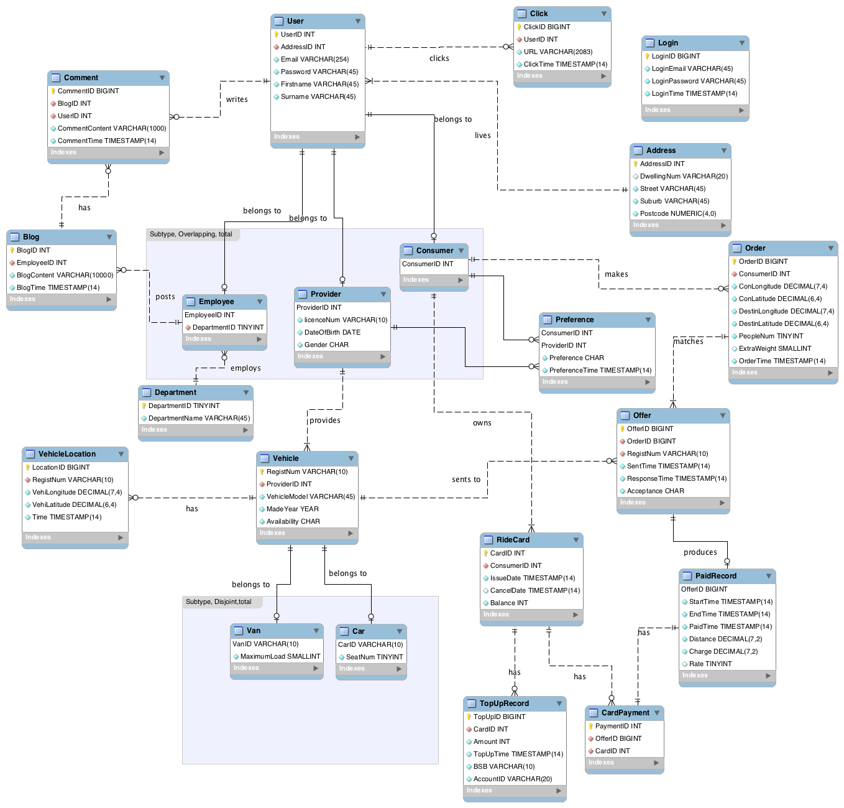Assumptions:

1. Each employee can only be assigned to one department.
2. Such model is designed based on the fact that population of Australia is approximately 23 million in 2015 and not going to change or increase rapidly in the near future.
3. Based on assumption 2, a rough estimation of the amount of order, login frequency can be derived, such that BIGINT datatype would be applied in relevant attributes (Order.OrderID, Login.LoginID, Comment.CommentID, Offer.OfferID, TopUpRecord.TouUpID, CardPayment.PaymentID)
4. The unit of distance and charge are assume to be KM and AUD. The maximum charge is set to be $10,000.
5. License required should be Australian license. (Related attribute only support no more than 10 digits)

**Data Dictionary-RideShare database**

# List of entities

|  |  |  |  |
| --- | --- | --- | --- |
| **Entities** | **Entity Type** | **Primary Key** | **#Attributes** |
| User | independent | UserID | 6 |
| Address | independent | AddressID | 5 |
| Click | independent | ClickID | 4 |
| Employee | dependent | EmployeeID | 2 |
| Department | independent | DepartmentID | 2 |
| Provider | dependent | ProviderID | 4 |
| Consumer | dependent | ConsumerID | 1 |
| Vehicle | independent | RegistNum | 5 |
| Van | dependent | VanID | 2 |
| Car | dependent | CarID | 2 |
| Blog | independent | BlogID | 4 |
| Comment | independent | CommentID | 5 |
| Login | independent | LoginID | 4 |
| RideCard | independent | CardID | 5 |
| TopUpRecord | independent | TopUpID | 6 |
| Preference | dependent | ConsumerID,ProviderID | 4 |
| Order | independent | OrderID | 9 |
| VehicleLocation | independent | LocationID | 5 |
| Offer | independent | OfferID | 6 |
| PaidRecord | dependent | OfferID | 6 |
| CardPayment | independent | PaymentID | 3 |

# Entity ‘User’

## Description

This entity represents all the users of RideShare, including Employee, Provider, and Consumer. At the same time, it is a supertype. Employee, Provider, and Consumer are three subtypes of User.

## Attributes

|  |  |  |  |  |  |
| --- | --- | --- | --- | --- | --- |
| **Key** | **Attribute** | **Data Type** | **Not Null** | **Unique** | **Description** |
| PK | UserID | INT | YES | YES | This is the primary-key of User. It is also a unique numerical identifier that is invisible to users. |
| FK | AddressID | INT | YES | NO | A foreign-key from the entity of Address. |
|  | Email | VARCHAR(254) | YES | YES | Users use Email as their login account. The maximum of 256-character length of a forward or reverse path restricts the entire email address to be no more than 254 characters long. |
|  | Password | VARCHAR(45) | YES | NO | Users should set their own password. |
|  | Firstname | VARCHAR(45) | YES | NO | It represents user's firstname. |
|  | Surname | VARCHAR(45) | YES | NO | It represents user's surname. |

# Entity ‘Address’

## Description

When users login the RideShare, they should provide their detail address information. This entity has been created by simply removing the 'multi-valued' attribute 'Address'.

## Attributes

|  |  |  |  |  |  |
| --- | --- | --- | --- | --- | --- |
| **Key** | **Attribute** | **Data Type** | **Not Null** | **Unique** | **Description** |
| PK | AddressID | INT | YES | YES | This is the primary-key of Address representing the address provided by users. |
|  | DwellingNum | VARCHAR(20) | YES | NO | It represents the dwelling number of address. |
|  | Street | VARCHAR(45) | YES | NO | It represents the street of address. |
|  | Suburb | VARCHAR(45) | YES | NO | It represents the suburb of address. |
|  | Postcode | NUMERIC(4,0) | YES | NO | It represents the postcode of address. In Australia, 4-digit number is used. |

# Entity ‘Click’

## Description

This entity records every trial of a user to navigate to a new screen in the app.

## Attributes

|  |  |  |  |  |  |
| --- | --- | --- | --- | --- | --- |
| **Key** | **Attribute** | **Data Type** | **Not Null** | **Unique** | **Description** |
| PK | ClickID | BIGINT | YES | YES | This is the primary-key of Click representing every operation when user navigates to a new screen. |
| FK | UserID | INT | YES | NO | A foreign-key from the entity of User. |
|  | URL | VARCHAR(2083) | YES | NO | It represents the URL being called by every click. Maximum URL length is 2083 characters in Internet Explorer. |
|  | ClickTime | TIMESTAMP(14) | YES | NO | The time (YYYY-MM-DD HH:MM:SS) represents the time of the operation; it stored in UTC and converted to local (Australia has three time zones so our database has to unify the time format). |

# Entity ‘Employee’

## Description

This entity is a subtype of User. It represents all employees working for Rideshare. They log in to check on the state of the RideShare network and to solve any operational problems that arise. They also post to the company blog.

## Attributes

|  |  |  |  |  |  |
| --- | --- | --- | --- | --- | --- |
| **Key** | **Attribute** | **Data Type** | **Not Null** | **Unique** | **Description** |
| PFK | EmployeeID | INT | YES | YES | It comes from the entity of User and represents the employee of Rideshare. |
| FK | DepartmentID | TINYINT | YES | NO | A foreign-key from the entity of Department. |

# Entity ‘Department’

## Description

This entity includes all the departments of RideShare.

## Attributes

|  |  |  |  |  |  |
| --- | --- | --- | --- | --- | --- |
| **Key** | **Attribute** | **Data Type** | **Not Null** | **Unique** | **Description** |
| PK | DepartmentID | TINYINT | YES | YES | This is the primary-key of Department and represents the department of Rideshare. |
|  | DepartmentName | VARCHAR(45) | YES | YES | It represents the name of department including operations, accounts, public relations and I.T. New department can be able to be added. |

# Entity ‘Provider’

## Description

This entity is a subtype of User. It represents the users who make themselves and their vehicles available for consumers to take rides in.

## Attributes

|  |  |  |  |  |  |
| --- | --- | --- | --- | --- | --- |
| **Key** | **Attribute** | **Data Type** | **Not Null** | **Unique** | **Description** |
| PFK | ProviderID | INT | YES | YES | It comes from the entity of User and represents the providers who provide vehicles. |
|  | LicenceNum | VARCHAR (10) | YES | YES | It represents the license number of the provider. In Australia, 6-digit number is used. |
|  | DateOfBirth | DATE | YES | NO | Date (YYYY-MM-DD) represents the date of birth of the provider. |
|  | Gender | CHAR | YES | NO | It represents the gender of provider (may hold either the value 'M' for Male, or 'F' for Female). |

# Entity ‘Consumer’

## Description

This entity represents all the consumers of RideShare and it is a subtype of User.

## Attributes

|  |  |  |  |  |  |
| --- | --- | --- | --- | --- | --- |
| **Key** | **Attribute** | **Data Type** | **Not Null** | **Unique** | **Description** |
| PFK | ConsumerID | INT | YES | YES | It comes from the entity of User and represents the consumers. |

# Entity ‘Vehicle’

## Description

Including the vehicles’ information and if it is available. It is a supertype of Car and Van.

## Attributes

|  |  |  |  |  |  |
| --- | --- | --- | --- | --- | --- |
| **Key** | **Attribute** | **Data Type** | **Not Null** | **Unique** | **Description** |
| PK | RegistNum | VARCHAR (10) | YES | YES | This is the primary-key of Vehicle and represents the registration number of vehicle. In Australia, 6-digit number is used. |
| FK | ProviderID | INT | YES | NO | A foreign-key from the entity of Provider representing the provider of vehicle. |
|  | VehicleModel | VARCHAR (45) | YES | NO | It represents the model of vehicle. |
|  | MadeYear | YEAR | YES | NO | Year (YYYY) represents the year of manufacture. |
|  | Availability | CHAR | YES | NO | It represents whether a vehicle is available (may hold either the value 'Y' for available, or 'N' for unavailable). |

# Entity ‘Van’

## Description

As a subtype of entity ‘Vehicle’, it provides van’s own attributes: the maximum load in kilograms.

## Attributes

|  |  |  |  |  |  |
| --- | --- | --- | --- | --- | --- |
| **Key** | **Attribute** | **Data Type** | **Not Null** | **Unique** | **Description** |
| PFK | VanID | VARCHAR (10) | YES | YES | It comes from the entity of Vehicle and represents van. |
|  | MaximumLoad | SMALLINT | YES | NO | It represents the maximum load of van (Kg). |

# Entity ‘Car’

## Description

As a subtype of entity ‘Vehicle’, it provides car’s own attributes: the number of seats.

## Attributes

|  |  |  |  |  |  |
| --- | --- | --- | --- | --- | --- |
| **Key** | **Attribute** | **Data Type** | **Not Null** | **Unique** | **Description** |
| PFK | CarID | VARCHAR (10) | YES | YES | It comes from the entity of Vehicle and represents car. |
|  | SeatNum | TINYINT | YES | NO | It represents the number of seats of car. |

# Entity ‘Blog’

## Description

Entity ‘Blog’ includes all the blog published by employees with the contents, the author and the publishing time. Any registered user can comment on these posts.

## Attributes

|  |  |  |  |  |  |
| --- | --- | --- | --- | --- | --- |
| **Key** | **Attribute** | **Data Type** | **Not Null** | **Unique** | **Description** |
| PK | BlogID | INT | YES | YES | This is the primary-key of Blog and represents blog posted by Employees. |
| FK | EmployeeID | INT | YES | NO | A foreign-key from the entity of Employee and represents the author to the blog. |
|  | BlogContent | VARCHAR (10000) | YES | NO | It represents the content of blog and we assumed that it should not longer than 10000 characters. |
|  | BlogTime | TIMESTAMP(14) | YES | NO | It represents the post time of the blog. |

# Entity ‘Comment’

## Description

Entity ‘Comment’ records every comment in the blog with the contents, the author and the publishing time.

## Attributes

|  |  |  |  |  |  |
| --- | --- | --- | --- | --- | --- |
| **Key** | **Attribute** | **Data Type** | **Not Null** | **Unique** | **Description** |
| PK | CommentID | BIGINT | YES | YES | This is the primary-key of Comment and represents comments posted by any users. |
| FK | BlogID | INT | YES | NO | A foreign-key from the entity of Blog and represents the blog that a certain comment belongs to. |
| FK | UserID | INT | YES | NO | A foreign-key from the entity of User and represents the author of a certain comment. |
|  | CommentContent | VARCHAR (1000) | YES | NO | It represents the content of comment and we assumed that it should not longer than 1000 characters. |
|  | CommentTime | TIMESTAMP(14) | YES | NO | It represents the post time of the comment. |

# Entity ‘Login’

## Description

This entity records every trial of login. It includes the login information and time of trial.

## Attributes

|  |  |  |  |  |  |
| --- | --- | --- | --- | --- | --- |
| **Key** | **Attribute** | **Data Type** | **Not Null** | **Unique** | **Description** |
| PK | LoginID | BIGINT | YES | YES | This is the primary-key of Login and represents every trial of login. |
|  | LoginEmail | VARCHAR(45) | YES | NO | It represents the Email used by the trial. |
|  | LoginPassword | VARCHAR(45) | YES | NO | It represents the password used by the trial. |
|  | LoginTime | TIMESTAMP(14) | YES | NO | It represents the time of the trial. |

# Entity ‘RideCard’

## Description

This entity represents the Ridecard of consumers. It is a smartcard issued by RideShare that can be used to pay for Rideshare services. Every consumer must own a RideCard and may own several over time.

## Attributes

|  |  |  |  |  |  |
| --- | --- | --- | --- | --- | --- |
| **Key** | **Attribute** | **Data Type** | **Not Null** | **Unique** | **Description** |
| PK | CardID | INT | YES | YES | This is the primary-key of Ridecard and represents the Ridecard used by Consumer. |
| FK | ConsumerID | INT | YES | NO | A foreign-key from the entity of Consumer and represents the owner of Ridecard. |
|  | IssueDate | TIMESTAMP (14) | YES | NO | It represents the issue date of Ridecard. |
|  | CancelDate | TIMESTAMP (14) | NO | NO | It represents the cancel date of Ridecard. |
|  | Balance | INT | YES | NO | It represents the balance of Ridecard. |

# Entity ‘TopUpRecord’

## Description

This entity records the entire top up information of Ridecard.

## Attributes

|  |  |  |  |  |  |
| --- | --- | --- | --- | --- | --- |
| **Key** | **Attribute** | **Data Type** | **Not Null** | **Unique** | **Description** |
| PK | TopUpID | BIGINT | YES | YES | This is the primary-key of TopUpRecord and represents the top-up record. |
| FK | CardID | INT | YES | NO | A foreign-key from the entity of Ridecard. |
|  | Amount | INT | YES | NO | It represents the top-up amount for every record. |
|  | TopUpTime | TIMESTAMP(14) | YES | NO | It represents the time of top-up. |
|  | BSB | VARCHAR(10) | YES | NO | It represents the BSB from which the money was transferred. |
|  | AccountID | VARCHAR(20) | YES | NO | It represents the bank account number from which the money was transferred. |

# Entity ‘Preference’

## Description

This is an entity between consumer and provider that records a list of consumer’s preferences.

## Attributes

|  |  |  |  |  |  |
| --- | --- | --- | --- | --- | --- |
| **Key** | **Attribute** | **Data Type** | **Not Null** | **Unique** | **Description** |
| PFK | ConsumerID | INT | YES | NO | It comes from the entity of Consumer who makes the preference list. |
| PFK | ProviderID | INT | YES | NO | It comes from the entity of Provider. |
|  | Preference | CHAR | YES | NO | It represents the preference (may hold either the value 'Y' or 'N' for prefer or not to do business.) |
|  | PreferenceTime | TIMESTAMP(14) | YES | NO | It represents the time when consumer makes this preference. |

# Entity ‘Order’

## Description

This entity records the information of order from consumer to sever. When consumers request rides using a phone app, it will send an order to our server.

## Attributes

|  |  |  |  |  |  |
| --- | --- | --- | --- | --- | --- |
| **Key** | **Attribute** | **Data Type** | **Not Null** | **Unique** | **Description** |
| PK | OrderID | BIGINT | YES | YES | This is the primary-key of Order and represents the order made by consumer. |
| FK | ConsumerID | INT | YES | NO | A foreign-key from the entity of Consumer. |
|  | ConLongitude | DECIMAL(7,4) | YES | NO | It represents consumer's longitude. The values of longitude are bounded by $±180°$ and we consider 4 decimal places to be sufficient resolution to track cars and people. |
|  | ConLatitude | DECIMAL(6,4) | YES | NO | It represents consumer's latitude. The values of longitude are bounded by $±90°$. |
|  | DestinLongitude | DECIMAL(7,4) | YES | NO | It represents destination's longitude. Destination means the location to which consumers want to travel. |
|  | DestinLatitude | DECIMAL(6,4) | YES | NO | It represents destination's latitude. |
|  | PeopleNum | TINYINT | YES | NO | It represents how many people will be travelling. |
|  | ExtraWeight | SMALLINT | NO | NO | It represents the extra weight of goods must be moved. |
|  | OrderTime | TIMESTAMP(14) | YES | NO | It represents the time when the order is made. |

# Entity ‘VehicleLocation’

## Description

This entity represents the vehicle’s location that should be provided to the server. Our app has to know the current location of each available vehicle. Data sends to server about once a minute.

## Attributes

|  |  |  |  |  |  |
| --- | --- | --- | --- | --- | --- |
| **Key** | **Attribute** | **Data Type** | **Not Null** | **Unique** | **Description** |
| PK | LocationID | BIGINT | YES | YES | This is the primary-key of VehicleLocation. Available vehicles should provide their location to the server. |
| FK | RegistNum | VARCHAR (10) | YES | NO | A foreign-key from the entity of Vehicle. |
|  | VehiLongitude | DECIMAL(7,4) | YES | NO | It represents vehicle's longitude. |
|  | VehiLatitude | DECIMAL(6,4) | YES | NO | It represents vehicle's latitude. |
|  | Time | TIMESTAMP(14) | YES | NO | It represents the time when the location is recorded. |

# Entity ‘Offer’

## Description

This entity records the details of offer sent from sever to provider. After getting the information of an order, our server will try to match up the ride-request with nearby available vehicles. For each potential match found, the server sends an offer message to the relevant vehicle provider.

## Attributes

|  |  |  |  |  |  |
| --- | --- | --- | --- | --- | --- |
| **Key** | **Attribute** | **Data Type** | **Not Null** | **Unique** | **Description** |
| PK | OfferID | BIGINT | YES | YES | This is the primary-key of Offer. |
| FK | OrderID | BIGINT | YES | NO | A foreign-key from the entity of Order and represents the order related to the offer. |
| FK | RegistNum | VARCHAR (10) | YES | NO | A foreign-key from the entity of Vehicle and represents the vehicle to which the offer is sent. |
|  | SentTime | TIMESTAMP(14) | YES | NO | It represents the time of sending offer. |
|  | ResponseTime | TIMESTAMP(14) | YES | NO | It represents the time of vehicle response. |
|  | Acceptance | CHAR | YES | NO | It represents whether the offer is accepted. (May hold either the value 'Y' for accept, or 'N' for refuse). |

# Entity ‘PaidRecord’

## Description

This entity represents those services that have been paid including the time, distance and other details. RideShare must keep track of each paid ride that takes place.

## Attributes

|  |  |  |  |  |  |
| --- | --- | --- | --- | --- | --- |
| **Key** | **Attribute** | **Data Type** | **Not Null** | **Unique** | **Description** |
| PFK | OfferID | BIGINT | YES | YES | It comes from the entity of Offer and it is also the primary-key of PaidRecord. It represents the offers that have been paid. |
|  | StartTime | TIMESTAMP(14) | YES | NO | It represents the time when the service starts. |
|  | EndTime | TIMESTAMP(14) | YES | NO | It represents the time when the service ends. |
|  | PaidTime | TIMESTAMP(14) | YES | NO | It represents the time when the service is paid. |
|  | Distance | DECIMAL(7,2) | YES | NO | It represents the distance traveled during the service (Km). |
|  | Charge | DECIMAL(7,2) | YES | NO | It represents the cost of service (AUD). |
|  | Rate | TINYINT | NO | NO | It represents the rate to the quality of service, using an integer from 0 to 10. |

# Entity ‘PaidRecord’

## Description

This entity records all the payments and its details of Ridecard.

## Attributes

|  |  |  |  |  |  |
| --- | --- | --- | --- | --- | --- |
| **Key** | **Attribute** | **Data Type** | **Not Null** | **Unique** | **Description** |
| PK | PaymentID | INT | YES | YES | This is the primary-key of CardPayment and represents the payment from the Ridecard. |
| FK | OfferID | BIGINT | YES | YES | A foreign-key from the entity of Offer from which we can find the amount paid, the time of payment, and the ride for which it is paid. |
| FK | CardID | INT | YES | NO | A foreign-key from the entity of Ridecard from which we can find the card used to make the payment. |