Regression test report
- for UniAir VCM
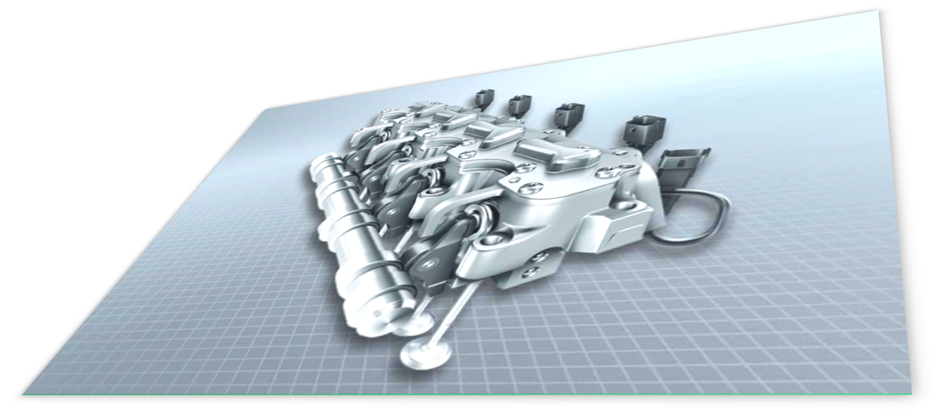

AM/HZA-EDM, Schaeffler Technologies

Regression test report: - for UniAir VCM
by AM/HZA-EDM, Schaeffler Technologies
Published 03-Jun-2013 16:25:18
A standard regression test has been performed on basis of a set of selected input and output signals. Pass or no-pass criterion is applied to each output signal/variable and abnormalities are identified.
Copyright 2013 AM/HZA-EDM, Schaeffler Technologies AG & Co. KG

Table of Contents
1. General information 1
1.1. Regression test description 1
1.2. Test status 1
2. Input, output and driving sequence 2
2.1. Input signal set 2
2.2. Driving sequence 2
2.3. Output signal set 3
3. Input signal quality 5
3.1. Comparison of variable - rpm 5
3.2. Comparison of variable - iBatteryVolt 6
3.3. Comparison of variable - eClosAReqEC 7
3.4. Comparison of variable - eOpenAReqLO 8
3.5. Comparison of variable - eOpenReqHB 9
3.6. Comparison of variable - nValveModeId 10
3.7. Comparison of variable - nAbsCylinderId 11
3.8. Comparison of variable - nActReqFreezTDC 12
4. Simulation results 13
4.1. Comparison of variable - wOilTemp 13
4.2. Comparison of variable - wCoilTemp 14
4.3. Comparison of variable - eStart 15
4.4. Comparison of variable - eStartCmd1 16
4.5. Comparison of variable - eStartCmd2 17
4.6. Comparison of variable - eFinish 18
4.7. Comparison of variable - eFinishCmd1 19
4.8. Comparison of variable - eFinishCmd2 20
4.9. Comparison of variable - tSwOnMeas 21
4.10. Comparison of variable - tSwOnSVSXCylCL0 22
4.11. Comparison of variable - tSwOnSVSXCylCL1 23
4.12. Comparison of variable - tSwOnSVSXCylCL2 24
4.13. Comparison of variable - tSwOnSVSXCylCL3 25
4.14. Comparison of variable - tSwOnLowPrecV0 26
4.15. Comparison of variable - tSwOnLowPrecV1 27
4.16. Comparison of variable - tSwOnLowPrecV2 28
4.17. Comparison of variable - tSwOnLowPrecV3 29
4.18. Comparison of variable - tSwOffMeas 30
4.19. Comparison of variable - tSwOffSVSXCylCL0 31
4.20. Comparison of variable - tSwOffSVSXCylCL1 32
4.21. Comparison of variable - tSwOffSVSXCylCL2 33
4.22. Comparison of variable - tSwOffSVSXCylCL3 34
5. SV current profiles 35
5.1. Selected SV current for cylinder 1 35
5.2. Selected SV current for cylinder 2 36
5.3. Selected SV current for cylinder 3 37
5.4. Selected SV current for cylinder 4 38
6. Mechanical and electric angles 39
6.1. eClosAReqEC vs eFinish 39
6.2. eOpenAReqLO vs eStart 40
6.3. eOpenReqHB vs eStart 41
7. Summary 42
8. Original input and output signals 44
8.1. Signal/variable - rpm 44
8.2. Signal/variable - iBatteryVolt 45
8.3. Signal/variable - eClosAReqEC 45
8.4. Signal/variable - eOpenAReqLO 46
8.5. Signal/variable - eOpenReqHB 46
8.6. Signal/variable - nValveModeId 47
8.7. Signal/variable - nAbsCylinderId 47
8.8. Signal/variable - nActReqFreezTDC 48
8.9. Signal/variable - wOilTemp 48
8.10. Signal/variable - wCoilTemp 49
8.11. Signal/variable - eStart 49
8.12. Signal/variable - eStartCmd1 50
8.13. Signal/variable - eStartCmd2 50
8.14. Signal/variable - eFinish 51
8.15. Signal/variable - eFinishCmd1 51
8.16. Signal/variable - eFinishCmd2 52
8.17. Signal/variable - tSwOnMeas 52
8.18. Signal/variable - tSwOnSVSXCylCL0 53
8.19. Signal/variable - tSwOnSVSXCylCL1 53
8.20. Signal/variable - tSwOnSVSXCylCL2 54
8.21. Signal/variable - tSwOnSVSXCylCL3 54
8.22. Signal/variable - tSwOnLowPrecV0 55
8.23. Signal/variable - tSwOnLowPrecV1 55
8.24. Signal/variable - tSwOnLowPrecV2 56
8.25. Signal/variable - tSwOnLowPrecV3 56
8.26. Signal/variable - tSwOffMeas 57
8.27. Signal/variable - tSwOffSVSXCylCL0 57
8.28. Signal/variable - tSwOffSVSXCylCL1 58
8.29. Signal/variable - tSwOffSVSXCylCL2 58
8.30. Signal/variable - tSwOffSVSXCylCL3 59

Chapter 1. General information

1.1. Regression test description
Table 1.1: Hardware, software, calibration and SV layout for the regression test
No | Item | Description
1 | ECU
2 | Software | SVT_EVC_11p02build1  SVT_EVC_11p21build1
3 | Calibration
4 | SV layout | fast/slow/nom/stuck-mid

Following calibrations have been specially set to supress certain diagnosis and facilitate a better reproduceability for th regressoion test conditions.
Table 2.1: Calibrations special for HIL test
No | Calbration label | Value(s) | Note
1
2
3
4
5
6
7
8
9

1.2. Test status
The status of the regression test for current build 'SVT_EVC_11p21build1': pass/not-pass.

Chapter 2. Input, output and driving sequence
A set of input signal is specified to include the important signals which largely determine the behaviour of UniAir VCm system in the corresponding driving sequence, besides the system itself. The rest of the input signals can be set to constant. To evaluate the system to the input signals in the driving sequence, a set of output signals is selected to measure the different responses of the systems from exactly the same set of input signals.

2.1. Input signal set
Following signals/variables are recorded in the driving sequence as input siganls for the regression test,
1. Engine speed: rpm
2. Voltage on power stage: iBatteryVolt
3. MV-close angle request (EVC): eClosAReqEC
4. MV-open angle request (LVO): eOpenAReqLO
5. MV-open angle request (HB): eOpenReqHB
6. SV mode ID: nValveModeId
7. Absolute cylinder ID: nAbsCylinderId
8. Freezing TDC: nActReqFreezTDC

2.2. Driving sequence
A driving sequence is specified to reveal the system features as much as possible in reality-near situations. Specifically for UniAir VCM system, it shall invoke ECM to issue real requests of mechancial angle and valve control mode under different operation and environment conditions. It shall also include certain worst cases for VCM control. With the considerations described above, the driving sequence for the regression test is defined as follows.
1. Ignition on
2. start recordings for normal variables (by INCA) and SV currents
3. Engine start
4. idle in neutral gear: 10 second
5. pedal depressed and releases quickly 3 times
6. back to idle: 5 second
7. engage 1st gear, accelerate to 20 km/h
8. engage 2nd gear, accelerate to 50 km/h
9. engage 3rd gear, accelerate to 80 km/h
10. engage 4th gear, accelerate to 120 km/h
11. stop the vehicle and keep the engine to run at idle for 10 second
12. save all recordings
The corresponding schematics of the driving sequence is shown in following figure.
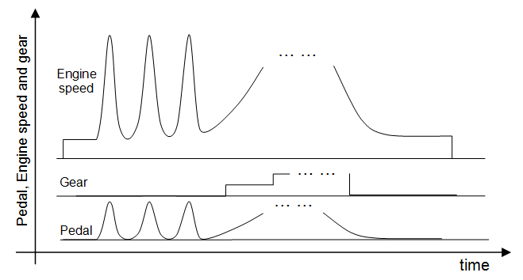
Figure 2.1: Schematic of a sdriving sequence for input signal collection.

2.3. Output signal set
For the evaluation of different software releases, calibration or harwares, following signals/variables are recorded as reference in the driving sequence and later recorded from the HIL regression test.
1. wOilTemp
2. wCoilTemp
3. eStart
4. eStartCmd1
5. eStartCmd2
6. eFinish
7. eFinishCmd1
8. eFinishCmd2
9. tSwOnMeas
10. tSwOnSVSXCylCL0
11. tSwOnSVSXCylCL1
12. tSwOnSVSXCylCL2
13. tSwOnSVSXCylCL3
14. tSwOnLowPrecV0
15. tSwOnLowPrecV1
16. tSwOnLowPrecV2
17. tSwOnLowPrecV3
18. tSwOffMeas
19. tSwOffSVSXCylCL0
20. tSwOffSVSXCylCL1
21. tSwOffSVSXCylCL2
22. tSwOffSVSXCylCL3

Chapter 3. Input signal quality
In this section, a few input signals for both cases are analysed to check the quality, e.g., syncronization, random error, disturbance, interpolation, etc.

3.1. Comparison of variable - rpm
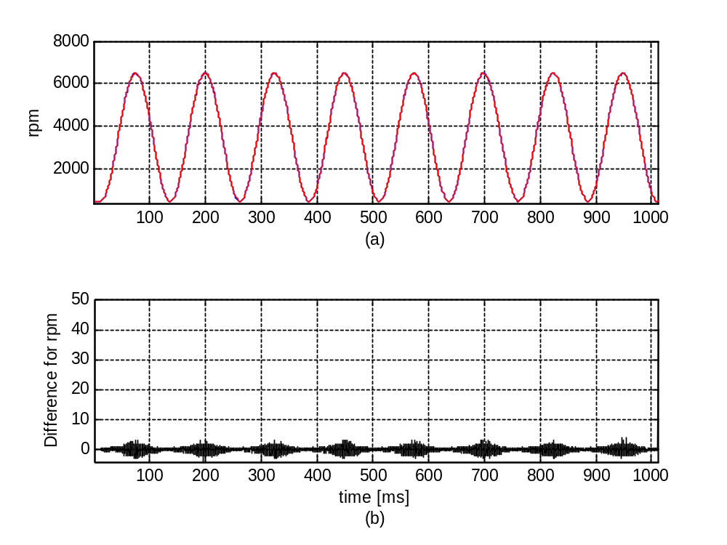
Figure 3.1: Engine speed 'rpm' (a) for cases of 'SVT_EVC_11p02build1' (blue) and 'SVT_EVC_11p21build1' (red), and their difference (b).

Table 3.1: Statistics for the difference for siganl 'rpm' for both cases
 | Maximum/Time | Minimum/Time | STD | Mean
Diff(abs) | 39.7708/1011.6703 | -4/194.4392 | 0.64628 | 0.0010438
Diff(rel) | 0.0795 | -6.2257e-004

3.2. Comparison of variable - iBatteryVolt
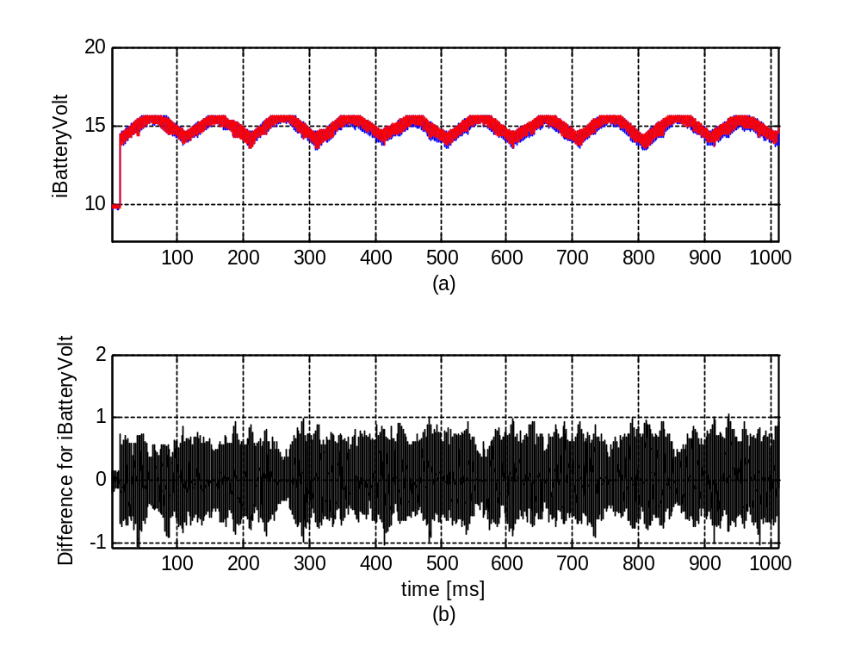
Figure 3.2: Voltage on power stage 'iBatteryVolt' (a) for cases of 'SVT_EVC_11p02build1' (blue) and 'SVT_EVC_11p21build1' (red), and their difference (b).

Table 3.2: Statistics for the difference for siganl 'iBatteryVolt' for both cases
 | Maximum/Time | Minimum/Time | STD | Mean
Diff(abs) | 1.0482/938.1861 | -1.0625/39.7506 | 0.24726 | 0.011404
Diff(rel) | 0.0729 | -0.0685

3.3. Comparison of variable - eClosAReqEC
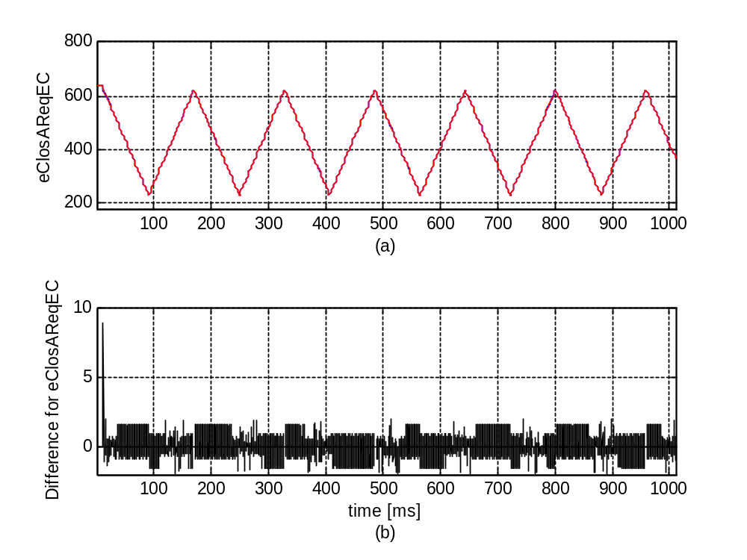
Figure 3.3: MV-close angle request (EVC) 'eClosAReqEC' (a) for cases of 'SVT_EVC_11p02build1' (blue) and 'SVT_EVC_11p21build1' (red), and their difference (b).

Table 3.3: Statistics for the difference for siganl 'eClosAReqEC' for both cases
 | Maximum/Time | Minimum/Time | STD | Mean
Diff(abs) | 8.8591/11.7428 | -2.0113/891.5779 | 0.20709 | -0.00063821
Diff(rel) | 0.0143 | -0.0069

3.4. Comparison of variable - eOpenAReqLO
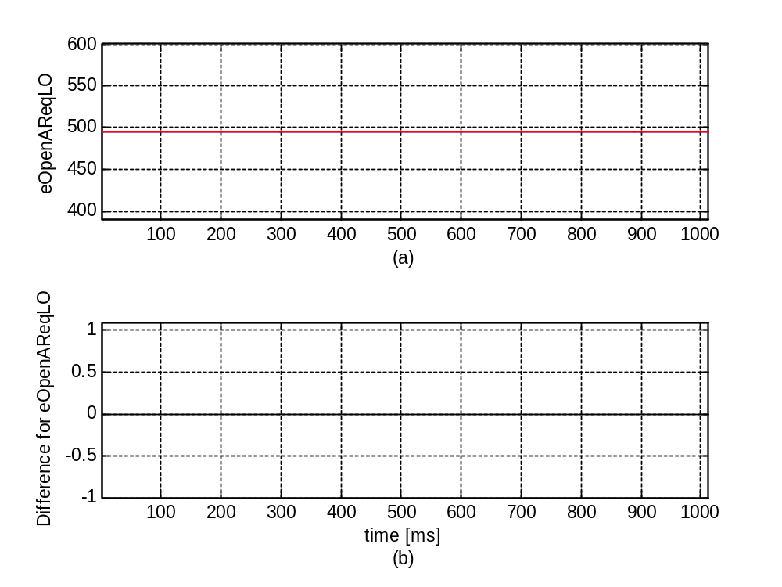
Figure 3.4: MV-open angle request (LVO) 'eOpenAReqLO' (a) for cases of 'SVT_EVC_11p02build1' (blue) and 'SVT_EVC_11p21build1' (red), and their difference (b).

Table 3.4: Statistics for the difference for siganl 'eOpenAReqLO' for both cases
 | Maximum/Time | Minimum/Time | STD | Mean
Diff(abs) | 0/0.10314 | 0/0.10314 | 0 | 0
Diff(rel) | 0 | 0

3.5. Comparison of variable - eOpenReqHB
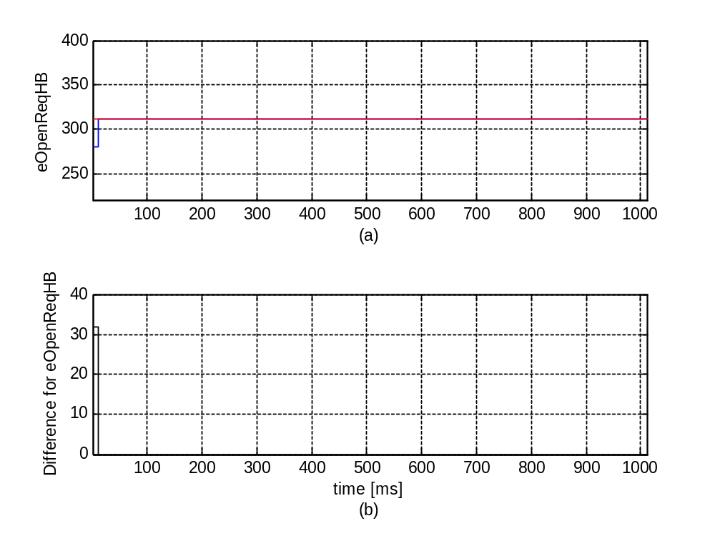
Figure 3.5: MV-open angle request (HB) 'eOpenReqHB' (a) for cases of 'SVT_EVC_11p02build1' (blue) and 'SVT_EVC_11p21build1' (red), and their difference (b).

Table 3.5: Statistics for the difference for siganl 'eOpenReqHB' for both cases
 | Maximum/Time | Minimum/Time | STD | Mean
Diff(abs) | 31.9375/0.10314 | 0/11.7428 | 1.3002 | 0.053022
Diff(rel) | 0.1141 | 0

3.6. Comparison of variable - nValveModeId
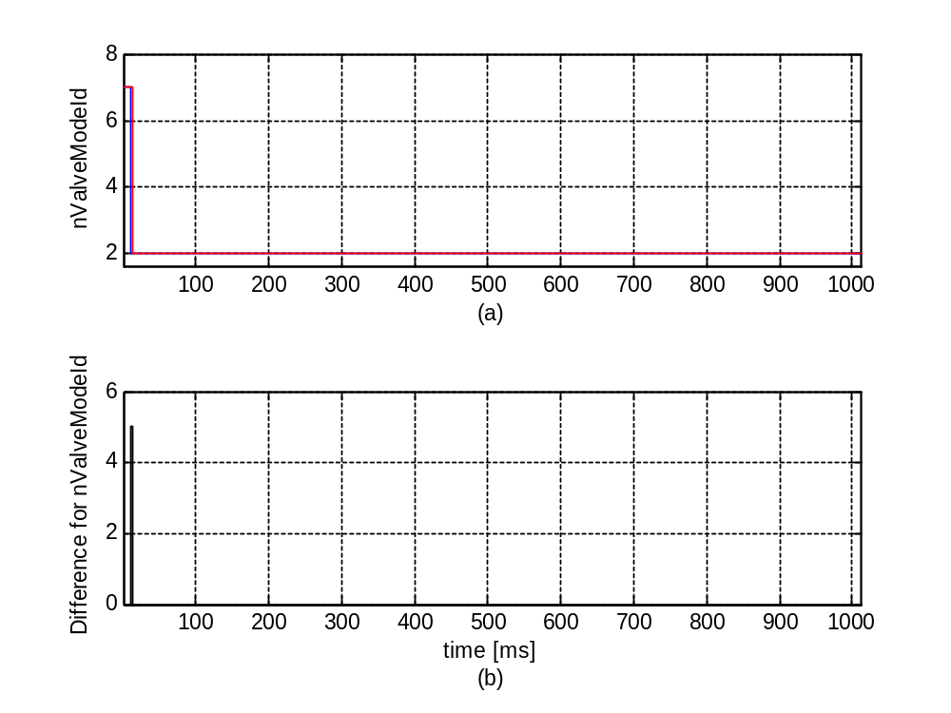
Figure 3.6: SV mode ID 'nValveModeId' (a) for cases of 'SVT_EVC_11p02build1' (blue) and 'SVT_EVC_11p21build1' (red), and their difference (b).

Table 3.6: Statistics for the difference for siganl 'nValveModeId' for both cases
 | Maximum/Time | Minimum/Time | STD | Mean
Diff(abs) | 5/11.7428 | 0/0.10314 | 0.014627 | 4.2788e-005
Diff(rel) | 2.5000 | 0

3.7. Comparison of variable - nAbsCylinderId
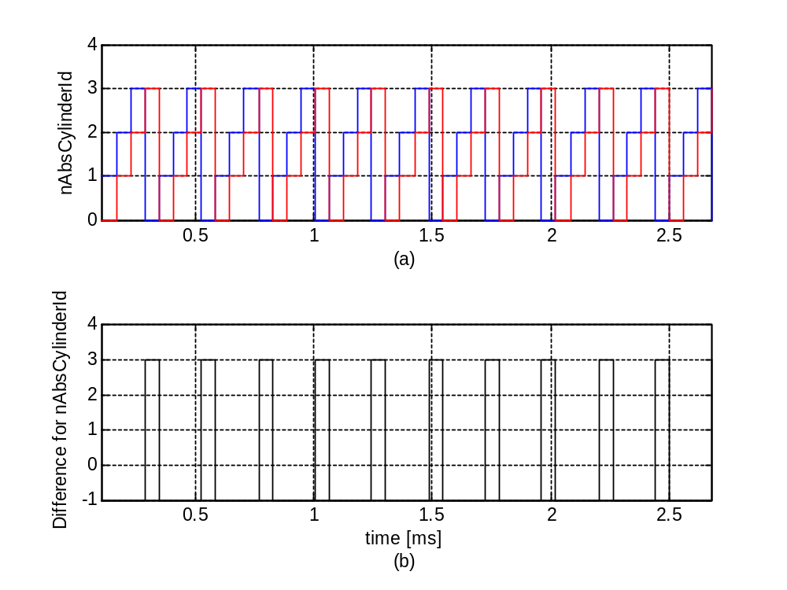
Figure 3.7: Absolute cylinder ID 'nAbsCylinderId' (a) for cases of 'SVT_EVC_11p02build1' (blue) and 'SVT_EVC_11p21build1' (red), and their difference (b).

Table 3.7: Statistics for the difference for siganl 'nAbsCylinderId' for both cases
 | Maximum/Time | Minimum/Time | STD | Mean
Diff(abs) | 3/0.28314 | -1/0.10314 | 1.7521 | 0
Diff(rel) | 3 | -1

3.8. Comparison of variable - nActReqFreezTDC
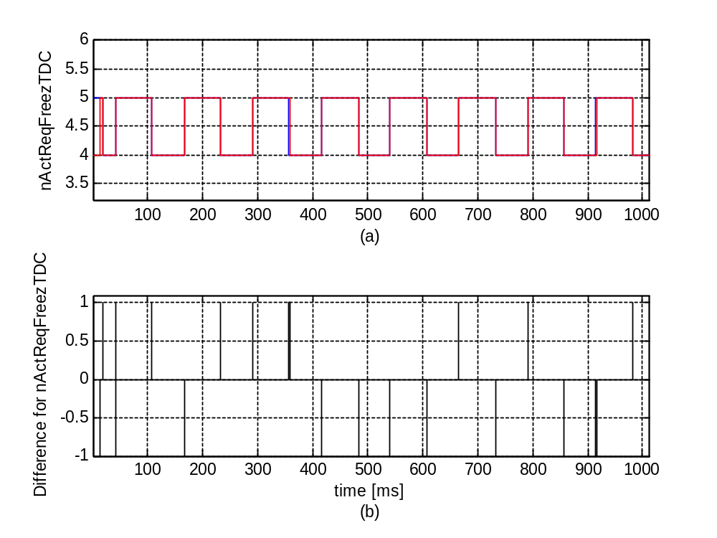
Figure 3.8: Freezing TDC 'nActReqFreezTDC' (a) for cases of 'SVT_EVC_11p02build1' (blue) and 'SVT_EVC_11p21build1' (red), and their difference (b).

Table 3.8: Statistics for the difference for siganl 'nActReqFreezTDC' for both cases
 | Maximum/Time | Minimum/Time | STD | Mean
Diff(abs) | 1/17.1552 | -1/0.10314 | 0.080327 | -0.00030807
Diff(rel) | 0.2500 | -0.2000

Chapter 4. Simulation results

4.1. Comparison of variable - wOilTemp
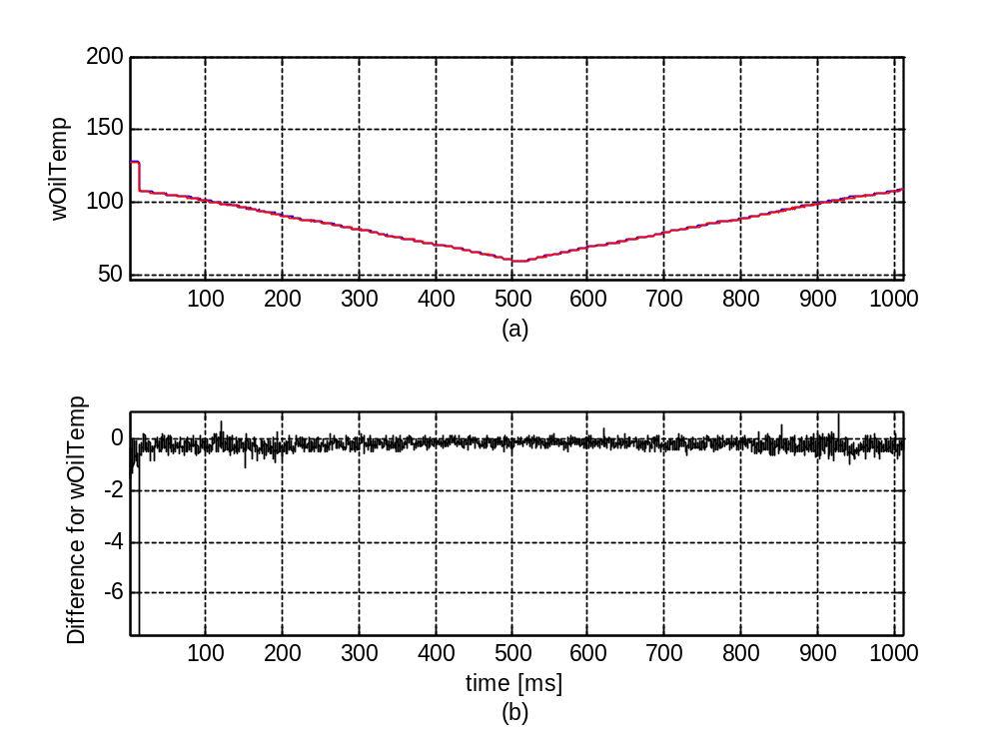
Figure 4.1: HPC oil temperature 'wOilTemp' (a) for cases of 'SVT_EVC_11p02build1' (blue) and 'SVT_EVC_11p21build1' (red), and their difference (b).

Table 4.1: Statistics for the difference for siganl 'wOilTemp' between two cases
 | Maximum/Time | Minimum/Time | STD | Mean
Diff(abs) | 1/927.1091 | -7.6085/11.8759 | 0.21427 | -0.19219
Diff(rel) | 0.0098 | -0.0597

Regression status for 'wOilTemp': pass/no pass.

4.2. Comparison of variable - wCoilTemp
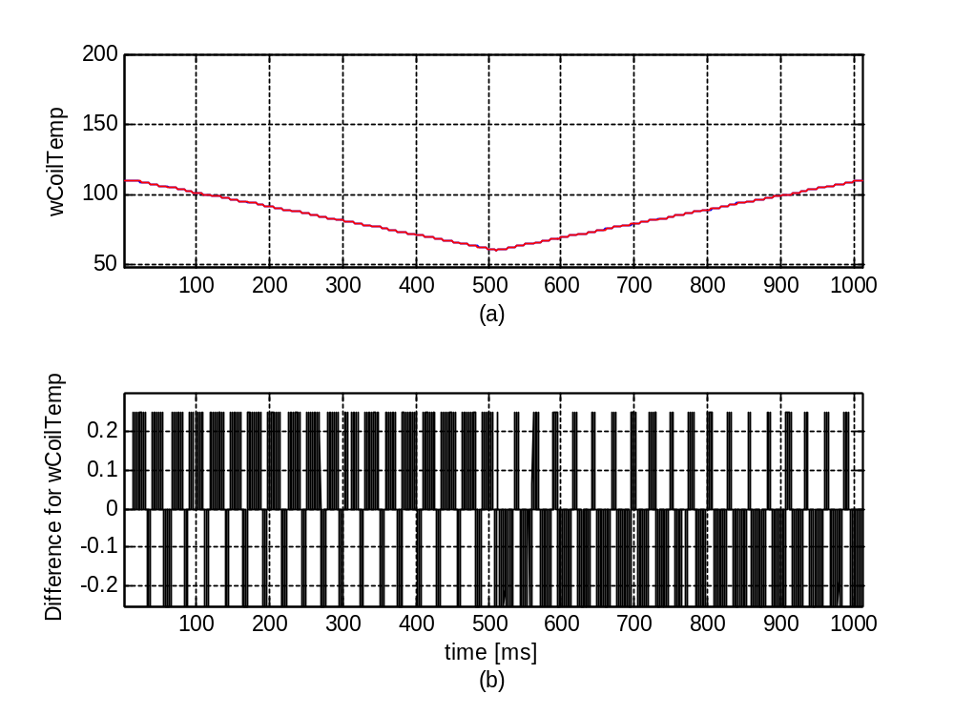
Figure 4.2: Coil temperature 'wCoilTemp' (a) for cases of 'SVT_EVC_11p02build1' (blue) and 'SVT_EVC_11p21build1' (red), and their difference (b).

Table 4.2: Statistics for the difference for siganl 'wCoilTemp' between two cases
 | Maximum/Time | Minimum/Time | STD | Mean
Diff(abs) | 0.25/12.996 | -0.25/30.4672 | 0.080591 | -1.8247e-005
Diff(rel) | 0.0023 | -0.0023

Regression status for 'wCoilTemp': pass/no pass.

4.3. Comparison of variable - eStart
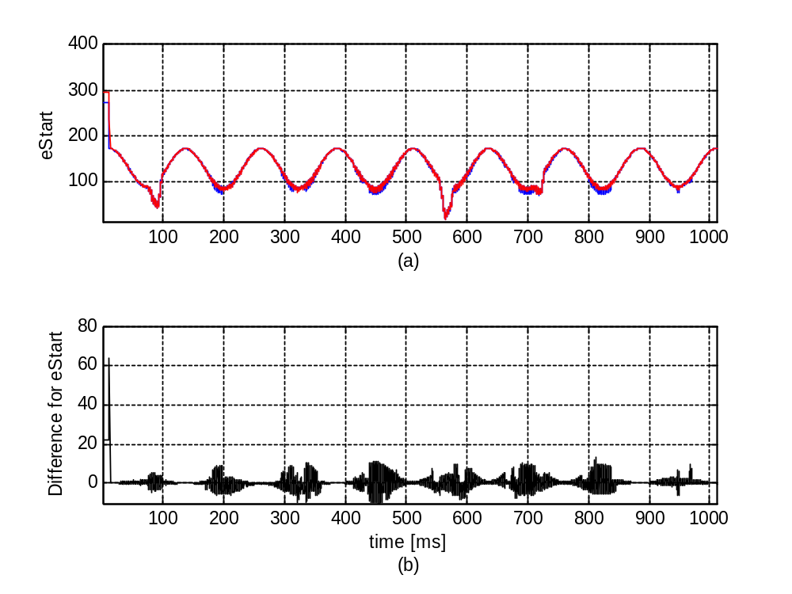
Figure 4.3: electric start angle 'eStart' (a) for cases of 'SVT_EVC_11p02build1' (blue) and 'SVT_EVC_11p21build1' (red), and their difference (b).

Table 4.3: Statistics for the difference for siganl 'eStart' between two cases
 | Maximum/Time | Minimum/Time | STD | Mean
Diff(abs) | 63.9312/11.7428 | -10.3125/453.703 | 3.3667 | -0.00096374
Diff(rel) | 0.3689 | -0.1153

Regression status for 'eStart': pass/no pass.

4.4. Comparison of variable - eStartCmd1
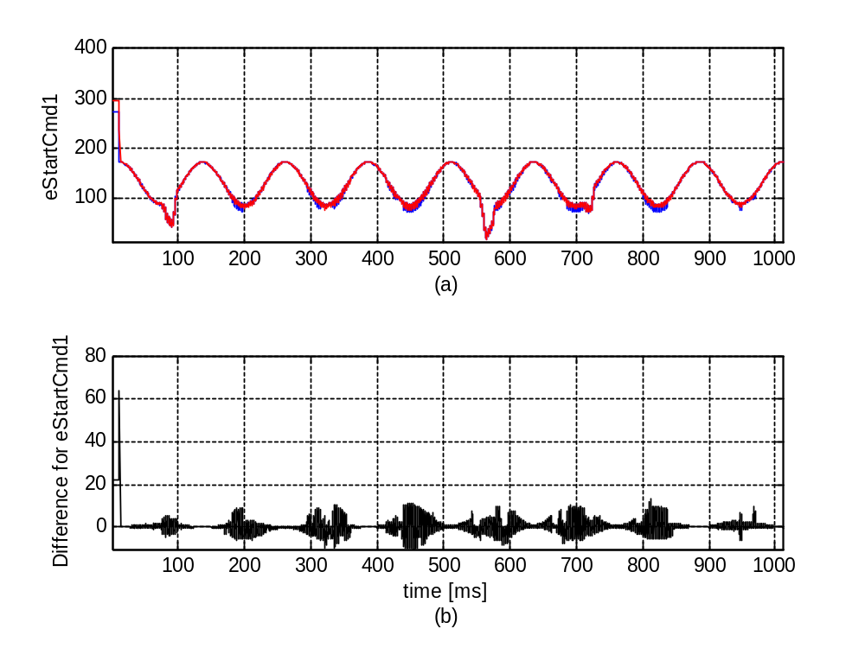
Figure 4.4: electric start angle (Cmd1) 'eStartCmd1' (a) for cases of 'SVT_EVC_11p02build1' (blue) and 'SVT_EVC_11p21build1' (red), and their difference (b).

Table 4.4: Statistics for the difference for siganl 'eStartCmd1' between two cases
 | Maximum/Time | Minimum/Time | STD | Mean
Diff(abs) | 63.9312/11.7428 | -10.3125/453.703 | 3.3667 | -0.00096374
Diff(rel) | 0.3689 | -0.1153

Regression status for 'eStartCmd1': pass/no pass.

4.5. Comparison of variable - eStartCmd2
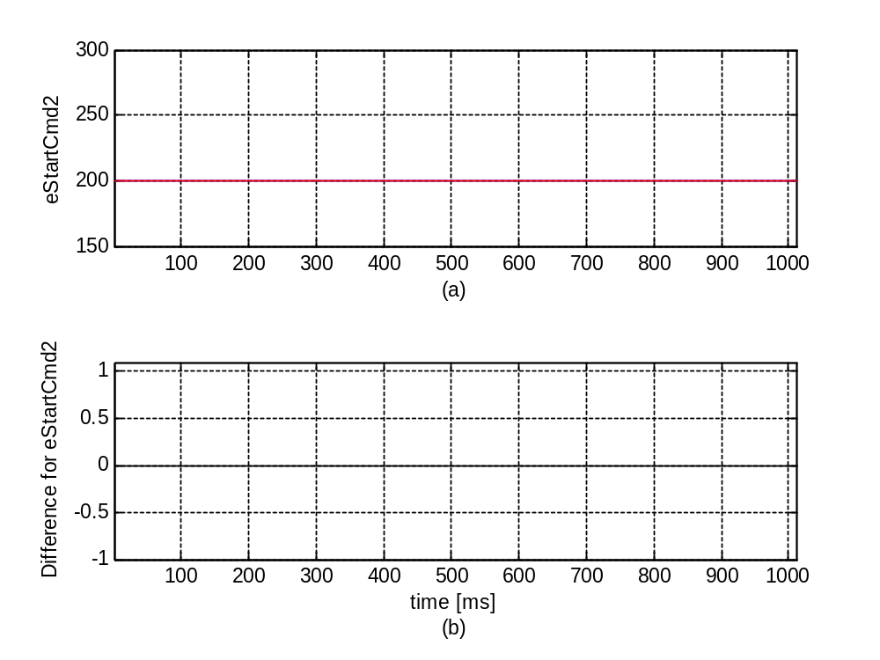
Figure 4.5: electric start angle (Cmd2) 'eStartCmd2' (a) for cases of 'SVT_EVC_11p02build1' (blue) and 'SVT_EVC_11p21build1' (red), and their difference (b).

Table 4.5: Statistics for the difference for siganl 'eStartCmd2' between two cases
 | Maximum/Time | Minimum/Time | STD | Mean
Diff(abs) | 0/0.10314 | 0/0.10314 | 0 | 0
Diff(rel) | 0 | 0

Regression status for 'eStartCmd2': pass/no pass.

4.6. Comparison of variable - eFinish
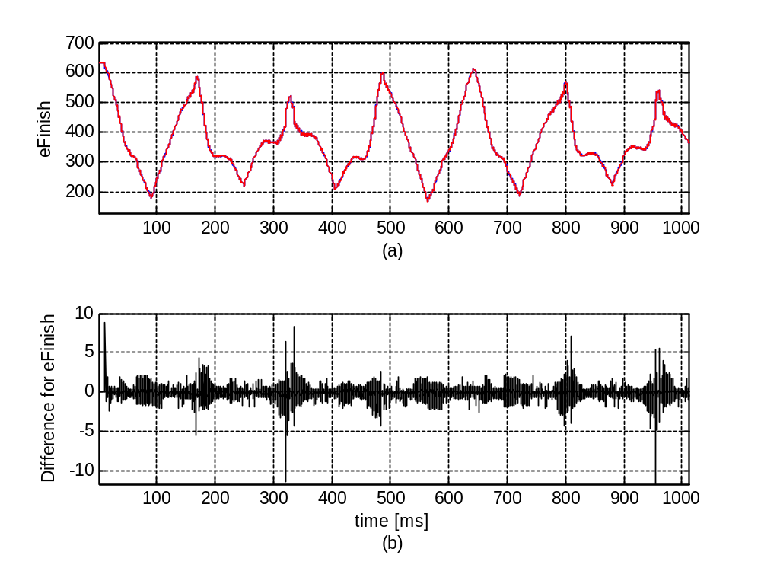
Figure 4.6: Electric finish angle 'eFinish' (a) for cases of 'SVT_EVC_11p02build1' (blue) and 'SVT_EVC_11p21build1' (red), and their difference (b).

Table 4.6: Statistics for the difference for siganl 'eFinish' between two cases
 | Maximum/Time | Minimum/Time | STD | Mean
Diff(abs) | 8.8591/11.7428 | -11.5691/953.5637 | 0.41431 | -0.030251
Diff(rel) | 0.0143 | -0.0239

Regression status for 'eFinish': pass/no pass.

4.7. Comparison of variable - eFinishCmd1
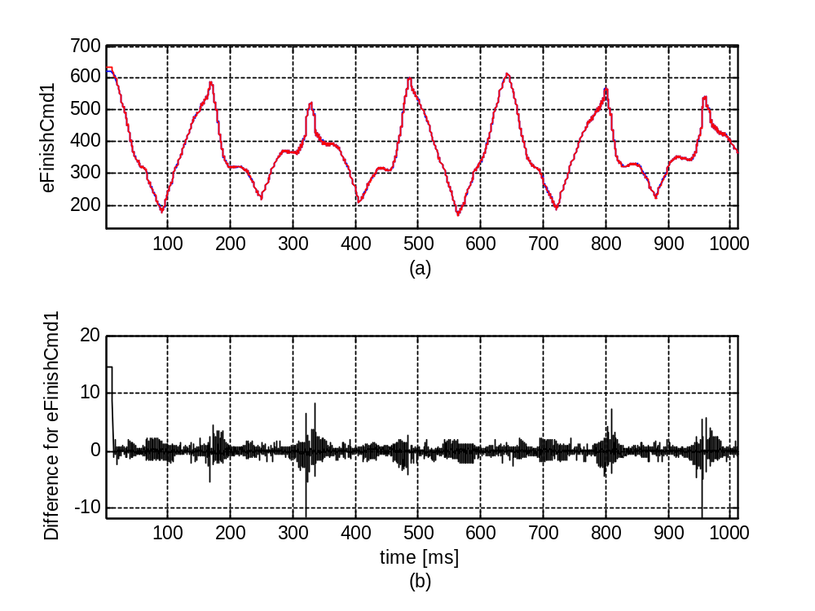
Figure 4.7: Electric finish angle (Cmd1) 'eFinishCmd1' (a) for cases of 'SVT_EVC_11p02build1' (blue) and 'SVT_EVC_11p21build1' (red), and their difference (b).

Table 4.7: Statistics for the difference for siganl 'eFinishCmd1' between two cases
 | Maximum/Time | Minimum/Time | STD | Mean
Diff(abs) | 14.625/0.10314 | -11.5691/953.5637 | 0.72638 | -0.0059704
Diff(rel) | 0.0236 | -0.0239

Regression status for 'eFinishCmd1': pass/no pass.

4.8. Comparison of variable - eFinishCmd2
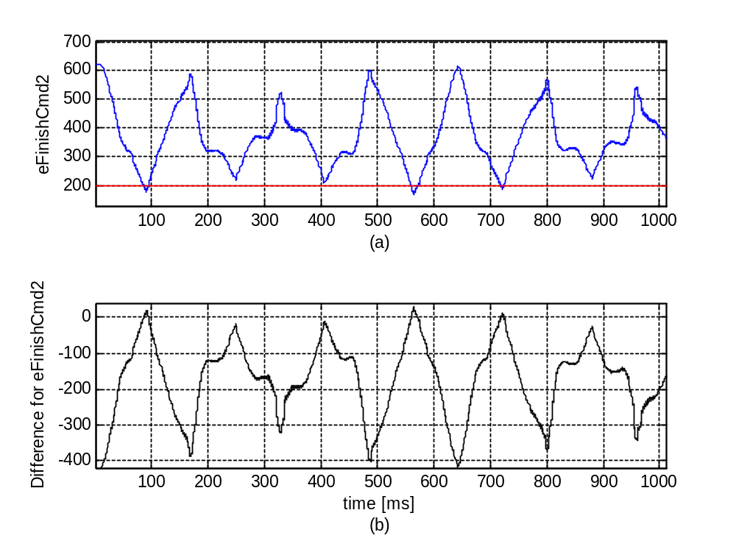
Figure 4.8: Electric finish angle (Cmd2) 'eFinishCmd2' (a) for cases of 'SVT_EVC_11p02build1' (blue) and 'SVT_EVC_11p21build1' (red), and their difference (b).

Table 4.8: Statistics for the difference for siganl 'eFinishCmd2' between two cases
 | Maximum/Time | Minimum/Time | STD | Mean
Diff(abs) | 29.875/565.4206 | -420.0625/0.10314 | 95.944 | -153.5003
Diff(rel) | 0.1757 | -0.6775

Regression status for 'eFinishCmd2': pass/no pass.

4.9. Comparison of variable - tSwOnMeas
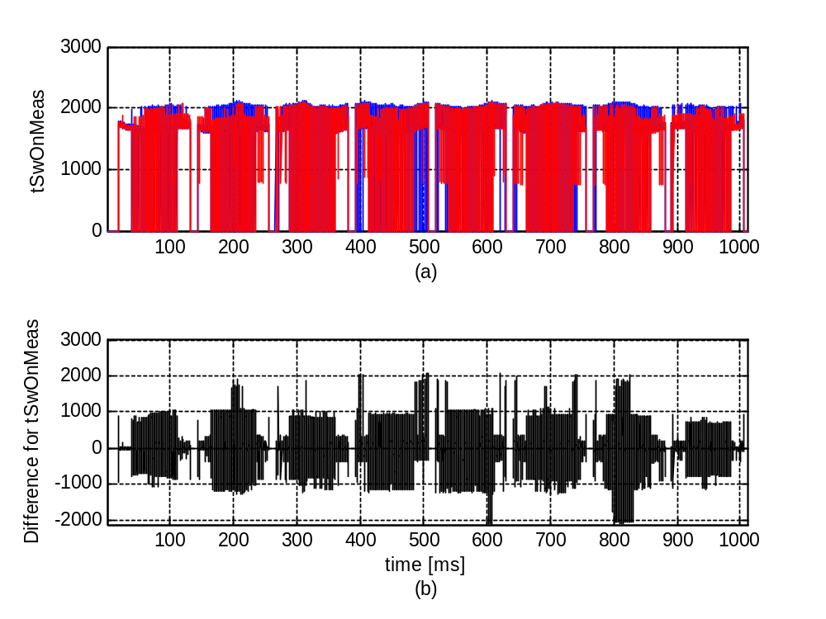
Figure 4.9: SV switch-on time (measurement) 'tSwOnMeas' (a) for cases of 'SVT_EVC_11p02build1' (blue) and 'SVT_EVC_11p21build1' (red), and their difference (b).

Table 4.9: Statistics for the difference for siganl 'tSwOnMeas' between two cases
 | Maximum/Time | Minimum/Time | STD | Mean
Diff(abs) | 2069.1342/505.8536 | -2107.6/608.3175 | 412.323 | 8.1652
Diff(rel) | 2.0691e+003 | -1

Regression status for 'tSwOnMeas': pass/no pass.

4.10. Comparison of variable - tSwOnSVSXCylCL0
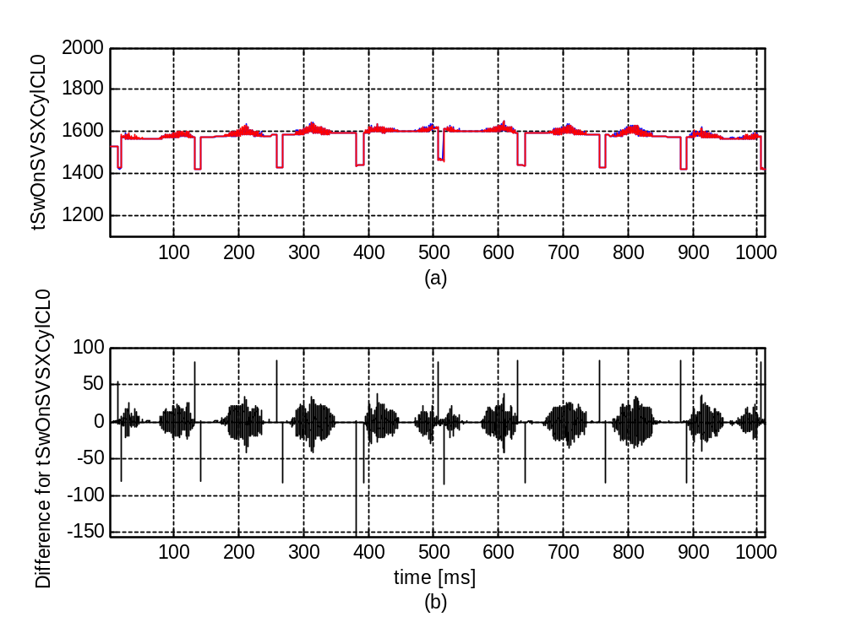
Figure 4.10: SV switch-on time (close-loop, cylinder 0) 'tSwOnSVSXCylCL0' (a) for cases of 'SVT_EVC_11p02build1' (blue) and 'SVT_EVC_11p21build1' (red), and their difference (b).

Table 4.10: Statistics for the difference for siganl 'tSwOnSVSXCylCL0' between two cases
 | Maximum/Time | Minimum/Time | STD | Mean
Diff(abs) | 83.1649/881.4963 | -155/381.4811 | 6.9502 | -0.30434
Diff(rel) | 0.0586 | -0.0973

Regression status for 'tSwOnSVSXCylCL0': pass/no pass.

4.11. Comparison of variable - tSwOnSVSXCylCL1
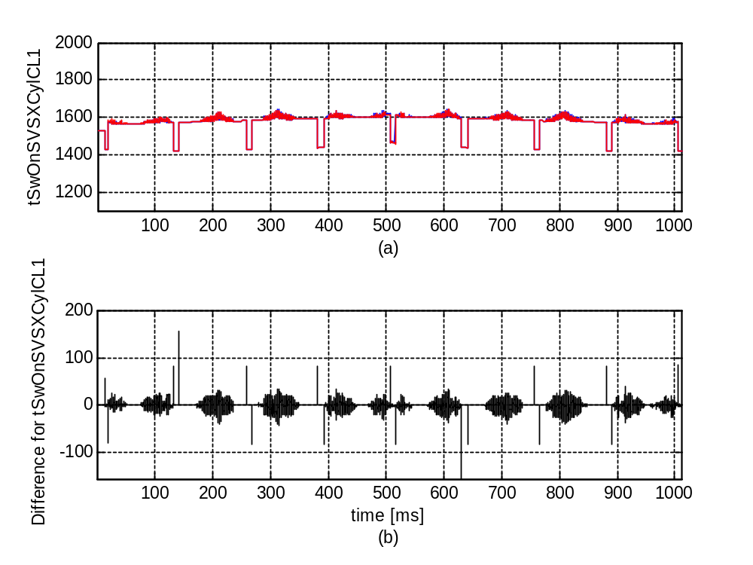
Figure 4.11: SV switch-on time (close-loop, cylinder 1) 'tSwOnSVSXCylCL1' (a) for cases of 'SVT_EVC_11p02build1' (blue) and 'SVT_EVC_11p21build1' (red), and their difference (b).

Table 4.11: Statistics for the difference for siganl 'tSwOnSVSXCylCL1' between two cases
 | Maximum/Time | Minimum/Time | STD | Mean
Diff(abs) | 155/141.7308 | -155/631.4633 | 7.1771 | -0.32144
Diff(rel) | 0.1093 | -0.0972

Regression status for 'tSwOnSVSXCylCL1': pass/no pass.

4.12. Comparison of variable - tSwOnSVSXCylCL2
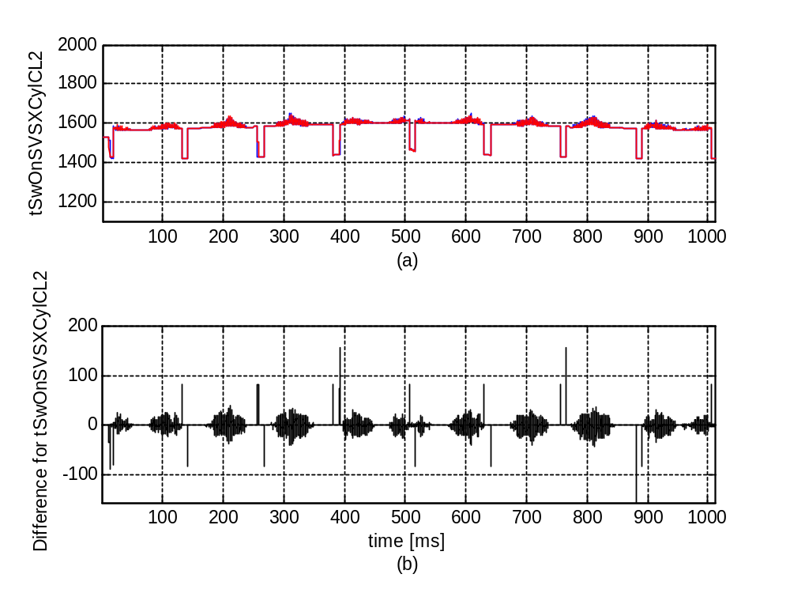
Figure 4.12: SV switch-on time (close-loop, cylinder 2) 'tSwOnSVSXCylCL2' (a) for cases of 'SVT_EVC_11p02build1' (blue) and 'SVT_EVC_11p21build1' (red), and their difference (b).

Table 4.12: Statistics for the difference for siganl 'tSwOnSVSXCylCL2' between two cases
 | Maximum/Time | Minimum/Time | STD | Mean
Diff(abs) | 155/391.7129 | -155/881.4456 | 7.0989 | -0.27091
Diff(rel) | 0.1077 | -0.0985

Regression status for 'tSwOnSVSXCylCL2': pass/no pass.

4.13. Comparison of variable - tSwOnSVSXCylCL3
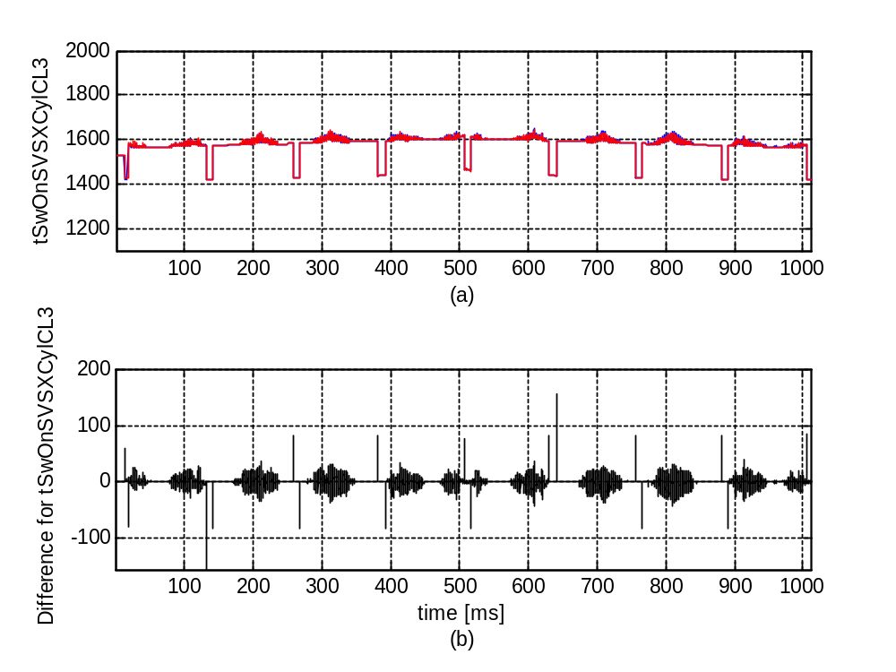
Figure 4.13: SV switch-on time (close-loop, cylinder 3) 'tSwOnSVSXCylCL3' (a) for cases of 'SVT_EVC_11p02build1' (blue) and 'SVT_EVC_11p21build1' (red), and their difference (b).

Table 4.13: Statistics for the difference for siganl 'tSwOnSVSXCylCL3' between two cases
 | Maximum/Time | Minimum/Time | STD | Mean
Diff(abs) | 155/641.6952 | -155/131.499 | 6.9697 | -0.27878
Diff(rel) | 0.1078 | -0.0986

Regression status for 'tSwOnSVSXCylCL3': pass/no pass.

4.14. Comparison of variable - tSwOnLowPrecV0
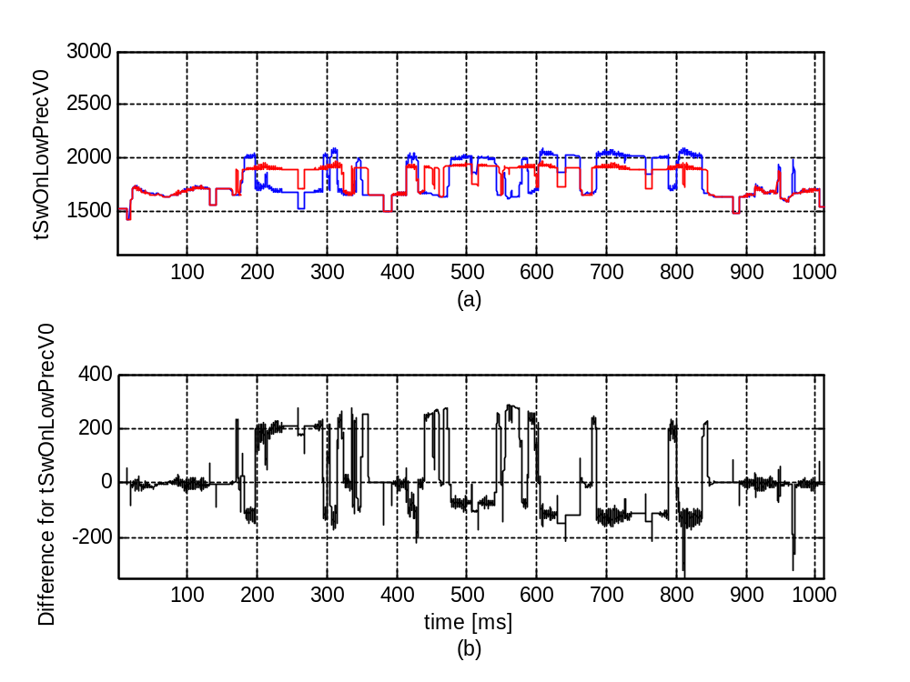
Figure 4.14: SV switch-on time (low precision, cylinder 0) 'tSwOnLowPrecV0' (a) for cases of 'SVT_EVC_11p02build1' (blue) and 'SVT_EVC_11p21build1' (red), and their difference (b).

Table 4.14: Statistics for the difference for siganl 'tSwOnLowPrecV0' between two cases
 | Maximum/Time | Minimum/Time | STD | Mean
Diff(abs) | 291.8/563.6163 | -348.8/811.9462 | 132.2443 | 22.4877
Diff(rel) | 0.1792 | -0.1674

Regression status for 'tSwOnLowPrecV0': pass/no pass.

4.15. Comparison of variable - tSwOnLowPrecV1
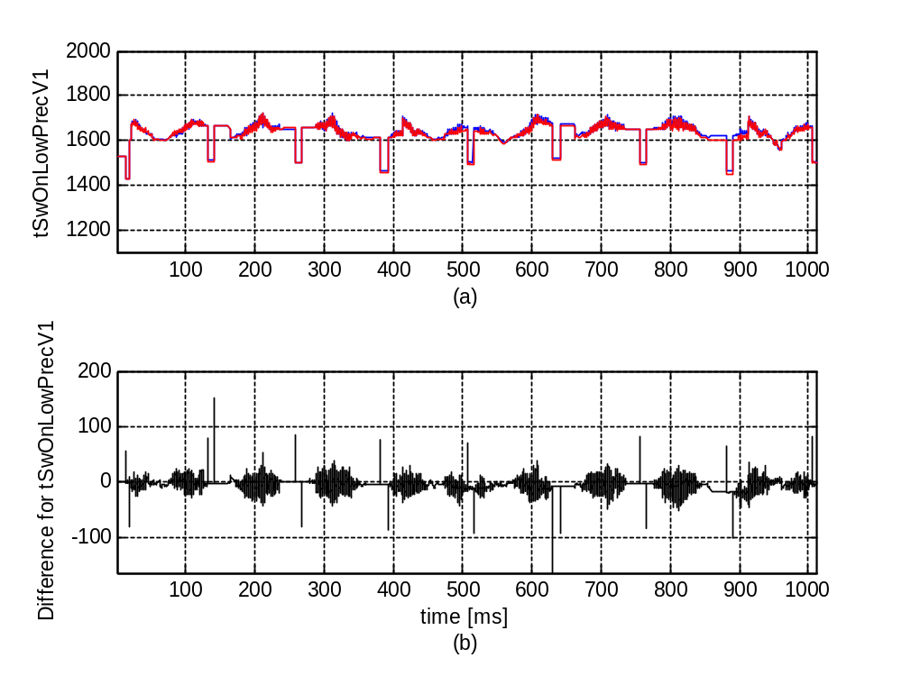
Figure 4.15: SV switch-on time (low precision, cylinder 1) 'tSwOnLowPrecV1' (a) for cases of 'SVT_EVC_11p02build1' (blue) and 'SVT_EVC_11p21build1' (red), and their difference (b).

Table 4.15: Statistics for the difference for siganl 'tSwOnLowPrecV1' between two cases
 | Maximum/Time | Minimum/Time | STD | Mean
Diff(abs) | 153/141.7308 | -163.8/631.4633 | 8.5347 | -3.5596
Diff(rel) | 0.1012 | -0.0977

Regression status for 'tSwOnLowPrecV1': pass/no pass.

4.16. Comparison of variable - tSwOnLowPrecV2
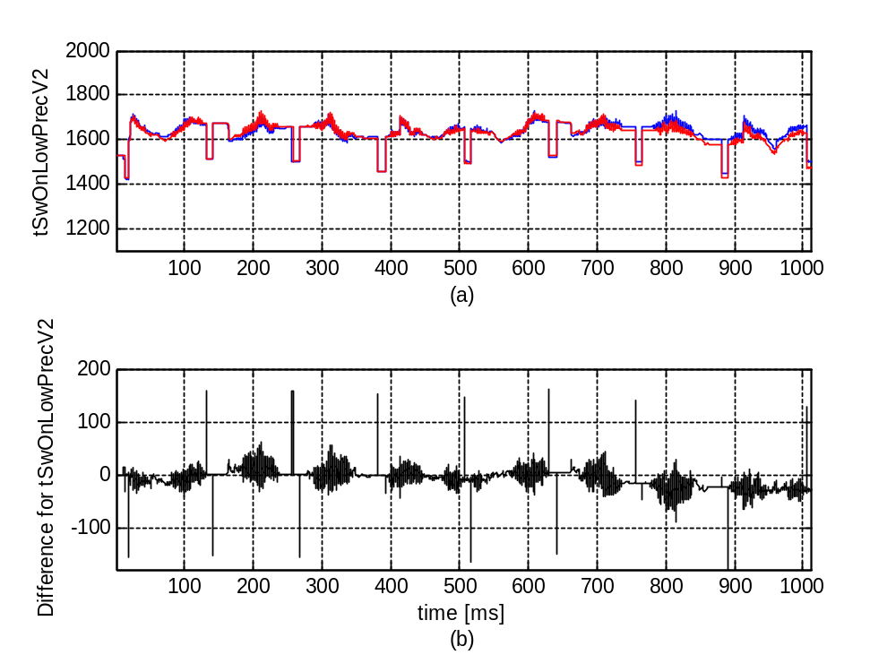
Figure 4.16: SV switch-on time (low precision, cylinder 2) 'tSwOnLowPrecV2' (a) for cases of 'SVT_EVC_11p02build1' (blue) and 'SVT_EVC_11p21build1' (red), and their difference (b).

Table 4.16: Statistics for the difference for siganl 'tSwOnLowPrecV2' between two cases
 | Maximum/Time | Minimum/Time | STD | Mean
Diff(abs) | 161.2/631.4633 | -176/891.7271 | 15.9016 | -4.9715
Diff(rel) | 0.1058 | -0.1099

Regression status for 'tSwOnLowPrecV2': pass/no pass.

4.17. Comparison of variable - tSwOnLowPrecV3
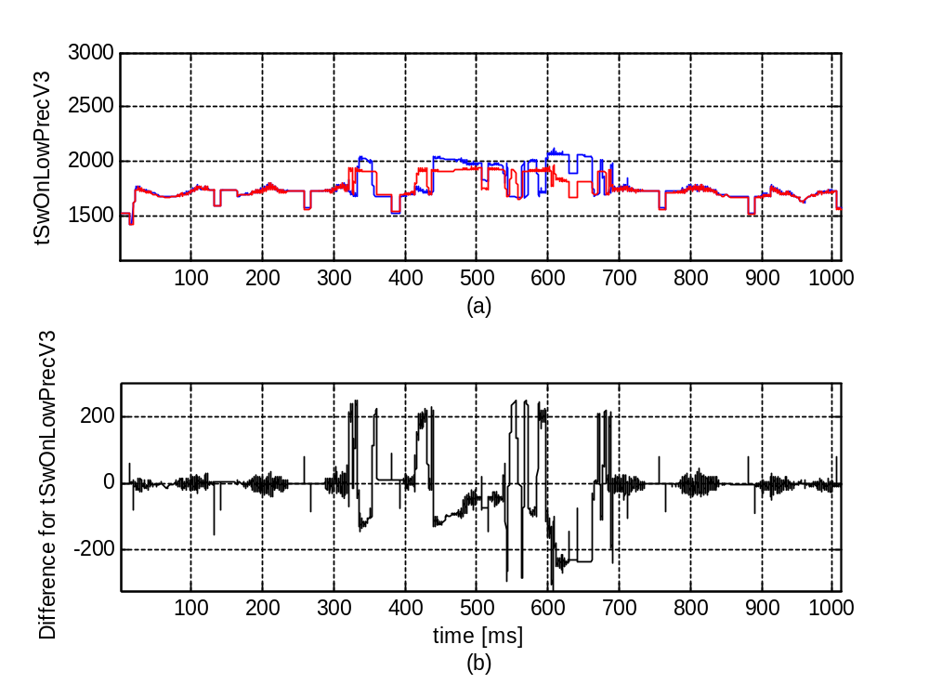
Figure 4.17: SV switch-on time (low precision, cylinder 3) 'tSwOnLowPrecV3' (a) for cases of 'SVT_EVC_11p02build1' (blue) and 'SVT_EVC_11p21build1' (red), and their difference (b).

Table 4.17: Statistics for the difference for siganl 'tSwOnLowPrecV3' between two cases
 | Maximum/Time | Minimum/Time | STD | Mean
Diff(abs) | 249/329.6891 | -322/606.5894 | 86.7609 | -5.6093
Diff(rel) | 0.1473 | -0.1540

Regression status for 'tSwOnLowPrecV3': pass/no pass.

4.18. Comparison of variable - tSwOffMeas
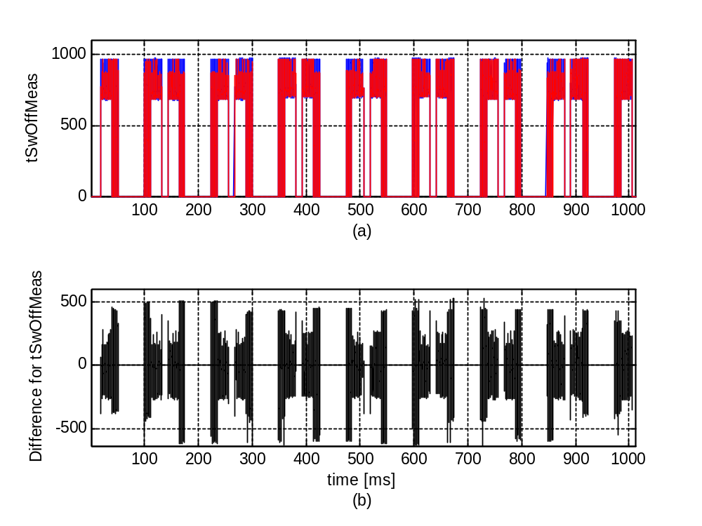
Figure 4.18: SV switch-off time (measurement) 'tSwOffMeas' (a) for cases of 'SVT_EVC_11p02build1' (blue) and 'SVT_EVC_11p21build1' (red), and their difference (b).

Table 4.18: Statistics for the difference for siganl 'tSwOffMeas' between two cases
 | Maximum/Time | Minimum/Time | STD | Mean
Diff(abs) | 526.7617/674.335 | -636.8694/727.9946 | 93.9403 | -0.93819
Diff(rel) | 526.7617 | -0.6634

Regression status for 'tSwOffMeas': pass/no pass.

4.19. Comparison of variable - tSwOffSVSXCylCL0
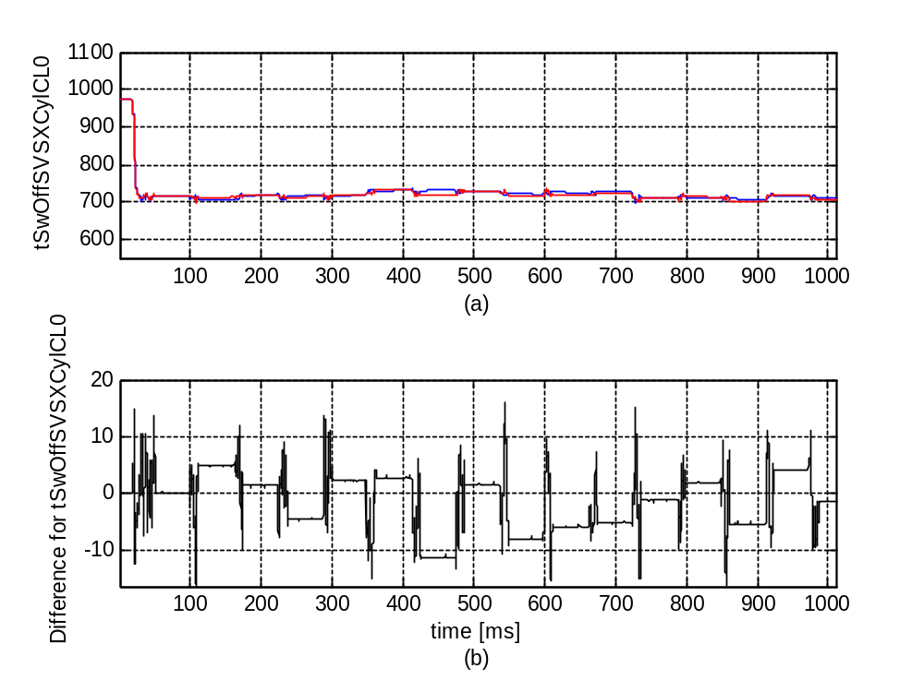
Figure 4.19: SV switch-off (close-loop, cylinder 0) 'tSwOffSVSXCylCL0' (a) for cases of 'SVT_EVC_11p02build1' (blue) and 'SVT_EVC_11p21build1' (red), and their difference (b).

Table 4.19: Statistics for the difference for siganl 'tSwOffSVSXCylCL0' between two cases
 | Maximum/Time | Minimum/Time | STD | Mean
Diff(abs) | 16.2102/543.6629 | -16.4/107.3921 | 5.274 | -1.4745
Diff(rel) | 0.0227 | -0.0229

Regression status for 'tSwOffSVSXCylCL0': pass/no pass.

4.20. Comparison of variable - tSwOffSVSXCylCL1
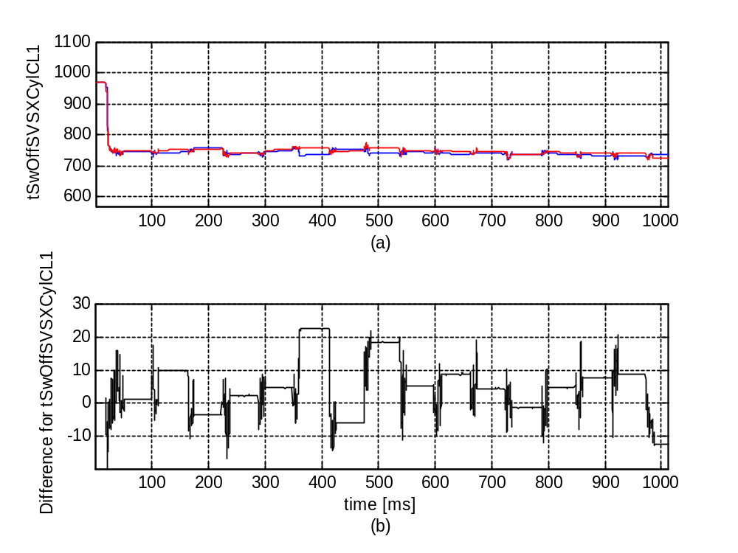
Figure 4.20: SV switch-off (close-loop, cylinder 1) 'tSwOffSVSXCylCL1' (a) for cases of 'SVT_EVC_11p02build1' (blue) and 'SVT_EVC_11p21build1' (red), and their difference (b).

Table 4.20: Statistics for the difference for siganl 'tSwOffSVSXCylCL1' between two cases
 | Maximum/Time | Minimum/Time | STD | Mean
Diff(abs) | 23/375.5683 | -19.8/20.4714 | 6.414 | 3.0694
Diff(rel) | 0.0313 | -0.0230

Regression status for 'tSwOffSVSXCylCL1': pass/no pass.

4.21. Comparison of variable - tSwOffSVSXCylCL2
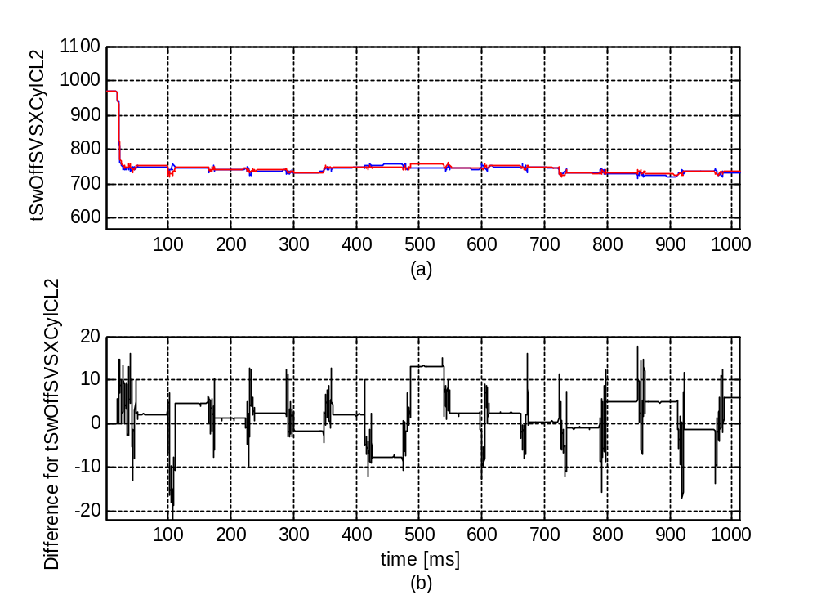
Figure 4.21: SV switch-off (close-loop, cylinder 2) 'tSwOffSVSXCylCL2' (a) for cases of 'SVT_EVC_11p02build1' (blue) and 'SVT_EVC_11p21build1' (red), and their difference (b).

Table 4.21: Statistics for the difference for siganl 'tSwOffSVSXCylCL2' between two cases
 | Maximum/Time | Minimum/Time | STD | Mean
Diff(abs) | 17.8/850.1041 | -22/106.6947 | 4.6654 | 0.66324
Diff(rel) | 0.0246 | -0.0291

Regression status for 'tSwOffSVSXCylCL2': pass/no pass.

4.22. Comparison of variable - tSwOffSVSXCylCL3
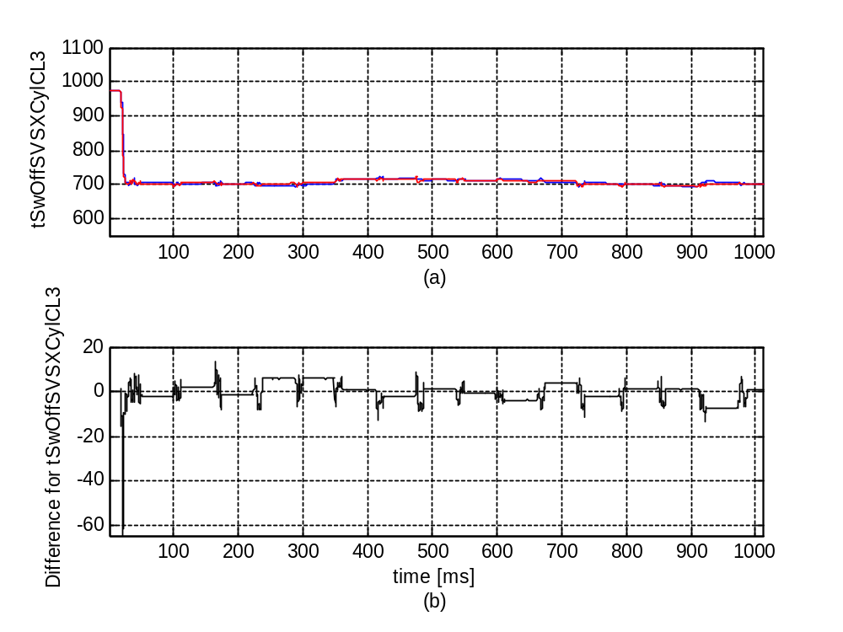
Figure 4.22: SV switch-off (close-loop, cylinder 3) 'tSwOffSVSXCylCL3' (a) for cases of 'SVT_EVC_11p02build1' (blue) and 'SVT_EVC_11p21build1' (red), and their difference (b).

Table 4.22: Statistics for the difference for siganl 'tSwOffSVSXCylCL3' between two cases
 | Maximum/Time | Minimum/Time | STD | Mean
Diff(abs) | 13.7045/165.0826 | -64.6/20.8399 | 4.0465 | -0.37947
Diff(rel) | 0.0197 | -0.0753

Regression status for 'tSwOffSVSXCylCL3': pass/no pass.

Chapter 5. SV current profiles
In this section, a set of SV current profiles are analyzed at certain fixed time points.

5.1. Selected SV current for cylinder 1
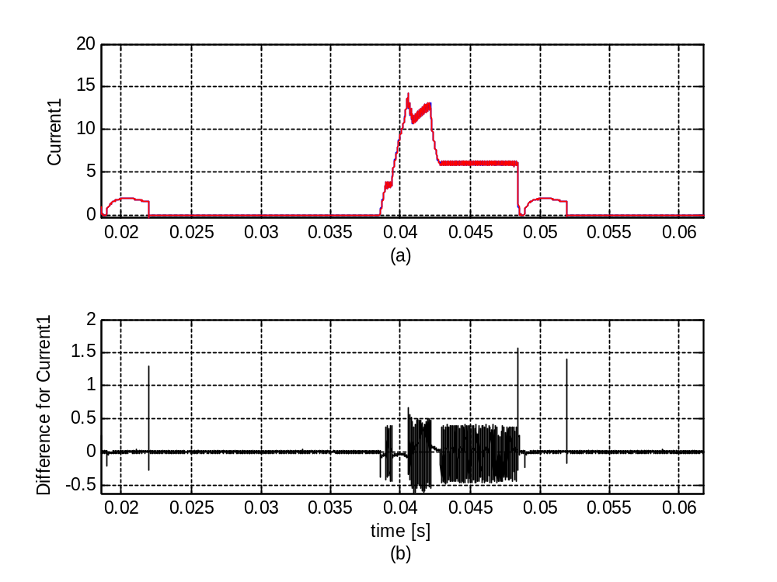
Figure 5.1: Current for SV in clyinder 1 'Current1' (a) for cases of 'SVT_EVC_11p02build1' (blue) and 'SVT_EVC_11p21build1' (red), and their difference (b).

Table 5.1: Statistics for the difference of 'Current1' between two cases
 | Maximum/Time | Minimum/Time | STD | Mean
Diff(abs) | 1.5686/0.029917 | -0.62256/0.022444 | 0.10867 | 0.00012318
Diff(rel) | 46.5748 | -15.6490

Regression status for 'Current1' : pass/no pass.

5.2. Selected SV current for cylinder 2
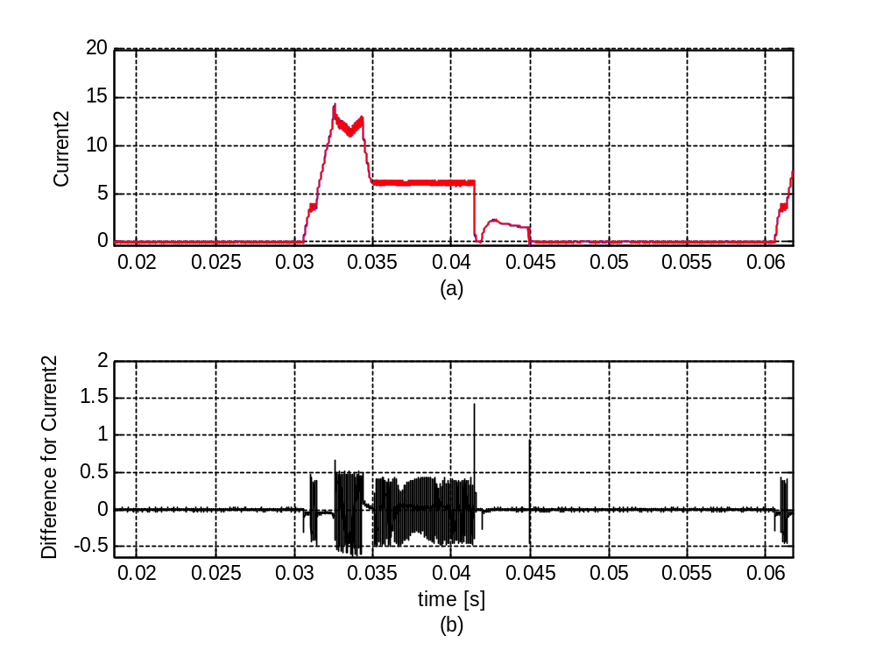
Figure 5.2: Current for SV in clyinder 2 'Current2' (a) for cases of 'SVT_EVC_11p02build1' (blue) and 'SVT_EVC_11p21build1' (red), and their difference (b).

Table 5.2: Statistics for the difference of 'Current2' between two cases
 | Maximum/Time | Minimum/Time | STD | Mean
Diff(abs) | 1.4282/0.022933 | -0.62866/0.015139 | 0.11846 | -0.00094703
Diff(rel) | 1.3000e+004 | -51.9677

Regression status for 'Current2' : pass/no pass.

5.3. Selected SV current for cylinder 3
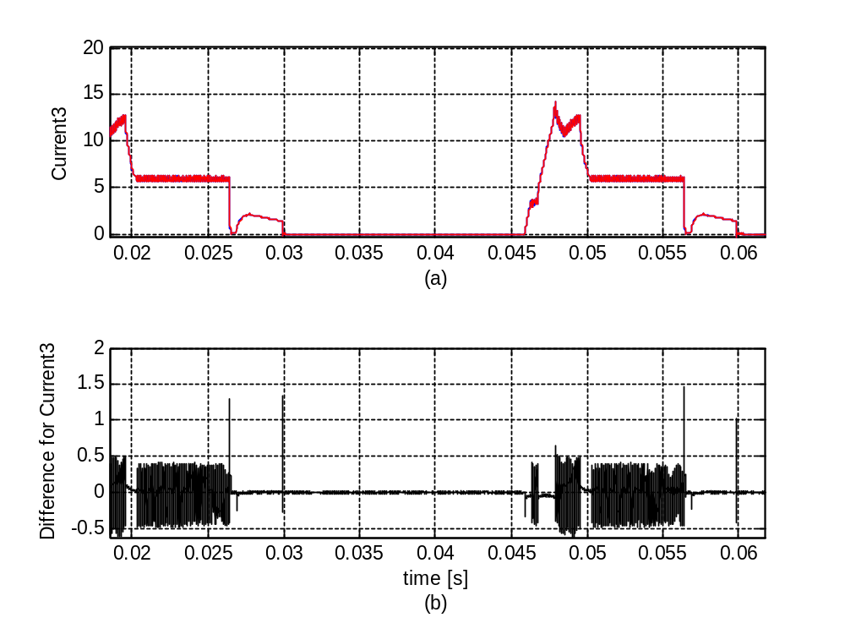
Figure 5.3: Current for SV in clyinder 3 'Current3' (a) for cases of 'SVT_EVC_11p02build1' (blue) and 'SVT_EVC_11p21build1' (red), and their difference (b).

Table 5.3: Statistics for the difference of 'Current3' between two cases
 | Maximum/Time | Minimum/Time | STD | Mean
Diff(abs) | 1.4618/0.037872 | -0.61646/0.03055 | 0.1494 | 0.001357
Diff(rel) | 59.6068 | -33.4659

Regression status for 'Current3' : pass/no pass.

5.4. Selected SV current for cylinder 4
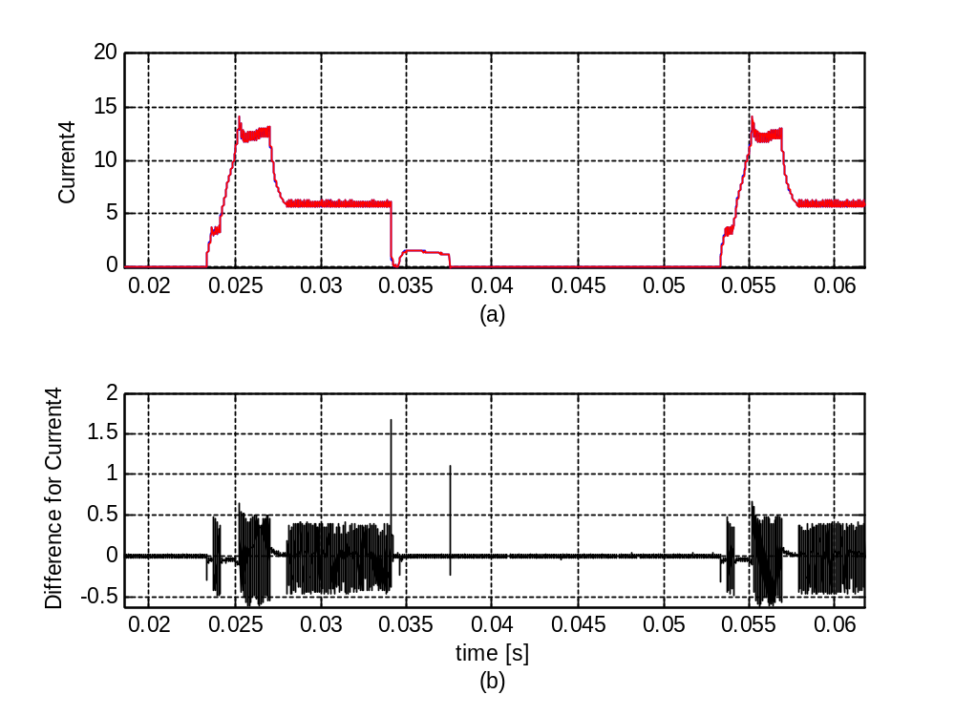
Figure 5.4: Current for SV in clyinder 4 'Current4' (a) for cases of 'SVT_EVC_11p02build1' (blue) and 'SVT_EVC_11p21build1' (red), and their difference (b).

Table 5.4: Statistics for the difference of 'Current4' between two cases
 | Maximum/Time | Minimum/Time | STD | Mean
Diff(abs) | 1.6815/0.015572 | -0.61646/0.037128 | 0.1435 | -0.0007395
Diff(rel) | 752.7322 | -0.5292

Regression status for 'Current4' : pass/no pass.

Chapter 6. Mechanical and electric angles
In this section, the mechanical angles requested by ECM are compared with the corresponding electric angles which are applied to solenoid valves to control the mechanical valves.

6.1. eClosAReqEC vs eFinish
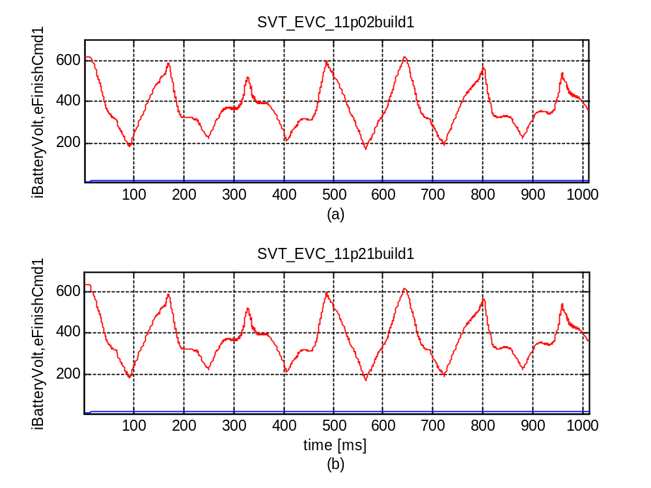
Figure 6.1: Relationship between 'iBatteryVolt' (blue) and 'eFinishCmd1' (red) for 'SVT_EVC_11p02build1' (a) and 'SVT_EVC_11p21build1' (b).

6.2. eOpenAReqLO vs eStart
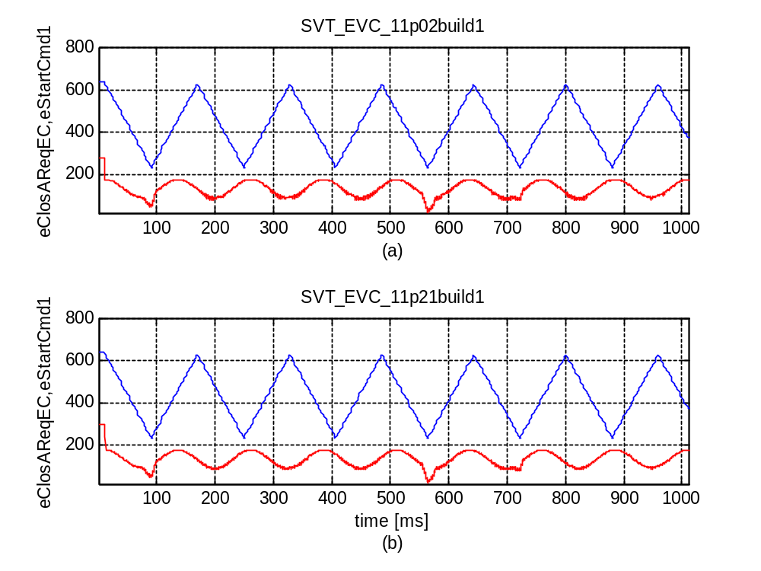
Figure 6.2: Relationship between 'eClosAReqEC' (blue) and 'eStartCmd1' (red) for 'SVT_EVC_11p02build1' (a) and 'SVT_EVC_11p21build1' (b).

6.3. eOpenReqHB vs eStart
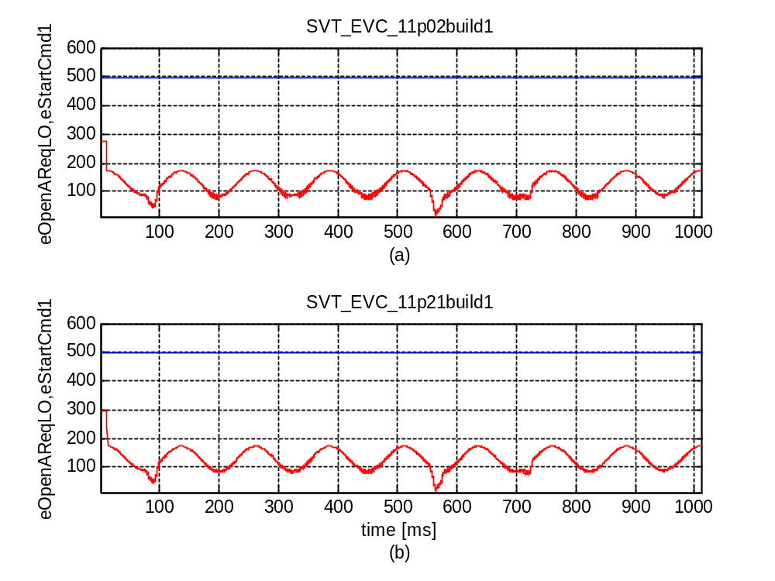
Figure 6.3: Relationship between 'eOpenAReqLO' (blue) and 'eStartCmd1' (red) for 'SVT_EVC_11p02build1' (a) and 'SVT_EVC_11p21build1' (b).

Chapter 7. Summary
Regression test has been performed for cases 'SVT_EVC_11p02build1' and 'SVT_EVC_11p21build1'. The findings are as follows.
Input signals listed in following table have shown already bigger discrepencies between the two cases. Details can be found in previous sections related to the corresponding signals.
Table 7.1: Input signals with bigger relative differences
Signal | Maximum(rel) | Minimum(rel) | STD | Mean
eOpenReqHB | 0.11406 | 0 | 1.3002 | 0.053022
nValveModeId | 2.5 | 0 | 0.014627 | 4.2788e-005
nAbsCylinderId | 3 | -1 | 1.7521 | 0
nActReqFreezTDC | 0.25 | -0.2 | 0.080327 | -0.00030807

Output signals listed in following table have shown bigger discrepencies between the two cases. Details can be found in previous sections related to the corresponding signals.
Table 7.2: Output signals with bigger relative differences
Signal | Maximum(rel) | Minimum(rel) | STD | Mean
eStart | 0.36888 | -0.1153 | 3.3667 | -0.00096374
eStartCmd1 | 0.36888 | -0.1153 | 3.3667 | -0.00096374
eFinishCmd2 | 0.17567 | -0.67752 | 95.944 | -153.5003
tSwOnMeas | 2069.1342 | -1 | 412.323 | 8.1652
tSwOnSVSXCylCL1 | 0.10929 | -0.09724 | 7.1771 | -0.32144
tSwOnSVSXCylCL2 | 0.10771 | -0.098525 | 7.0989 | -0.27091
tSwOnSVSXCylCL3 | 0.10777 | -0.098575 | 6.9697 | -0.27878
tSwOnLowPrecV0 | 0.17924 | -0.16739 | 132.2443 | 22.4877
tSwOnLowPrecV1 | 0.10123 | -0.097721 | 8.5347 | -3.5596
tSwOnLowPrecV2 | 0.10584 | -0.10993 | 15.9016 | -4.9715
tSwOnLowPrecV3 | 0.1473 | -0.15396 | 86.7609 | -5.6093
tSwOffMeas | 526.7617 | -0.66341 | 93.9403 | -0.93819

SV current signals listed in following table have shown bigger discrepencies between the two cases. Details can be found in previous sections related to the corresponding signals.
Table 7.3: SV current with bigger relative differences
Signal | Maximum(rel) | Minimum(rel) | STD | Mean
Current1 | 46.5748 | -15.649 | 0.10867 | 0.00012318
Current2 | 13000 | -51.9677 | 0.11846 | -0.00094703
Current3 | 59.6068 | -33.4659 | 0.1494 | 0.001357
Current4 | 752.7322 | -0.52917 | 0.1435 | -0.0007395

Chapter 8. Original input and output signals
In this section, some subplementary information is provided. Specifically, the original input and output signals colleced in a driving sequence from vehicle/engine is presented. These signals are from realility and shall be taken as original reference, although they are never expected to be reproduced in a HIL test.

8.1. Signal/variable - rpm
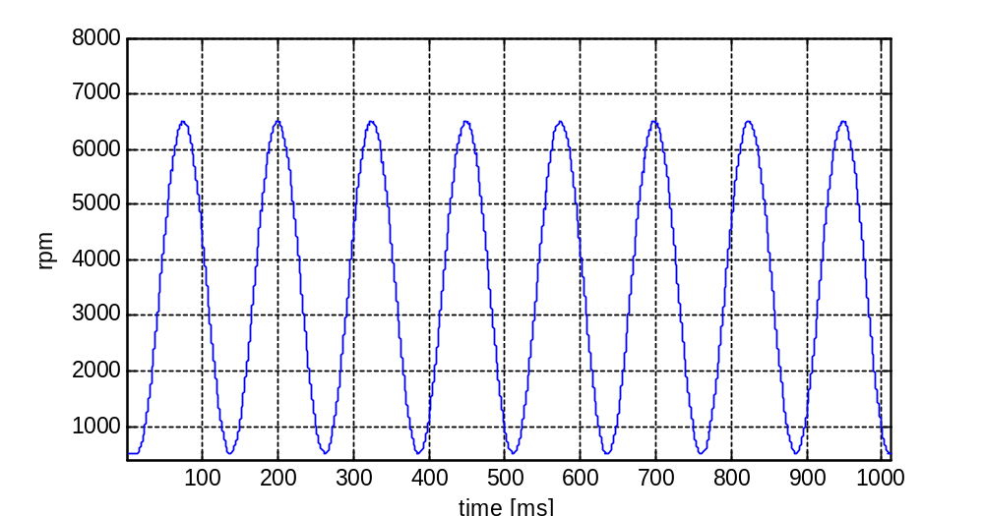
Figure 8.1: Engine speed 'rpm'.

8.2. Signal/variable - iBatteryVolt
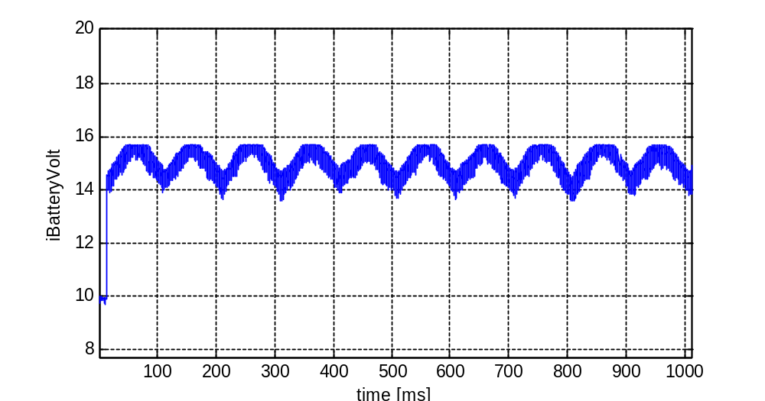
Figure 8.2: Voltage on power stage 'iBatteryVolt'.

8.3. Signal/variable - eClosAReqEC
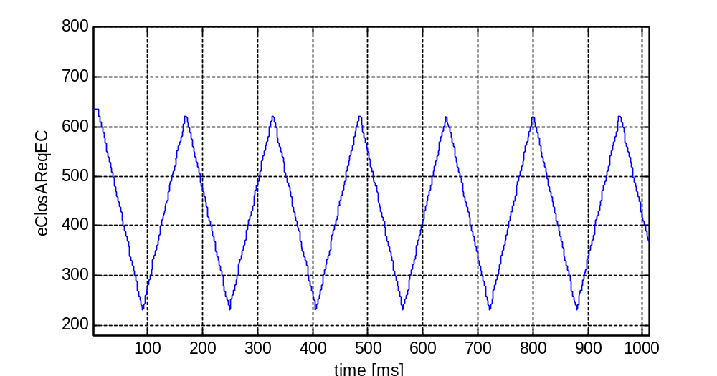
Figure 8.3: MV-close angle request (EVC) 'eClosAReqEC'.

8.4. Signal/variable - eOpenAReqLO
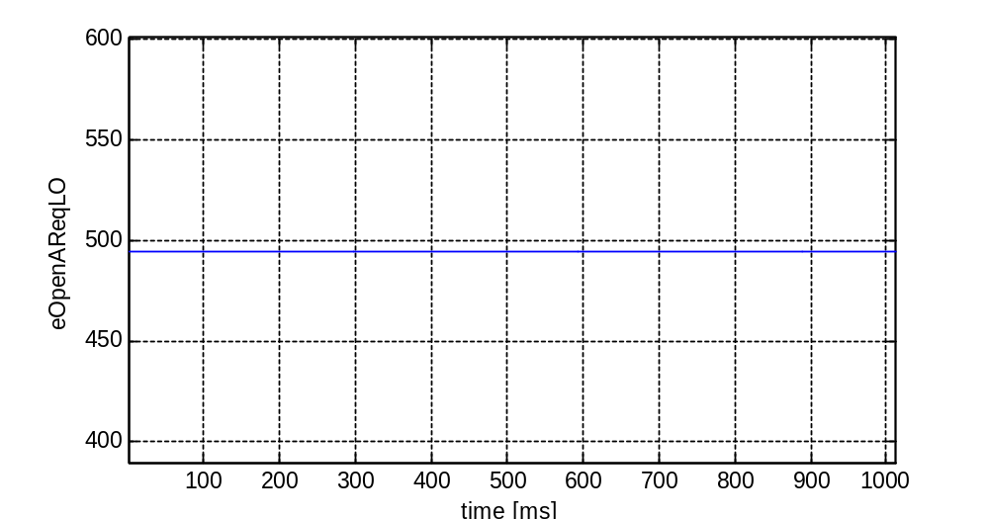
Figure 8.4: MV-open angle request (LVO) 'eOpenAReqLO'.

8.5. Signal/variable - eOpenReqHB
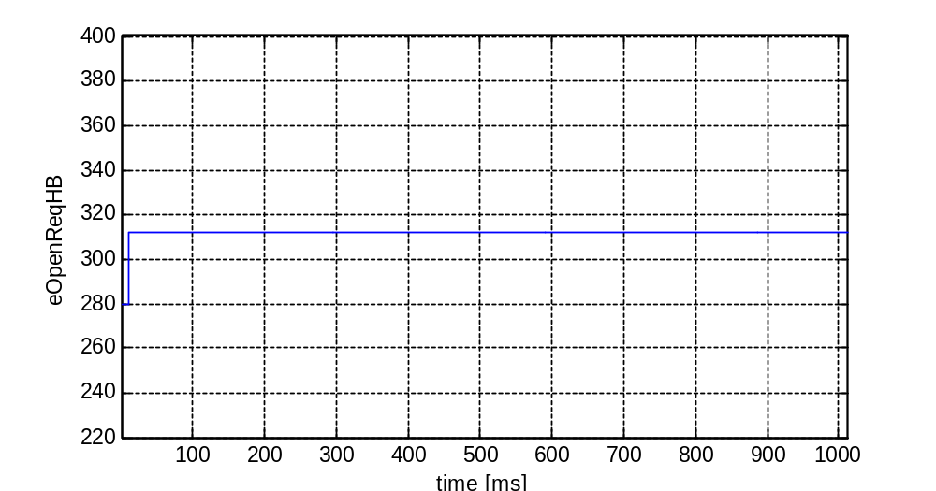
Figure 8.5: MV-open angle request (HB) 'eOpenReqHB'.

8.6. Signal/variable - nValveModeId
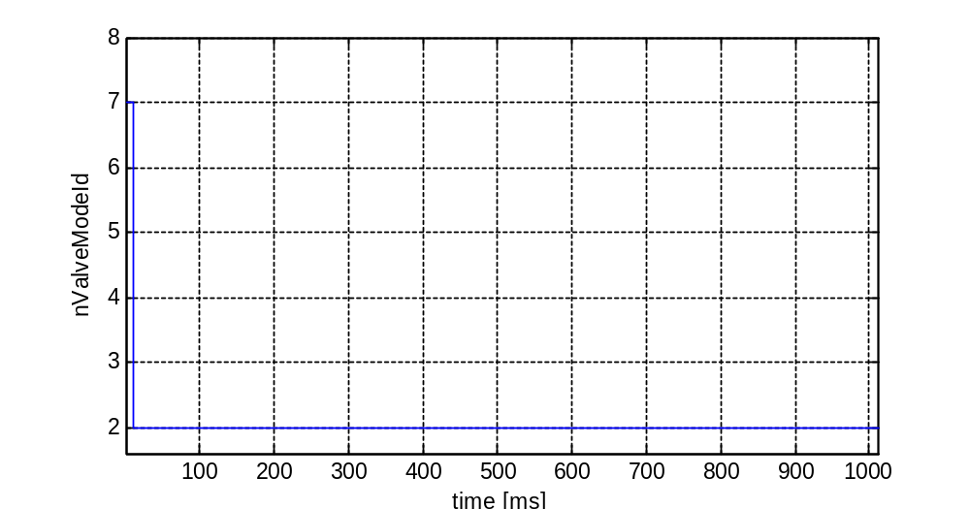
Figure 8.6: SV mode ID 'nValveModeId'.

8.7. Signal/variable - nAbsCylinderId
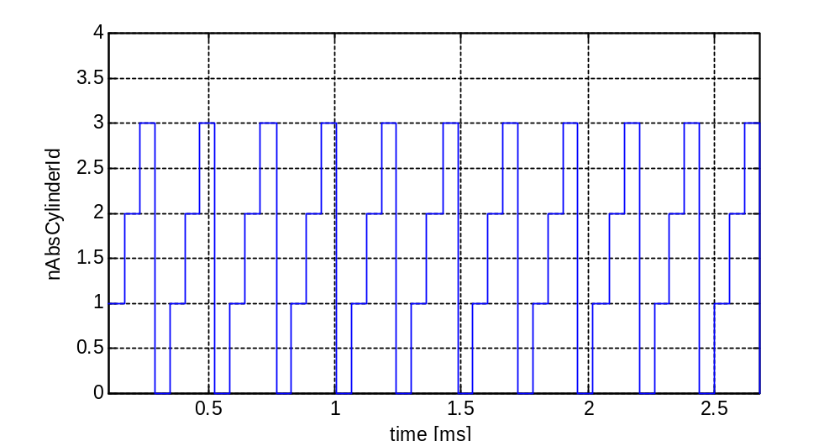
Figure 8.7: Absolute cylinder ID 'nAbsCylinderId'.

8.8. Signal/variable - nActReqFreezTDC
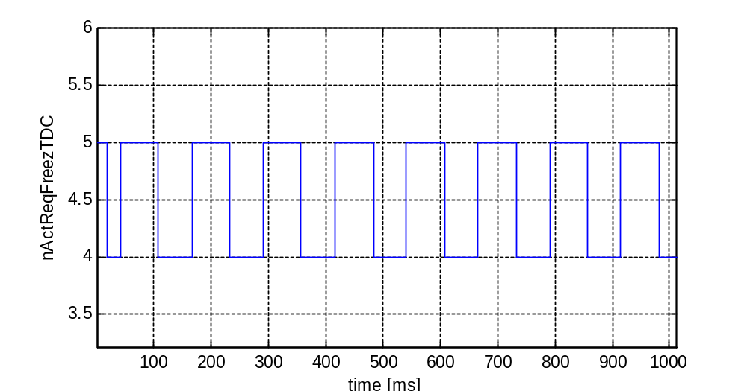
Figure 8.8: Freezing TDC 'nActReqFreezTDC'.

8.9. Signal/variable - wOilTemp
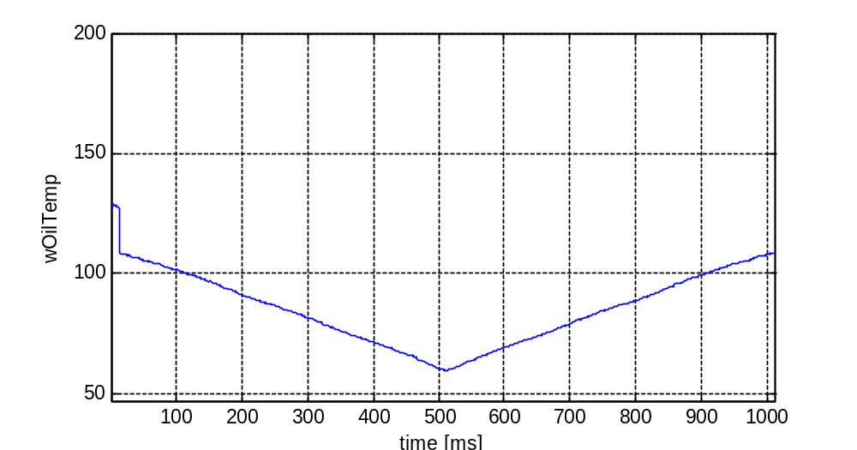
Figure 8.9: HPC oil temperature 'wOilTemp'.

8.10. Signal/variable - wCoilTemp
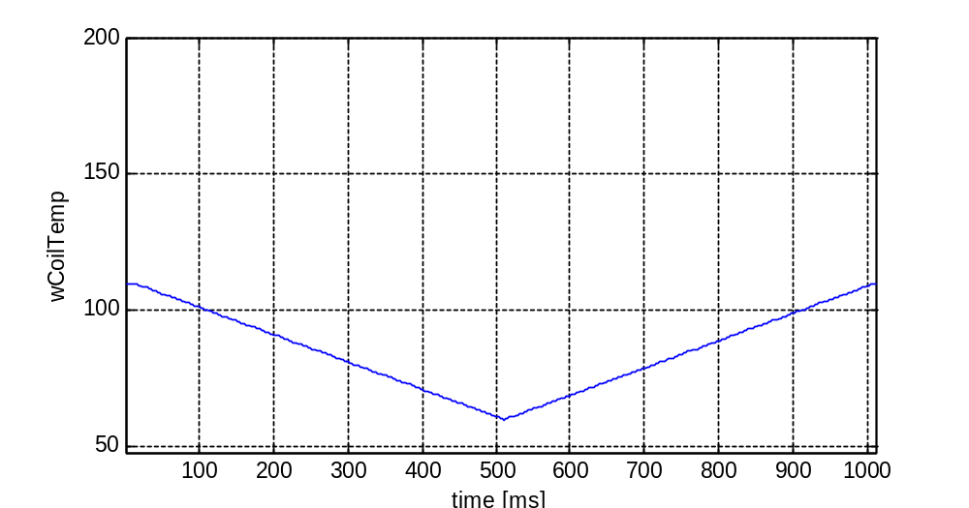
Figure 8.10: Coil temperature 'wCoilTemp'.

8.11. Signal/variable - eStart
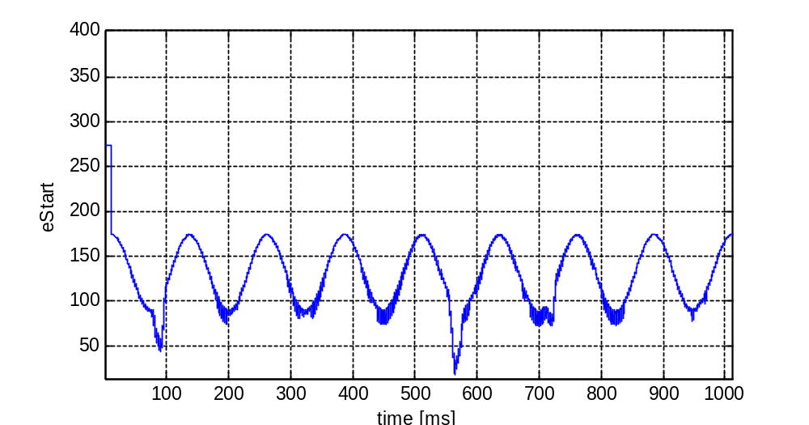
Figure 8.11: electric start angle 'eStart'.

8.12. Signal/variable - eStartCmd1
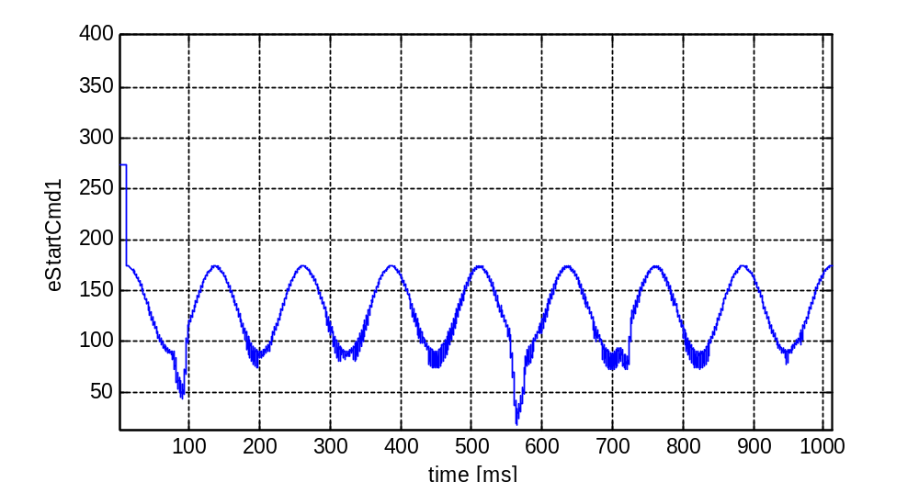
Figure 8.12: electric start angle (Cmd1) 'eStartCmd1'.

8.13. Signal/variable - eStartCmd2
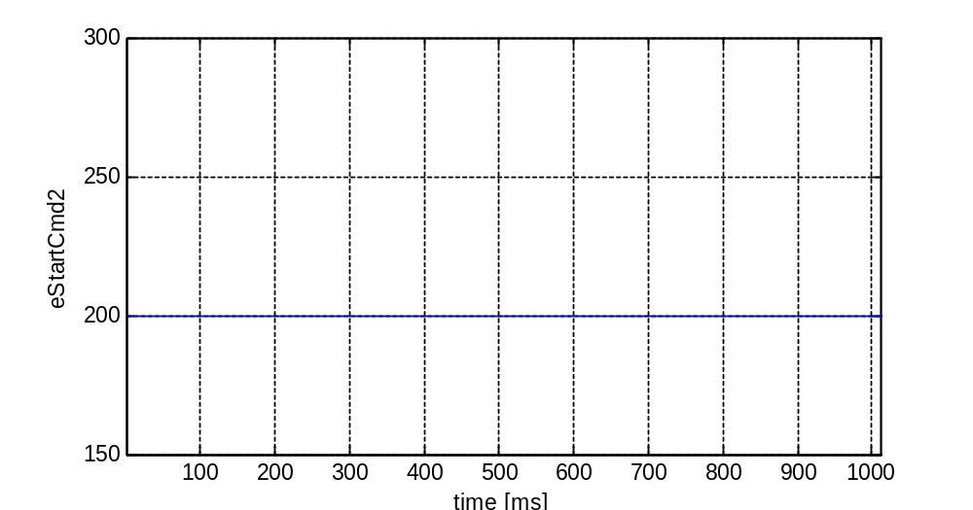
Figure 8.13: electric start angle (Cmd2) 'eStartCmd2'.

8.14. Signal/variable - eFinish
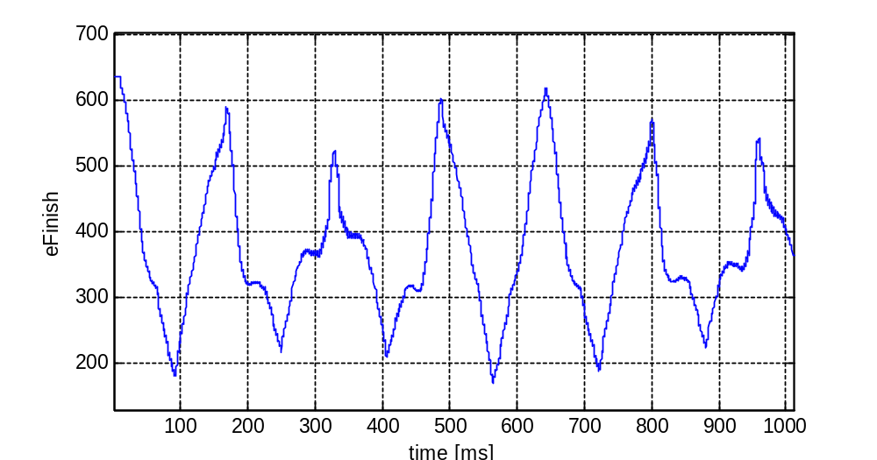
Figure 8.14: Electric finish angle 'eFinish'.

8.15. Signal/variable - eFinishCmd1
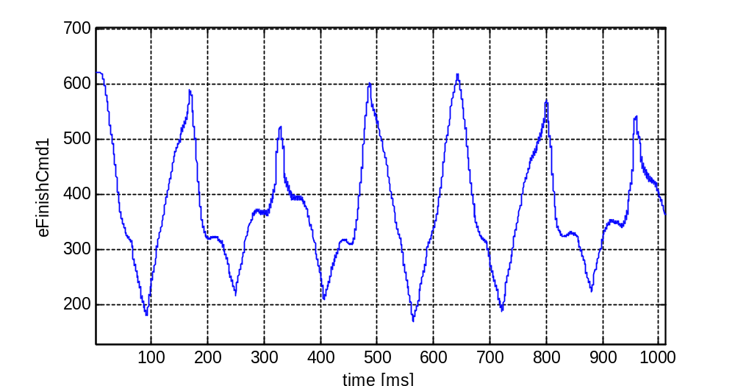
Figure 8.15: Electric finish angle (Cmd1) 'eFinishCmd1'.

8.16. Signal/variable - eFinishCmd2
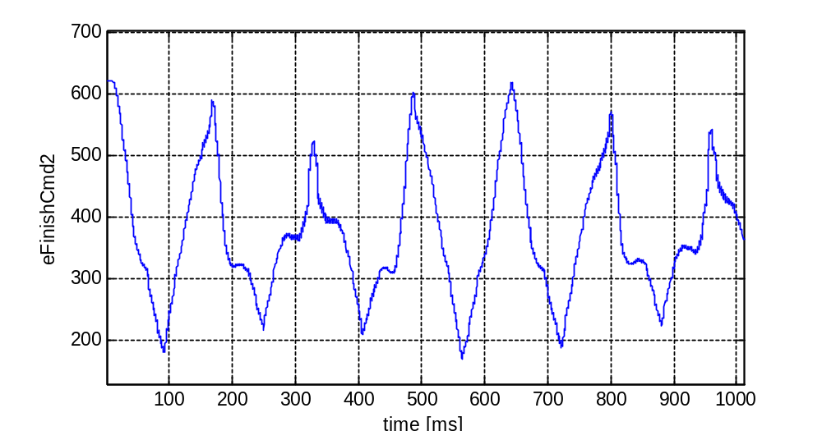
Figure 8.16: Electric finish angle (Cmd2) 'eFinishCmd2'.

8.17. Signal/variable - tSwOnMeas
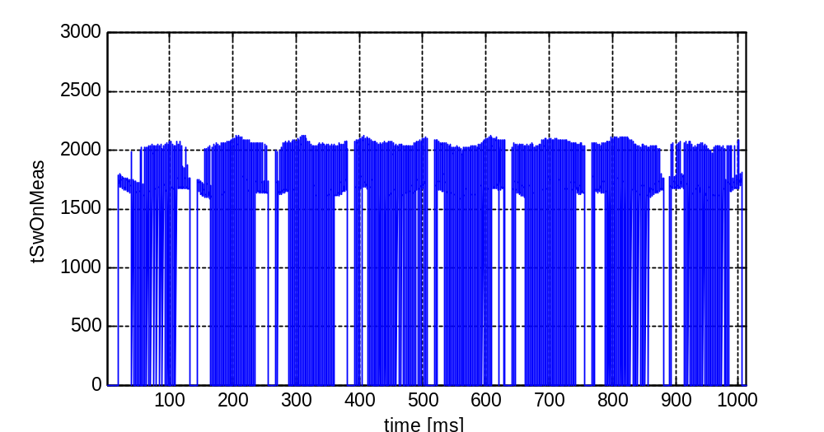
Figure 8.17: SV switch-on time (measurement) 'tSwOnMeas'.

8.18. Signal/variable - tSwOnSVSXCylCL0
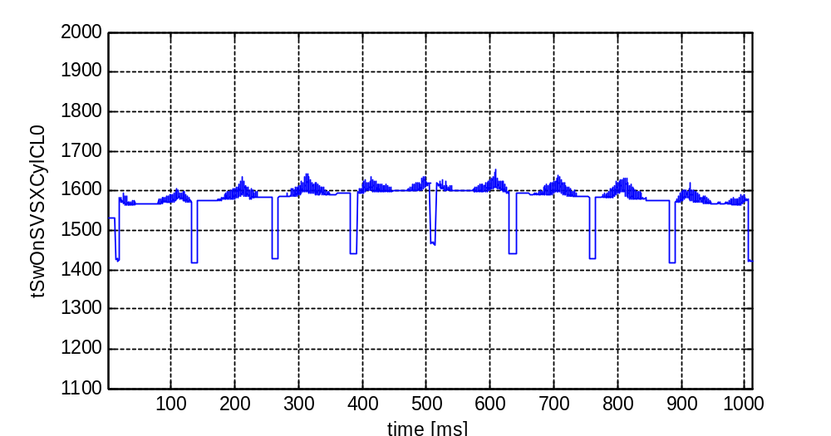
Figure 8.18: SV switch-on time (close-loop, cylinder 0) 'tSwOnSVSXCylCL0'.

8.19. Signal/variable - tSwOnSVSXCylCL1
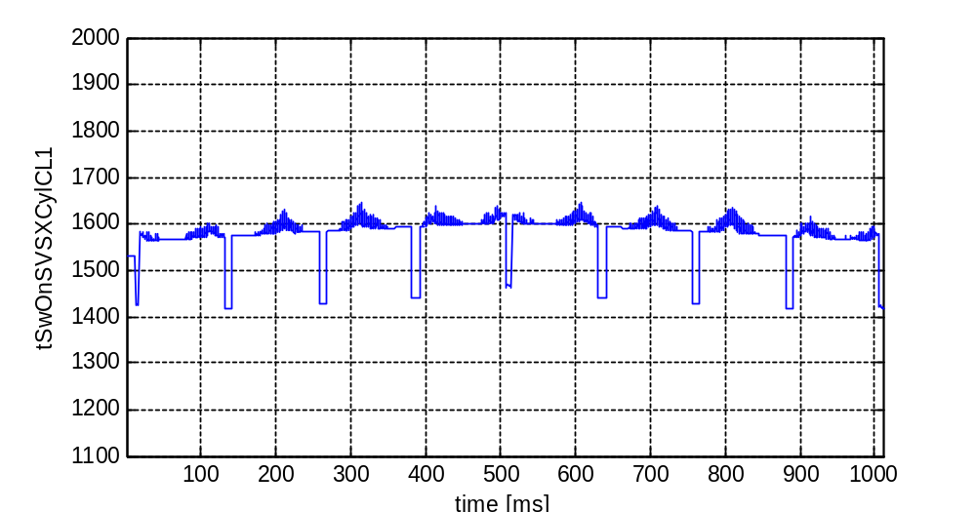
Figure 8.19: SV switch-on time (close-loop, cylinder 1) 'tSwOnSVSXCylCL1'.

8.20. Signal/variable - tSwOnSVSXCylCL2
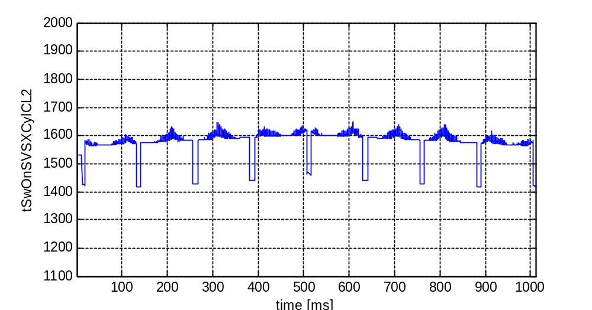
Figure 8.20: SV switch-on time (close-loop, cylinder 2) 'tSwOnSVSXCylCL2'.

8.21. Signal/variable - tSwOnSVSXCylCL3
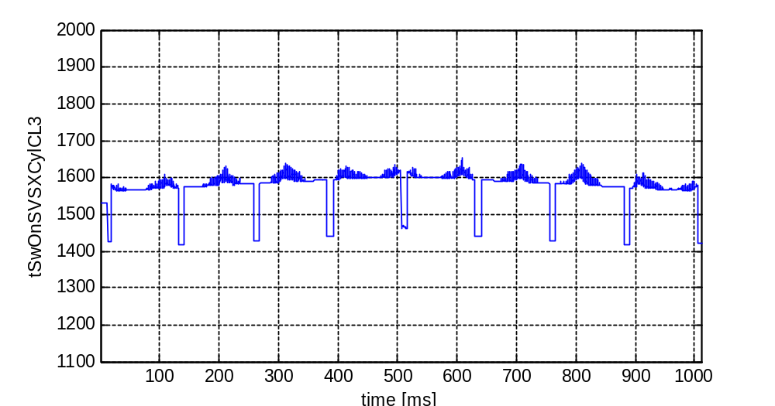
Figure 8.21: SV switch-on time (close-loop, cylinder 3) 'tSwOnSVSXCylCL3'.

8.22. Signal/variable - tSwOnLowPrecV0
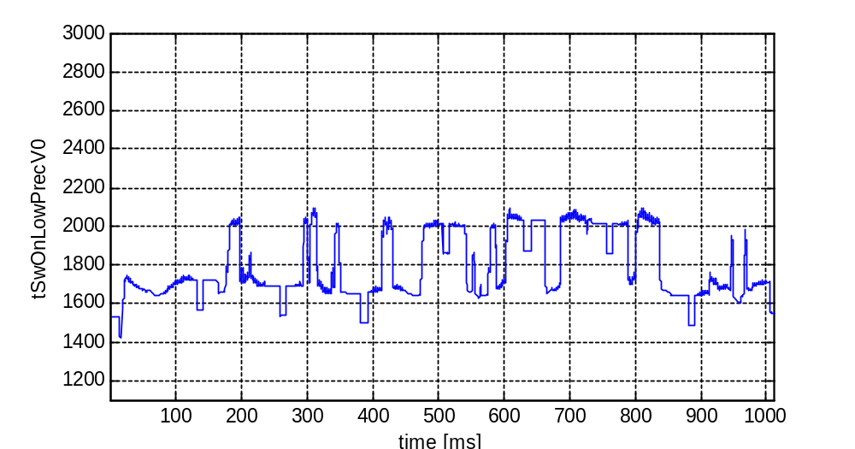
Figure 8.22: SV switch-on time (low precision, cylinder 0) 'tSwOnLowPrecV0'.

8.23. Signal/variable - tSwOnLowPrecV1
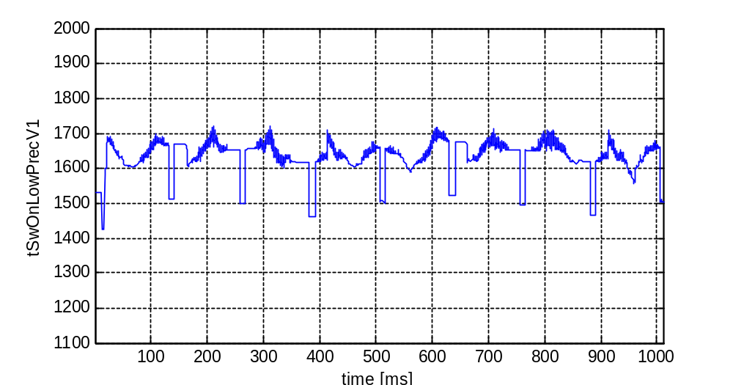
Figure 8.23: SV switch-on time (low precision, cylinder 1) 'tSwOnLowPrecV1'.

8.24. Signal/variable - tSwOnLowPrecV2
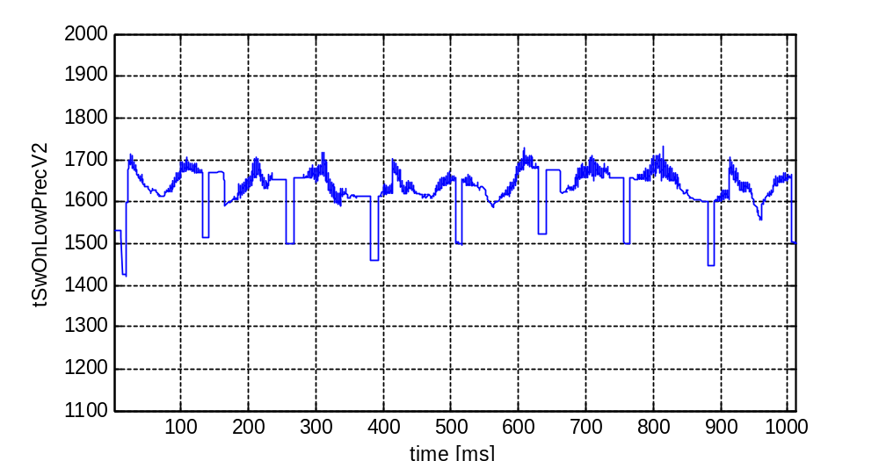
Figure 8.24: SV switch-on time (low precision, cylinder 2) 'tSwOnLowPrecV2'.

8.25. Signal/variable - tSwOnLowPrecV3
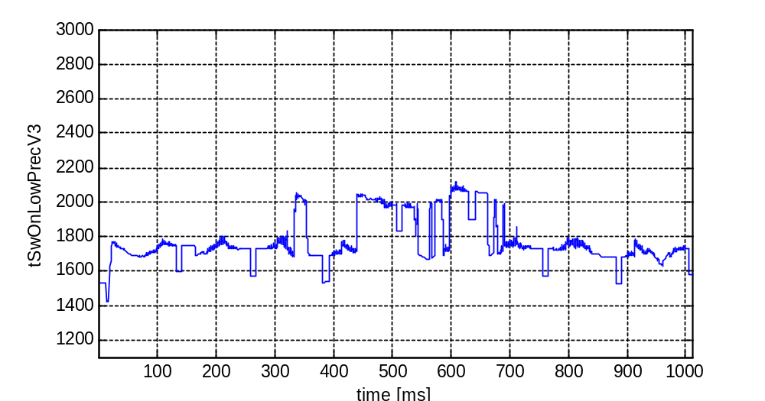
Figure 8.25: SV switch-on time (low precision, cylinder 3) 'tSwOnLowPrecV3'.

8.26. Signal/variable - tSwOffMeas
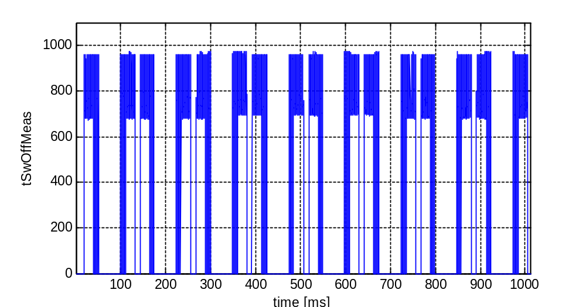
Figure 8.26: SV switch-off time (measurement) 'tSwOffMeas'.

8.27. Signal/variable - tSwOffSVSXCylCL0
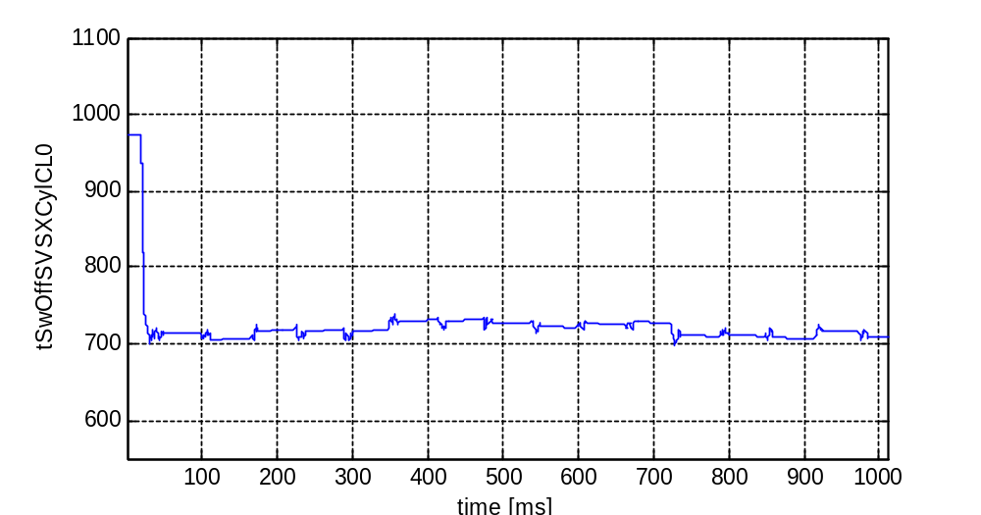
Figure 8.27: SV switch-off (close-loop, cylinder 0) 'tSwOffSVSXCylCL0'.

8.28. Signal/variable - tSwOffSVSXCylCL1
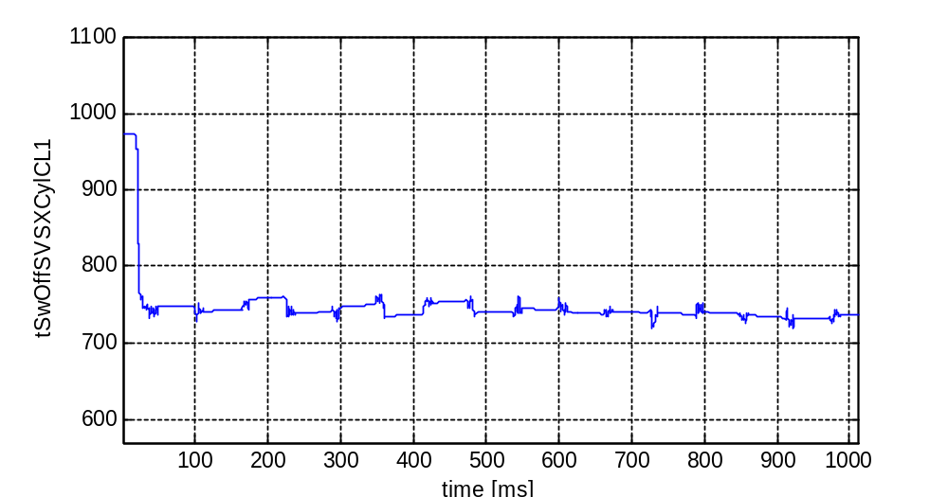
Figure 8.28: SV switch-off (close-loop, cylinder 1) 'tSwOffSVSXCylCL1'.

8.29. Signal/variable - tSwOffSVSXCylCL2
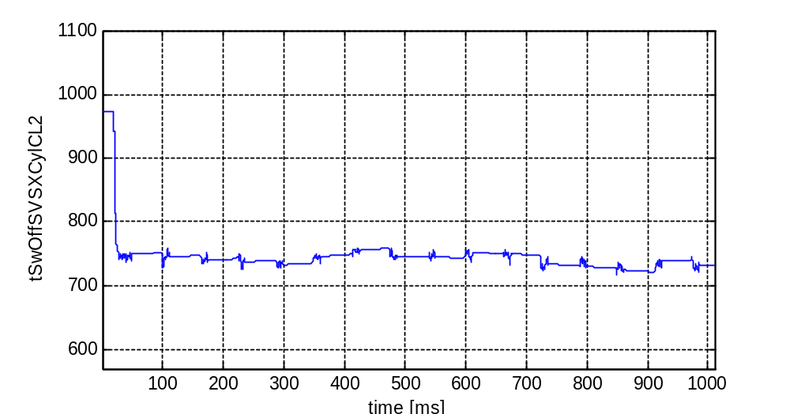
Figure 8.29: SV switch-off (close-loop, cylinder 2) 'tSwOffSVSXCylCL2'.

8.30. Signal/variable - tSwOffSVSXCylCL3
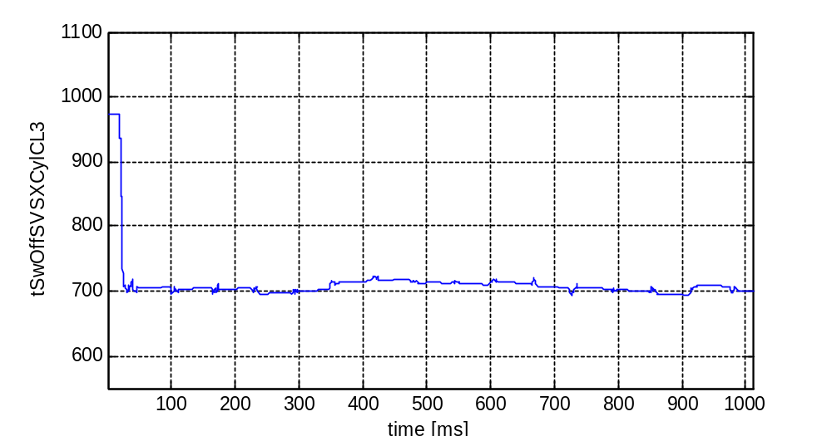
Figure 8.30: SV switch-off (close-loop, cylinder 3) 'tSwOffSVSXCylCL3'.

