Request
A regression test procedure for VCM system based on open-loop HIL shall be specified with following features, i.e.,
Hi there,
Please have a look at Section 4 and 6, especially, Section 6.4 where I might have hopelessly unconsciously “massaged” a few points to make the whole idea shining a little more ☺
As always, make comments, correction, suggestions, etc.
Have fun.
Weigang
- Input signals shall be defined and collected from vehicle/engine test;
- A driving sequence as close as possible to on-road driving situations with vehicle (or simulated in engine test) shall be defined;
- Certain worst case situations shall be integrated into the test sequence;
- The actuator block with solenoid valves shall be placed in temperature chamber dynamically-regulated during HIL regression test, e.g., from -20 to 110°C;
- The output signals/variables for regression evaluation shall be selected to represent the major control features and diagnostic signal from VCM;
- The format and contents of a complete regression test report shall be defined.

The regression test thus defined shall be performed for each and every system release.

General information
As a common tool for embedded-system development, the regression test is absolutely indispensible and its use shall be extended to system level in HIL in UniAir department.
The long-term objective is to perform regression tests with closed-loop HIL method. However, the lack of ECM models in the present time makes the open-loop HIL a practical approach between SW release builds not only for same but also potentially for different platforms of hardware/software.

Status and history

Status
Author | Reviser | Phase

Version history
Revision | Date | Author | Comment

Requirement for regression test
The essential components for a regression test based on open-loop HIL approach shall include,
- Input signal/variable definition;
- Driving sequence for input signal collection;
- Output signals/variable definition;
- Special calibration for regression test;
- Hardware specification;
- Test report specification.
The work flow for the entire regression test is shown in Fig.2.1.

Software test
division

System
division
System/test division
Driving sequence definition
Input signal
collection
Report
generation
Input signal
definition
Report
adaptation
Test review
Actuator and SV layout
Temperature chamber
Regression test in HIL
Output signal definition
Test report
release

Figure 2.1: Work flow of regression test in HIL and the corresponding responsibility. The working elements marked with bold fonts are performed for every test; while the elements marked with normal fonts are performed before and during the case definition phase and irregularly carried out afterwards.

ECM
VCM
VCM input
VCM output
Input signal set for regression test
Actuator with
SV’s
Temperature chamber

Figure 2.2: Signal flow for open-loop regression test. A by-pass in VCM side selects input signals generated for regression test from the defined driving sequence. VCM output signals are diverted into INCA recording as well as used to control real SV’s.

ECU
SW2
SW1
Regression
ECU1
SW/Cali
Regression
ECU2
ECU/SW
Cali2
Cali1
Regression
ECU1
SW1/Cali1
Comparison
ECU2
SW2/Cali2

(a) SW related (b) HW related (c) Cal related (d) SW/HW/Cal related
Figure 2.3: Four different hardware/software/calibration layouts for regression tests. Number 1 indicates the last release of software, hardware or calibration; number 2 implies the current release.

During an open-loop operation, the interaction between ECM and VCM is off and the input signals for VCM are taken from a set of recorded signals from a defined driving sequence; while the output signals from VCM are recorded and save by INCA, see Fig.2.2. The input/output signals and the driving sequence are specified in next sections.

For hardware and software layout in block Regression test in HIL in Fig.2.1, a few possibilities exist. Some common layout for the regression test are shown in Fig.2.2 (a), (b) and (c) in which software, hardware and calibration are isolated one at a time, respectively, from other components to identify the corresponding difference between different cases.

In a few other situations, the approach shown in Fig.2.3 (d) can also be applied to simply check if one set of hardware and software with its calibration is capable to function at all, which is especially useful in early-phase development, e.g., just before A-ample (ECU) phase.

In the following sections, the requirements for the regression test are defined / specified in details.

Input signals/variables
A minimal set of signals listed in Table 2.1 shall be recorded and prepared for the regression test.
The signal set shall evolve along with the development of new functionalities in software, hardware evolution and/or more critical cases revealed from labs and fields.

Table 2.1: Minimal input signals from ECM to VCM
No | Signal description | Variable name
1 | Engine speed | rpm
2 | Value of the voltage on the power stage | iBatteryVolt
3 | Cylinder in expansion phase (90°CA after TDC) | nAbsCylinderId
4 | Cylinder to be programmed | nCylSelectionId
5 | Mechanical Valve Closing Angle of a cylinder in Early Closing Mode | eClosAReqEC
6 | Mechanical Valve Opening Angle of a cylinder in Late Opening Mode | eOpenAReqLO
7 | Mechanical valve opening angle of a cylinder in Hybrid Actuation Mode | eOpenReqHB
8 | Valve Mode Code | nValveModeId
9 | Oil temperature in HPC | wOilTemp

Driving sequence for signal collection
A driving sequence shall be defined in a way that the essential features of VCM system can be best reproduced in HIL simulation environment. Furthermore, worst cases shall be covered as ,any as possible.
The input signal recording shall be performed in vehicle. If the vehicle test is not available, an engine test which simulates the defined driving sequence shall be acceptable.

The basic driving pattern is defined as follows.
- Ignition on;
- start recordings for normal variables (by INCA) and SV currents;
- Engine start;
- idle in neutral gear: 10 second;
- pedal is pressed and released quickly 3 times;
- back to idle: 5 second;
- engage 1st gear, accelerate the car to 20 km/h;
- engage 2nd gear, accelerate the car to 50 km/h;
- engage 3rd gear, accelerate the car to 80 km/h;
- engage 4th gear, accelerate the car to120 km/h;
- stop the vehicle and keep the engine to run at idle for 10 second;
- save all recordings;
If the measurement/recording sets for normal variables and SV currents are performed separately, the synchronization of both signal shall be ensured by,
- physical synchronization by electronic hardware, or,
- recording of a common signal (e.g., rpm) for both measurements, in order to perform off-line synchronization.
A schematic of the driving sequence is shown in Fig.1.2.
The basic driving sequence defined above shall be improved with more and deeper understanding to the critical conditions and the worst cases.
Following aspect is especially important for building a regression test focusing on software and calibration sides, i.e.,
- It shall cover as wide as possible the UniAir control functionalities, e.g., cold start, learning phase, adaptation, compensation, transient, idle, high speed, low/high temperature region, violation-prone region, diagnosis activation region, etc.;

time
Pedal, Engine speed and gear
… …
… …
Engine speed
Gear
… …
Pedal

Figure 2.2: A schematic driving sequence for input signal acquisition.

Software, hardware and SV for HIL test
The overall setup for regression test is based on the intended test objective, see in Fig.2.2. For software-intended regression test in Fig.2.2(a), the setup shall be specified as follows,
- Software: last released and currently to be released SW;
- ECU: an ECU designated for the current VCM release;
- Temperature chamber: dynamically regulated from -20 – 120°C with high repeatability; (if not, we need a refrigerator for minus degree and an oven for 120°C : )
- Current clams and the signal recording device for each and every SV;
- SV layout for the actuator block,
  - for 4-cylinder engine: fast (open), slow, nominal, stuck/fast(mid);
  - for 2-cylinder engine: fast (open), nominal.

Output signals from HIL test
The output signals from regression test shall be selected to best reflect the system behavior. They shall be mainly the variables of performance-sensitive at system level. Some of module-level variables shall be included if they affect directly the system behavior.
Table 2.2: Minimal output/input signals from HIL test
No | Signal description | Variable type | Variable name
1 | Engine speed | Input | rpm
2 | Oil temperature in HPC | Input | wOilTemp
3 | Coil temperature | Output | wCoilTemp
4 | electric close angle | Output | eFinishSX_Cy*
5 | electric open angle | Output | eStartSX_Cy*
6 | SV switch-on time | Output | tSwOnSVSXCylCL*
7 | SV switch-on time (measurement) | Output | tSwOnMeas
8 | SV switch-off time | Output | tSwOffSVSXCylCL*
9 | SV switch-off time (measurement) | Output | tSwOffMeas
10 | SV current profile | Output | Current_*

Test report
Test report shall be complete and ready to share with customer. A document template shall be provided for its contents and format. The contents and format is defined in following sections.

Contents
Following contents shall be included in the test report, i.e.,
- Abstract;
- Hardware type and number;
- Software version and release number;
- Calibration version;
- Special calibration for HIL;
- Major input signals in graphic form;
- Major output signal in graphic form;
- Statistic analysis for every major output signal;
- Pass and no-pass criteria and status;
- Abnormality identification;
- Summary.

Format
Test report shall be a Word document for internal use and a PDF document for customer release.

Summary
The requirements for regression test have been specified from the input signal definition / acquisition, driving sequence specification, output signal/variable definition to the final reporting.
A very important aspect for the requirements of the regression test is that the requirements need to be continuously improved to accommodate / facilitate the abnormality-prone and worst cases in future.

Background, questions and answers
In this section, some background information is explained and a few questions are answered to make thing clearer.

Background
We have been in following dilemma for quite a long time,
- We deliver our VCM software (in earlier to middle development phases) without system test because we do not have the resource to do real system test in test engine/vehicle;
- Our HIL regression test by SW is not up to a stage to be very useful at system level.
Consequently,
- buggy SW, not well-validated strategies or not-optimal/thoughtful requirements caused by not-fully understanding of the system (by us at the first place), etc. go directly to customer or to our supplier partner →
- a few weeks later, we get issues, error reports, customer findings of abnormalities and so on so forth →
- we have no time to react promptly because, to us also, most of the issues are surprises which leave us no other choice but passively react under heavy pressure→
- very often than not, the issues go to top management and system team looks in a bad shape.
We need to minimize such vicious cycle to happen again and again. Especially, we are in a phase to introduce ‘Basic Air’ which we have “keine Ahnung” about it.
It was, is and will be not enough to expect SW team to deliver a “good” software (which will never happen). SW team will always deliver buggy software and one of tasks of system team is to catch the bugs as early as possible.
Therefore, to catch an issue as earlier as possible in our V-Cycle development for VCM software is very important and indispensible to us. Otherwise, things would pop up in final fleet tests and it is already too late!
At present, we (system team) have an activity vacuum between new VCM software and the customer validation/test. It is on the high end of V-Cycle, see the area marked in red in Fig.4.1. This activity vacuum belongs to the tasks of “system house/team” and not “software house/team” !
We should “fill” something there. Otherwise, software house, top process people, top management and quality people could point this system-team deficit out. Then, they will kill us! because those abnormalities, errors, etc. will occur at the later stage of the developments of the whole engine or vehicle, see Fig.4.2. Correction cost will be very high.
To achieve this goal, the best way is to implement real system test before each and every software release [1].
However, the (human) resource is our bottle neck and we have, at the present time, little chance to implement that process.

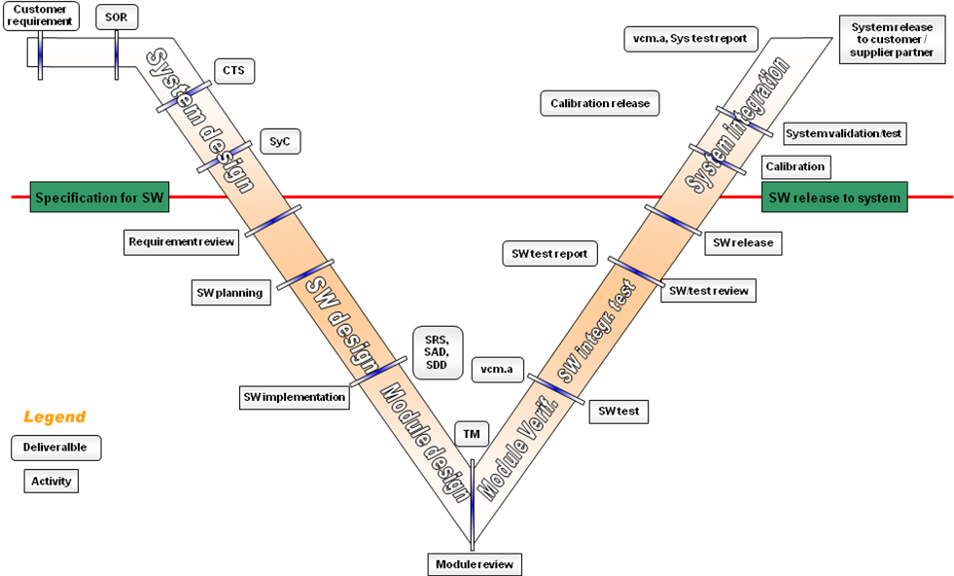
Activity vacuum

Figure 4.1: V-cycle for VCM system development: software development aspect.

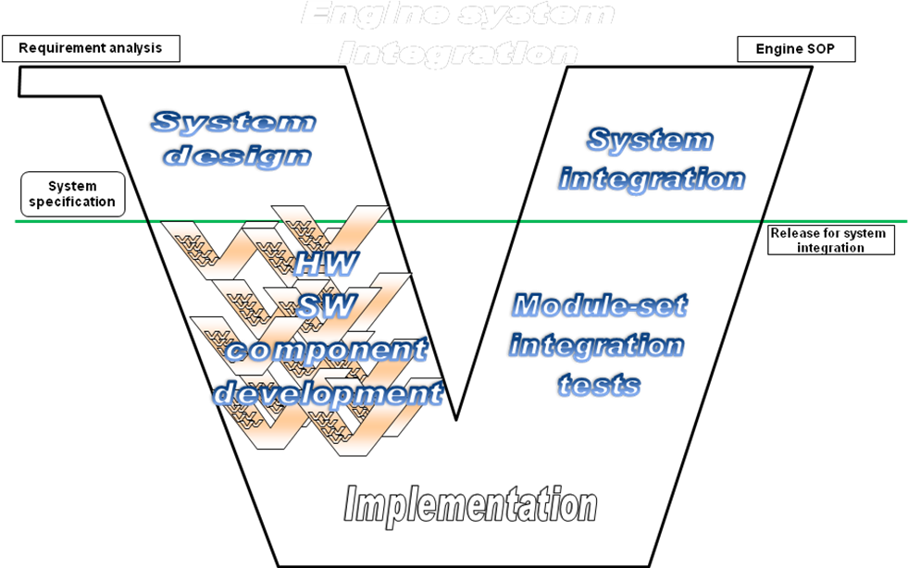

It would be very bad if UniAir throws many abnormalities in this phase!
If errors pop up in UniAir here: this is the way of life.

Figure 4.2: V-cycle for entire engine development with all HW/SW/components.
We could passively pray that SW team would do their job well and after a release everything is quietly working well or curse software team for their imperfect work if error reports were thrown out to us by customer. Or we implement some strategies/procedures (not perfect but helps a lot) and improve our product, our situation as well as our process.
As afore mentioned, a clean way to “fill” this vacuum should be realized as follows,,
- System house (we) does for each and every SW release a complete system validation/test,
  - for minor SW release, the complete system validation includes only HIL regression test at system level;
  - for major SW release, the complete system validation includes real system tests in engine/vehicle as defined in [1];
- Part of the tasks (operate dSpace) is performed by software team for system team.

Furthermore, a clean way to avoid double regression can be realized as follows,
- SW team tailors the procedure (by system team) to fit their own special requirements, especially for module-level debugging, etc.;
- System team has the opportunity to ask/check/review the regression test done at software level.
Of course, SW team has its own regression test for the last 3 years already but not yet up to a high standard. If SW team could have performed high-quality regression test during the middle phase in the V-Cycle, as the phase marked in light green in Fig.4.1, system team could simply perform real system validation test as specified in reference [1].

Questions and explanations

Questions
- What is regression test (Arno)?
- Why do we need this procedure (all)?
- What is the objective of this procedure (all)?
- What can we achieve by regression test (all)?
- Who is responsible to specify the requirement (all)?
- Who should implement it and carry out it (Heinrich)?
- A regression test in HIL is, in some way, not very “system”, how can we get the HIL test to reflect things at system level (all)?
- Is this the task for SW team (Heinrich)?
- Who should do the regression test (all)?
- SW team should be in charge of finding their own bugs in their SW (Heinrich).
- Do we need the complicated temperature chamber at all (all)?
- Why does this regression test come at this time and at this place when/where we have lot of more important things to do (Kevin/Christian)?
- Why does this regression test not in line with CMMI activities and can we wait till CMMI team has made final short list for process improvement (Christian)?
- Philosophically, is CMMI3 a goal or only a tool (Weigang)?
- Why there is no coordination with other teams (Christian)?
- Who the hell has started all these (Christian)? ☺
- Why there is no brainstorm for this issue?
- If it is taken as an acceptance test by system team for a SW release, it is ok (Heinrich).
- Why is the temperature chamber necessary (all)?
- Even with the same environment conditions, we still cannot ensure VCM system behave exactly the same (Dr. Elicker).
- Why do we need a new regression test procedure, instead of using the one from SW team (Christian/Ludger) ?
- Why do we need real SV for the regression test (all)?
- Why the gear change in vehicle is relevant to actuator (Ludger)?
- Why did we not start with a brainstorm and directly get into review stage (Christian)?

Answers and explanations
- What is regression test (Arno)?
A: For SW case, it is a test to prove if two SW’S are responding the same (or similar) to a same (or similar) set of hardware and input signals under same (or similar) operation/environment conditions. The absolute correctness of the output signal and the system performance is not the goal to achieve at all.
Regression test is never limited only to software level.
Similar description can be applied to the regression test for cases of HW, calibration, etc.

- Why do we need this procedure (all)?
A: as mentioned in Section 4.1,
- We have problems: abnormalities, errors, etc. popped up in a surprising way and too late;
- One of the system activities is missing in the V-Cycle and it happens to belong to system responsibility.
- These two things afore are not isolated; they are directly or indirectly inter-related;
- We could minimize things described in the first point, if we do a system-regression test as a compromise way towards a complete system release test defined in [1].

- What is the objective of this procedure (all)?
A: Catch as many SW bugs or abnormalities as possible and as early as possible with minimal cost and effort.

- What can we achieve by regression test (all)?
A: We find the SW bugs, HW issue and calibration issue at an earliest stage in the development.

- Who is responsible to specify the requirement (all)?
A: If system house has special requirements, especially at system level, system house should define/specify them. On the other hand, system house is obliged to support SW house in improving their process if the capability does not yet reach to certain level.

- Who should implement it and carry out it (Heinrich)?
A: System, test and software teams need to work together to implement the whole thing; SW team should carry out the regression test tasks before SW release because system team does not have the equipment (dSpace).

- A regression test in HIL is, in some way, not very “system”, how can we get the HIL test to reflect things at system level (all)?
A: Three things can be used to raise the regression test up to system level, i.e.,
  - get the mechanical angles;
  - feed the HIL with reality near input signals to achieve reality-near operation conditions;
  - place the hardware in a reality-near environment conditions.
We could not 100% realize the system-level requirement for the regression test. However, we have following starting position for the points above, i.e.,
- a realistic approach is to build MV actuation model which we do not have but we take electric angles instead mechanical angles;
- we generate a set of real input signal from a predefined driving sequence, see Section 2.2;
- we get a temperature chamber to get a reality-near environment conditions. In fact, if a dynamic temperature chamber is not possible, we could do following two regression test separately, i.e.,
  - one fixed high temperature with corresponding input data from a high-temperature driving sequence;
  - one fixed low temperature with corresponding input data from a low-temperature driving sequence.
- Is this the task for SW team (Heinrich)?
A: Yes, if module-level (or SW only) is requested. No, if system has lots of system-level requests.

- Who should do the regression test (all)?
A: see question/answer 6;

- SW team should be in charge of finding their own bugs in their SW (Heinrich).
A: Yes, SW team should but system team should also because the SW belongs to part of our entire system. If it belongs to our system, it also belongs to our responsibility (Weigang).

- Do we need the complicated temperature chamber at all (all)?
A: see question/answer 7.

The rest of the questions are to be discussed in the Coordi Meeting,

Background

We have an activity void in our V-cycle and we shall fill it. However, how should we do it?
More details in Section 4.

Main points discussed

- A “perfect” VCM regression test is necessary for system release (all);
- The regression test shall be carried out by SW team but the requirement and support shall come from system team (Heinrich/Camilo/Kevin);
- System team shall take it as an acceptance test (Heinrich);
- Even we could not realize the 100% reality in HIL test, it is already very good to take a stepwise way towards the reality (Camilo);
- Even for two 30% different systems (e.g., GII vs. Jaguar), comparison test could still reveal important information such as, how peak control is working, what the learn process is doing, etc. (Camilo);
- The entire regression task is an effort from SW, system and test teams, specifically,
  - System team shall define,
    - a driving sequence with its corresponding operation/environment condition which can cover, as much as possible, the VCM functionalities including control and diagnosis (similar as the way for CARB driving sequence (Camilo));
    - a set of requirements to be fulfilled by regression test in form of which input/output signals functions, variables, diagnosis, etc. shall be included in the test and the report;
  - Test team shall run the defined driving sequence and collect the data;
  - System/test team shall support SW team in building the temperature chamber, HW/component setup (Camilo and others );
  - SW test team shall implement the regression test defined and build a complete test report (all);
  - System team shall review the regression test report and apply pass/no pass criteria for final acceptance of the release (all);
- Even if we could have a perfect HIL regression test for VCM software, what mechanism do we have to validate whether our system concept has deficit (horizontally in V-cycle)? (Weigang)

Points collected after meeting

Action plan (to be defined)
Actions |  | Deadline |  | Owner | Status

