Note: the project has been add workaround , if want to reproduce the issue , just remove the work around in step4.

1. ADD macro in tx_port.h and IAR options of assembler.

1. Let’s check the priority of systick and pendsv

Systick priority = 0x40

Pendsv priority = 0xf0 , both of them are masked when BASEPRI= 0x30

Armv7 docmument:

1. Get the TIM interrupt number and check the priority = 0 , it is not masked by BASEPRI, so we changed it to 0x40 in debug register. Then we can found that the whole application can’t exit low power mode,

Get the TIM6 interrupt priority and set the priority masked by BASEPRI(0x30).

Interrupt number = 70 (0x46)

And 70 -16 = 54 (16 means the special priorities setting in SCB: SHPR1,2,3. And other reserved value:

0 is stack, 1 is reset handler.)

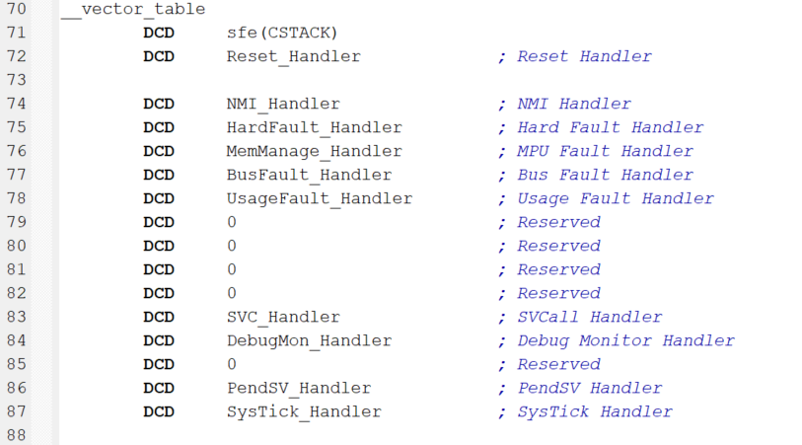

1. Add work around :

#ifdef TX_ENABLE_WFI

#ifdef TX_PORT_USE_BASEPRI

CPSID i

MOV r1, #0

MSR BASEPRI, r1

#endif

DSB // Ensure no outstanding memory transactions

WFI // Wait for interrupt

ISB // Ensure pipeline is flushed

#ifdef TX_PORT_USE_BASEPRI

LDR r1, =TX_PORT_BASEPRI

MSR BASEPRI, r1

CPSIE i

#endif

#endif