同样的一辈子。外出打工和在家乡混的区别！

[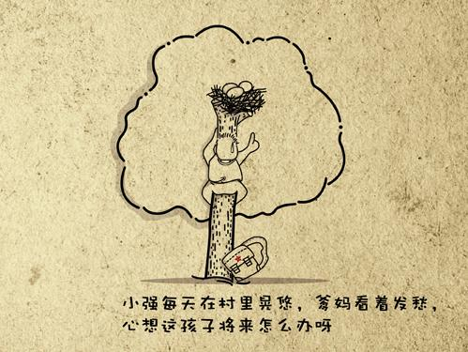](http://b324.photo.store.qq.com/psb?/V10Q8OxC2RwMrf/nQpMB2ChqkBnJ4B5IuyT8xEbRDbQJFcaaEfVFHjF2Jk%21/b/dOY6KcEMBwAA&bo=8wF3AQAAAAABAKM%21)

[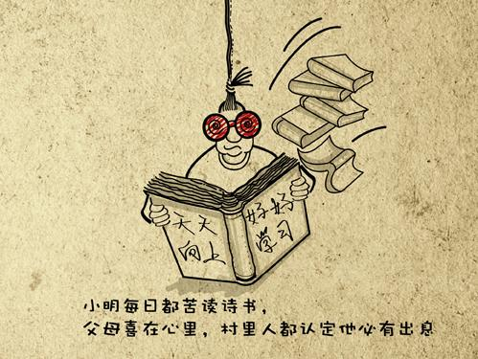](http://b321.photo.store.qq.com/psb?/V10Q8OxC2RwMrf/6pVwSVVPp8acCN.OSUljUha3gzcS0iPi8ePxrjmNGSc%21/b/dP3fWr8VIwAA&bo=8wF3AQAAAAABAKM%21)

[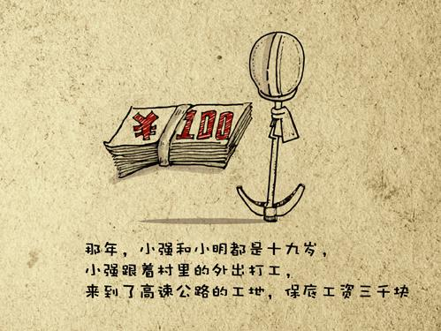](http://b322.photo.store.qq.com/psb?/V10Q8OxC2RwMrf/2ttD3LYQNwDvxPYiNM*kH7wesZBH9C3brcw*XWeZeaw%21/b/dOOC.b*YDgAA&bo=8wF3AQAAAAABAKM%21)

[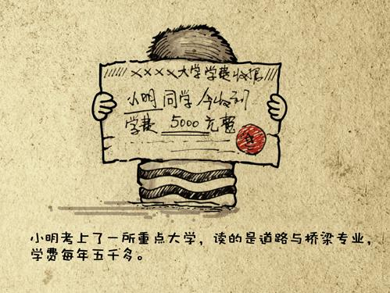](http://b322.photo.store.qq.com/psb?/V10Q8OxC2RwMrf/zmaCFm.DDmdAJ9xFW781Yfy3WFk7AoKu0NMUbQPgCfs%21/b/dMRp8L*ADgAA&bo=8wF3AQAAAAABAKM%21)

[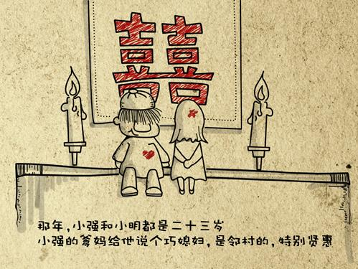](http://b322.photo.store.qq.com/psb?/V10Q8OxC2RwMrf/ZBJwjPvSVBf0u3.zXhAfG.Vaj1xfJ3MV6IgGLCycFOg%21/b/dHas*L8YDAAA&bo=8wF3AQAAAAABAKM%21)

[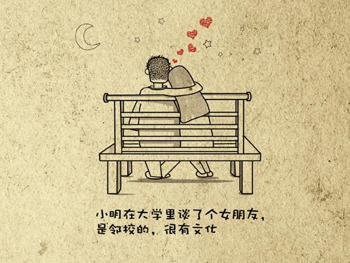](http://b324.photo.store.qq.com/psb?/V10Q8OxC2RwMrf/z*CNDxPCvgO*2BncAmSpqN*BOKgnBncx2d6pURisidU%21/b/dP83LMELBwAA&bo=8wF3AQAAAAABAKM%21)

[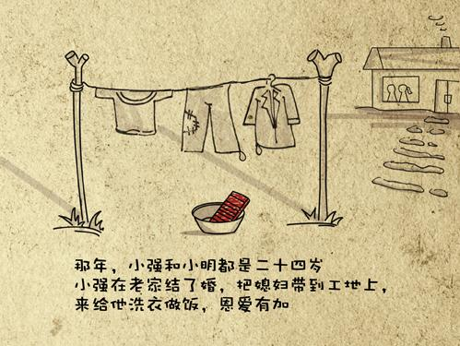](http://b322.photo.store.qq.com/psb?/V10Q8OxC2RwMrf/1gCQ2TIRhOnNh7ZTOZQenERzgrrhwu24IPMTj.5QEmw%21/b/dI989r*bDAAA&bo=8wF3AQAAAAABAKM%21)

[](http://b323.photo.store.qq.com/psb?/V10Q8OxC2RwMrf/BvRHYPhGlL01bCIXBDHWs9LwG2eilEKpaEyRtW4HlgQ%21/b/dKMplcCmDgAA&bo=8wF3AQAAAAABAKM%21)

[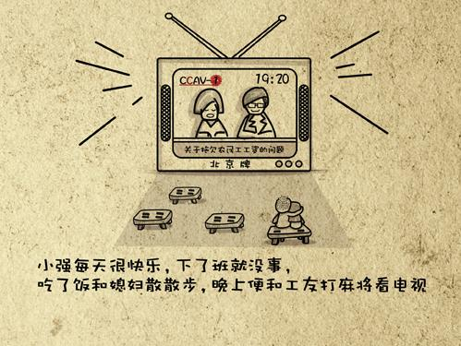](http://b320.photo.store.qq.com/psb?/V10Q8OxC2RwMrf/OKW9NIkr3KFPErZz5Mmr0lnxZ52g5520gzd1PMluVGY%21/b/dLuuvb54IwAA&bo=8wF3AQAAAAABAKM%21)

[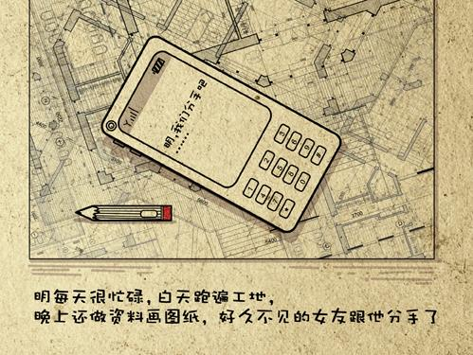](http://b321.photo.store.qq.com/psb?/V10Q8OxC2RwMrf/FhvMjtp4wF4qMbju3lpYVSZIuVU85KdNFXzhm1XzERk%21/b/dMtdWb8SIwAA&bo=8wF3AQAAAAABAKM%21)

[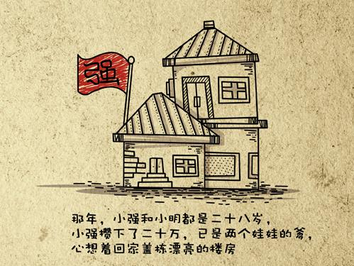](http://b321.photo.store.qq.com/psb?/V10Q8OxC2RwMrf/VozvGJpKDjuwOZ*AwHE5L5JdRPPVtR.VmsmrTMI7oi0%21/b/dInbV78YIwAA&bo=8wF3AQAAAAABAKM%21)

[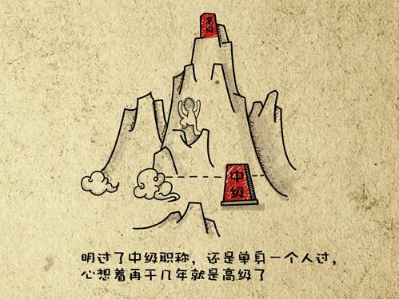](http://b324.photo.store.qq.com/psb?/V10Q8OxC2RwMrf/In9O7L6SUcOKBNBduAuThoJewb7cfO4jC4NZ7FTMeqU%21/b/dBqTIcEOBwAA&bo=8wF3AQAAAAABAKM%21)

[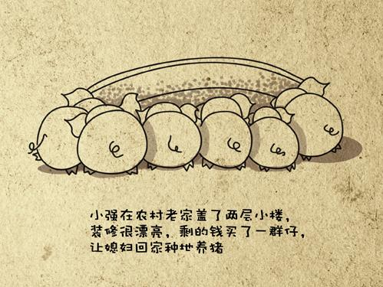](http://b322.photo.store.qq.com/psb?/V10Q8OxC2RwMrf/vEblxkKU5liYNF.rs1dhG5jA23J8ATmG*6e5Uxwi.m4%21/b/dMiQ*L8ADAAA&bo=8wF3AQAAAAABAKM%21)

[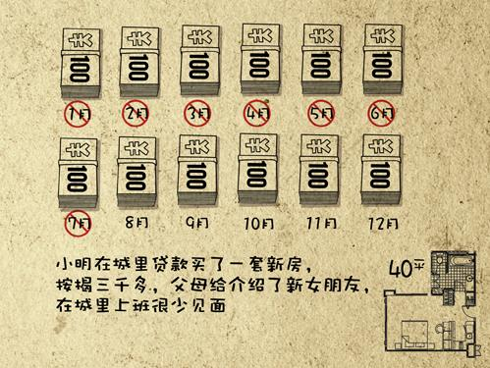](http://b321.photo.store.qq.com/psb?/V10Q8OxC2RwMrf/P2USK7cp3PY3qqnmtQoXoJx1SL6hn130jW7JG9ursqw%21/b/dNRdWb8SIwAA&bo=8wF3AQAAAAABAKM%21)

[](http://b321.photo.store.qq.com/psb?/V10Q8OxC2RwMrf/EqVq4NfSQ3l5sHFGe3.g.8I4vDNyaIwoxKgfpB*k02w%21/b/dMxKVr*yIgAA&bo=8wF3AQAAAAABAKM%21)

[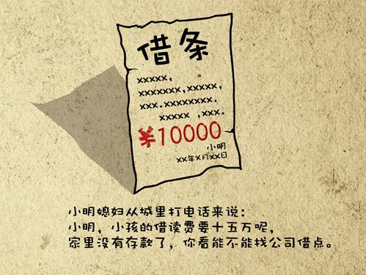](http://b324.photo.store.qq.com/psb?/V10Q8OxC2RwMrf/RjlFmdV1UgtVROk.MbSOB4AIQeA31VfRWqSkkJIIXbA%21/b/dOAWI8ELBwAA&bo=8wF3AQAAAAABAKM%21)

[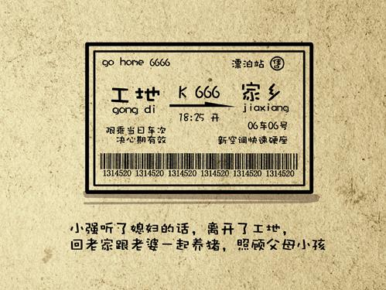](http://b321.photo.store.qq.com/psb?/V10Q8OxC2RwMrf/gNEVo4yoAsmr4CdNtVmLDVFwmEThqUxCU9zd4zazZYk%21/b/dG9bWb*9IgAA&bo=8wF3AQAAAAABAKM%21)

[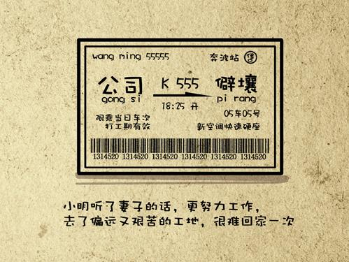](http://b320.photo.store.qq.com/psb?/V10Q8OxC2RwMrf/aDB0PBJfL.EOP6Ng9Xskxr*8d8.oV1beUJERl*TKe*U%21/b/dInGwL6vIQAA&bo=8wF3AQAAAAABAKM%21)

[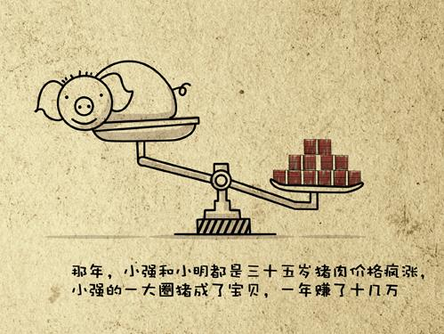](http://b322.photo.store.qq.com/psb?/V10Q8OxC2RwMrf/cjWTYeD2OSv1xwNYMnmB*Mqd9FImHHFbyybARjcHMvU%21/b/dE*y7r.rDgAA&bo=8wF3AQAAAAABAKM%21)

[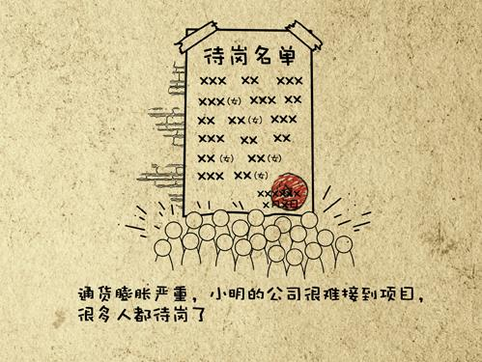](http://b323.photo.store.qq.com/psb?/V10Q8OxC2RwMrf/87bEs60fqkTZD9YJbM6hapFv7UXNQVDZ04kzTPq389c%21/b/dMKjk8ChDgAA&bo=8wF3AQAAAAABAKM%21)

[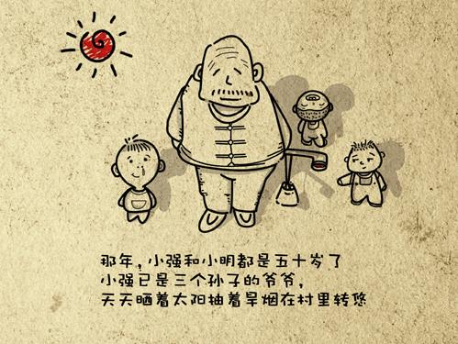](http://b320.photo.store.qq.com/psb?/V10Q8OxC2RwMrf/ntRRoBkpgzYcz.8.*63NWW07CO7TBzA1M1XCaQYfJBI%21/b/dOBUwr5EIwAA&bo=8wF3AQAAAAABAKM%21)

[](http://b321.photo.store.qq.com/psb?/V10Q8OxC2RwMrf/KxzpbnDgZluld0Oyv654xkwn5pEnBLgXNUvygvnvgOw%21/b/dHh3X78fIwAA&bo=8wF3AQAAAAABAKM%21)

[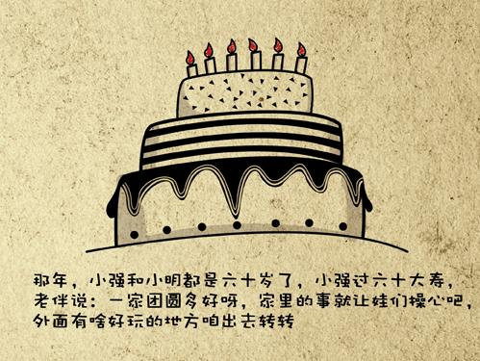](http://b322.photo.store.qq.com/psb?/V10Q8OxC2RwMrf/Y2r4g2I9z9FejblldaS1rbgPhxlKr40L74YvCsOYWF8%21/b/dHb19L*gDgAA&bo=8wF3AQAAAAABAKM%21)

[](http://b321.photo.store.qq.com/psb?/V10Q8OxC2RwMrf/nC8dDmiDg*7*acg5k2*x3UWrw2QEvtFKd*WPDMRwVDE%21/b/dBTMV78NIwAA&bo=8wF3AQAAAAABAKM%21)

[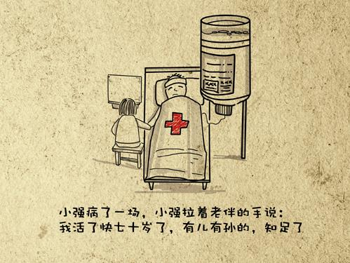](http://b321.photo.store.qq.com/psb?/V10Q8OxC2RwMrf/sgEx3871DZ35KqtSU9ZYNy0q8GEhMaVKIfFL3geLMGQ%21/b/dCkOZL*MIgAA&bo=8wF3AQAAAAABAKM%21)

[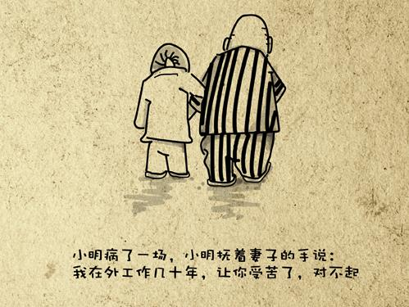](http://b324.photo.store.qq.com/psb?/V10Q8OxC2RwMrf/UTnH6wxw5.lHuTyyzv4loPBmE2ilAniUqUO9eRCs6W4%21/b/dDwCIMH0BQAA&bo=8wF3AQAAAAABAKM%21)

[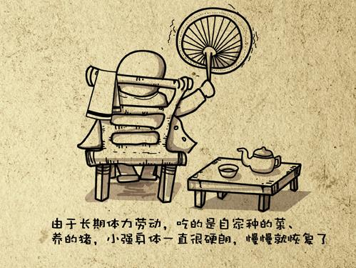](http://b323.photo.store.qq.com/psb?/V10Q8OxC2RwMrf/RyovNC3jFIvWNtWZUQm6ht.OXKa5aDVM03IzfsX*2v4%21/b/dAs4lcCjDgAA&bo=8wF3AQAAAAABAKM%21)

[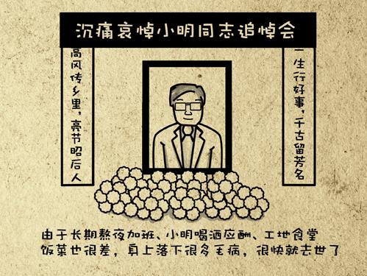](http://b323.photo.store.qq.com/psb?/V10Q8OxC2RwMrf/FGv3gBMyU.NejMZpNBugfV3WVbjzxAnNN0nPfdOD2W8%21/b/dBf9iMCiDgAA&bo=8wF3AQAAAAABAKM%21)

[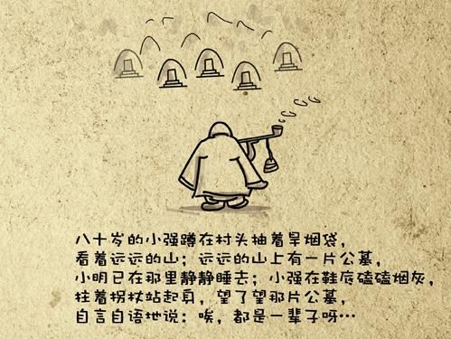](http://b321.photo.store.qq.com/psb?/V10Q8OxC2RwMrf/L8dHaTxatQ3BR69dik0IQ9a.s..q3cFfRZPK5aWe*yo%21/b/dCftXb*tIgAA&bo=8wF3AQAAAAABAKM%21)

[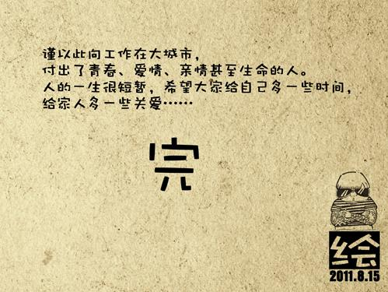](http://b324.photo.store.qq.com/psb?/V10Q8OxC2RwMrf/Yg4f*MbbPTVZFQTPCRoFGHADviLRdb0mskFALb*d*3Q%21/b/dB9BJsEQBwAA&bo=8wF3AQAAAAABAKM%21)