1.
print("Hour\tNumber of Bacteria ")
B0=200
for n in range(0,16,5):
B=B0*2**n
print(n,"\t",B)
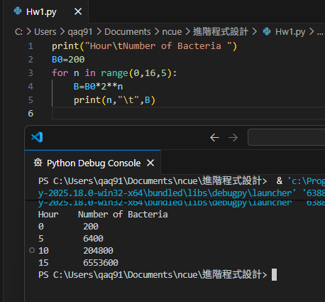
2.
St1="Tom"
St2="Jim"
Stn1=ord(St1[0])
Stn2=ord(St2[0])
if(Stn1>Stn2):
print(St1,"先玩")
else:
print(St2,"先玩")
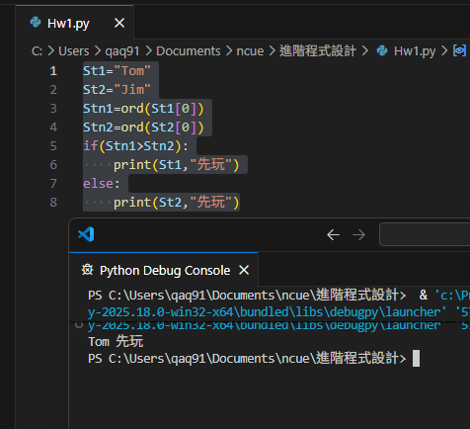

3.
o=10
pu=0.03
pd=-0.03
print("Year\tMoney Per Hours\tUp&Down")
for n in range(1,6,1):
w=o*(1+pu)**n
w1=f"{w:.3f}"
print(n,"\t",w1,"\tUp")
for n in range(1,3,1):
w=o*(1+pd)**n
w1=f"{w:.3f}"
print(n,"\t",w1,"\t\tDown")

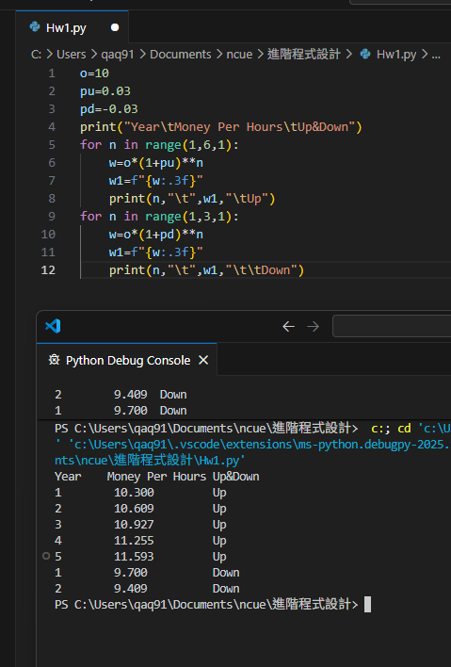
4.
i=1
while i<=9:
j=1
while j<=9:
S=f"{i}x{j}={i*j}"
print(f"{S:<10}",end="")
j+=1
i+=1
print()

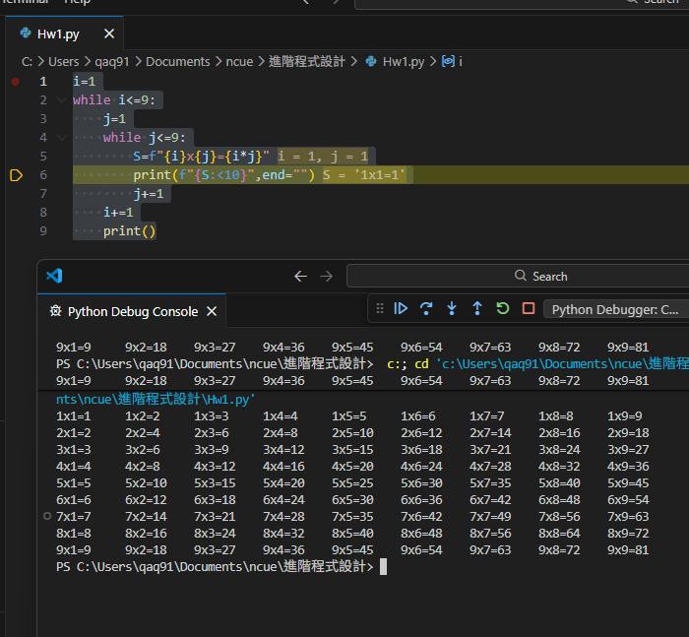

5.
max=0
mini=0
sum=0
for i in range(0,10,1):
n=input(print("輸入數字",i+1,":"))
n1=int(n)
print(n1)
if(n1>max):
max=n1
if(n1<mini):
mini=n1
sum=sum+n1
avg=sum/10
print("最大值:",max,",最小值:",mini,",平均值:",avg)

