1.
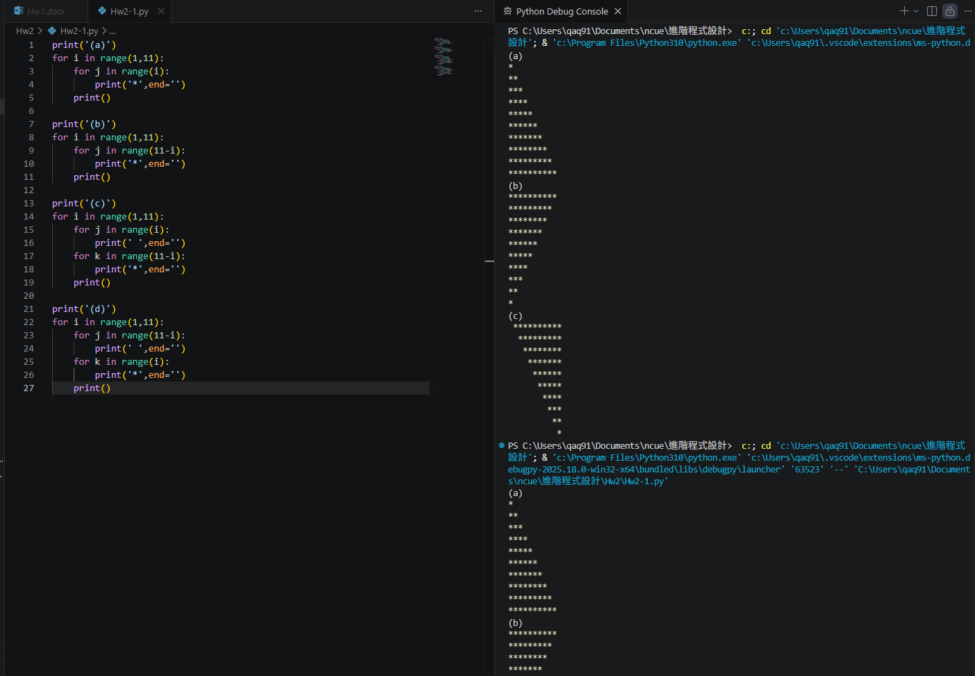
print('(a)')
for i in range(1,11):
for j in range(i):
print('*',end='')
print()

print('(b)')
for i in range(1,11):
for j in range(11-i):
print('*',end='')
print()

print('(c)')
for i in range(1,11):
for j in range(i):
print(' ',end='')
for k in range(11-i):
print('*',end='')
print()

print('(d)')
for i in range(1,11):
for j in range(11-i):
print(' ',end='')
for k in range(i):
print('*',end='')
print()

2. 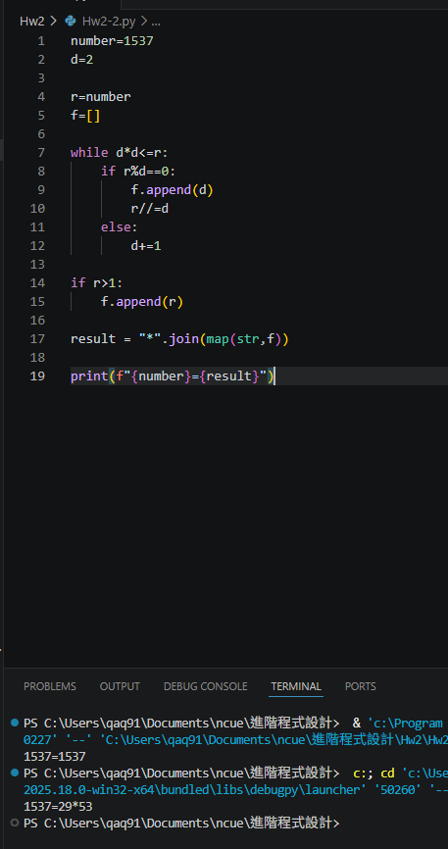

number=1537
d=2

r=number
f=[]

while d*d<=r:
if r%d==0:
f.append(d)
r//=d
else:
d+=1

if r>1:
f.append(r)

result = "*".join(map(str,f))

print(f"{number}={result}")

3. 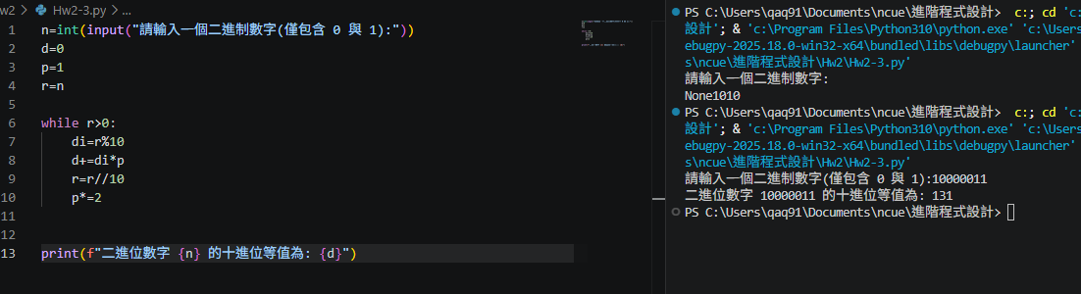

n=int(input("請輸入一個二進制數字(僅包含 0 與 1):"))
d=0
p=1
r=n

while r>0:
di=r%10
d+=di*p
r=r//10
p*=2

print(f"二進位數字 {n} 的十進位等值為: {d}")

4. False, Sentinel-controlled Repetition 執行次數是不確定的，依照使用者決定，通常是輸入-1

5. 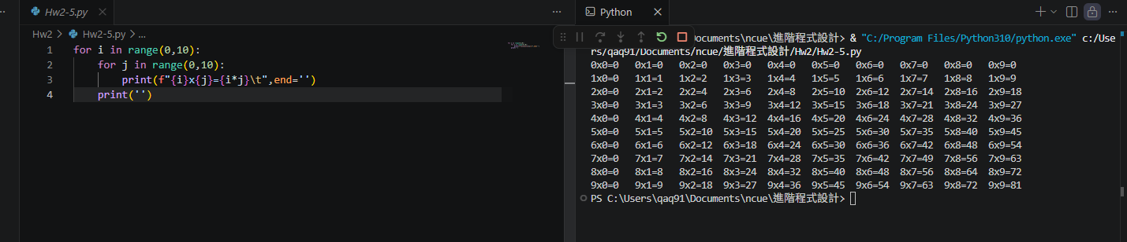

for i in range(0,10):
for j in range(0,10):
print(f"{i}x{j}={i*j}\t",end='')
print('')

6. 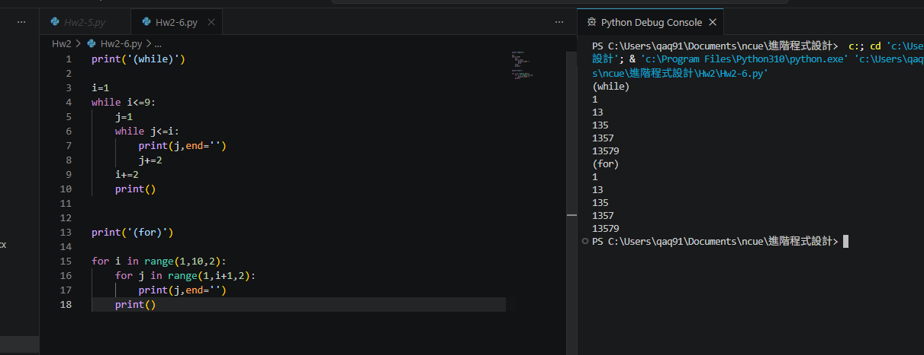

print('(while)')

i=1
while i<=9:
j=1
while j<=i:
print(j,end='')
j+=2
i+=2
print()

print('(for)')

for i in range(1,10,2):
for j in range(1,i+1,2):
print(j,end='')
print()

