1.
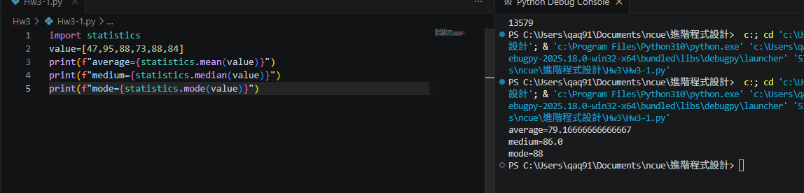

import statistics
value=[47,95,88,73,88,84]
print(f"average={statistics.mean(value)}")
print(f"medium={statistics.median(value)}")
print(f"mode={statistics.mode(value)}")

2. 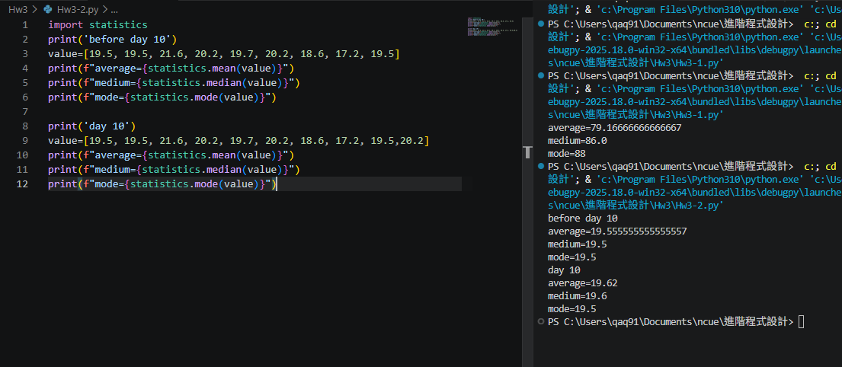

import statistics
print('before day 10')
value=[19.5, 19.5, 21.6, 20.2, 19.7, 20.2, 18.6, 17.2, 19.5]
print(f"average={statistics.mean(value)}")
print(f"medium={statistics.median(value)}")
print(f"mode={statistics.mode(value)}")

print('day 10')
value=[19.5, 19.5, 21.6, 20.2, 19.7, 20.2, 18.6, 17.2, 19.5,20.2]
print(f"average={statistics.mean(value)}")
print(f"medium={statistics.median(value)}")
print(f"mode={statistics.mode(value)}")

3. 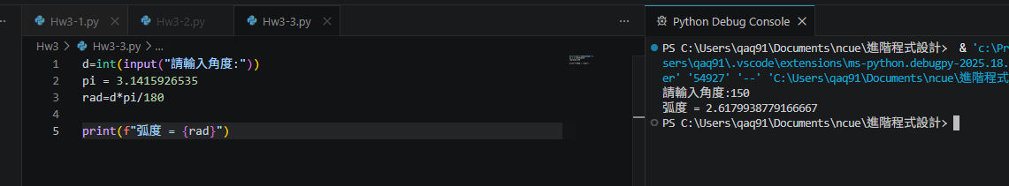

d=int(input("請輸入角度:"))
pi = 3.1415926535
rad=d*pi/180

print(f"弧度 = {rad}")

4.
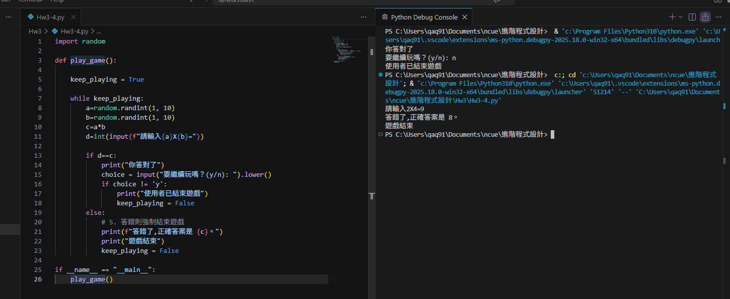

import random

def play_game():

keep_playing = True

while keep_playing:
a=random.randint(1, 10)
b=random.randint(1, 10)
c=a*b
d=int(input(f"請輸入{a}X{b}="))

if d==c:
print("你答對了")
choice = input("要繼續玩嗎？(y/n): ").lower()
if choice != 'y':
print("使用者已結束遊戲")
keep_playing = False
else:
# 5. 答錯則強制結束遊戲
print(f"答錯了,正確答案是 {c}。")
print("遊戲結束")
keep_playing = False

if __name__ == "__main__":
play_game()

5. 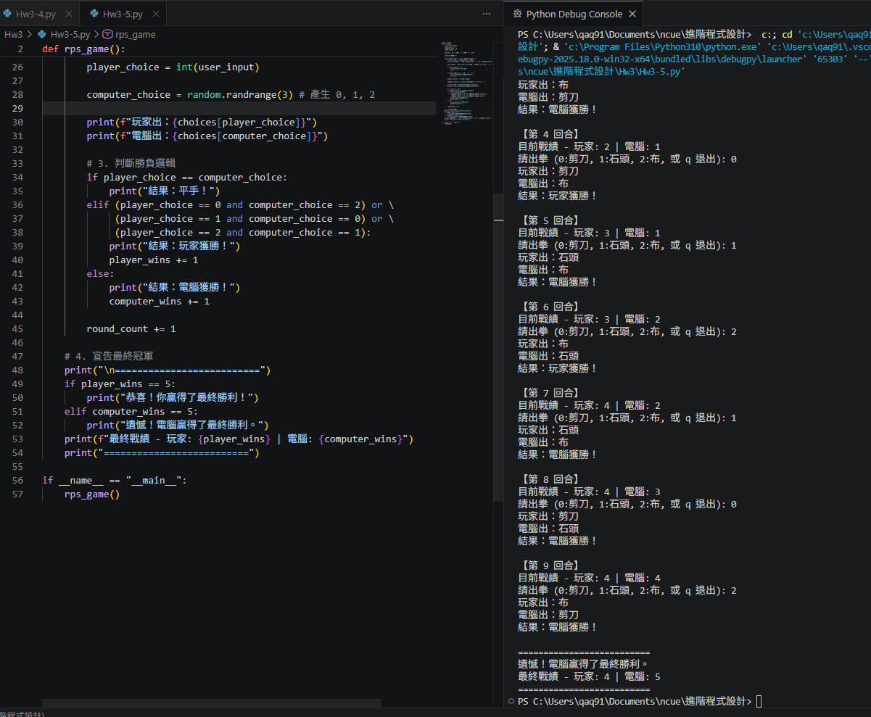

import random
def rps_game():
# 初始化勝場計數器
player_wins = 0
computer_wins = 0
round_count = 1

choices = {0: "剪刀", 1: "石頭", 2: "布"}

print("遊戲開始")

while player_wins < 5 and computer_wins < 5:
print(f"\n【第 {round_count} 回合】")
print(f"目前戰績 - 玩家: {player_wins} | 電腦: {computer_wins}")

user_input = input("請出拳 (0:剪刀, 1:石頭, 2:布, 或 q 退出): ").lower()

if user_input == 'q':
print("玩家中途離場。")
break

if user_input not in ['0', '1', '2']:
print("無效輸入，請重新選擇！")
continue

player_choice = int(user_input)

computer_choice = random.randrange(3) # 產生 0, 1, 2

print(f"玩家出：{choices[player_choice]}")
print(f"電腦出：{choices[computer_choice]}")

# 3. 判斷勝負邏輯
if player_choice == computer_choice:
print("結果：平手！")
elif (player_choice == 0 and computer_choice == 2) or \
(player_choice == 1 and computer_choice == 0) or \
(player_choice == 2 and computer_choice == 1):
print("結果：玩家獲勝！")
player_wins += 1
else:
print("結果：電腦獲勝！")
computer_wins += 1

round_count += 1

# 4. 宣告最終冠軍
print("\n==========================")
if player_wins == 5:
print("恭喜！你贏得了最終勝利！")
elif computer_wins == 5:
print("遺憾！電腦贏得了最終勝利。")
print(f"最終戰績 - 玩家: {player_wins} | 電腦: {computer_wins}")
print("==========================")

if __name__ == "__main__":
rps_game()

6. 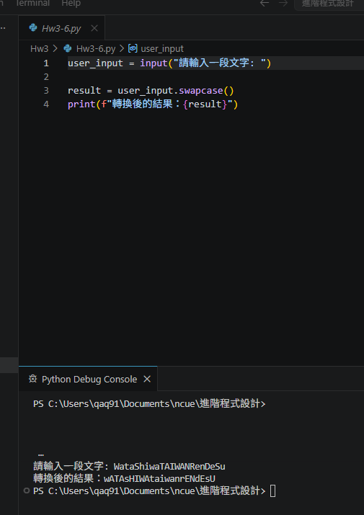

user_input = input("請輸入一段文字: ")

result = user_input.swapcase()
print(f"轉換後的結果：{result}")

