Homework #4

4.12 (Drawing Patterns with Nested for Loops) Write a program that uses for statements to
print the following patterns separately, one below the other. Use for /while/ do_while loops to generate the patterns.
All asterisks (*) should be printed by a single statement of the form cout << '*'; (this causes the
asterisks to print side by side). [Hint: The last two patterns require that each line begin with an appropriate
number of blanks. Extra credit: Combine your code from the four separate problems into
a single program that prints all four patterns side by side by making clever use of nested for loops.]
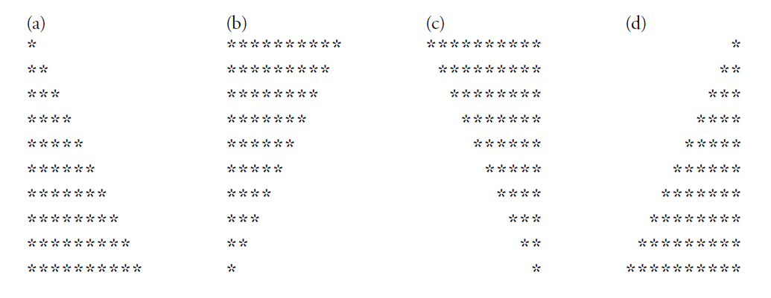

4.14 (Calculating Total Sales) A mail order house sells five different products whose retail prices
are: product 1 — $2.98, product 2—$4.50, product 3—$9.98, product 4—$4.49 and product 5—
$6.87. Write a program that reads a series of pairs of numbers as follows:
a) product number
b) quantity sold
Your program should use a switch statement to determine the retail price for each product. Your
program should calculate and display the total retail value of all products sold. Use a sentinel-controlled
loop to determine when the program should stop looping and display the final results.
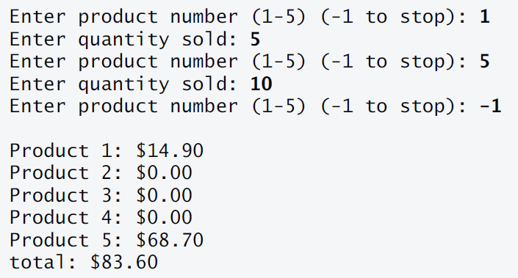

4.20 (Pythagorean Triples) A right triangle can have sides that are all integers. A set of three integer
values for the sides of a right triangle is called a Pythagorean triple. These three sides must satisfy
the relationship that the sum of the squares of two of the sides is equal to the square of the
hypotenuse. Find all Pythagorean triples for side1, side2 and hypotenuse all no larger than 500.
Use a triple-nested for loop that tries all possibilities. This is an example of brute force computing.
You’ll learn in more advanced computer science courses that there are many interesting problems
for which there is no known algorithmic approach other than sheer brute force.
