Homework #8
6.11 (Bubble Sort) In the bubble sort algorithm, smaller values gradually “bubble” their way upward
to the top of the array like air bubbles rising in water, while the larger values sink to the bottom.
The bubble sort makes several passes through the array. On each pass, successive pairs of
elements are compared. If a pair is in increasing order (or the values are identical), we leave the values
as they are. If a pair is in decreasing order, their values are swapped in the array. Write a program
that sorts an array of 10 integers using bubble sort.
ANS:
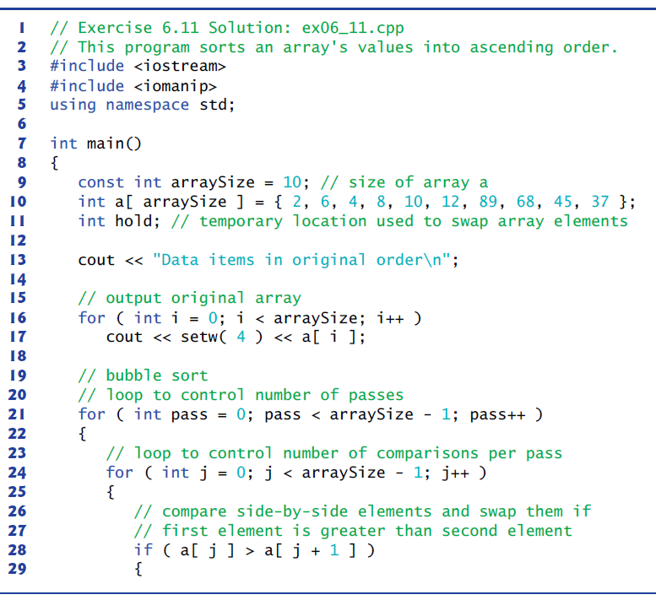
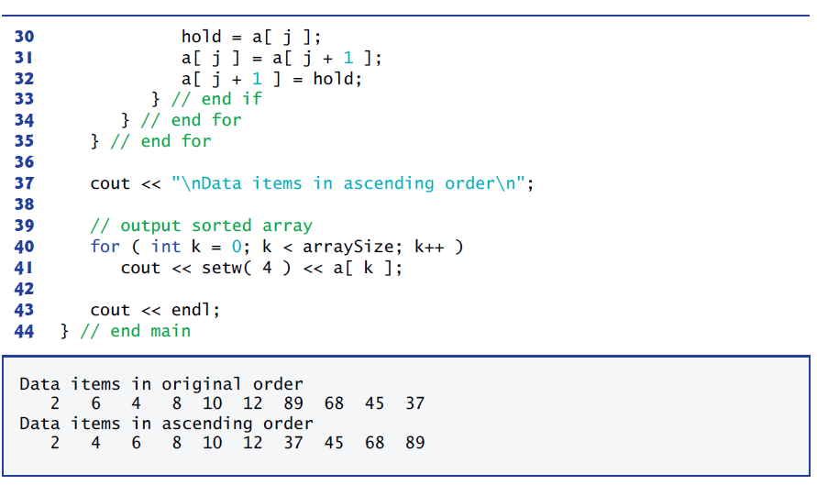

6.12 (Bubble Sort Enhancements) The bubble sort described in Exercise 6.11 is inefficient for
large arrays. Make the following simple modifications to improve the performance of the bubble
sort:
a) After the first pass, the largest number is guaranteed to be in the highest-numbered element
of the array; after the second pass, the two highest numbers are “in place,” and
so on. Instead of making nine comparisons on every pass, modify the bubble sort to
make eight comparisons on the second pass, seven on the third pass, and so on.
b) The data in the array may already be in the proper order or near-proper order, so why
make nine passes if fewer will suffice? Modify the sort to check at the end of each pass
if any swaps have been made. If none have been made, then the data must already be in
the proper order, so the program should terminate. If swaps have been made, then at
least one more pass is needed.
ANS:
