Homework #11
1. Pascal's triangle
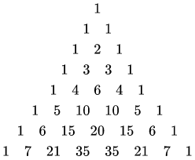
Write C++ program to print a Pascal’s triangle with n rows.
You must use loop and array.

2. Pascal's triangle.
Write C++ program to print a Pascal’s triangle with n rows.
You must use loop and vector<int>.

3. Write C++ program that asks the user to enter 10 students’ names and scores. The program sorts the scores (and names), and then print the students’ names and scores according to their scores form high to low.
string name[10]; int score[10];

4.
■ C-string string copy函式
char *strcpy(char *s1, const char *s2)
把s2所指的字串拷貝到s1所指的地方
傳回s1的值
寫一個模仿strcpy的函式my_strcpy()
char *my_strcpy(char *s1, const char *s2)
並寫一個main()來驗證my_strcpy()的正確性

5.
■ C-string string concatenate函式
#include <cstring>
char *strcat(char *s1, char *s2);
把s2所指的字串拷貝串接到s1所指的字串後面
傳回s1的值
寫一個模仿strcat的函式my_strcat()
char *my_strcat(char *s1, const char *s2)
並寫一個main()來驗證my_strcat()的正確性

6.
C-string string comparison
int strcmp(char *s1, char *s2);
s1所指的字串跟s2所指的字串相同的話 傳回0
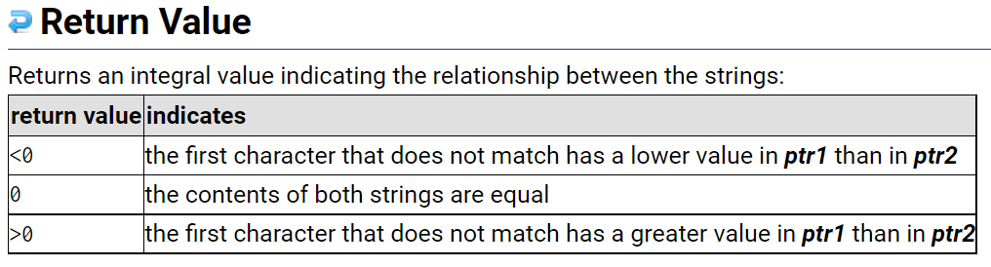
寫一個模仿strcmp的函式my_strcmp()
int my_strcmp(char *s1, const char *s2)
並寫一個main()來驗證my_strcmp()的正確性

