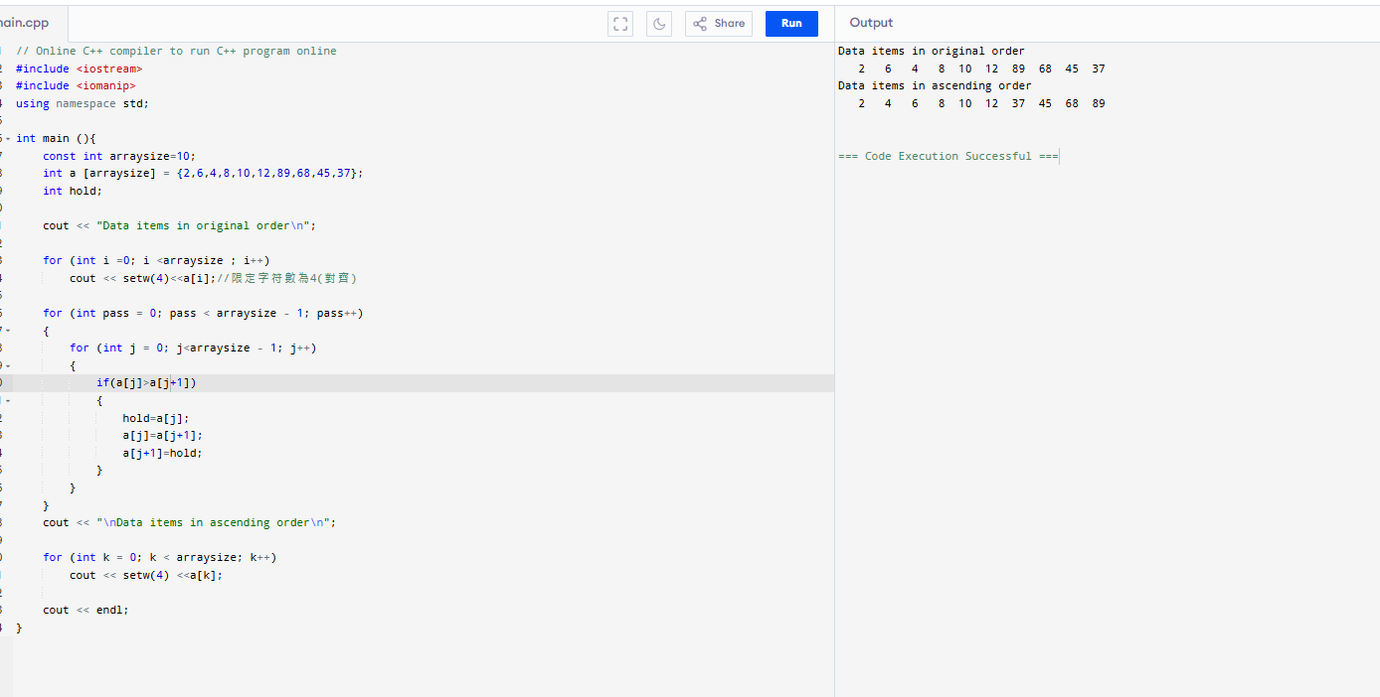
Code:
// Online C++ compiler to run C++ program online
#include <iostream>
#include <iomanip>
using namespace std;

int main (){
const int arraysize=10;
int a [arraysize] = {2,6,4,8,10,12,89,68,45,37};
int hold;

cout << "Data items in original order\n";

for (int i =0; i <arraysize ; i++)
cout << setw(4)<<a[i];//限定字符數為4(對齊)

for (int pass = 0; pass < arraysize - 1; pass++)
{
for (int j = 0; j<arraysize - 1; j++)
{
if(a[j]>a[j+1])
{
hold=a[j];
a[j]=a[j+1];
a[j+1]=hold;
}
}
}
cout << "\nData items in ascending order\n";

for (int k = 0; k < arraysize; k++)
cout << setw(4) <<a[k];

cout << endl;
}
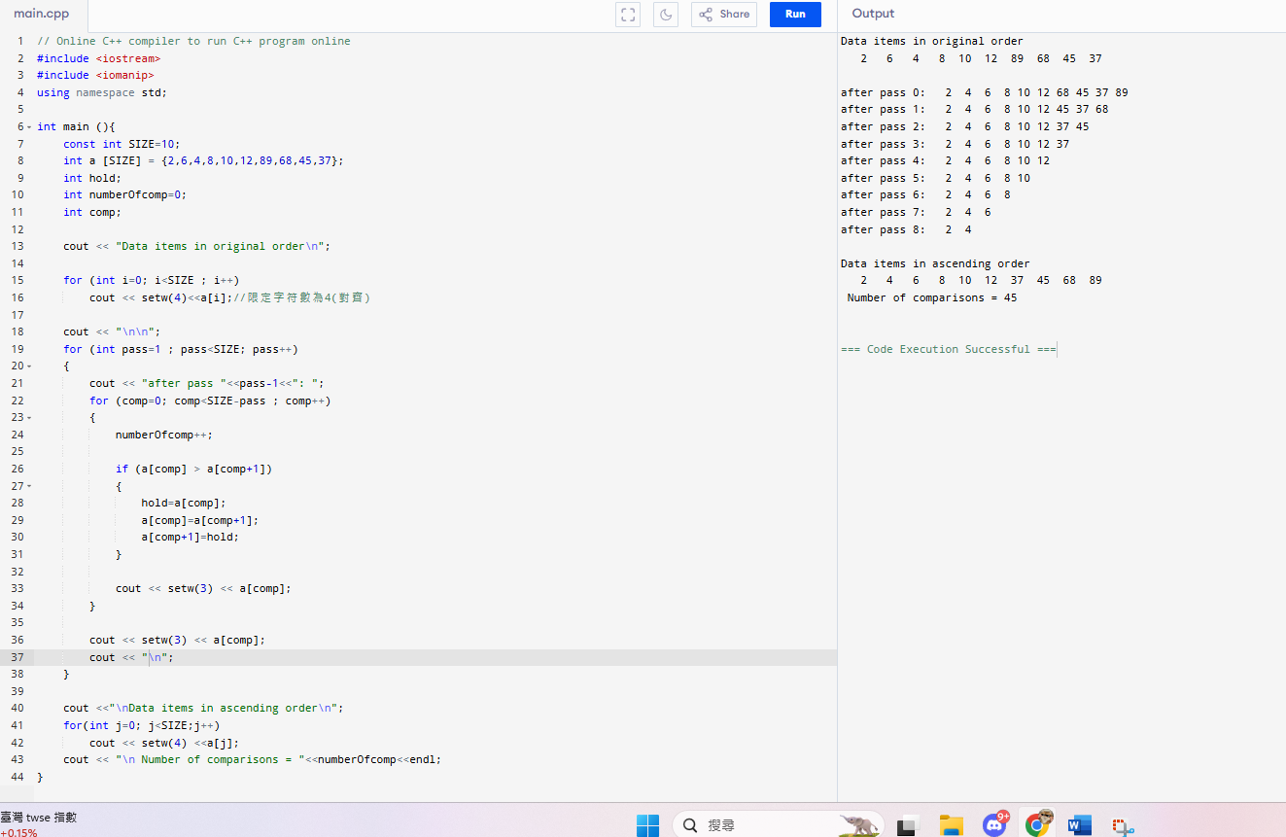
code:
#include <iostream>
#include <iomanip>
using namespace std;

int main (){
const int SIZE=10;
int a [SIZE] = {2,6,4,8,10,12,89,68,45,37};
int hold;
int numberOfcomp=0;
int comp;

cout << "Data items in original order\n";

for (int i=0; i<SIZE ; i++)
cout << setw(4)<<a[i];//限定字符數為4(對齊)

cout << "\n\n";
for (int pass=1 ; pass<SIZE; pass++)
{
cout << "after pass "<<pass-1<<": ";
for (comp=0; comp<SIZE-pass ; comp++)
{
numberOfcomp++;

if (a[comp] > a[comp+1])
{
hold=a[comp];
a[comp]=a[comp+1];
a[comp+1]=hold;
}

cout << setw(3) << a[comp];
}

cout << setw(3) << a[comp];
cout << "\n";
}

cout <<"\nData items in ascending order\n";
for(int j=0; j<SIZE;j++)
cout << setw(4) <<a[j];
cout << "\n Number of comparisons = "<<numberOfcomp<<endl;
}

