7.1
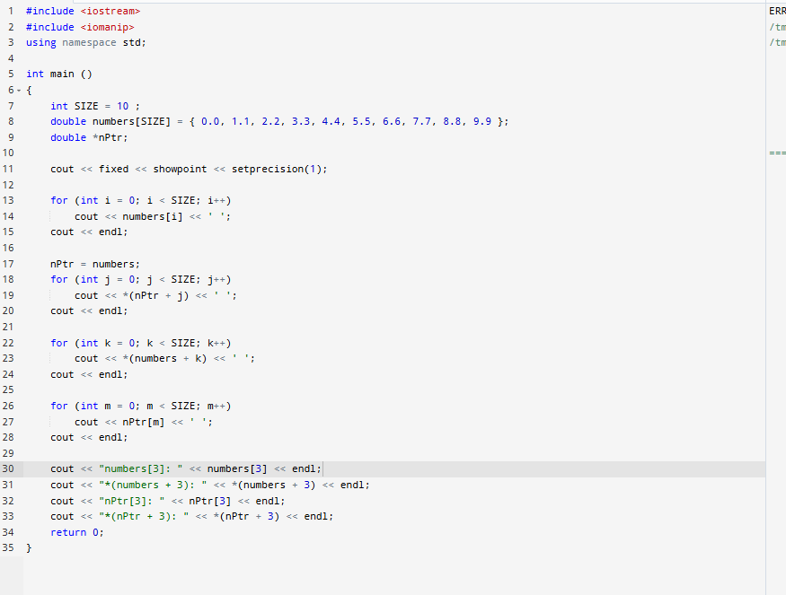
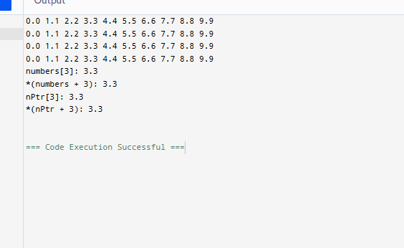
code
#include <iostream>
#include <iomanip>
using namespace std;

int main ()
{
int SIZE = 10 ;
double numbers[SIZE] = { 0.0, 1.1, 2.2, 3.3, 4.4, 5.5, 6.6, 7.7, 8.8, 9.9 };
double *nPtr;

cout << fixed << showpoint << setprecision(1);

for (int i = 0; i < SIZE; i++)
cout << numbers[i] << ' ';
cout << endl;

nPtr = numbers;
for (int j = 0; j < SIZE; j++)
cout << *(nPtr + j) << ' ';
cout << endl;

for (int k = 0; k < SIZE; k++)
cout << *(numbers + k) << ' ';
cout << endl;

for (int m = 0; m < SIZE; m++)
cout << nPtr[m] << ' ';
cout << endl;

cout << "numbers[3]: " << numbers[3] << endl;
cout << "*(numbers + 3): " << *(numbers + 3) << endl;
cout << "nPtr[3]: " << nPtr[3] << endl;
cout << "*(nPtr + 3): " << *(nPtr + 3) << endl;
return 0;
}
7.4
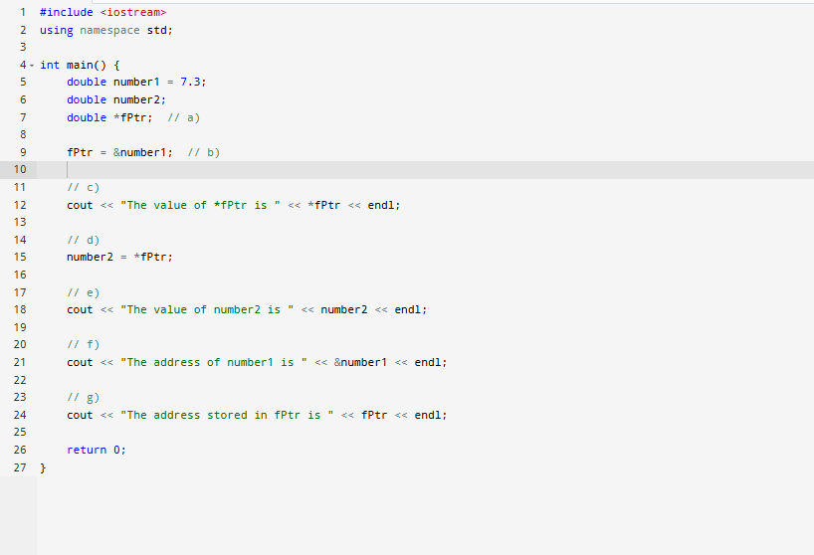
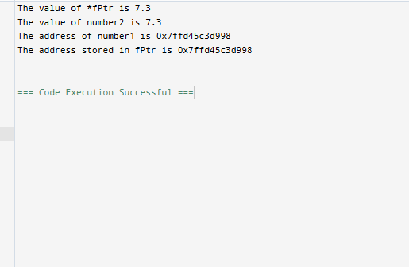
Code
#include <iostream>
using namespace std;

int main() {
double number1 = 7.3;
double number2;
double *fPtr; // a)

fPtr = &number1; // b)

// c)
cout << "The value of *fPtr is " << *fPtr << endl;

// d)
number2 = *fPtr;

// e)
cout << "The value of number2 is " << number2 << endl;

// f)
cout << "The address of number1 is " << &number1 << endl;

// g)
cout << "The address stored in fPtr is " << fPtr << endl;

return 0;
}

