1.
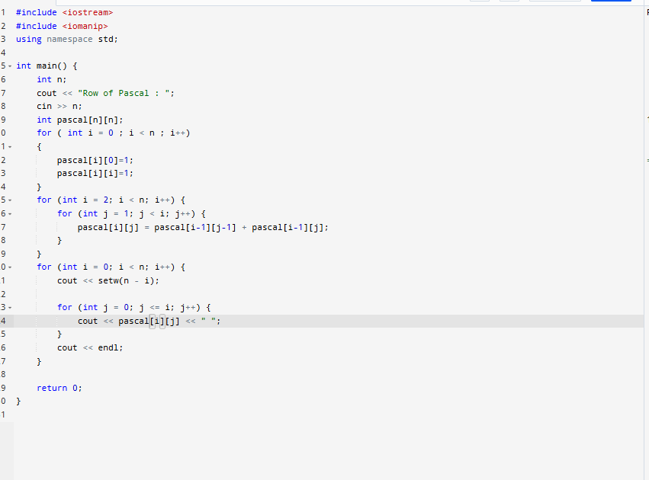
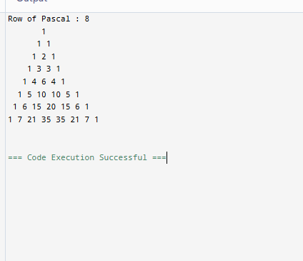
Code
#include <iostream>
#include <iomanip>
using namespace std;

int main() {
int n;
cout << "Row of Pascal : ";
cin >> n;
int pascal[n][n];
for ( int i = 0 ; i < n ; i++)
{
pascal[i][0]=1;
pascal[i][i]=1;
}
for (int i = 2; i < n; i++) {
for (int j = 1; j < i; j++) {
pascal[i][j] = pascal[i-1][j-1] + pascal[i-1][j];
}
}
for (int i = 0; i < n; i++) {
cout << setw(n - i);

for (int j = 0; j <= i; j++) {
cout << pascal[i][j] << " ";
}
cout << endl;
}

return 0;
}
2.
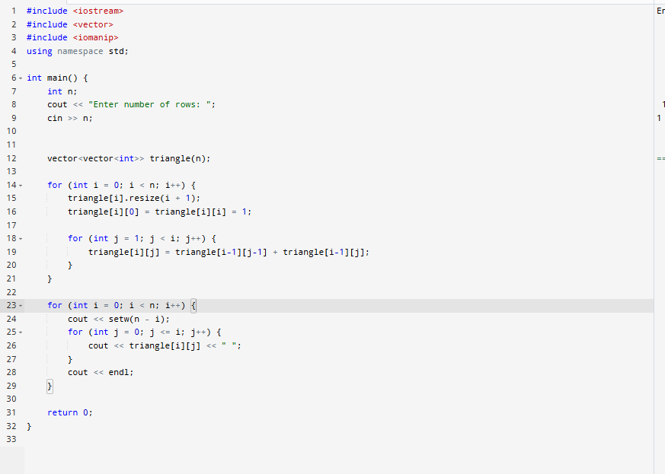
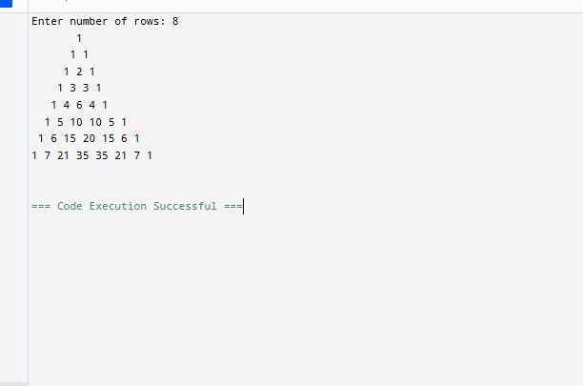
Code
#include <iostream>
#include <vector>
#include <iomanip>
using namespace std;

int main() {
int n;
cout << "Enter number of rows: ";
cin >> n;

vector<vector<int>> triangle(n);

for (int i = 0; i < n; i++) {
triangle[i].resize(i + 1);
triangle[i][0] = triangle[i][i] = 1;

for (int j = 1; j < i; j++) {
triangle[i][j] = triangle[i-1][j-1] + triangle[i-1][j];
}
}

for (int i = 0; i < n; i++) {
cout << setw(n - i);
for (int j = 0; j <= i; j++) {
cout << triangle[i][j] << " ";
}
cout << endl;
}

return 0;
}#include <iostream>
#include <vector>
#include <iomanip>
using namespace std;

int main() {
int n;
cout << "Enter number of rows: ";
cin >> n;

vector<vector<int>> triangle(n);

for (int i = 0; i < n; i++) {
triangle[i].resize(i + 1);
triangle[i][0] = triangle[i][i] = 1;

for (int j = 1; j < i; j++) {
triangle[i][j] = triangle[i-1][j-1] + triangle[i-1][j];
}
}

for (int i = 0; i < n; i++) {
cout << setw(n - i);
for (int j = 0; j <= i; j++) {
cout << triangle[i][j] << " ";
}
cout << endl;
}

return 0;
}

3.
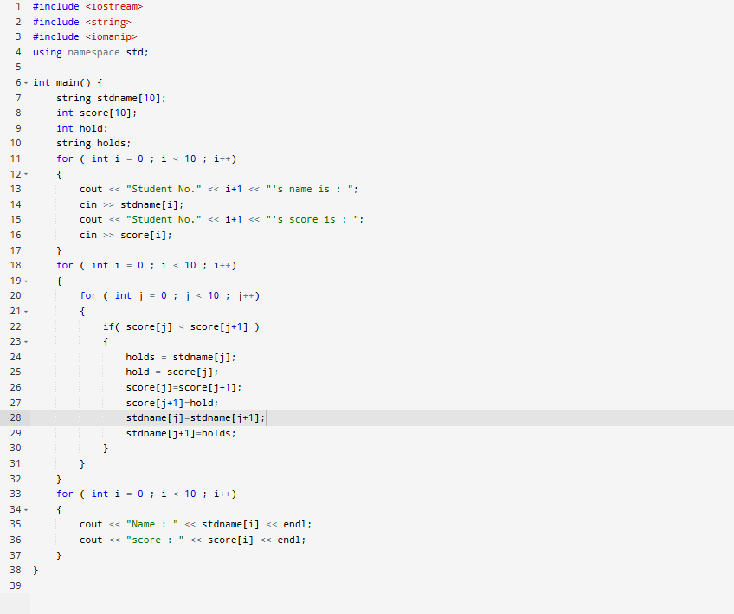
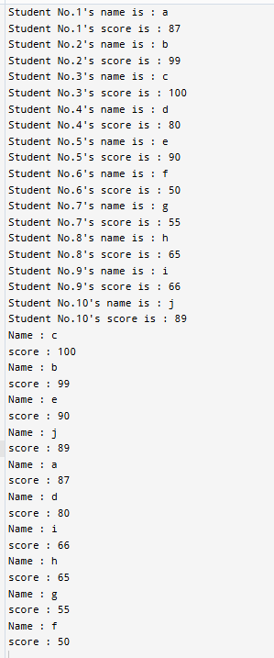
Code
#include <iostream>
#include <string>
#include <iomanip>
using namespace std;

int main() {
string stdname[10];
int score[10];
int hold;
string holds;
for ( int i = 0 ; i < 10 ; i++)
{
cout << "Student No." << i+1 << "'s name is : ";
cin >> stdname[i];
cout << "Student No." << i+1 << "'s score is : ";
cin >> score[i];
}
for ( int i = 0 ; i < 10 ; i++)
{
for ( int j = 0 ; j < 10 ; j++)
{
if( score[j] < score[j+1] )
{
holds = stdname[j];
hold = score[j];
score[j]=score[j+1];
score[j+1]=hold;
stdname[j]=stdname[j+1];
stdname[j+1]=holds;
}
}
}
for ( int i = 0 ; i < 10 ; i++)
{
cout << "Name : " << stdname[i] << endl;
cout << "score : " << score[i] << endl;
}
}

4.
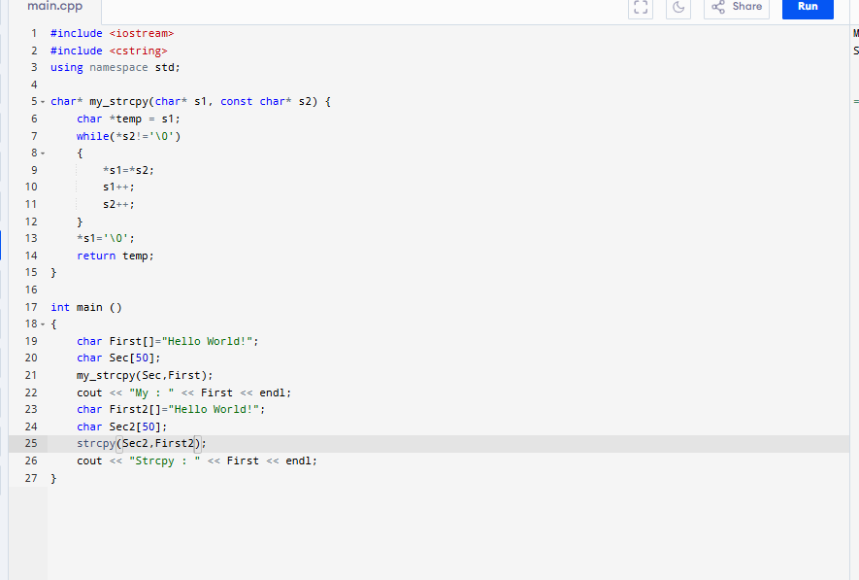
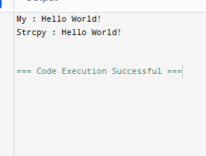
#include <iostream>
#include <cstring>
using namespace std;

char* my_strcpy(char* s1, const char* s2) {
char *temp = s1;
while(*s2!='\0')
{
*s1=*s2;
s1++;
s2++;
}
*s1='\0';
return temp;
}

int main ()
{
char First[]="Hello World!";
char Sec[50];
my_strcpy(Sec,First);
cout << "My : " << First << endl;
char First2[]="Hello World!";
char Sec2[50];
strcpy(Sec2,First2);
cout << "Strcpy : " << First << endl;
}

5
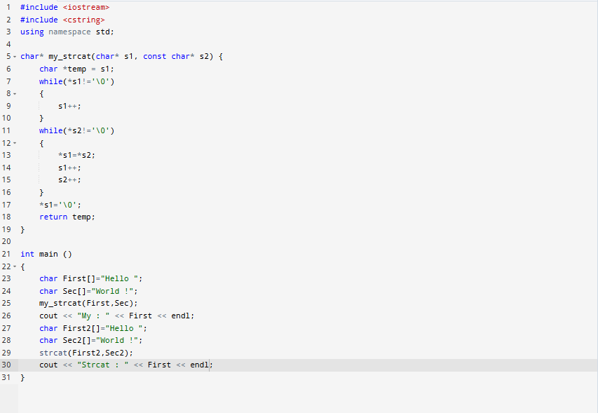
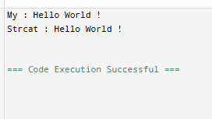
Code
#include <iostream>
#include <cstring>
using namespace std;

char* my_strcat(char* s1, const char* s2) {
char *temp = s1;
while(*s1!='\0')
{
s1++;
}
while(*s2!='\0')
{
*s1=*s2;
s1++;
s2++;
}
*s1='\0';
return temp;
}

int main ()
{
char First[]="Hello ";
char Sec[]="World !";
my_strcat(First,Sec);
cout << "My : " << First << endl;
char First2[]="Hello ";
char Sec2[]="World !";
strcat(First2,Sec2);
cout << "Strcat : " << First << endl;
}

6.
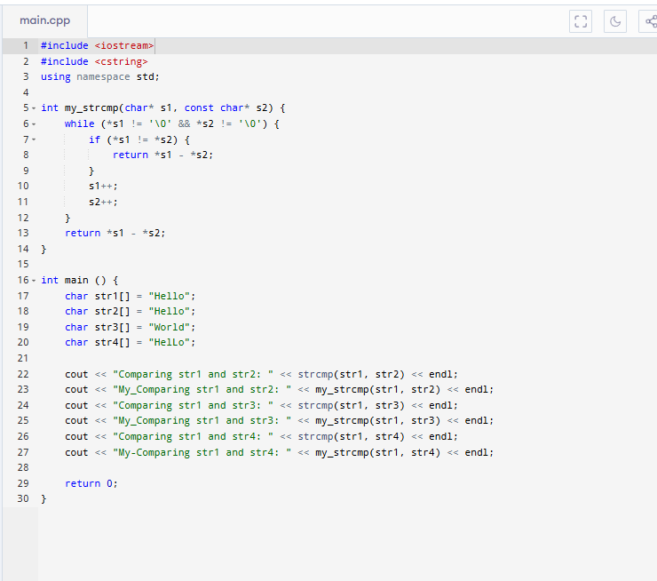’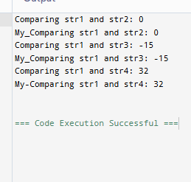
Code
#include <iostream>
#include <cstring>
using namespace std;

int my_strcmp(char* s1, const char* s2) {
while (*s1 != '\0' && *s2 != '\0') {
if (*s1 != *s2) {
return *s1 - *s2;
}
s1++;
s2++;
}
return *s1 - *s2;
}

int main () {
char str1[] = "Hello";
char str2[] = "Hello";
char str3[] = "World";
char str4[] = "HelLo";

cout << "Comparing str1 and str2: " << strcmp(str1, str2) << endl;
cout << "My_Comparing str1 and str2: " << my_strcmp(str1, str2) << endl;
cout << "Comparing str1 and str3: " << strcmp(str1, str3) << endl;
cout << "My_Comparing str1 and str3: " << my_strcmp(str1, str3) << endl;
cout << "Comparing str1 and str4: " << strcmp(str1, str4) << endl;
cout << "My-Comparing str1 and str4: " << my_strcmp(str1, str4) << endl;

return 0;
}

